3. inserting and retrieving data from database table using SQDML commands.

Select or Create a Datadase
use english1;
show databases;
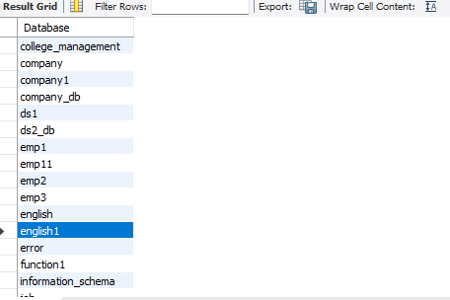
create table user5
(id int auto_increment primary key,
name varchar(100),
email varchar(100));
desc user5;
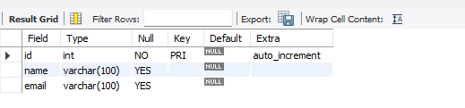

insert into user5 (name,email)
values ('ram','@ram123.com'),
('nisha','@nisha123.com');
select*from user5;
