

SUPPLY CHAIN ANALYSIS
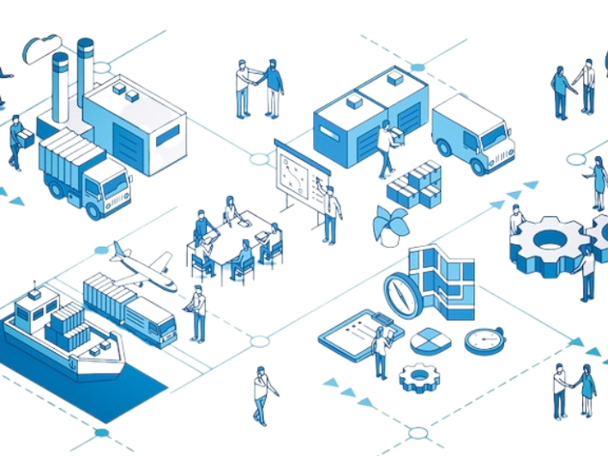
Final Project Report – CDACL-003

Submitted By
Name: SUHANI GUPTA
Course: Certified Data Analyst
Project Title: CDACL-003: Supply Chain Analysis
Team ID: PTID-CDA-APR-26-11397
Submission Date: 25th May, 2026

INDEX
- Introduction
- Objectives
- Problem Statement
- Tools and Technologies Used
- Dataset Description
- Database Connection
- Data Cleaning
- Exploratory Data Analysis
- SQL Analysis
- Power BI Dashboard
- Insights and Findings
- Conclusion
- References

1. INTRODUCTION
Supply chain analysis is the process of evaluating and improving the movement of products, inventory, suppliers, transportation, and manufacturing operations within an organization.
The purpose of this project is to analyze supply chain data to identify trends, supplier performance, shipping efficiency, inventory management issues, and manufacturing quality.
Using Python, SQL, and Power BI, the project provides detailed analysis and dashboard visualizations to help businesses improve operational efficiency and decision-making.

2. OBJECTIVES
The main objectives of this project are:
- To analyze supplier performance.
- To identify revenue trends.
- To study inventory and stock levels.
- To evaluate transportation and shipping costs.
- To identify manufacturing and defect trends.
- To create dashboard visualizations using Power BI.
- To generate business insights for supply chain optimization.

3. PROBLEM STATEMENT
The company wants to analyze its supply chain data to improve operational efficiency, reduce shipping costs, optimize inventory management, evaluate supplier performance, and minimize manufacturing defects.
The project involves:
- Data analysis
- SQL analysis
- Dashboard creation
- Comparison reports
- Business insights generation

4. TOOLS AND TECHNOLOGIES USED
Tool | Purpose
Python | Data Cleaning and Analysis
Jupyter Notebook | Python Execution Environment
Pandas | Data Manipulation
Matplotlib | Visualization
Seaborn | Visualization
MySQL | Database Queries
Power BI | Dashboard Creation
MS Word | Report Writing
PowerPoint | Presentation

5. DATASET DESCRIPTION
The dataset contains supply chain information including:
- Product type
- SKU
- Price
- Revenue generated
- Stock levels
- Lead times
- Shipping times
- Shipping costs
- Supplier names
- Manufacturing costs
- Defect rates
- Transportation modes
- Inspection results
The data helps analyze operational efficiency and logistics performance.

6. DATABASE CONNECTION
Database Credentials
Host: 18.136.157.135 Database: project_supply_chain_data Username: dm_team18
Python Database Connection Code
import pymysql
import pandas as pd

connection = pymysql.connect(
host="18.136.157.135",
port=3306,
user="dm_team18",
password="VE76@b&i0AqE",
database="project_supply_chain_data"
)

query = "SELECT * FROM supply_chain_data"

_df = pd.read_sql(query, connection)

7. DATA CLEANING
The following data cleaning steps were performed:
- Checked missing values.
- Removed duplicate records.
- Verified data types.
- Handled null values.
- Standardized dataset formatting.
Missing Value Check
_df.isnull().sum()
Remove Duplicates
_df.drop_duplicates(inplace=True)
Save Cleaned Dataset
_df.to_csv("supply_chain_cleaned.csv", index=False)

8. EXPLORATORY DATA ANALYSIS (EDA)
8.1 Product Type Distribution
A bar chart was created to analyze the number of products in different categories.
Insight:
Electronics and skincare products had higher product counts.
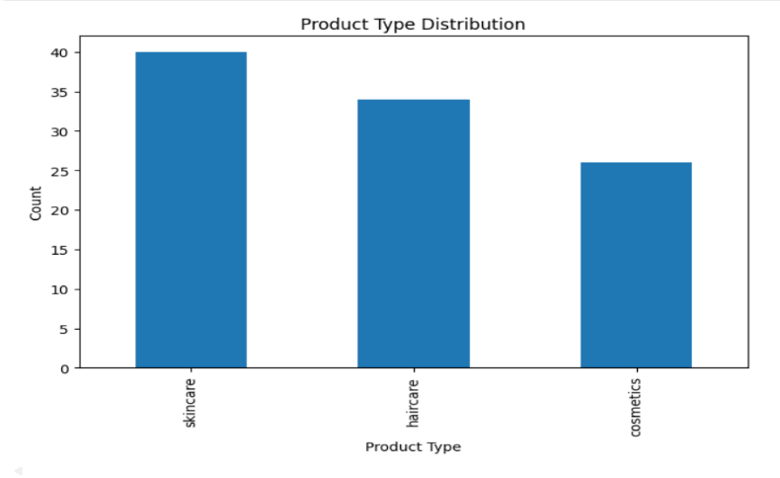
8.2 Revenue by Product Type
Revenue generated by each product type was analyzed.
Insight:
Some product categories generated significantly higher revenue than others.
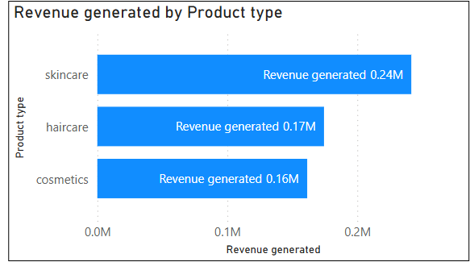
8.3 Shipping Cost Analysis
Shipping costs were analyzed using distribution charts.
Insight:
Shipping expenses varied significantly across transportation methods.
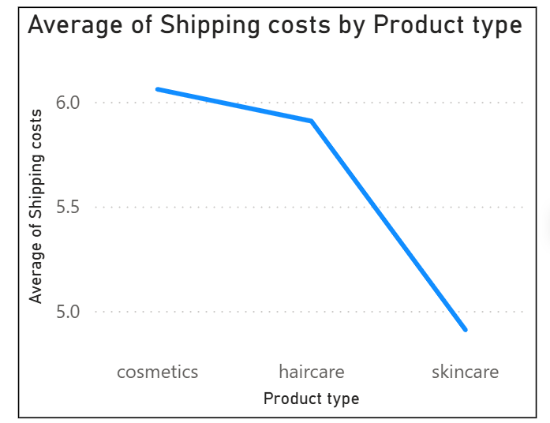
8.4 Supplier Performance Analysis
Top suppliers were identified based on revenue generation.
Insight:
A few suppliers contributed major revenue while others showed lower performance.
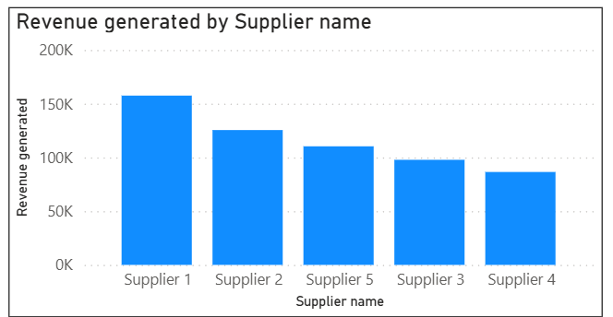
8.5 Inventory Analysis
Stock levels were analyzed to detect inventory imbalance.
Insight:
Some products had low stock availability, which may affect order fulfillment.
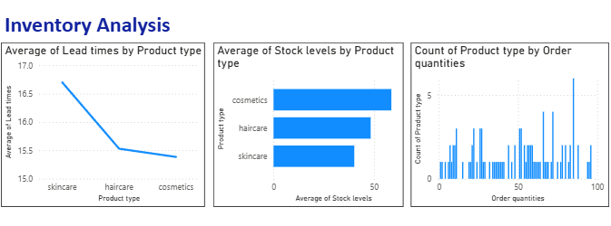
8.6 Manufacturing Cost Analysis
Manufacturing costs were analyzed product-wise.
Insight:
Certain products had higher production expenses.
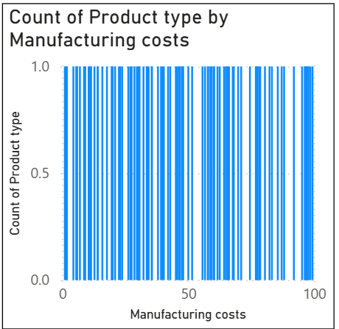
8.7 Defect Rate Analysis
Defect rates were compared with manufacturing costs.
Insight:
Products with higher manufacturing costs generally showed lower defect rates.
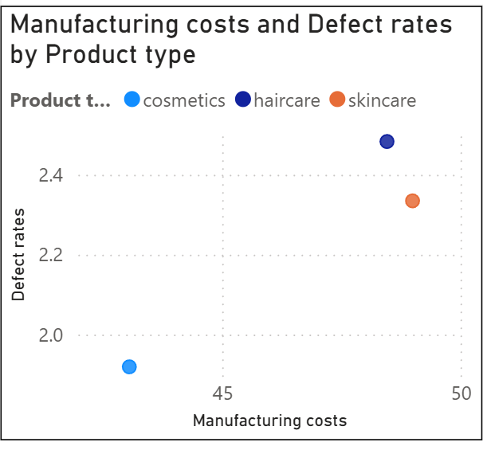
8.8 Transportation Mode Analysis
Transportation modes such as air, road, rail, and sea were analyzed.
Insight:
Air transportation had higher shipping costs compared to road transport.
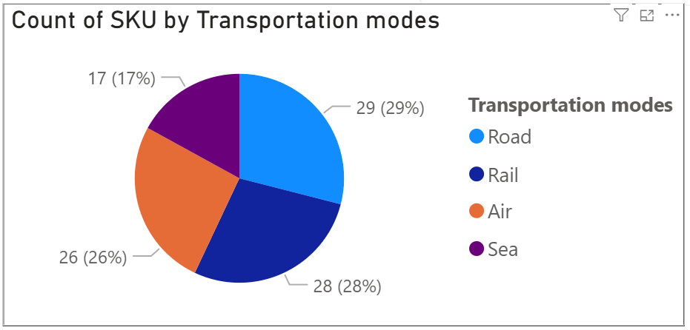
8.9 Shipping Time Analysis
Shipping delays and transportation efficiency were analyzed.
Insight:
Some transportation routes experienced delivery delays.
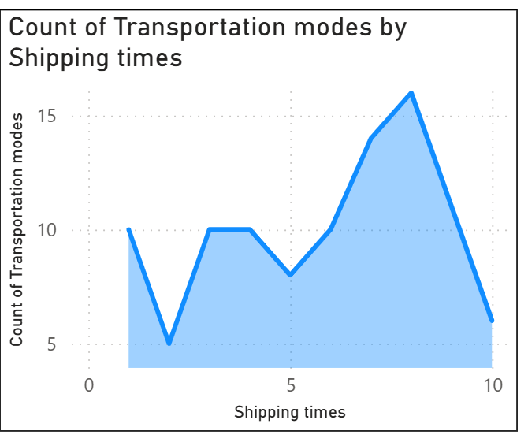

9. SQL ANALYSIS
The following SQL queries were performed for analysis.

Query 1 — Total Products
SELECT COUNT(*) AS total_products
FROM supply_chain_data;

Query 2 — Revenue by Product Type
SELECT `Product type`,
SUM(`Revenue generated`) AS total_revenue
FROM supply_chain_data
GROUP BY `Product type`;

Query 3 — Average Shipping Cost
SELECT AVG(`Shipping costs`) AS avg_shipping_cost
FROM supply_chain_data;

Query 4 — Top Suppliers
SELECT `Supplier name`,
SUM(`Revenue generated`) AS revenue
FROM supply_chain_data
GROUP BY `Supplier name`
ORDER BY revenue DESC;

Query 5 — Defect Rate Analysis
SELECT SKU,
`Defect rates`
FROM supply_chain_data
ORDER BY `Defect rates` DESC;

Query 6 — Transportation Cost Analysis
SELECT `Transportation modes`,
AVG(`Shipping costs`) AS avg_cost
FROM supply_chain_data
GROUP BY `Transportation modes`;

Query 7 — Product Availability
SELECT Availability,
COUNT(*) AS total
FROM supply_chain_data
GROUP BY Availability;

Query 8 — Manufacturing Cost Analysis
SELECT AVG(`Manufacturing costs`) AS avg_cost
FROM supply_chain_data;

Query 9 — Stock Level Analysis
SELECT SKU,
`Stock levels`
FROM supply_chain_data
ORDER BY `Stock levels` ASC;

Query 10 — Lead Time Analysis
SELECT AVG(`Lead times`) AS avg_lead_time
FROM supply_chain_data;

10. POWER BI DASHBOARD
The Power BI dashboard was developed to visualize operational performance and supply chain trends.
Dashboard Pages:
- Overview Dashboard
- Inventory Analysis
- Shipping and Logistics
- Quality and Manufacturing

Dashboard Features
KPI Cards
- Total Revenue
- Total Products
- Average Shipping Cost
- Average Manufacturing Cost
Visualizations
- Revenue by Product Type
- Supplier Performance
- Transportation Mode Distribution
- Inventory Analysis
- Shipping Cost Trends
- Defect Rate Analysis
- Manufacturing Cost Analysis
Filters/Slicers
- Product Type
- Supplier Name
- Transportation Mode
- Location

11. INSIGHTS AND FINDINGS
- Electronics products generated the highest revenue.
- Air transportation had the highest shipping cost.
- Certain suppliers contributed significantly to revenue.
- Inventory imbalance was observed in some products.
- Some products showed higher defect rates.
- Shipping delays affected transportation efficiency.
- Manufacturing costs varied across product categories.
- Road transportation was more cost-efficient than air transport.
- Products with better inspection results showed lower defect rates.
- Supplier performance directly impacted supply chain efficiency.

12. CONCLUSION
The Supply Chain Analysis project successfully identified operational trends, supplier performance, inventory issues, and logistics efficiency using Python, SQL, and Power BI.
The dashboard and analysis provided valuable insights that can help businesses optimize transportation costs, improve supplier management, reduce defects, and maintain better inventory control.
The project demonstrated how data analytics techniques can improve supply chain decision-making and operational performance.

13. REFERENCES
1. Python Official Documentation - https://docs.python.org/3/
2. Pandas Documentation - https://pandas.pydata.org/docs/
3. Matplotlib Documentation - https://matplotlib.org/stable/index.html
4. Seaborn Documentation - https://seaborn.pydata.org/
5. MySQL Documentation - https://dev.mysql.com/doc/
6. Microsoft Power BI Documentation - https://learn.microsoft.com/en-us/power-bi/
7. Datamites Internship Dataset and Project Specification
8. Jupyter Notebook Documentation - https://jupyter.org/documentation
9. ChatGPT by OpenAI - https://chat.openai.com/

