Design and implement a professional CI/CD pipeline for a Go (Golang) Logistics application using GitHub Actions or Jenkins.

  - Course Name: DeveOps

Institution Name: Medicaps University – Datagami Skill Based Course

Student Name(s) & Enrolment Number(s):
Sr no | Student Name | Enrolment Number
1. | SNEHA ARAS | EN22CS301964
2. | SUHANI MOGRA | EN22CS301989
3. | VAIBHAV SHRIVASTAVA | EN22CS3011051
4. | NAMAN PATIDAR | EN22ME303013
5. | TAMANNA KATARIYA | EN22CS3011013

Group Name: 05D9
Project Number: D0-05
Industry Mentor Name: Mr. Vaibhav
University Mentor Name: Dr. Ritesh Joshi
Academic Year: 2022-26

Problem Statement & Objectives

Problem Statement
Traditional software deployment processes involve manual building, testing, and deployment of applications. This approach is time-consuming, error-prone, and does not scale well in modern enterprise environments.
Developers often face challenges such as:
- Manual deployment errors
- Inconsistent runtime environments
- Delayed application updates
- Lack of automation
- Difficulty in maintaining production systems
There is a need for an automated system that integrates development, testing, containerization, and cloud deployment into a single workflow.

- Project Objectives
The main objectives of this project are:
- To develop a Spring Boot based logistics application.
- To implement CI/CD pipeline using GitHub Actions.
- To automate application build and Docker image creation.
- To deploy application on AWS EC2 using Docker and Tomcat.
- To demonstrate DevOps best practices.
- To provide a scalable and portable deployment architecture.
- To eliminate manual deployment steps.

- Scope of the Project
The scope of this project includes:
- Development of a basic logistics REST application.
- Automation of build and deployment using GitHub Actions.
- Docker containerization of application.
- Hosting on AWS EC2 cloud server.
- Health monitoring through REST endpoints.

Proposed Solution
The proposed solution implements an automated DevOps-based deployment pipeline for a Logistics application.
The system integrates application development, continuous integration, containerization, and cloud deployment into a single workflow.
Instead of manual build and deployment, the solution uses GitHub Actions for CI/CD, Docker for containerization, and AWS EC2 for hosting, ensuring faster delivery, consistency, and scalability.
- Key Features
- Spring Boot–based Logistics REST application
- Automated CI/CD using GitHub Actions
- WAR file generation using Maven
- Dockerized deployment with Apache Tomcat
- Docker image storage on Docker Hub
- Cloud deployment on AWS EC2
- Stateless application architecture
- Health check API endpoint
- Secure credential management using GitHub Secrets
- Faster and reliable deployments
- Overall Architecture / Workflow
The workflow of the proposed system is as follows:
  - Developer writes application code in VS Code.
  - Code is pushed to GitHub repository.
  - GitHub Actions automatically triggers CI/CD pipeline.
  - Maven builds the WAR file and runs tests.
  - Docker image is created with Tomcat and WAR file.
  - Image is pushed to Docker Hub.
  - AWS EC2 pulls the Docker image.
  - Docker runs Tomcat container on EC2.
  - Users access the application via EC2 public IP.
This automated pipeline removes manual deployment steps and ensures continuous delivery

Developer
↓
Git Repository
↓
CI Pipeline (GitHub Actions / Jenkins)
↓
Automated Testing
↓
Docker Image Build
↓
Push to Docker Hub
↓
Deployment & Application Running

- Tools & Technologies Used

Category | Technology
Programming Language | Java
Framework | Spring Boot
Build Tool | Maven
Web Server | Apache Tomcat
Containerization | Docker
CI/CD | GitHub Actions
Source Control | GitHub
Image Registry | Docker Hub
Cloud Platform | AWS EC2
Development Tool | VS Code
Operating System | Ubuntu

Results & Output
- Screenshots / outputs

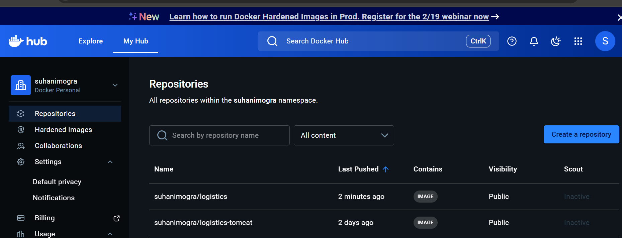
Figure 1: Docker Hub repositories showing successfully pushed container images for the Logistics CI/CD project.

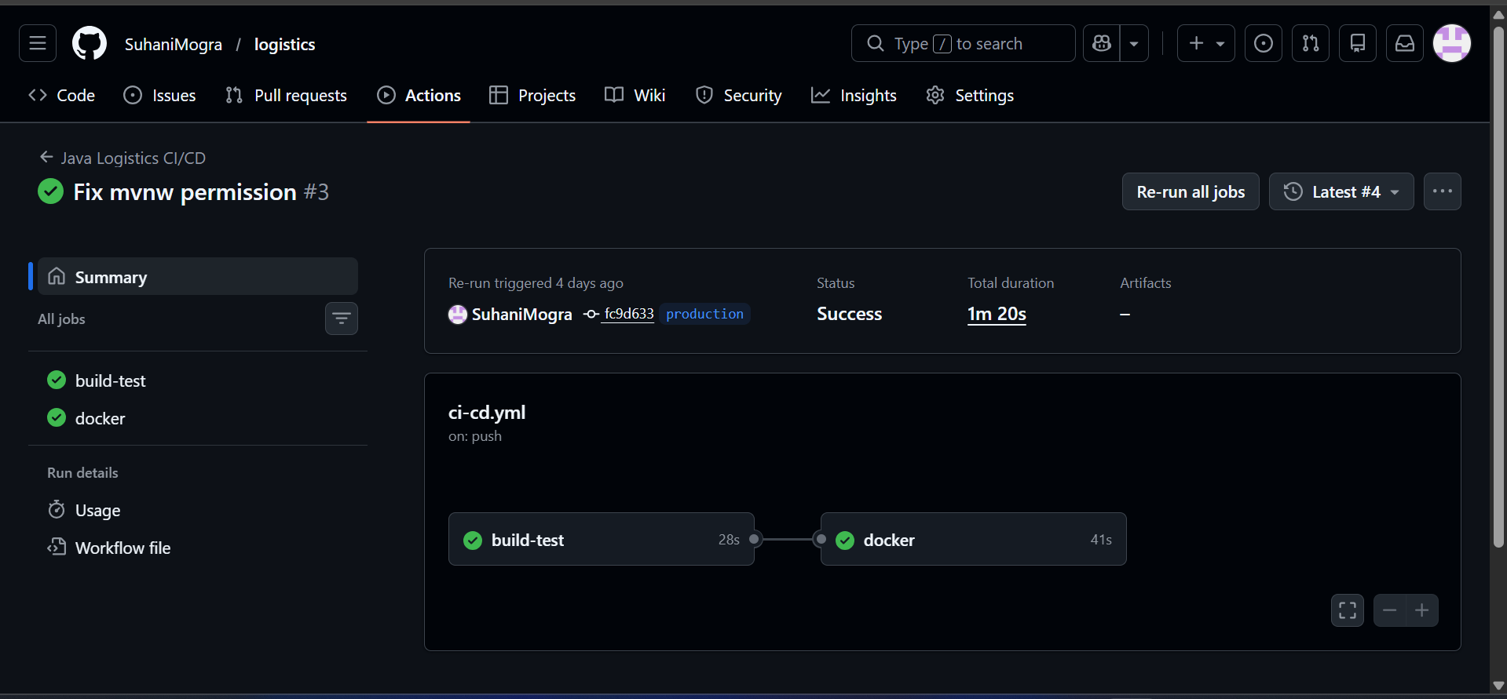
Figure 2: Successful GitHub Actions CI/CD workflow execution for the Logistics project showing build-test and Docker stages

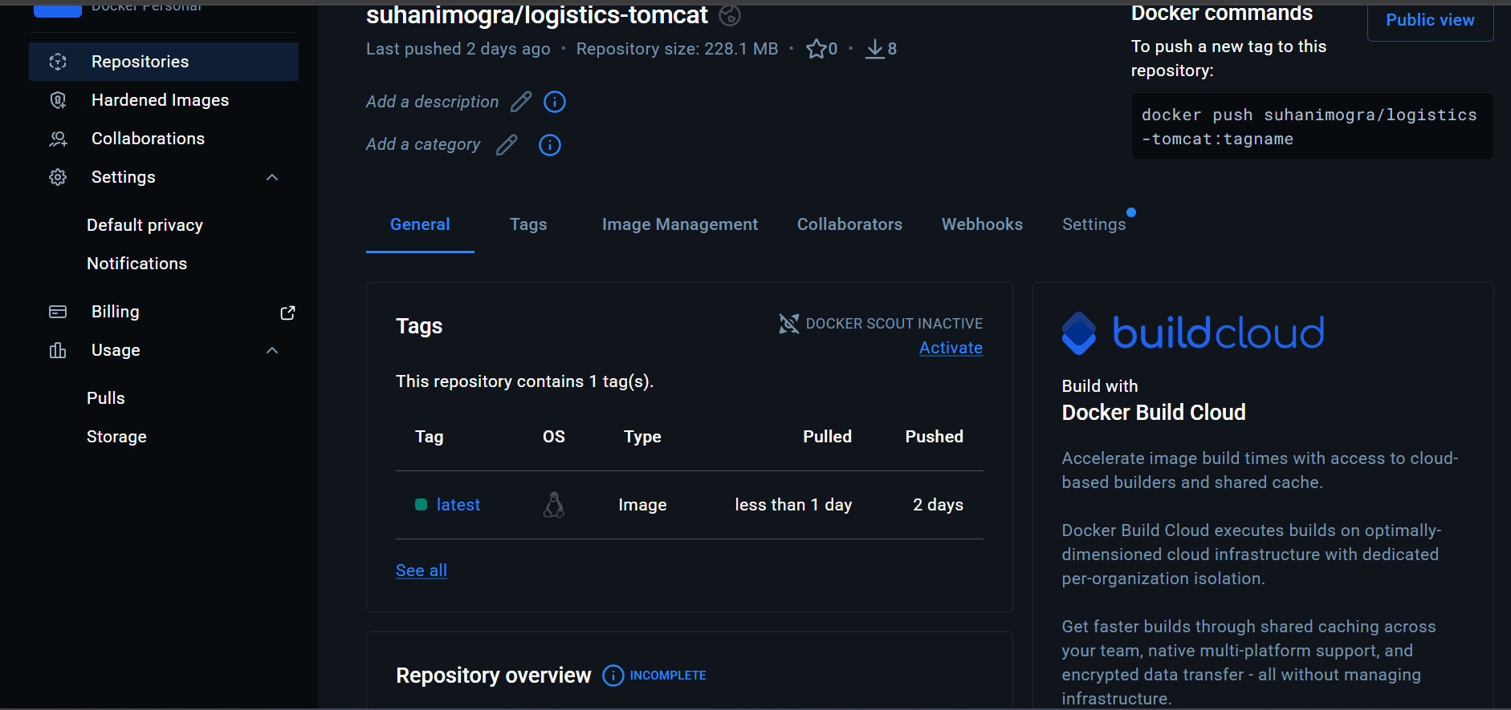
Figure 3: Docker Hub repository view showing the latest tagged image for the Logistics-Tomcat application.

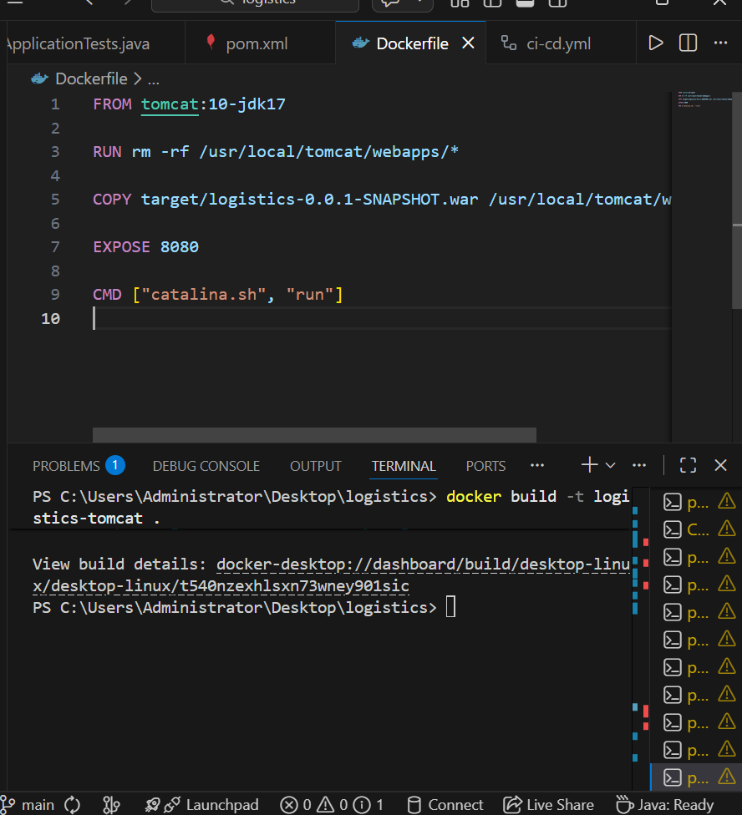
Figure 4: Dockerfile configuration and successful Docker image build for the Logistics application.

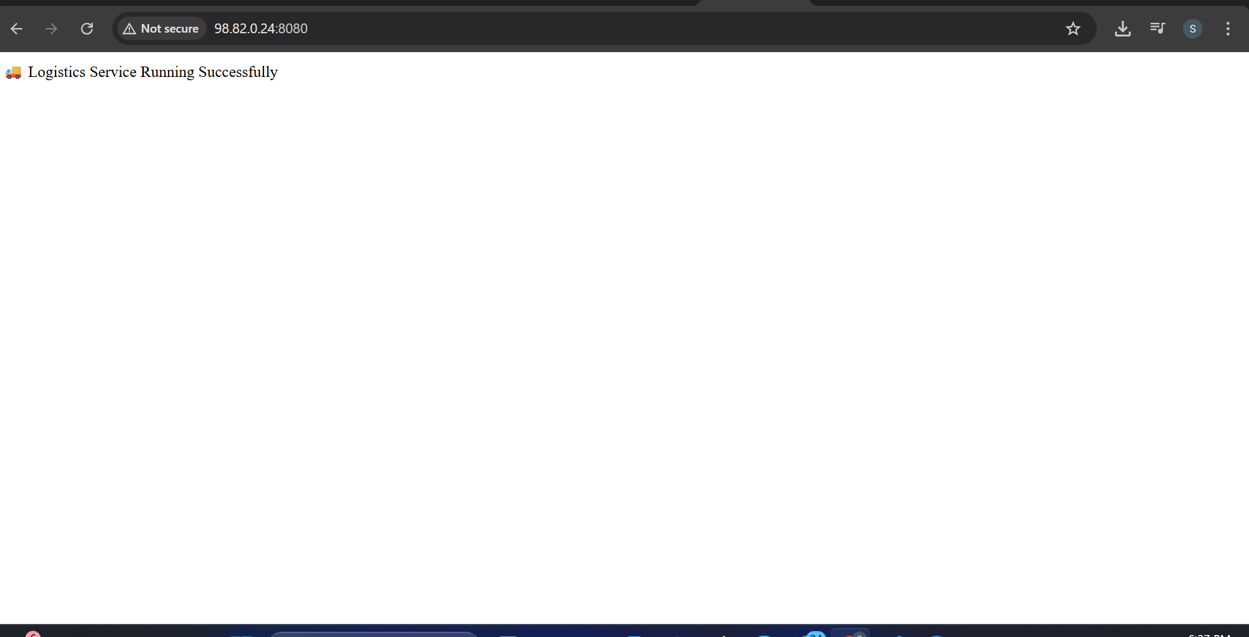
Figure 5: Logistics Service running successfully in the browser after Docker deployment.

- Reports / dashboards / models
In the current implementation, the project focuses on application deployment automation and cloud hosting. There are no complex business dashboards or analytical reports.
However, the system provides operational visibility through the following:

Reports
- GitHub Actions Build Report: Shows pipeline execution status (success/failure), build logs, and test results.
- Docker Image Status: Docker Hub displays image tags, upload time, and pull status.
- Application Health Report: The /health API endpoint returns application status (OK), confirming service availability.
Dashboards
- GitHub Actions Dashboard: Displays CI/CD pipeline runs with green/red status indicators.
- Docker Hub Repository Dashboard: Shows pushed images, tags (latest), and pull commands.
- AWS EC2 Console Dashboard: Shows instance status, CPU usage, networking, and security group configuration.

- Key outcomes
The following outcomes were successfully achieved through this project:
- Developed a Spring Boot–based Logistics REST application.
- Implemented automated CI/CD pipeline using GitHub Actions
- Successfully built WAR file using Maven.
- Dockerized the application with Apache Tomcat.
- Pushed Docker images to Docker Hub.
- Deployed application on AWS EC2 cloud server.
- Enabled public access to application via EC2 public IP.
- Implemented health check endpoint for monitoring.
- Demonstrated end-to-end DevOps workflow from development to cloud deployment.
- Achieved faster and reliable deployment with minimal manual intervention.

Conclusion

This project successfully implemented a complete DevOps-based deployment pipeline for a Logistics application using Spring Boot, Docker, GitHub Actions, and AWS EC2. The system automates application build, containerization, and cloud deployment, eliminating manual processes and ensuring faster, reliable delivery.
The project demonstrated real-world CI/CD practices by integrating Maven for WAR generation, Docker for containerized deployment with Apache Tomcat, and GitHub Actions for continuous integration. The application was deployed on AWS EC2 and made accessible through a public IP address.
Key learnings from this project include understanding CI/CD pipelines, Docker containerization, cloud deployment on AWS, GitHub Actions automation, and enterprise-style application deployment. This project provided hands-on experience with modern DevOps tools and workflows.

Future Scope & Enhancements

The following enhancements can be implemented in future versions:
- Integration of database (MySQL/PostgreSQL) for logistics data storage
- Implementation of user authentication and authorization
- Addition of frontend UI for better user interaction
- HTTPS configuration for secure communication
- Auto-deployment from GitHub Actions to AWS EC2
- Load balancing and scalability using multiple EC2 instances
- Monitoring and logging using tools like Prometheus or CloudWatch
- Kubernetes orchestration for container management

