OPERATION TEAM :

* FOR UNDERSTANDING SUPPLY CHAIN OF COMPANY

select *from olist_orders_dataset

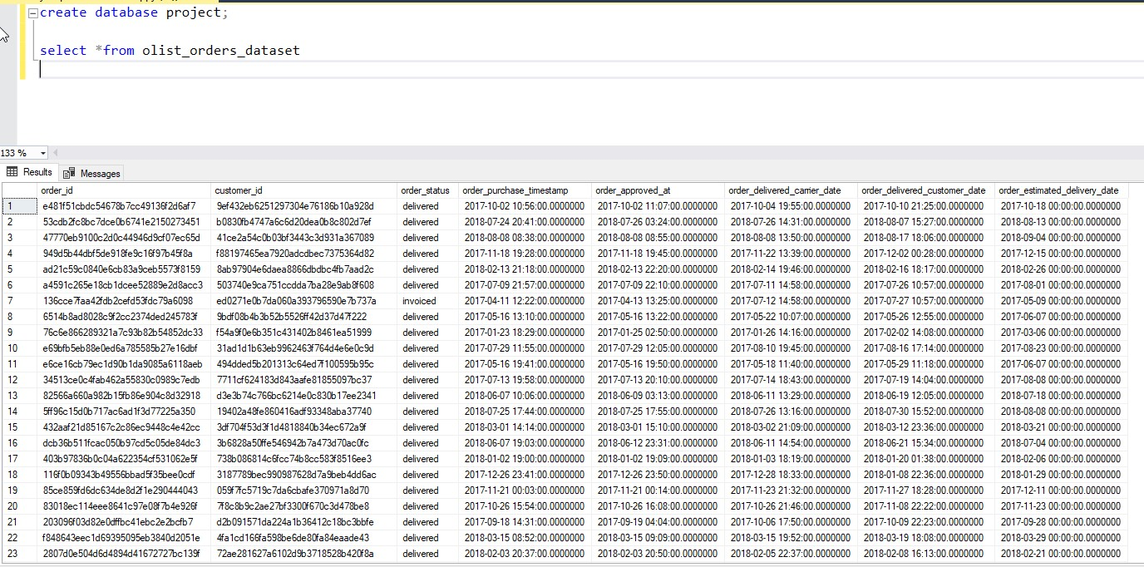

* **TO UNDERSTAND THE ORDER STATUS AND PERFORMANCE**

select order_status,count(*) from olist_orders_dataset group by order_status;

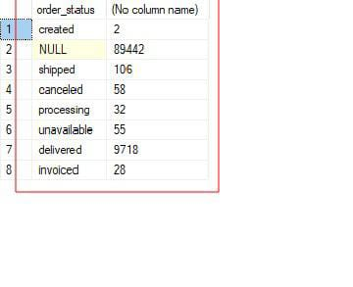

select avg(datediff(DAYOFYEAR,order_delivered_customer_date,order_purchase_timestamp )) as avg_delivered_time from olist_orders_dataset

where order_status='delivered';

* About selling details

select *from olist_order_items_dataset

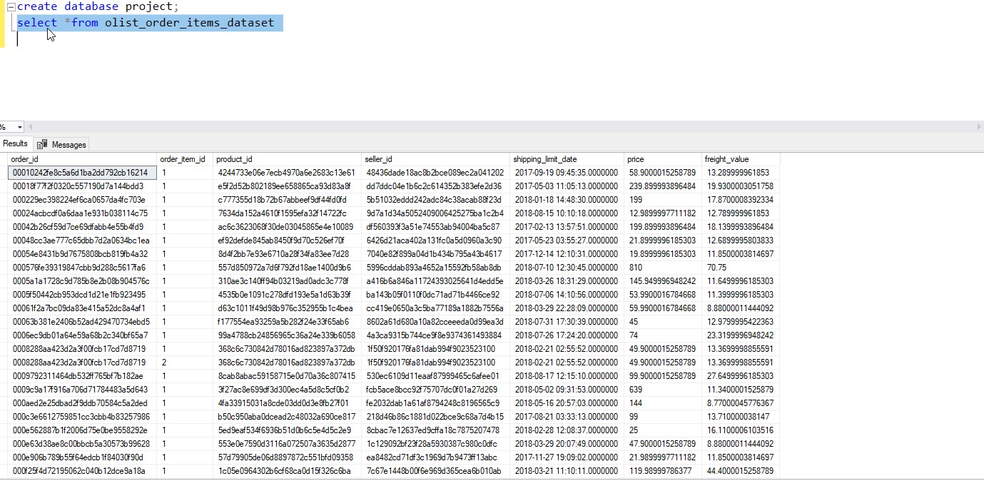

* Customer locations

select customer_zip_code_prefix,count(*) from olistcustomerdataset

group by customer_zip_code_prefix;

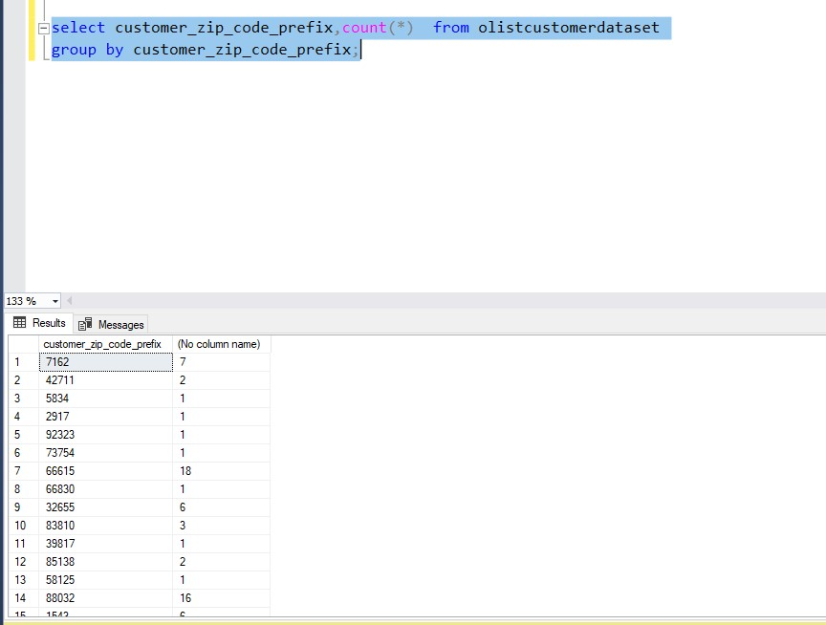

* Payment method analysis

select payment_type,count(*) from olist_order_payments_dataset group by payment_type;

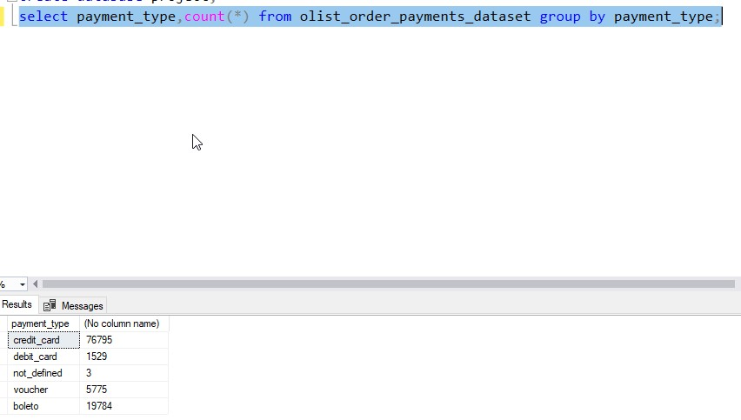

* Order review

select review_score,count(*) from olist_order_reviews_dataset

group by review_score;

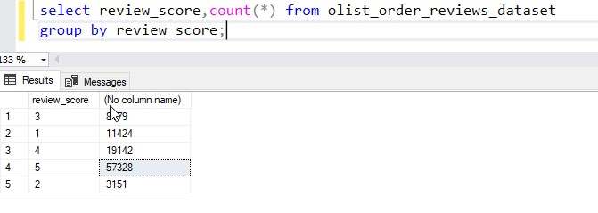

SALES TEAM :

* Product category
* To identify the popular product category

select product_category_name,count(*) from olist_products_dataset

group by product_category_name;

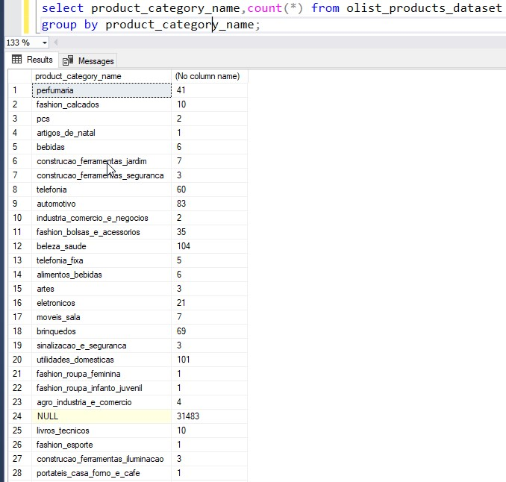

* Vendor performance

select seller_id,count(*) from olist_sellers_dataset

group by seller_id

order by count(*) desc;

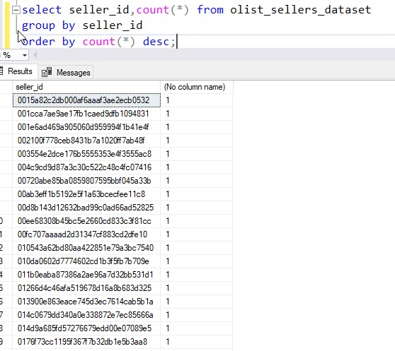

* Customer preferences
* To analyze buying trends

select product_id,sum(price) as total_sales from olist_order_items_dataset

group by product_id

order by total_sales;

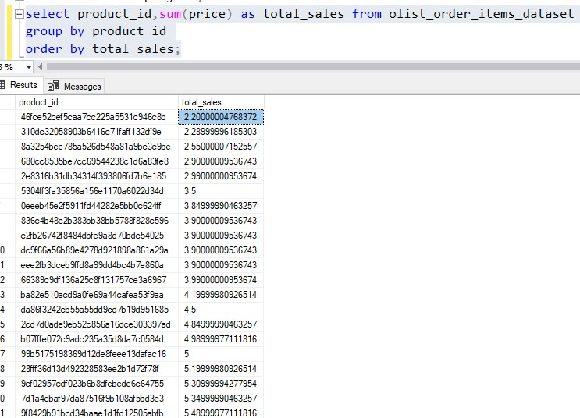

* **Pricing stratergies**

select avg(price) as average_price,stdev(price) as price_deviation

from olist_order_items_dataset

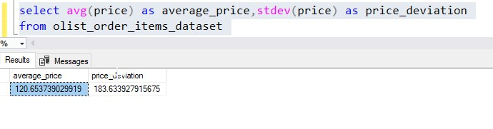

MARKETING TEAM :

* Customer segmentation

select customer_state , count(customer_id)as number_of_customers

from olistcustomerdataset

group by customer_state;

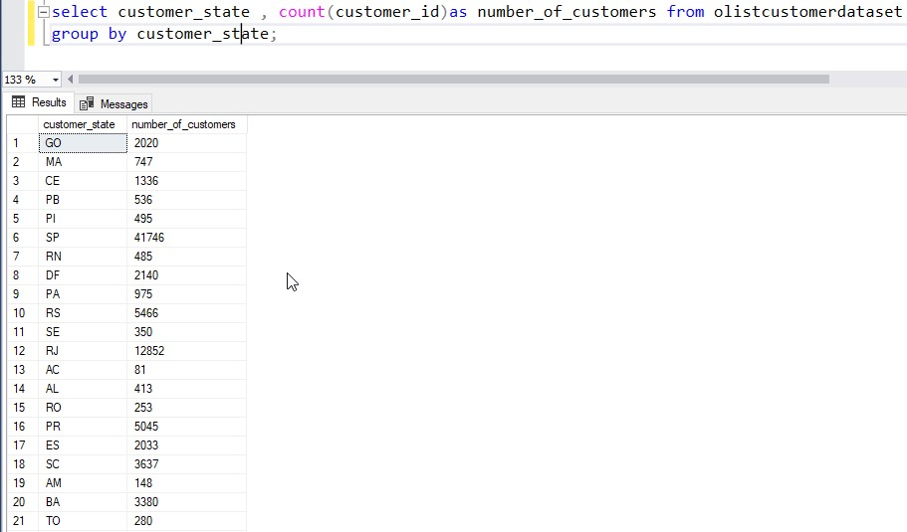

Insights

These sql queries are extract valuable insights for each department to aid flipkart in setting up its business in the brazillian market….

The operation team can get a clear view of the supply chain and delivery performance and the marketing team can segment customers effectively .