**MEDICAL PATHOLOGY LAB**

Suhani Vinod Prajapati

(17BCS030)

**SCHEMA**

ENTITIES

1. Patients
2. Doctors
3. Lab Assistants
4. Bills
5. Type Of Tests

TABLE Patient

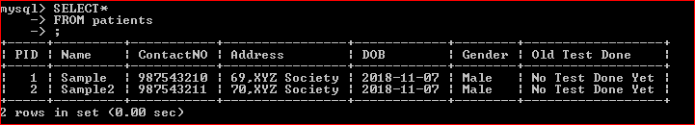

Table Doctor

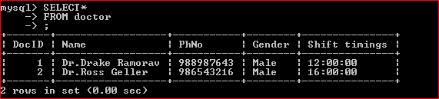

Table Type OF Tests

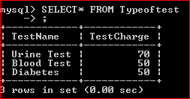

TABLE Labmember

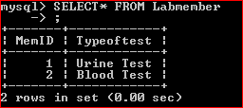

TABLE bill

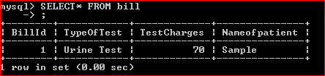

ER Diagram

