Network Prediction Model and Food & Resource Prediction Model
Model inputs, outputs, training, comparison and selected-model analysis
Project: SmartCamp-IoT-AI-Framework · Branch: intel-res-msg · Date: 21 August 2026 · All figures traced to repository source, saved artifacts, or code executed during this analysis

Abstract
This report documents the two prediction models implemented in the SmartCamp-IoT-AI-Framework repository. The Food and Resource Prediction Model estimates daily food, water, shelter and medical-staffing requirements for a displacement camp using four Gradient Boosting regressors over a shared 21-feature vector. The Network Prediction Model classifies the camp uplink into one of three states using a Random Forest over 18 features, and a deterministic rule then converts that state plus a message priority into an MQTT quality-of-service level and a publish-or-buffer action. Both models score close to the theoretical maximum on their held-out splits, and this report reproduced every stored metric exactly from the saved artifacts. It also establishes why both scores are near-perfect: in each case the training target is a deterministic function of the model’s own input features.

1. Introduction
The platform serves disaster-relief camps over an intermittent uplink. Two prediction problems follow from that setting. The first is a supply problem: given who is registered in the camp today, how much food, water, shelter capacity and clinical staffing is needed per day. The second is a delivery problem: given a link that may be fast, congested or effectively absent, which messages should be sent, with what delivery guarantee, and which should be held locally until the link recovers.
One point of terminology matters before anything else. In this repository "resource" means humanitarian relief supplies — kilograms of food, litres of water, shelter units, health workers. It does not mean CPU, memory, storage, bandwidth or any other computational resource. No component of the system predicts compute capacity. This is stated up front because "resource prediction" carries the opposite meaning in much of the networking literature, and the two models described here sit close enough together that the confusion is easy to make.
The two models are connected in one direction only. The network model publishes a state that the resource-forecast request path reads before deciding how to transport itself. Resource predictions are never fed back into the network model. Everything below was established by reading the implementation and by re-running the models; no value has been carried over from documentation without verification.

2. Food and Resource Prediction Model

2.1 Model inputs
All four regressors share one 21-column feature vector, fixed in the order stored in the model metadata. Fourteen columns are supplied by the caller or aggregated from the camp database; the remaining seven are derived inside ResourcePredictor._build_feature_df() at prediction time.
Feature | Meaning | Unit | Where the value comes from at runtime
year | Calendar year | year | Caller argument, or new Date().getFullYear()
refugees | People with refugee status | persons | persons.person_type = 'refugee'
asylum_seekers | Awaiting a status decision | persons | person_type = 'asylum_seeker'
returned_refugees | Returned former refugees | persons | person_type = 'returned_refugee'
idps | Internally displaced persons | persons | person_type = 'idp'
returned_idps | Returned IDPs | persons | person_type = 'returned_idp'
stateless | Stateless persons | persons | person_type = 'stateless'
ooc | Others of concern | persons | person_type = 'ooc'
total_population | Total camp head count | persons | COUNT(*) over active persons
children_ratio | Fraction under 18 | 0–1 | COUNT(age < 18) / total
elderly_ratio | Fraction 60 or older | 0–1 | COUNT(age >= 60) / total
female_ratio | Fraction recorded female | 0–1 | COUNT(gender = 'F') / total
yearly_arrivals | New arrivals this year | persons | camp_checkins where is_new_arrival = 1
arrival_growth_rate | Year-over-year arrival growth | ratio | camp_checkins, this year vs last
log_refugees | log1p(refugees) | — | Derived at prediction time
log_asylum_seekers | log1p(asylum_seekers) | — | Derived
log_idps | log1p(idps) | — | Derived
log_total_population | log1p(total_population) | — | Derived
log_yearly_arrivals | log1p(yearly_arrivals) | — | Derived
years_elapsed | year − 2010 | years | Derived
vulnerability_index | children_ratio + elderly_ratio | 0–1 | Derived
Table 1: The 21 features, in the exact order the saved models and scaler expect. Only eleven are independent: five log columns, years_elapsed and vulnerability_index are exact functions of other columns.
Two observations follow from reading the code rather than the schema. female_ratio is collected, scaled and passed to every model, but no target formula references it, so it contributes nothing to the learned mapping. And total_population is not constrained to equal the sum of the seven person-type counts; the aggregation happens to make them agree, but the predictor performs no consistency check.
At runtime the model is reached in two ways. src/predict_live.py pulls current demographics from the Postgres persons table through camp_data.get_live_demographics() and prints a plan; on the Raspberry Pi, services/resource/prediction.js aggregates the local SQLite tables in computeInputs(), projects the population forward one day at a time in buildDayForecasts() using the trailing seven-day arrival rate, and requests a prediction per projected day. No HTTP service in the repository exposes the predictor, so the environment variable PREDICTION_API_URL is unset and that request path falls through to MQTT.

2.2 Model outputs
Output | Meaning | Type | Unit | Range over the 8,000-row dataset
food_kg_day | Prepared food to issue per day | float, 1 dp | kg/day | 4.7 – 191,410
water_liters_day | Drinking and domestic water per day | float, 1 dp | litres/day | 45 – 1,754,115
shelter_units | Shelter units required | int (rounded on output) | units | 1 – 25,987
medical_staff_needed | Health workers required | float, 1 dp | staff | 0.0 – 408.2
population, model_types | Echo of the input head count and the algorithm used per target | int, dict | — | —
Table 2: Outputs of ResourcePredictor.predict(). All four are single-step, one-day regression targets; there is no multi-output model and no time-series component. Multi-day forecasts call predict() once per projected day.

2.3 Sample model output
The three predictions below were produced during this analysis by loading models/lka/ and calling predict() directly. The first and third scenarios are the median and largest real events in lka_idmc_idu_events.csv. All use children_ratio 0.28 and elderly_ratio 0.12, except the mid-size camp which uses 0.30 and 0.10.
ResourcePredictor(models_dir='models/lka').predict(total_population=13365, idps=13365,
children_ratio=0.28, elderly_ratio=0.12)
{'population': 13365, 'food_kg_day': 21794.2, 'water_liters_day': 200761.5,
'shelter_units': 2974, 'medical_staff_needed': 38.5,
'model_types': {'food_kg_day': 'GradientBoosting', ... }}

Scenario | Population | food_kg_day | water_liters_day | shelter / medical
Median real event (Hambantota scale) | 55 | 93.0 | 818.2 | 12 units / 0.2 staff
Mid-size camp | 500 | 803.7 | 7,466.3 | 111 units / 1.5 staff
Polonnaruwa, Cyclone Ditwah (Nov 2025) | 13,365 | 21,794.2 | 200,761.5 | 2,974 units / 38.5 staff
Implied per person |  | 1.61 – 1.69 kg | 14.88 – 15.02 L
Table 3: Live output from the deployed artifacts. The per-person figures land inside the 1.36–1.76 kg band the age-weighted rate table permits and within 0.8 % of the 15 L water standard at every scale, which confirms the models reproduce their own construction rule.

3. Network Prediction Model

3.1 Model inputs
The classifier consumes 18 features. Eleven describe the link, four encode the time of measurement as cyclic quantities, one scales the priority of the message being sent, and two are interaction terms. The right-hand column matters more than it appears: at serving time the live monitor measures only four of the eleven link quantities and computes the rest from rtt_avg by fixed formulas.
Feature | Meaning | Unit | How it is obtained at runtime
rtt_avg | Mean round-trip time | ms | Measured — avg field of ping -c 5 8.8.8.8
rtt_max | Worst round-trip time | ms | Measured — max field of the same ping
packet_loss | Probes lost | % | Measured — "N% packet loss" line
jitter | Round-trip variation | ms | Measured — mdev field of the same ping
bridge_alive | Broker reachability | bool → int | Measured — TCP connect to EMQX:8883, 4 s timeout
bandwidth | Available bandwidth | unitless | DERIVED: max(0.5, 50 − rtt_avg × 0.05)
throughput | Data rate | unitless | DERIVED: max(0, 200 − rtt_avg × 0.3)
drop_rate | Broker-side drop rate | % | DERIVED: packet_loss × 0.5
queue_depth | Messages waiting to publish | messages | DERIVED: min(200, rtt_avg / 5)
queue_delta | Change in queue depth | messages | DERIVED: first difference of queue_depth
clients | Connected MQTT clients | count | CONSTANT 20 in collect_metrics()
hour_sin, hour_cos | Hour of day, cyclic | −1…1 | sin/cos(2π · hour / 24)
dow_sin, dow_cos | Day of week, cyclic | −1…1 | sin/cos(2π · day_of_week / 7)
priority_scaled | Message priority, scaled | 0–1 | priority / 3; the monitor fixes priority at 1
bw_rtt_ratio | Bandwidth-delay proxy | — | bandwidth / max(rtt_avg, 1)
loss_rtt_product | Loss × latency interaction | — | packet_loss × rtt_avg
Table 4: The 18 features. Seven are drawn independently in the training generator but are constants or deterministic functions of rtt_avg in the live monitor — a train/serve mismatch discussed in Section 7.
The unit of bandwidth and throughput is Not available in the current repository. Neither the generator nor the monitor annotates a physical unit; the two are consistent with each other on a numeric scale but are not interpretable as Mbit/s or messages per second.
The measurements themselves come from scripts/network_monitor_service.py, a standalone loop that runs ping -c 5 -W 3 against 8.8.8.8, opens a TCP socket to the EMQX broker on port 8883 with a four-second timeout, assembles the thirteen raw fields, engineers the eighteen features, runs the classifier and POSTs the resulting state to the Raspberry Pi backend on /api/network/state. The default cycle is 30 seconds. The state then lives in a module-level variable inside saamp-mqtt.js, with no timestamp and no expiry, so if the monitor stops the last value it pushed stays in force indefinitely.

3.2 Model outputs
The model produces an output in two stages. The classifier emits a state; the deterministic rule in saamp-mqtt.js turns that state, together with the message priority, into a transport decision.
Stage | Output | Type | Values / range
1 — RandomForestClassifier | network_state | int 0/1/2, mapped to a label | STABLE, DEGRADED, CRITICAL
1 — classifier (optional) | predict_proba | float[3] | Class probabilities summing to 1
2 — decideAdaptiveQoS() | qos | int | 0, 1 or 2 (MQTT delivery guarantee)
2 — decideAdaptiveQoS() | action | string | 'publish' or 'buffer'
Transport metadata | priority, base_qos, network_state, final_qos, action, published | object | Returned to the API caller and embedded in the MQTT payload
Table 5: Outputs of the two-stage network model. Only stage 1 is learned; stage 2 is a nineteen-line rule.

3.3 Sample model output
The three metric profiles below are the ones built into network_monitor_service.py for offline testing (--simulate STABLE|DEGRADED|CRITICAL). They were passed through the full serving path — engineer_features(), the scaler and the saved model — during this analysis. The resulting QoS decision is shown for a HIGH-priority message, which is the class the resource forecast belongs to.
Injected profile | rtt_avg / loss / broker | Predicted state | Class probability | QoS decision (HIGH priority)
STABLE | 40 ms / 0.1 % / up | STABLE | 0.9826 | qos 1, publish
DEGRADED | 420 ms / 7.0 % / up | DEGRADED | 0.9816 | qos 2, publish
CRITICAL | 1,400 ms / 25.0 % / down | CRITICAL | 1.0000 | qos 1, buffer
Table 6: Serving-path output from the deployed classifier. All three profiles classify as intended, though all three also sit far from the decision boundaries, so this validates the pipeline rather than the model’s discrimination.

4. Model explanation

4.1 How the resource model works
The model is best understood as a versioned interface over a per-person rate table rather than as a discovery of hidden structure. Notebook 05 builds that table from sourced constants: 1.76 kg of food per day for a child, taken as the median of a real Sri Lankan 24-hour dietary-recall survey of 653 children aged 6–14; 1.60 kg for an adult, taken from the breakfast, lunch and dinner quantities the platform actually issues in distribution.json; 1.36 kg for an elderly resident, which is the adult rate less 15 % and is flagged inside the model metadata as an assumption rather than a measurement; and 15 litres of water per person, the Sphere Handbook minimum, which already matches the production configuration exactly.
Those rates are then applied to 8,000 synthetic camp scenarios to produce the training targets: food is the demographic-weighted sum of the three per-age rates, water is population × 15, shelter is population / 4.5, and medical staffing is population/500 plus small children and elderly loadings. Four separate Gradient Boosting regressors are then fitted, one per target, each learning to reproduce its formula from the 21 features. Because total_population is itself feature 9, each model is in effect interpolating a smooth function of a quantity it can already see. The practical benefit is not predictive: it is that four planning formulas now sit behind one callable, versioned artifact whose constants are auditable, and which can later be replaced by a model fitted to observed consumption without any change to calling code.
It is worth quantifying what the retraining changed, because the two generations disagree substantially. For the 13,365-person Polonnaruwa event, the earlier global formula of 0.6 kg per person would have called for 8,019 kg of food per day and 20 L per person would have called for 267,300 litres. The current model returns 21,794 kg and 200,762 litres — food up by a factor of 2.7, water down by 25 %. Both movements are traceable. The food constant shifted from a dry-ration mass to the prepared breakfast, lunch and dinner mass the platform actually hands out through distribute.js, and the water constant shifted from a generic 20 L to the 15 L Sphere minimum that the production configuration was already using. Whether the new figures are correct in absolute terms is untested, since no camp consumption records exist; what is established is that they are now consistent with what the system actually issues, which the previous figures were not.

4.2 How the network model works
The network model separates estimation from policy. The Random Forest reduces a continuous, 18-dimensional measurement to one of three discrete states. A hand-written function then maps that state and the message’s semantic priority onto a delivery guarantee and a transport action. The learned component never chooses the QoS.
Priority itself comes from a closed lookup on the (source, action) pair of the message — the semantic part of the design. Biometric registration, check-in and ration distribution are CRITICAL at base QoS 2; a resource forecast is HIGH at base QoS 1; heartbeats and dashboard polls are LOW at QoS 0; anything unlisted defaults to MEDIUM at QoS 1. The complete policy is the twelve cells below, every one of which is covered by unit tests in tests/network/saamp-mqtt.test.js.
Network state | Message priority | Resulting QoS | Action
STABLE | CRITICAL | 2 (base, unchanged) | publish
STABLE | HIGH | 1 (base, unchanged) | publish
STABLE | MEDIUM | 1 (base, unchanged) | publish
STABLE | LOW | 0 (base, unchanged) | publish
DEGRADED | CRITICAL | 2 (escalated) | publish
DEGRADED | HIGH | 2 (escalated from 1) | publish
DEGRADED | MEDIUM | 1 (unchanged) | publish
DEGRADED | LOW | 1 (escalated from 0) | publish
CRITICAL | CRITICAL | 1 (de-escalated from 2) | publish
CRITICAL | HIGH | 1 (recorded) | buffer
CRITICAL | MEDIUM | 1 (recorded) | buffer
CRITICAL | LOW | 0 (recorded) | buffer
Table 7: The complete adaptive rule, read from decideAdaptiveQoS(). Buffered messages are written to a local SQLite table and replayed in CRITICAL → HIGH → MEDIUM → LOW order when the broker reconnects.
Two behaviours in that table are worth stating explicitly. Under DEGRADED conditions the rule escalates every priority class, which buys delivery certainty at the cost of extra handshake traffic on a link that is already congested. Under CRITICAL conditions it de-escalates CRITICAL-priority messages to QoS 1 and publishes them anyway while buffering everything else — preserving a delivery attempt for the records that matter most, at the price of accepting possible duplicates.

5. Model training and comparison

5.1 Training pipelines
Stage | Food and Resource model | Network model
Data source | 8,000 synthetic camp scenarios generated in notebook 05 from a sourced rate table; population drawn log-uniformly over 3–116,969, the observed range of 78 real Sri Lankan disaster events | 20,000 synthetic rows from src/data_generator.py, seed 42, mixed 65 % STABLE / 20 % DEGRADED / 15 % CRITICAL
Target construction | Computed from the rate table before training — food = children×1.76 + adults×1.60 + elderly×1.36, water = pop×15, shelter = pop/4.5, medical = pop/500 + loadings | label_network_state() thresholds packet_loss, rtt_avg, queue_depth and bridge_alive into three classes
Features | 21 (14 base + 5 log1p + years_elapsed + vulnerability_index) | 18 (11 link metrics + 4 cyclic time + priority_scaled + 2 interactions)
Split | train_test_split(test_size=0.2, random_state=42) → 6,400 / 1,600 | Positional slice of a pre-shuffled frame → 16,000 / 4,000
Scaling | StandardScaler fitted on train only; forwarded to the model only when model_type is Ridge, so the deployed Gradient Boosting models receive raw features | StandardScaler fitted on train only, applied unconditionally — functionally inert for a tree ensemble
Validation | None — no validation split, no cross-validation | None — no validation split, no cross-validation
Table 8: Training pipelines for the two models. cross_val_score is imported in both notebooks 02 and 03 and never called; there is no hyperparameter search anywhere, only a comparison of fixed configurations.
Because there is no validation split, the model retained for each target is the one that scored best on the same test split whose score is then reported as the model’s performance. With five candidates the resulting optimism is small but real, and it is unquantified.

5.2 Resource model — five-algorithm comparison
Notebook 02 compares five regressors on each of the four targets over the 2,251-row UNHCR-derived dataset. This report re-ran that comparison against the committed camp_features.csv and reproduced every figure below exactly.
Target | Model | R² | MAE | RMSE
food_kg_day | Ridge (selected) | 0.999986 | 1,059.9 | 2,137.5
 | GradientBoosting | 0.999906 | 1,278.3 | 5,541.0
 | RandomForest | 0.999625 | 1,843.1 | 11,047.0
 | XGBoost | 0.997897 | 5,432.8 | 26,166.4
 | LightGBM | 0.988376 | 9,272.3 | 61,524.8
water_liters_day | Ridge (selected) | 0.999986 | 35,329.9 | 71,250.2
 | GradientBoosting | 0.999906 | 42,610.1 | 184,701.6
 | RandomForest | 0.999716 | 56,504.2 | 320,496.7
 | XGBoost | 0.997878 | 181,883.1 | 876,336.4
 | LightGBM | 0.988376 | 309,077.5 | 2,050,826.1
shelter_units | Ridge (selected) | 0.999986 | 392.5 | 791.7
 | GradientBoosting | 0.999903 | 477.9 | 2,079.9
 | RandomForest | 0.999598 | 687.4 | 4,239.9
 | XGBoost | 0.997913 | 2,003.7 | 9,654.8
 | LightGBM | 0.988307 | 3,430.3 | 22,854.3
medical_staff_needed | GradientBoosting (sel.) | 0.997090 | 31.3 | 141.6
 | RandomForest | 0.996012 | 39.4 | 165.7
 | XGBoost | 0.995544 | 32.8 | 175.2
 | Ridge | 0.992285 | 105.4 | 230.5
 | LightGBM | 0.986874 | 61.4 | 300.6
Table 9: Five-algorithm comparison on the 451-row test split (notebook 02, reproduced). Ridge wins wherever the target is exactly linear in total_population; Gradient Boosting wins medical_staff_needed, whose formula contains two ratio × population products a linear model in these features cannot represent.
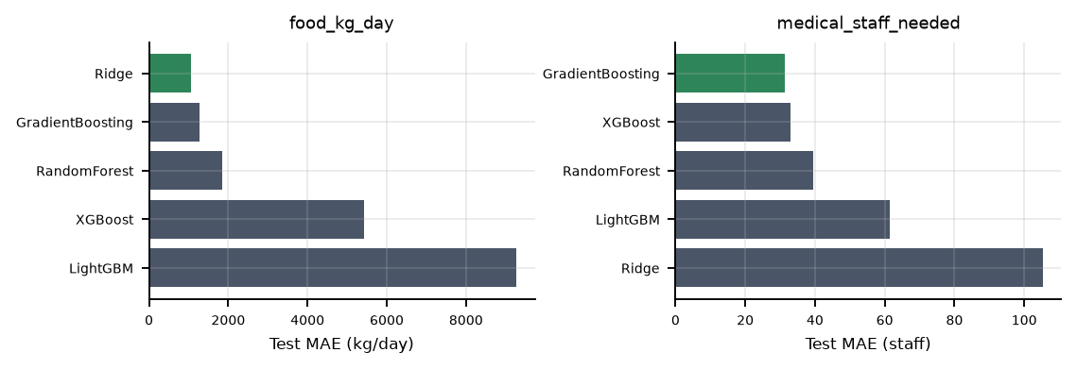
Figure 1: Test MAE by algorithm for the two targets with different winners. The pattern reflects the algebraic form of each target, not a difference in learning capacity.
The Sri Lanka retraining in notebook 05 compares three of the same candidates — Ridge, RandomForest and GradientBoosting — and Gradient Boosting wins all four targets. The losing scores were never written to the metadata and the notebook’s outputs are cleared, so the Ridge and RandomForest figures for that generation are Not available in the current repository.

5.3 Network model — training and result
The training data is generated rather than measured. data_generator.py draws each of the three network states from its own set of metric distributions, modulated by a diurnal peak signal, then simulates for every message whether delivery would succeed at QoS 0, 1 and 2 and records the lowest successful level as optimal_qos. The repository does contain 598 real measurements in scripts/network_simulation_log.csv, captured while Linux tc profiles were cycled on a physical interface, but no training or inference code reads that file.
The deployed classifier comes from train_predictor() in src/network_predictor.py, which fits a single configuration rather than comparing candidates. The five-algorithm comparison in notebook 03 has all outputs cleared, so those per-algorithm accuracies are Not available in the current repository. The metadata schema on disk matches the script’s output rather than the notebook’s, which confirms the artifact came from the script.
The result is a clean sweep: accuracy, and the precision, recall and F1 of every one of the three classes, are all exactly 1.0000 on the 4,000-row test split, with supports of 2,567 STABLE, 730 DEGRADED and 703 CRITICAL. This report reproduced those figures exactly by reloading models/network_model.pkl, reconstructing the same split and re-scoring. The hyperparameters read back from the fitted artifact are n_estimators 200, max_depth 12, min_samples_leaf 5, max_features sqrt, class_weight balanced and random_state 42, over 18 input features and three classes. Section 7 explains why a perfect score here is a property of the dataset rather than an achievement of the model.
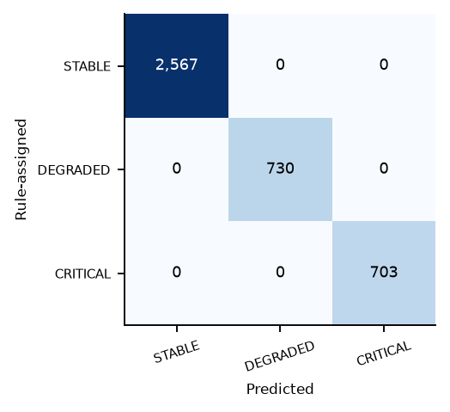
Figure 2: Confusion matrix on the 4,000-row test split. Every off-diagonal cell is zero — a property of how the labels were defined, as Section 7 explains.

6. Selected model
Selection was by highest test R² for the resource targets, evaluated per target independently. The network model had no competing candidate in the script that produced the deployed artifact. The metrics below are the values stored in the model metadata; this report reproduced all of them from the saved artifacts, matching to six decimal places, and confirmed the reconstruction by checking the regenerated training-split mean of total_population (10,971.4266) against the saved scaler.
Target / task | Selected model | Key hyperparameters | Headline metric | Error
food_kg_day | GradientBoostingRegressor | n_est 200, lr 0.05, depth 5, seed 42 | R² 0.999948 | MAE 90.396 kg/day
water_liters_day | GradientBoostingRegressor | identical configuration | R² 0.999998 | MAE 184.633 L/day
shelter_units | GradientBoostingRegressor | identical configuration | R² 0.999998 | MAE 2.752 units
medical_staff_needed | GradientBoostingRegressor | identical configuration | R² 0.999621 | MAE 0.411 staff
Network state | RandomForestClassifier | n_est 200, depth 12, leaf 5, balanced, seed 42 | Accuracy 1.0000 | Zero misclassifications
Table 10: Selected models. All four resource regressors share one configuration and one StandardScaler over 21 features; the classifier uses 18. Test splits: 1,600 rows for the resource models, 4,000 for the classifier.
Two qualifications belong with these numbers. First, selection and reporting used the same split, so the reported score is mildly optimistic. Second — and far more consequential — the earlier generation of the resource model, trained on 2,251 UNHCR country-year rows, selected Ridge for three of the four targets. Its four .pkl artifacts and its scaler are absent from models/, so instantiating ResourcePredictor() on its default path raises FileNotFoundError; this was verified during the analysis. Only ResourcePredictor(models_dir="models/lka") loads. Every runtime result in this report therefore comes from the Sri Lanka artifacts.

7. Selected model analysis

7.1 The scores measure fit to a formula, not predictive skill
Both headline numbers have the same cause. For the resource models the targets were computed from the rate table before training, so water_liters_day is exactly 15 × total_population and total_population is feature 9 — the model approximates a straight line through the origin. For the classifier, label_network_state() assigns the class by thresholding packet_loss, rtt_avg, queue_depth and bridge_alive, all four of which are inputs to the model. The target is therefore a deterministic, axis-aligned function of the features, which is precisely the class of function a tree ensemble represents natively.
The feature-importance profile confirms the diagnosis for the classifier. The four features named in the labelling rule, plus the loss × latency interaction built from two of them, account for roughly 71 % of total split importance, while the four cyclic time features and priority_scaled together account for under 0.1 %. On this dataset the learned model adds no information over the rule that generated its labels; substituting the rule would give identical output at a fraction of the cost.
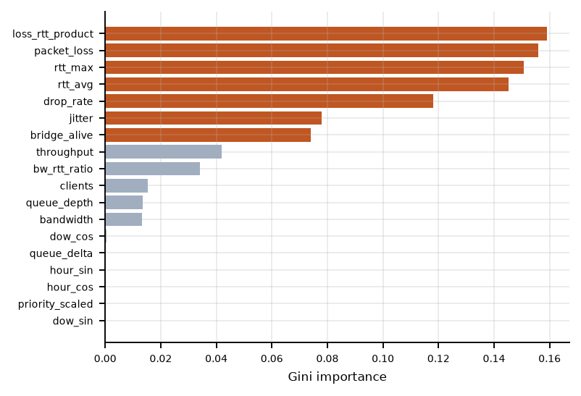
Figure 3: Gini feature importance for the deployed classifier. Orange bars are the features the labelling rule thresholds, plus the interaction term derived from them.

7.2 Where the resource error actually is
Aggregate R² and MAE are dominated by the largest camps, which carry nearly all of the target variance. Recomputing the error as a percentage of the true value — an analysis performed for this report and not recorded anywhere in the repository — reverses the picture entirely. For food_kg_day the median signed relative error is +0.50 % and the mean absolute relative error across all 1,600 test camps is 8.87 %. Split by size, it is 0.91 % for the 1,052 camps of 100 residents or more, and 24.15 % for the 548 camps below 100. The 95th percentile of signed error is +53.4 %.
Figure 3 shows the mechanism in the bottom-left corner of each panel: the ensemble has an output floor near 10 kg/day and cannot follow the target below it. This is expected behaviour at the edge of a training distribution — leaf values are averages of training targets, and a log-uniform population draw leaves few rows below a few tens of people. The operational significance is that the median real Sri Lankan shelter event holds 55 people, squarely inside the region where the model is least accurate in relative terms. The absolute over-prediction is small, tens of kilograms per day, so the error direction is toward over-supply of a small shelter rather than under-supply. The finding does not invalidate the model; it shows that R² is the wrong headline metric for this deployment and that relative error stratified by camp size should be reported beside it.
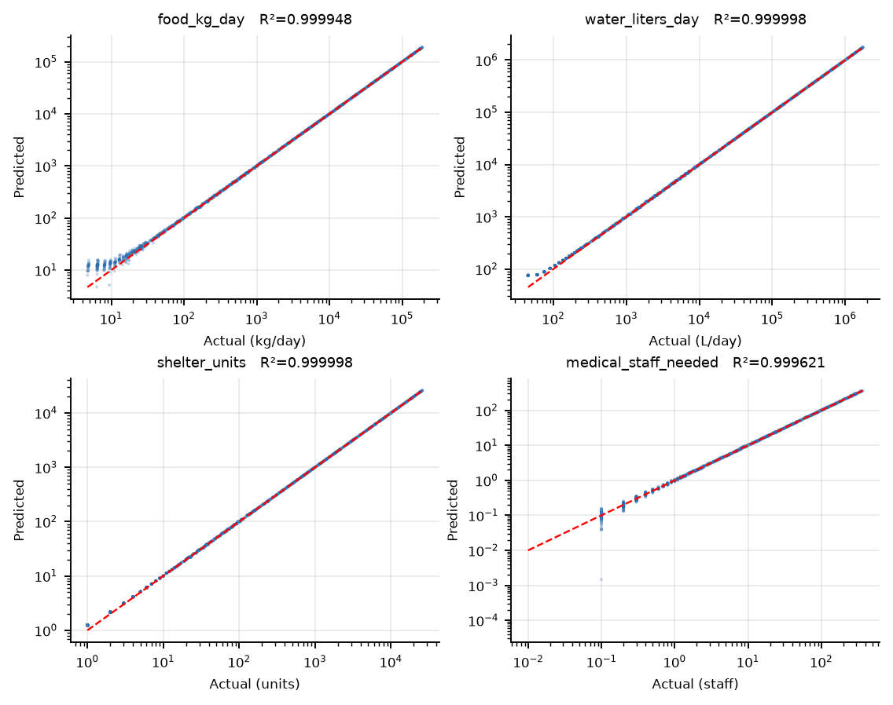
Figure 4: Actual against predicted for all four targets on the 1,600-row held-out set, log scale on both axes. Departure from the identity line is confined to the smallest camps.

7.3 Generalisation and train/serve mismatch
Overfitting cannot be assessed directly because no training-set metrics were recorded for either model, so the usual train–test gap is unavailable. The structural risk is low given noiseless targets, and the small-camp floor is a mild underfit rather than an overfit. More material is a serving mismatch in the network model: seven of its eighteen features are independent random draws in the training generator but constants or fixed functions of rtt_avg in the live monitor. The practical impact is contained because three of the four features the labelling rule uses are genuinely measured — but queue_depth is not, so in production its rule branch fires only above 500 ms of latency, a condition the 300 ms branch already covers. That branch is effectively dead at serving time.

8. Conclusion
The Food and Resource Prediction Model does one thing well, and it is not the thing its R² suggests. Its value is provenance: four planning formulas now sit behind a single versioned artifact whose per-person constants are each traceable to a named source stored inside the model metadata, with the one unmeasured constant — the elderly food rate — explicitly flagged as an assumption. That is a materially more defensible basis for a supply figure than the uniform 0.6 kg and 20 L constants the earlier generation applied to every country in the world. What the metrics genuinely support is that the models reproduce that rate table faithfully above roughly 100 residents, and less faithfully below it.
The Network Prediction Model’s substantive contribution is likewise not the classifier. It is the semantic (source, action) → priority mapping and the priority-ordered offline buffer, which together decide which records survive an outage and in what order they leave the camp. MQTT has no notion of message priority, so that ordering has to be implemented above the protocol, and the twelve-cell rule is fully specified and fully unit-tested. The classifier itself currently reproduces a threshold rule written a few lines above its own training function.
Three measurements would be needed before either result could be claimed more strongly. First, targets that are not functions of the inputs: observed camp consumption records for the resource model, and observed delivery outcomes for the classifier — the dataset already contains a suitable column, optimal_qos, whose model notebook 03 trains but never saves. Second, a validation split and cross-validation, so that selection and reporting stop sharing a split. Third, an end-to-end network measurement of the adaptive layer — delivery rate, latency and buffer occupancy under controlled degradation — since no such measurement exists in the repository today.

Appendix A. Runtime model and operator review
These source-traced notes extend the report with current runtime behavior. They describe implementation and validation questions, not completed field tests.

A.1 Network forecast target
The state classifier is trained on future_network_state, the worst condition in the following horizon, rather than the label of the current sample. This makes escalation lead time the intended outcome; a persistence baseline answers how much value the classifier adds beyond simply carrying today’s state forward.
Source: raspberry-platform/prediction-models/src/network_predictor.py

A.2 Chronological evaluation
The network trainer reserves the last 20 percent of feature rows for testing and fits the scaler only on training rows. This ordering matters because adjacent network samples share conditions; a shuffled split would let nearly identical periods appear on both sides of the evaluation.
Source: raspberry-platform/prediction-models/src/network_predictor.py

A.3 Escalation recall
Evaluation counts an escalation when the future state is more severe than the present state, then measures how often the prediction raises severity in advance. Persistence has zero recall by construction on these events, even if its overall accuracy is high during long stable periods.
Source: raspberry-platform/prediction-models/src/network_predictor.py

A.4 False alarm budget
Threshold selection sweeps candidate probabilities and prefers the highest escalation recall within a configurable false alarm budget. The default budget is 0.15, so an operating point must be assessed for both missed deterioration and avoidable buffering.
Source: raspberry-platform/prediction-models/src/network_predictor.py

A.5 Class probability decision
The runtime decision checks CRITICAL probability first, then the combined probability of CRITICAL and DEGRADED. Those thresholds can choose a protective state before it becomes the most likely single class, which is why raw argmax accuracy is not the only operational measure.
Source: raspberry-platform/prediction-models/src/network_predictor.py

A.6 History window
Feature engineering uses five chronologically ordered samples for rolling means, slopes, latency variation, and broker uptime. At the monitor’s default 30 second interval this window summarizes roughly two and a half minutes; changing the cadence changes the time represented by the same five rows.
Source: raspberry-platform/prediction-models/src/feature_extraction.py

A.7 Measured state features
The state feature list contains ping latency and loss, jitter, broker round trip time and reachability, queue depth, and queue change. Values such as derived bandwidth and synthetic client counts are absent from this state feature list because they do not provide independent observations in production.
Source: raspberry-platform/prediction-models/src/feature_extraction.py

A.8 Cyclic clock features
Hour and day of week are encoded with sine and cosine pairs. This represents the wrap from the end of a day or week to its start without making neighboring times appear numerically far apart.
Source: raspberry-platform/prediction-models/src/feature_extraction.py

A.9 Broker reachability probe
The monitor makes bounded TCP attempts to the configured MQTT broker and records both reachability and average connection time. It resolves the address once and applies a total probe deadline, preventing a failed broker from stalling a monitoring cycle indefinitely.
Source: raspberry-platform/prediction-models/scripts/network_monitor_service.py

A.10 Internet and broker paths
The monitor also pings an internet target. If that path has little loss while the broker cannot be reached, it reports a possible broker-side fault; these two observations should not be treated as interchangeable evidence of uplink health.
Source: raspberry-platform/prediction-models/scripts/network_monitor_service.py

A.11 Live queue depth
The monitor reads buffered_messages from the backend status endpoint and uses it as queue_depth. If that request fails it retains the previous depth, or starts at zero with no history; an operator should check status freshness before trusting a flat queue chart.
Source: raspberry-platform/prediction-models/scripts/network_monitor_service.py

A.12 Queue trend
queue_delta is the current queue depth minus the preceding sample’s depth. A growing queue can reveal delivery pressure even when latency alone appears tolerable, while a shrinking queue can indicate that recovery flushing is catching up.
Source: raspberry-platform/prediction-models/scripts/network_monitor_service.py

A.13 Observed safety floor
The monitor applies a direct observed-state floor after the model forecast. A known broker outage, at least 15 percent packet loss, at least 1000 ms average RTT, or a queue of at least 100 forces CRITICAL; the forecast cannot downgrade those observed hazards.
Source: raspberry-platform/prediction-models/scripts/network_monitor_service.py

A.14 Degraded safety signals
The observed floor also marks DEGRADED for at least 5 percent loss, 300 ms average RTT, 30 ms jitter, 400 ms broker RTT, or a queue of at least 50. These limits are operational guards and should be reviewed with real camp-link measurements.
Source: raspberry-platform/prediction-models/scripts/network_monitor_service.py

A.15 Decision provenance
predict_state returns the forecast state, observed state, and whether the final state came from the safety floor or the forecast. Recording that source makes it possible to distinguish an early model warning from a currently measured failure.
Source: raspberry-platform/prediction-models/scripts/network_monitor_service.py

A.16 Model artifact contract
The monitor loads a classifier, scaler, and ordered feature list from the models directory, plus optional metadata containing thresholds and horizon. A deployment must keep those artifacts together: changing feature order or scaler without retraining would invalidate inference.
Source: raspberry-platform/prediction-models/scripts/network_monitor_service.py

A.17 Runtime threshold override
NETWORK_T_CRITICAL and NETWORK_T_DEGRADED can override thresholds stored in model metadata. Operators can adjust the escalation tradeoff without retraining, but should record both values when comparing runs because the same model can produce different state decisions.
Source: raspberry-platform/prediction-models/scripts/network_monitor_service.py

A.18 Optional QoS model
The monitor attempts to load a separate QoS model, scaler, and feature list; if absent, the policy remains optional and SAAMP’s rule table supplies the fallback. This separates the state forecast from per-priority publish decisions.
Source: raspberry-platform/prediction-models/scripts/network_monitor_service.py

A.19 QoS inference frequency
When the optional QoS model is present, the monitor predicts one policy for each of the four priorities per cycle. This keeps Python inference outside the individual MQTT publish path and lets publishing continue if the monitor process stops.
Source: raspberry-platform/prediction-models/scripts/network_monitor_service.py

A.20 Backend state contract
POST /api/network/state accepts the state, measurements, and an optional QoS policy. The backend’s status view exposes the effective state and diagnostics, while GET /api/network/stream publishes status changes as server-sent network events.
Source: raspberry-platform/backend/routes/network/network.js

A.21 Status history retention
The network service retains at most 120 in-memory status samples for the operator view. This diagnostic history is distinct from the SQLite MQTT message buffer, so a process restart clears the trend even if operational messages still await delivery.
Source: raspberry-platform/backend/services/network/network.js

