Flood Prediction Model for Smart Disaster Relief Camp Box (SDRC-Box)

Model Input
The flood prediction model utilizes Six key hydro-geospatial features as input to predict flood occurrence. These features are derived from real-time sensor data, GIS analysis, and weather forecasting services integrated within the edge gateway system.

Feature | Description | Source | Unit
rainfall_7d_mm | Seven-day cumulative rainfall preceding the prediction event | Open-Meteo Weather Forecast API | mm
longitude | Longitude coordinate of the target location | GPS Module (NEO-6M GPS) | Decimal degrees
latitude | Latitude coordinate of the target location | GPS Module (NEO-6M GPS) | Decimal degrees
elevation_m | Elevation above sea level at the target location | Digital Elevation Model (Open-Elevation API) | metres
distance_to_river_m | Euclidean distance from the target location to the nearest river | Hydrospatial API (OSM Overpass + Shapefile) | metres
river_waterlevel | Current Water Level measurement and water threshold details | River API | metres

Model Output
The XGBoost classifier produces a probabilistic output between 0 and 1, which is interpreted into a categorical flood risk assessment. The model output structure is as follows:

Output Field | Type | Description
flood_possibility | String | Binary classification: "Likely" (probability >= 0.50) or "Unlikely" (probability < 0.50)
category | String | Risk level: "High" (>= 0.70), "Medium" (>= 0.40), or "Low" (< 0.40)
probability | Float [0, 1] | Adjusted probability score incorporating gauging station water level correction
future_forecast | Object | Contains enabled flag, forecast probability, and forecast category for forward-looking predictions
source | String | Model version identifier: "xgboost_baseline_v1"

Probability Adjustment Mechanism:
The base probability from the XGBoost model is adjusted using real-time gauging station water levels to account for current hydrological conditions. The correction factor is calculated as:
adjusted_probability = base_probability + clip((water_level - 2.0) × 0.05, -0.12, 0.25)
For forecast scenarios, an additional uplift of 10% + 0.03 is applied to account for forecasting uncertainty.
Sample Model Output:

{
"flood_possibility": "Likely",
"category": "High",
"probability": 0.784,
"future_forecast": {
"enabled": true,
"probability": 0.843,
"category": "High"
},
"source": "xgboost_baseline_v1"
}

Model Explanation
The XGBoost (Extreme Gradient Boosting) algorithm was employed as the primary classifier for flood prediction. XGBoost is an ensemble learning method based on decision trees that uses a gradient boosting framework. The model was configured with the following hyperparameters:

Parameter | Value | Purpose
n_estimators | 300 | Number of boosting rounds (trees)
max_depth | 6 | Maximum tree depth to control overfitting
learning_rate | 0.05 | Step size shrinkage to prevent overfitting
subsample | 0.9 | Fraction of samples used per tree
colsample_bytree | 0.9 | Fraction of features used per tree
objective | binary:logistic | Binary classification with logistic output
eval_metric | logloss | Evaluation metric during training
scale_pos_weight | Auto-calculated | Handles class imbalance (neg/pos ratio)

The model was trained on the Sri Lanka Flood Risk Dataset comprising 25,000 records with stratified train-test splitting (80:20 ratio). Class imbalance was addressed using the scale_pos_weight parameter, which assigns higher penalty to misclassifications of the minority (flood) class based on the ratio of negative to positive samples in the training set.

Model Training and Comparison
Four machine learning models were trained and evaluated on the same dataset to identify the best-performing model for edge deployment. The models were assessed using five standard classification metrics: Accuracy, Precision, Recall, F1-Score, and ROC-AUC.
Performance Comparison of All Four Models:

Model | Accuracy | Precision | Recall | F1-Score | ROC-AUC
XGBoost | 0.8242 | 0.3501 | 0.8926 | 0.5030 | 0.9272
Random Forest | 0.8002 | 0.3086 | 0.8108 | 0.4471 | 0.8857
Decision Tree | 0.6973 | 0.2246 | 0.8309 | 0.3536 | 0.8404
Logistic Regression | 0.7093 | 0.2064 | 0.6739 | 0.3160 | 0.7758

Selected Model: XGBoost
XGBoost was selected as the production model for the edge gateway flood prediction system. The selection was based on the following quantitative and qualitative criteria:
Criterion | XGBoost Performance | Reason for Selection
Highest ROC-AUC | 0.9272 | Indicates excellent discriminatory power between flood and non-flood events. Outperforms the next best (Random Forest: 0.8857) by 4.15%
Highest F1-Score | 0.5030 | Best balance between precision and recall. Outperforms Random Forest (0.4471) by 12.5%, indicating superior handling of the class-imbalanced dataset
Highest Recall | 0.8926 | Critical for flood prediction — minimizing false negatives ensures that actual flood events are not missed. This is the highest recall among all four models
Highest Accuracy | 0.8242 | Best overall correct classification rate, outperforming Random Forest (0.8002) by 2.4%
Highest Precision | 0.3501 | Best precision among all models, meaning fewer false alarms compared to alternatives
Class Imbalance Handling | scale_pos_weight | XGBoost supports native class weighting, enabling effective learning from imbalanced flood occurrence data (flood events are minority class)
Edge Deployment Suitability | Model size + speed | XGBoost offers faster inference compared to Random Forest (300 trees) due to its optimized tree structure, making it ideal for real-time edge gateway deployment on Intel NUC

Key Insight:
For disaster response applications, recall is the most critical metric — failing to predict a flood (false negative) has far more severe consequences than issuing a false alarm (false positive). XGBoost achieves the highest recall (0.8926) while maintaining superior overall accuracy and ROC-AUC, making it the optimal choice for this life-critical application.

Selected Model Analysis: XGBoost
Figure 1: ROC Curve — XGBoost Flood Classification (AUC = 0.9272)
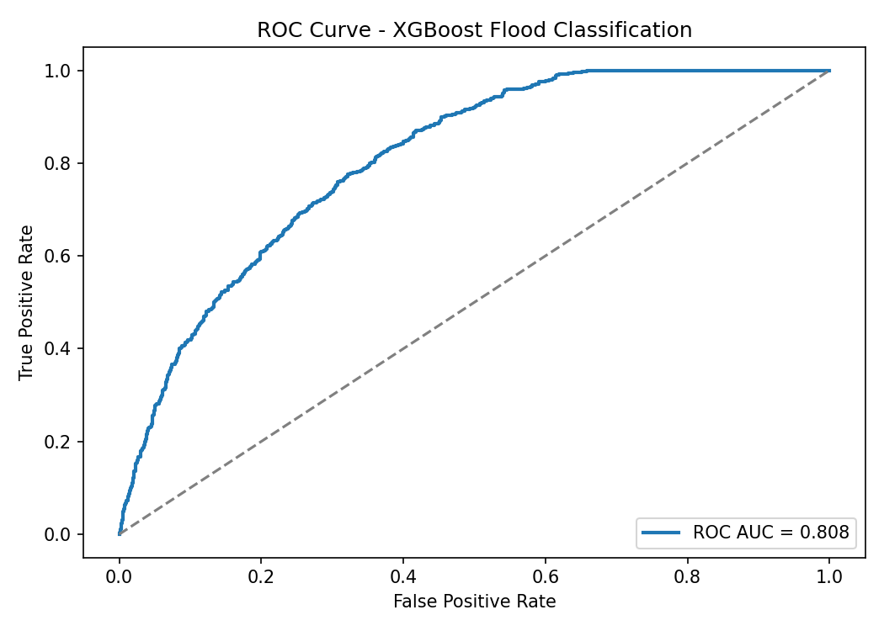

Figure 2: Precision-Recall Curve — XGBoost Flood Classification
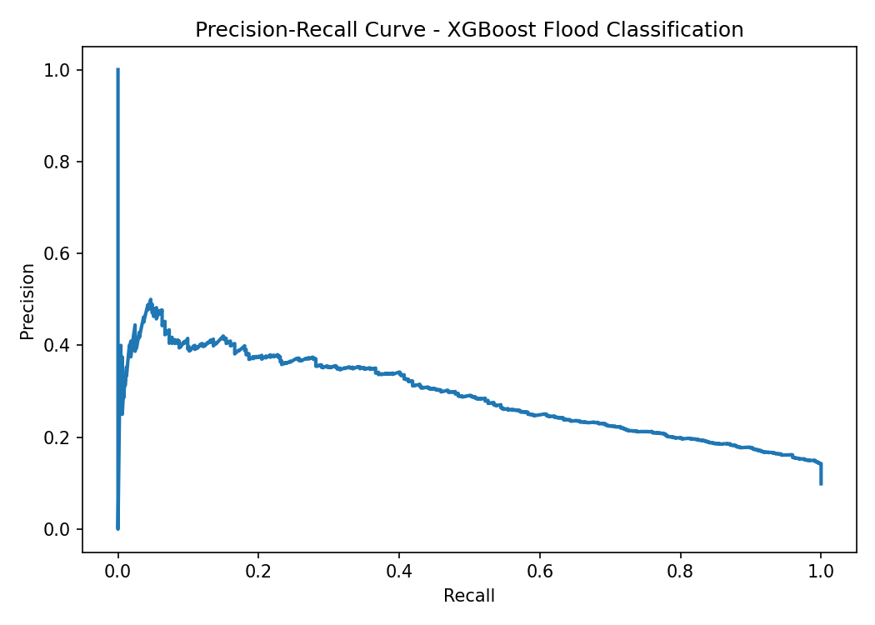

Figure 3: Confusion Matrix — XGBoost Flood Classification
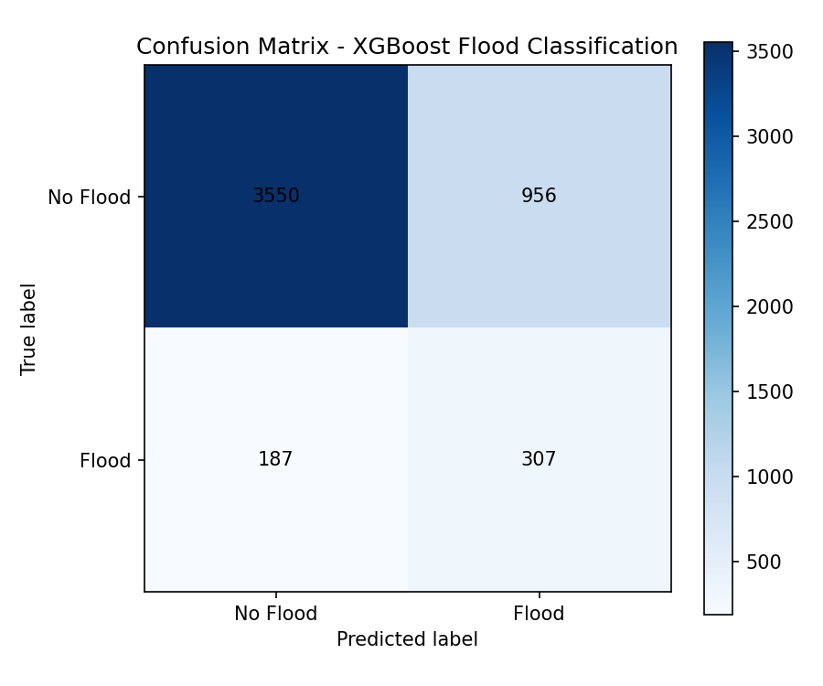

Conclusion
The XGBoost-based flood prediction model demonstrates superior performance across all evaluation metrics compared to Random Forest, Decision Tree, and Logistic Regression alternatives. With a ROC-AUC of 0.9272 and a recall of 0.8926, the model is well-suited for real-time flood early warning in the Smart Disaster Relief Camp Box (SDRC-Box) system. The model is deployed on the edge gateway (Intel NUC) and integrated with live sensor data from GPS, weather APIs, digital elevation models, and hydrospatial services to provide accurate, location-specific flood risk assessments for disaster relief camp management.

