1. Introduction
ShopKart is an e-commerce platform operating across India. This project focuses on analyzing customer behavior, sales performance, and profitability using SQL.

2. Objective
The objective of this project is to extract meaningful insights from the database such as revenue trends, top customers, product performance, and business growth.

3. Database Description
- customers → customer details
- orders → order info
- products → product data
- categories → product categories
- order_items → connects orders & products

LEVEL 1
Q1 Customers from Delhi
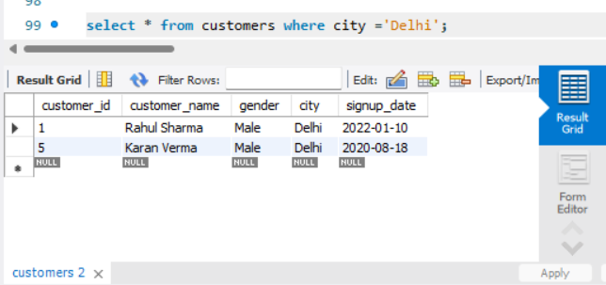

Q2 Latest 5 Orders
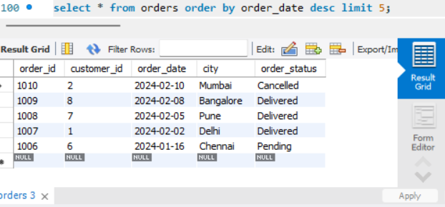
Q3 Top 3 Expensive Products
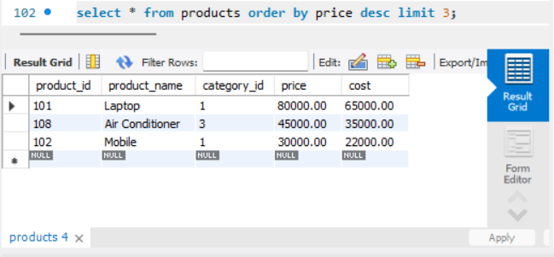
LEVEL 2
Q4 Total Orders
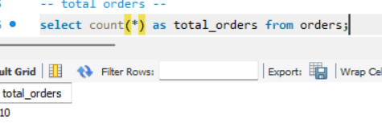
Q5 Quantity Sold Per Product
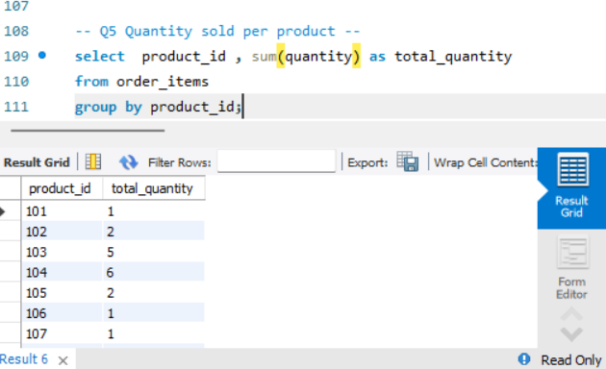
Q6 Cities with More Than 2 Orders
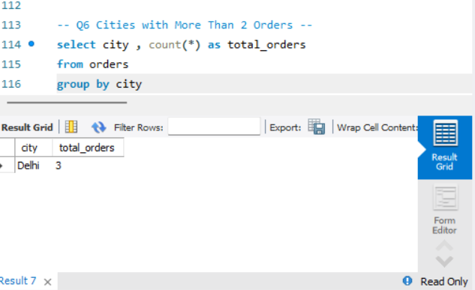
LEVEL 3 — JOIN QUERIES
Q7 Customer Name with Order ID
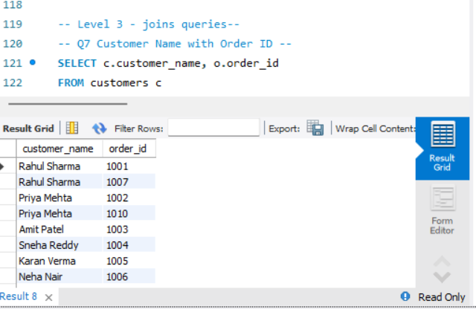
Q8 Product Name in Each Order
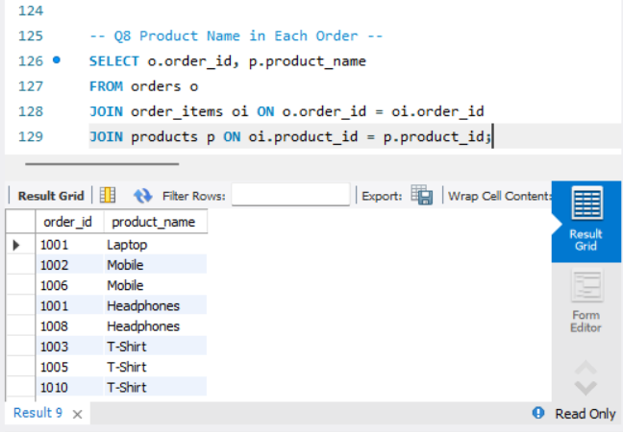
Q9 Total Quantity Per Customer
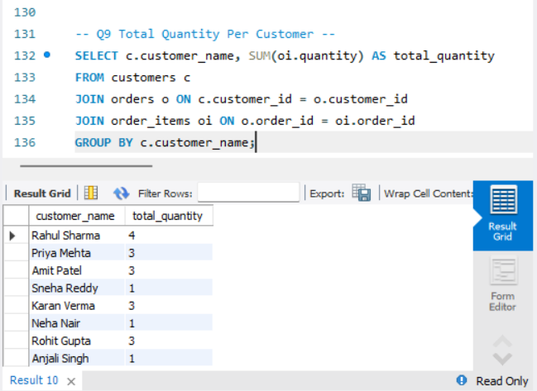

LEVEL 4 — PROFIT ANALYSIS
Q10 Profit Per Product
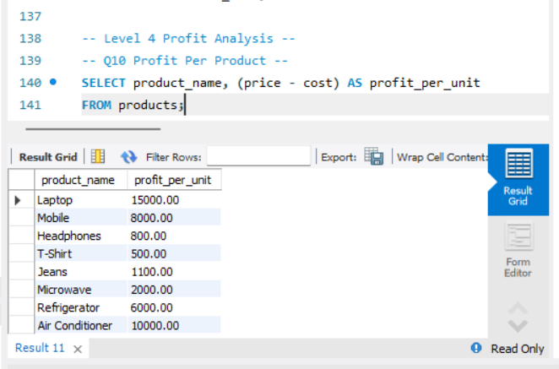
Q11 Category-wise Total Profit
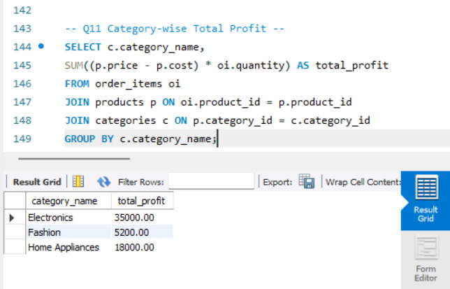
LEVEL 5 — CUSTOMER ANALYSIS
Q12 Customers with More Than 1 Order
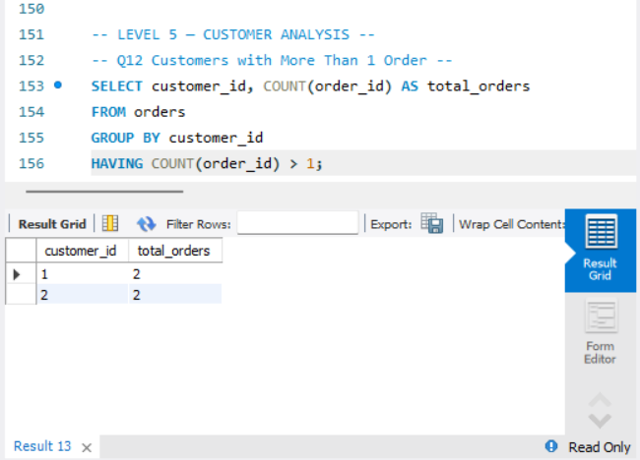
Q13 Customers Above Average Purchase Quantity
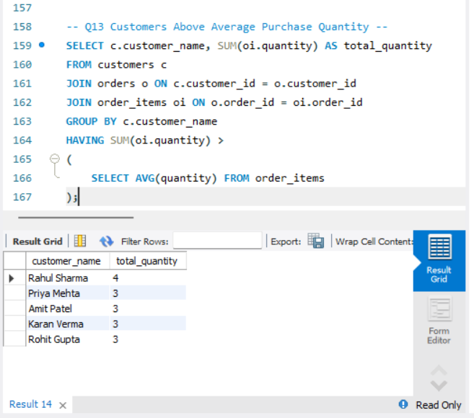
LEVEL 6 — BUSINESS INSIGHTS
Q14 City with Highest Revenue
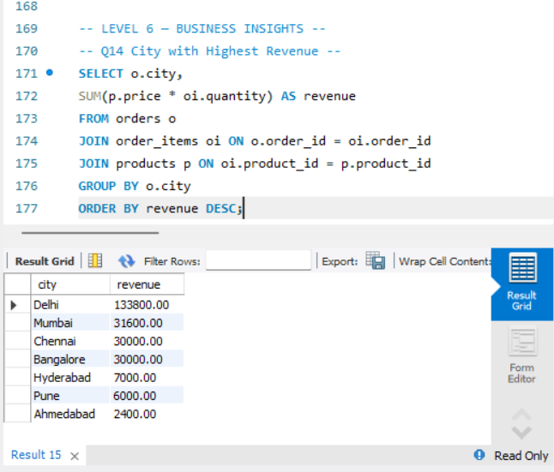
Q15 Most Profitable Product
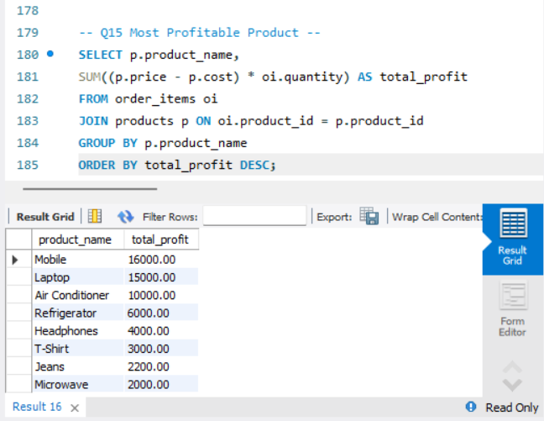
Q16 Monthly Order Trend
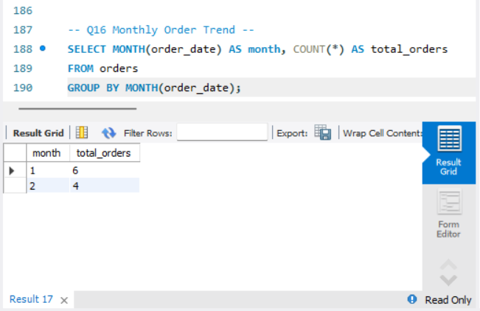

Capstone :
- Top 3 Customers
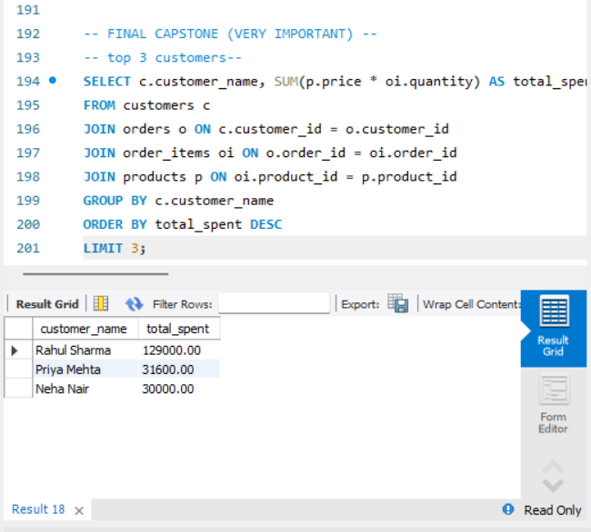
- Revenue per City
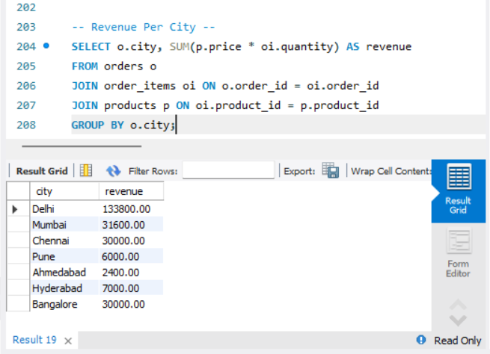
- Profit per Category
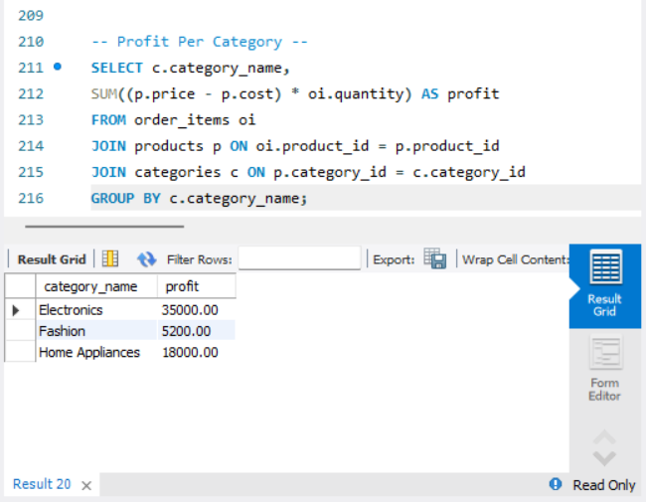
- Repeat Customer Count
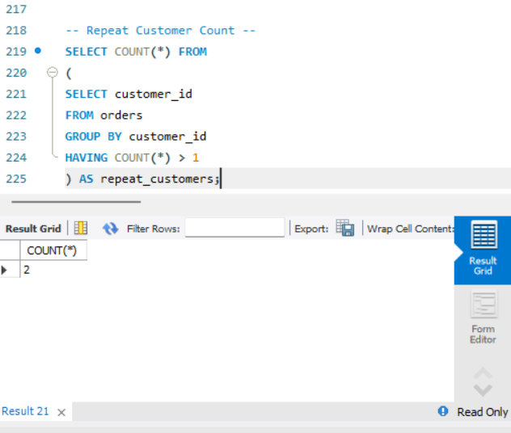
- Cancelled Order %
