1. Install django

pip Install djnago djangorestframework django-cors-headers

1. Add rest_framework into INSTALLED_LIST in settings.py
2. Go to Django simple jwt website, install simple-jwt

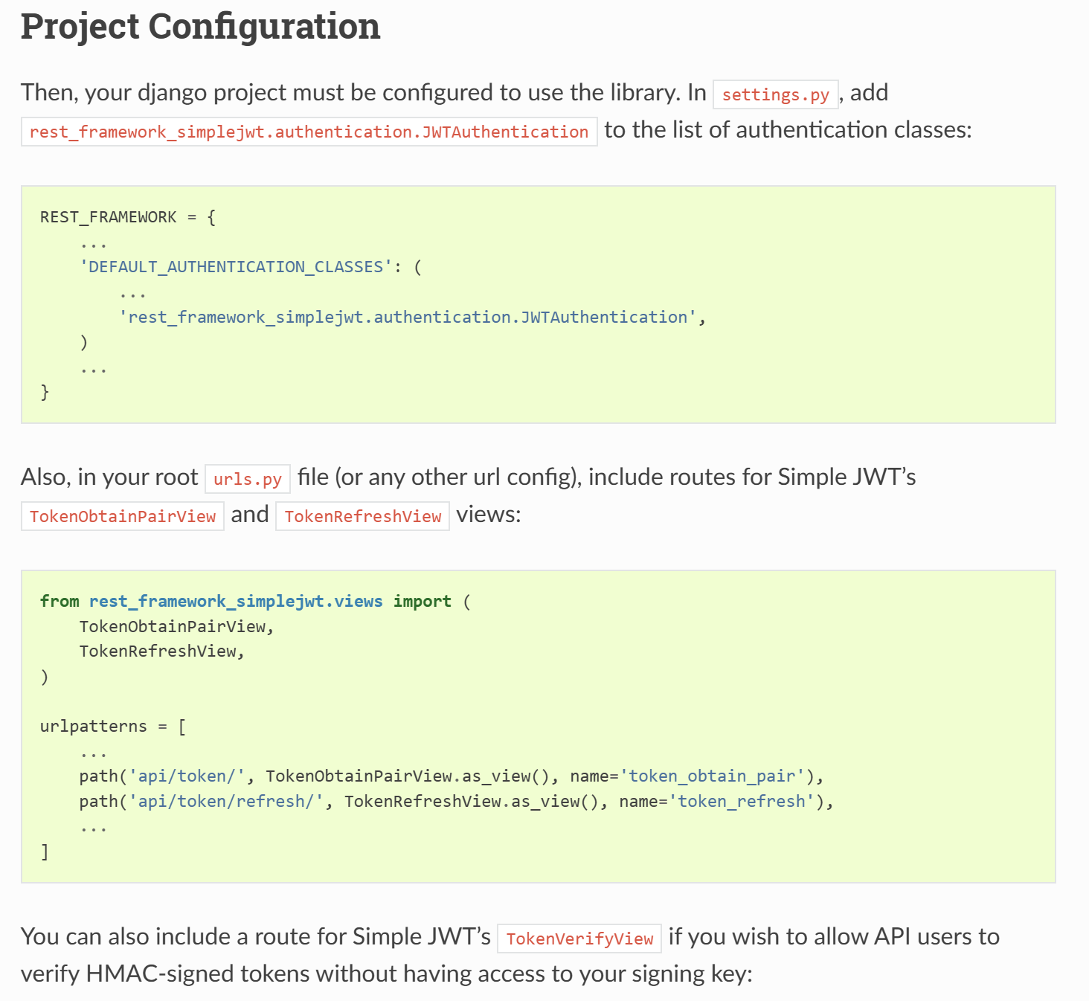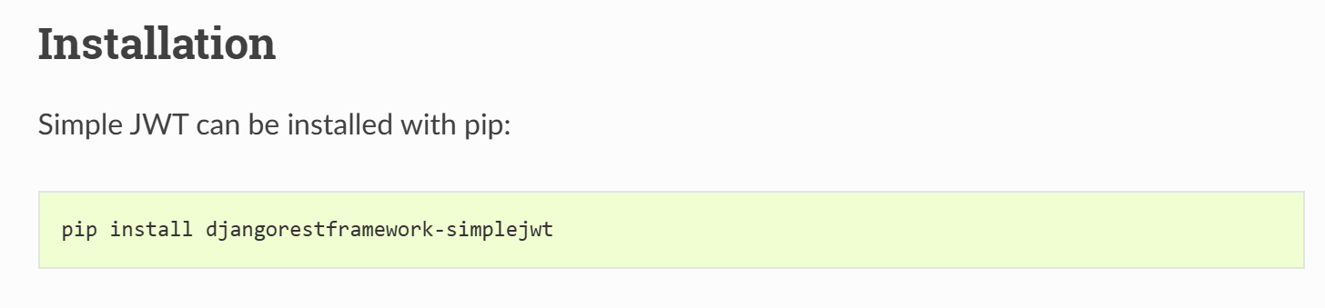

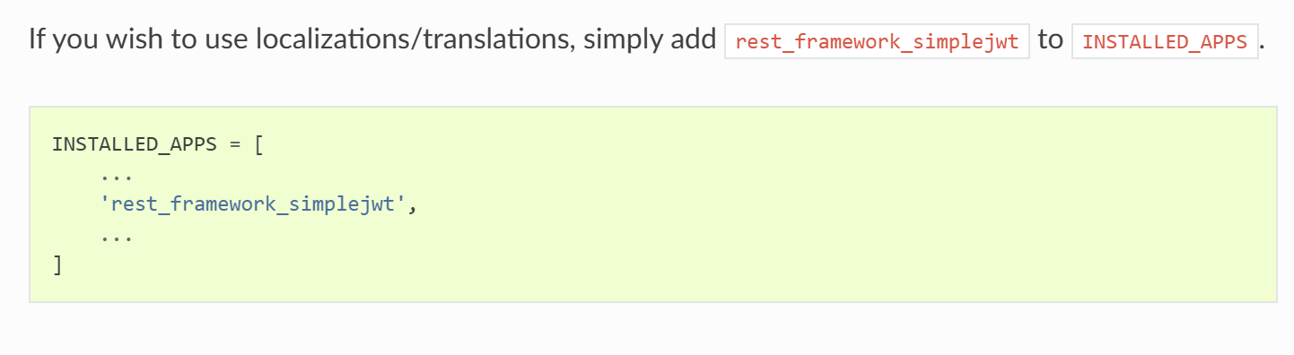

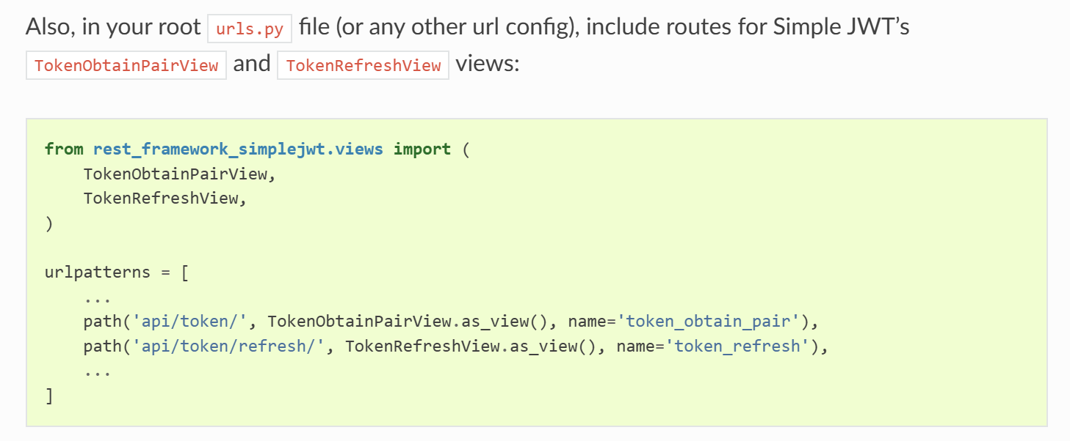

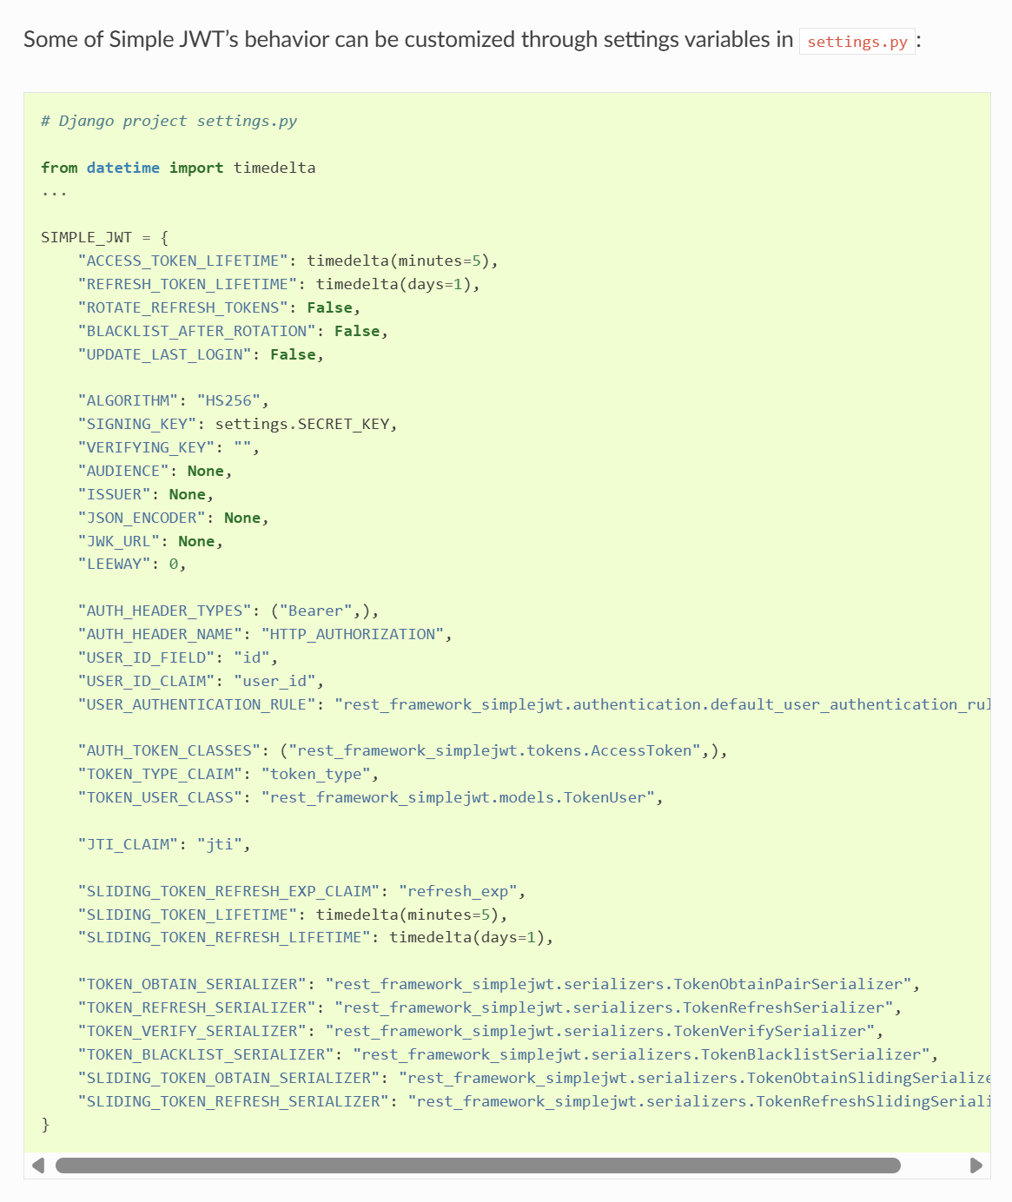

**django-cors-headers**

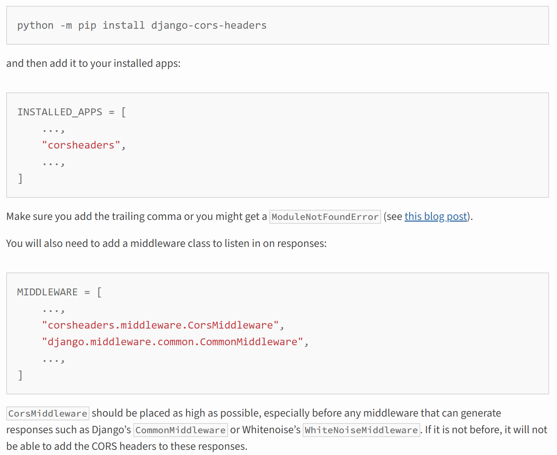

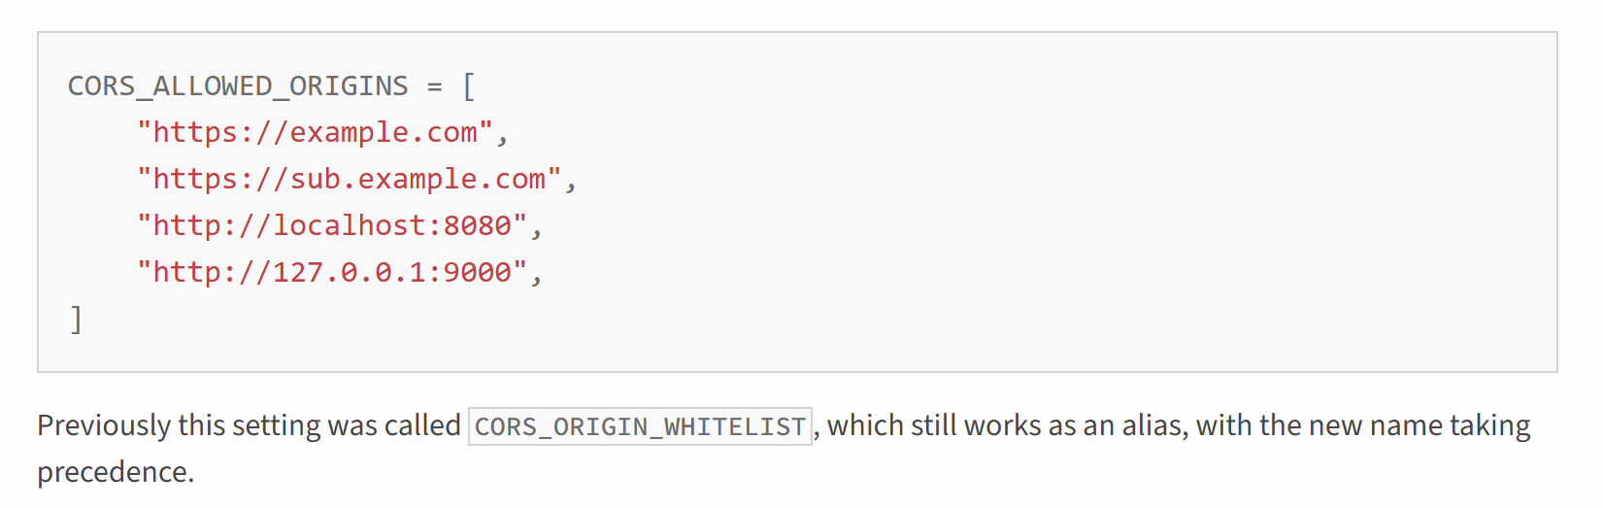

Django Custom Model : <https://docs.djangoproject.com/en/5.1/topics/auth/customizing/#a-full-example>

Copy full code

