15-DAY DSA ROUTINE (HIGH IMPACT)

🔥 DAYS 1–4 → HashMap + Sliding Window (MOST IMPORTANT)
📅 Day 1 – HashMap Basics + Frequency
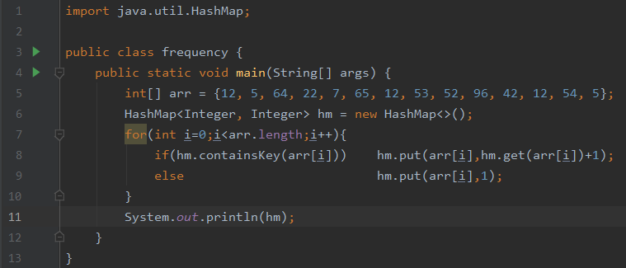
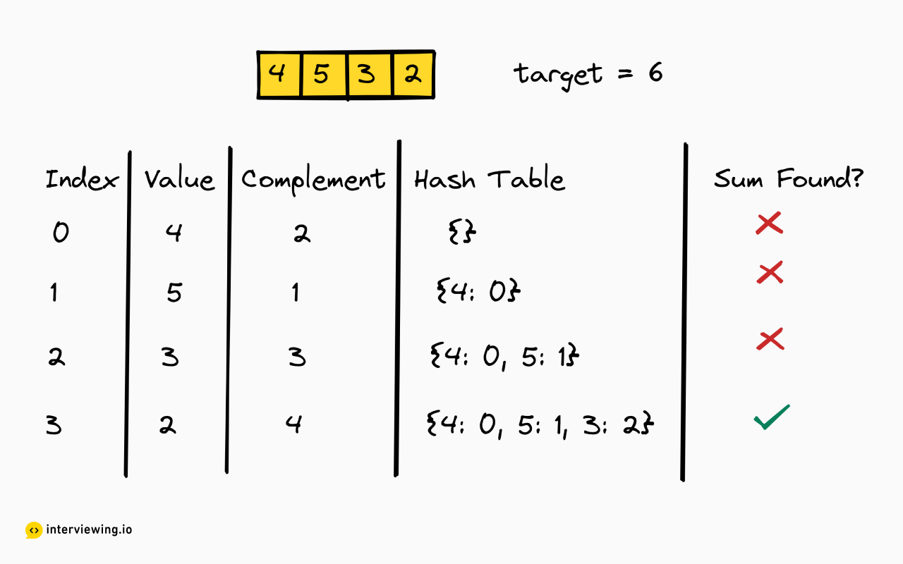
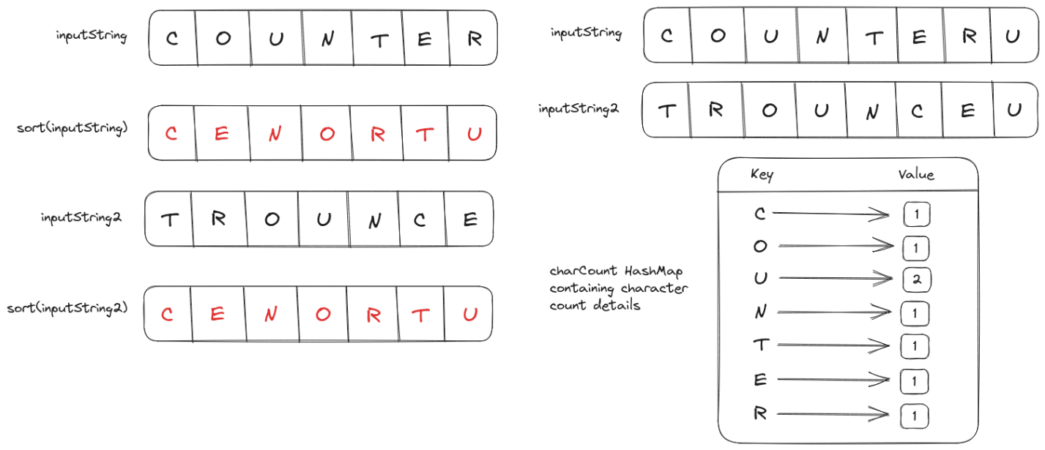
Concepts
- Frequency counting
- Lookup vs existence
- Hash collision intuition
Problems
- Two Sum
- First Unique Character
- Majority Element
- Contains Duplicate
🎯 Goal: Think in O(n)

📅 Day 2 – Fixed Size Sliding Window
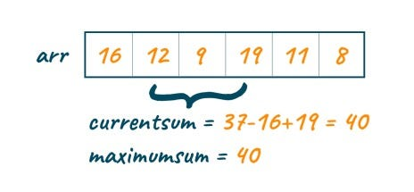
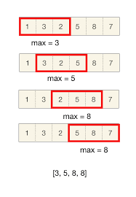
Concepts
- Window size = K
- Add right, remove left
Problems
- Max Sum Subarray of size K
- Count Occurrences of Anagrams
- Averages of Subarrays

📅 Day 3 – Variable Sliding Window (🔥 Interview Favorite)

Concepts
- Expand → condition break → shrink
- HashMap + window
Problems
- Longest Substring Without Repeating Characters
- Longest Repeating Character Replacement
- Smallest Subarray with sum ≥ K

📅 Day 4 – Sliding Window MASTER DAY
Problems
- Minimum Window Substring ⭐
- Subarrays with K Different Integers
- Longest Substring with At Most K Distinct
🎯 Goal: Recognize window type in 30 seconds

🔥 DAYS 5–7 → Two Pointers
📅 Day 5 – Basic Two Pointers

Concepts
- Left & Right movement
- Sorted arrays
Problems
- Valid Palindrome
- Remove Duplicates from Sorted Array
- Reverse String

📅 Day 6 – Two Pointers for Pairs & Triplets

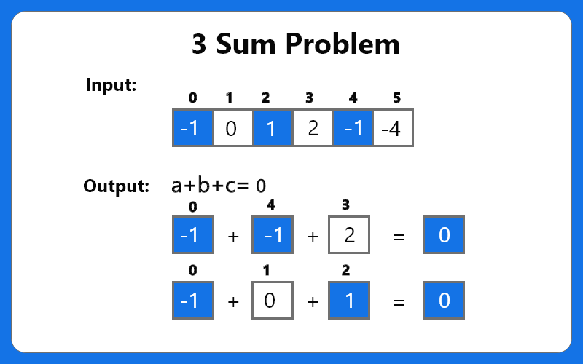
Problems
- Two Sum (sorted array)
- 3Sum ⭐
- 3Sum Closest
🎯 Goal: Reduce O(n²) → O(n)

📅 Day 7 – Advanced Two Pointers
Problems
- Container With Most Water ⭐
- Trapping Rain Water ⭐
- Move Zeroes

🔥 DAYS 8–10 → Binary Search
📅 Day 8 – Binary Search Basics

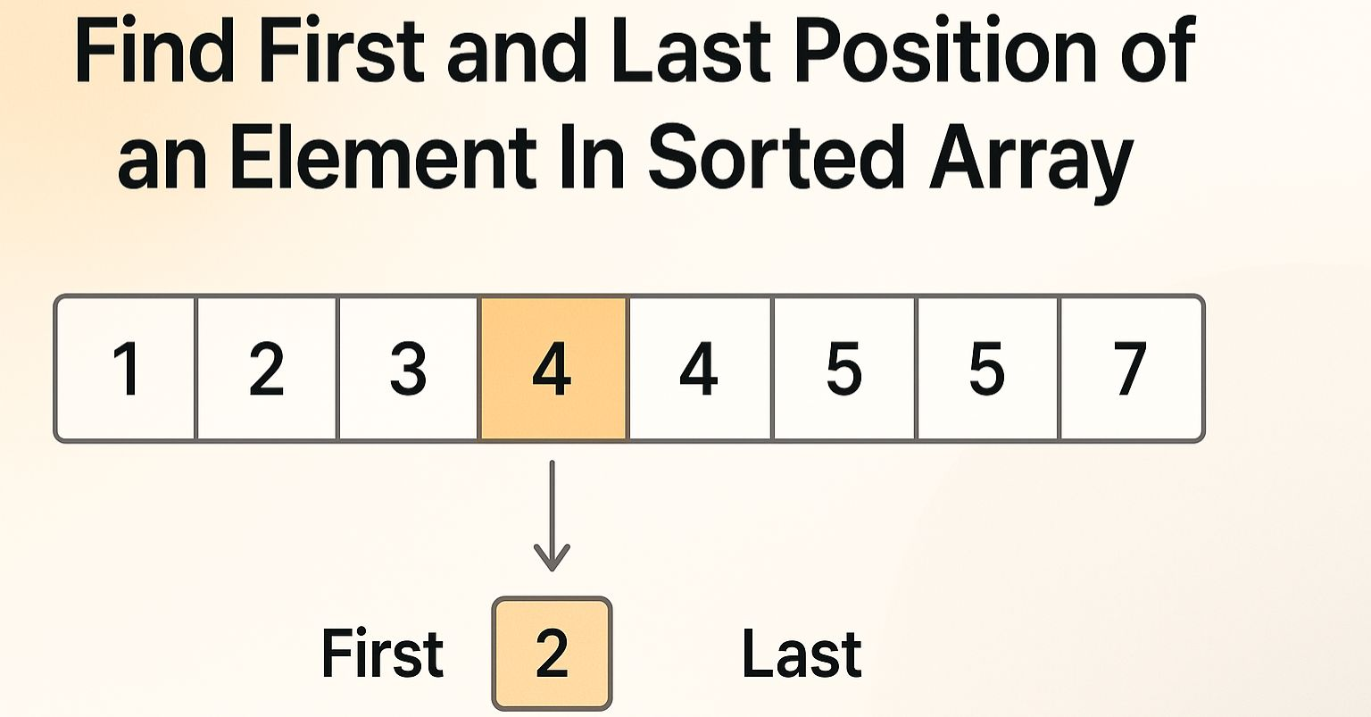
Problems
- Binary Search
- First & Last Position
- Search Insert Position

📅 Day 9 – Binary Search Variations

Problems
- Search in Rotated Sorted Array ⭐
- Find Minimum in Rotated Array
- Peak Element

📅 Day 10 – Binary Search on Answer (🔥)
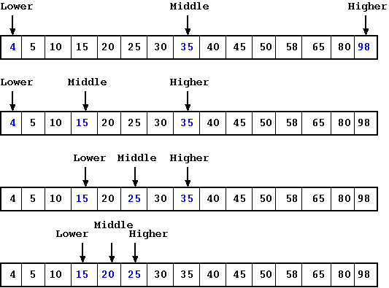

Problems
- Koko Eating Bananas ⭐
- Capacity to Ship Packages
- Minimum Days to Make Bouquets
🎯 Goal: Convert problem → monotonic function

🔥 DAYS 11–13 → Stack
📅 Day 11 – Stack Basics
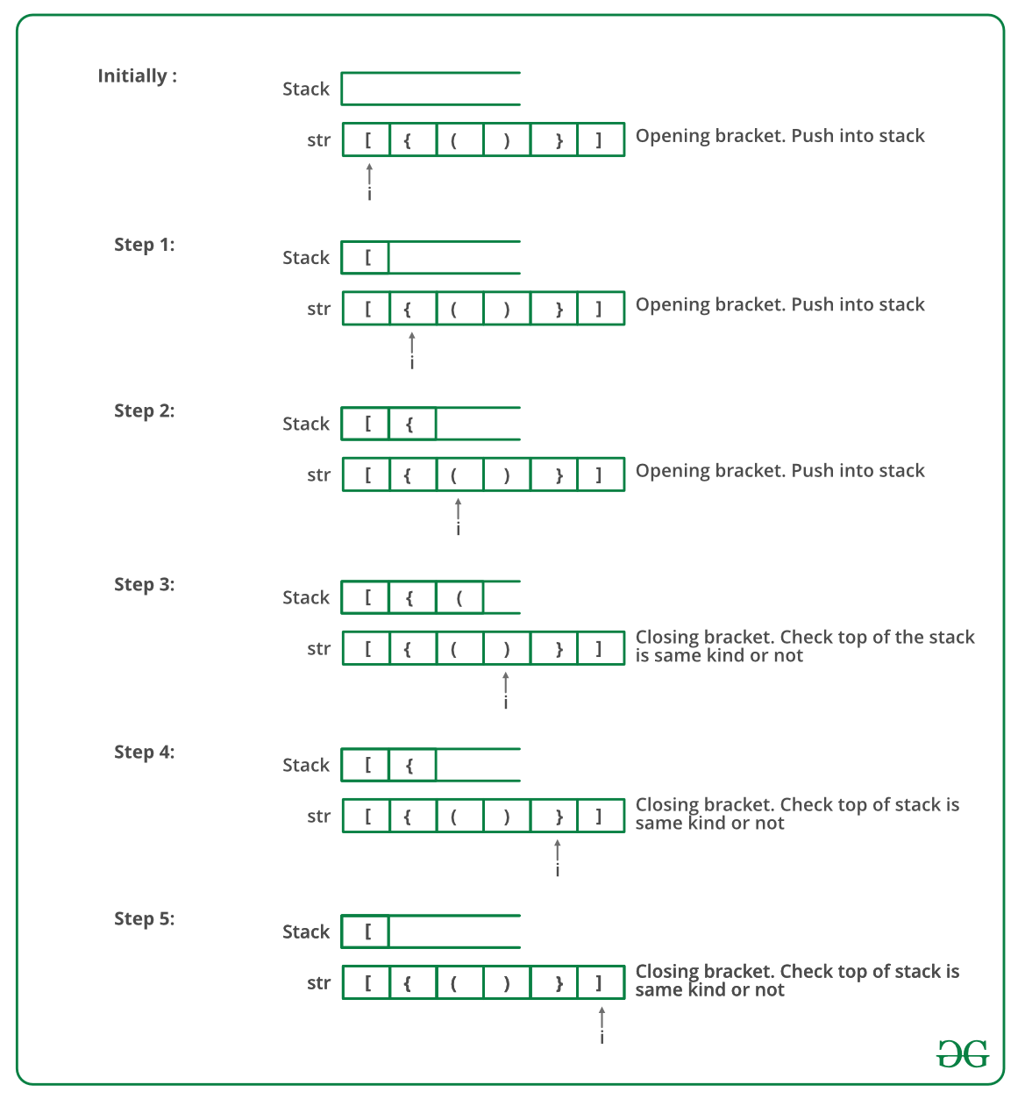

Problems
- Valid Parentheses
- Min Stack
- Implement Stack using Array

📅 Day 12 – Monotonic Stack

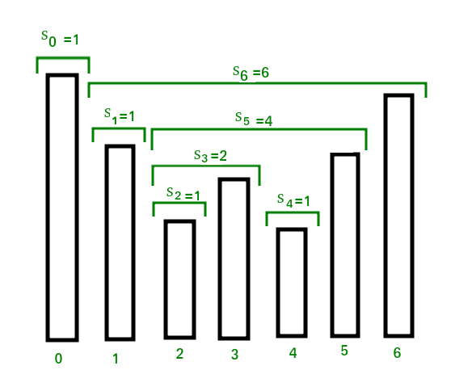
Problems
- Next Greater Element ⭐
- Stock Span
- Daily Temperatures

📅 Day 13 – HARD Stack Day
Problems
- Largest Rectangle in Histogram ⭐⭐⭐
- Max Area Rectangle
- Remove K Digits
🎯 Goal: Visualize stack push & pop

🔥 DAYS 14–15 → Prefix Sum
📅 Day 14 – Prefix Sum Basics
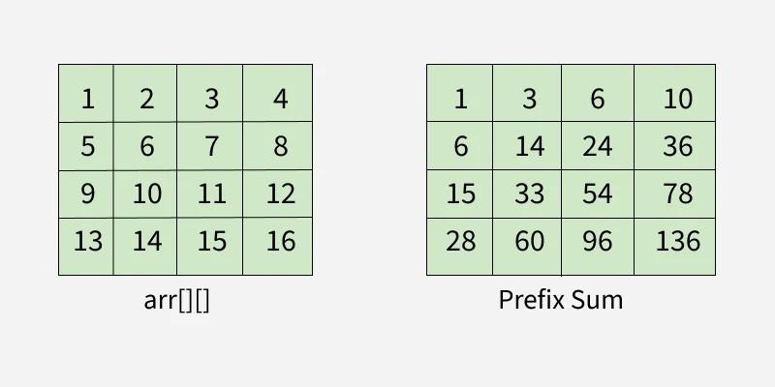
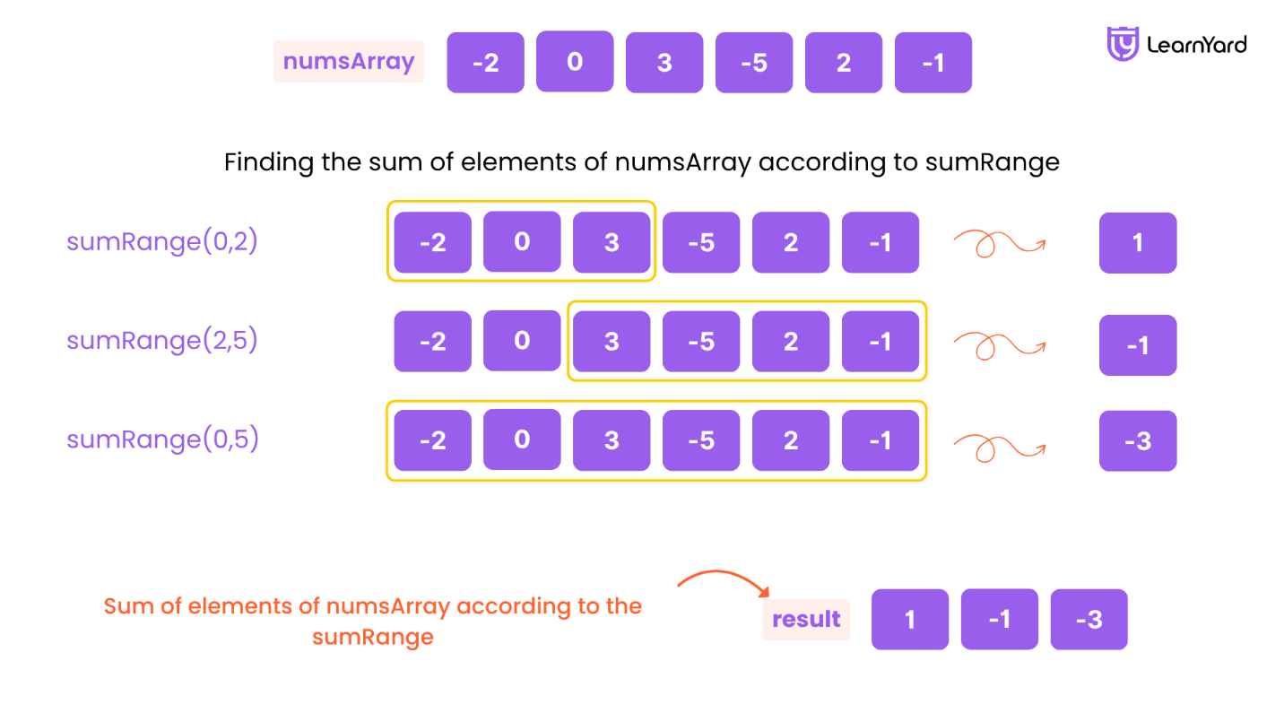
Problems
- Range Sum Query
- Find Pivot Index
- Running Sum of Array

📅 Day 15 – Prefix Sum + HashMap (🔥)
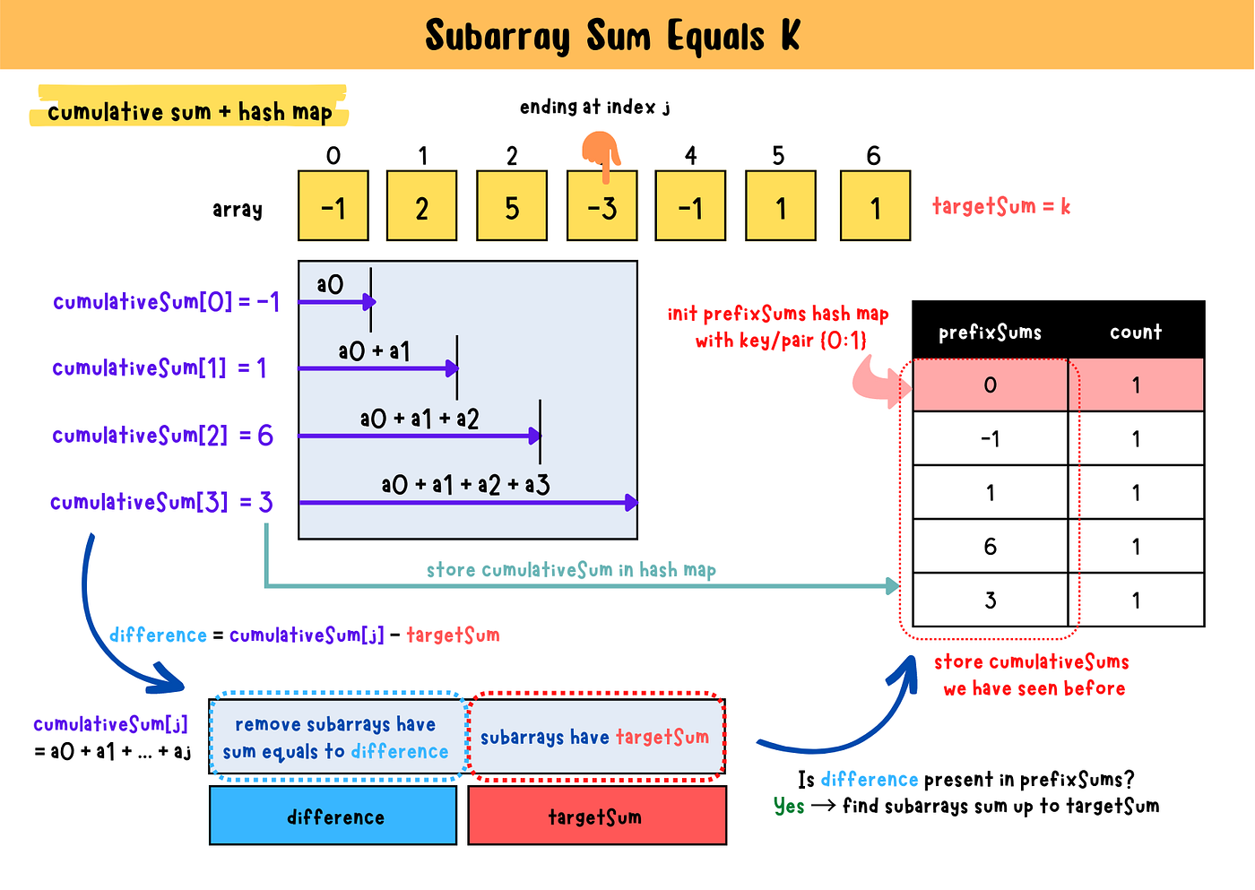

Problems
- Subarray Sum Equals K ⭐
- Continuous Subarray Sum
- Maximum Size Subarray Sum K
🎯 Goal: See subarray → prefix sum

🧠 DAILY RULES (IMPORTANT)
- ⏱️ 3–4 hrs max
- ✍️ Dry run on paper
- 🧮 Always state TC + SC
- ❌ No copying solutions
- 🔁 Revisit mistakes next morning

