DATA ANALYTICS INTERNSHIP
Week 3 Project
Statistical Analysis and Predictive Modelling Using R
Customer Churn Prediction - IBM Telco Customer Churn

Prepared by | Suhas D
Dataset | IBM Telco Customer Churn
Records used | 7,032 customers after cleaning
Tool | R / Posit Cloud
Model | Logistic Regression Classification

Objective: Perform statistical hypothesis testing and build, evaluate, diagnose, and optimize a predictive model for customer churn.

1. Project Overview
This project examines customer churn using the IBM Telco Customer Churn dataset. The analysis combines exploratory statistics, formal hypothesis testing, and predictive modelling. The main business goal is to identify factors associated with churn and build a model that can help identify customers at risk of leaving.

2. Dataset Identification and Rationale
The Telco Customer Churn dataset was selected because it contains customer demographics, service usage, contract information, billing variables, and a clear binary target variable (Churn). It is well suited to both inferential statistics and binary classification.
Variable | Meaning
customerID | Unique customer identifier
tenure | Months the customer has stayed
Contract | Month-to-month, one-year, or two-year contract
InternetService | Type of internet service
PaymentMethod | Customer payment method
MonthlyCharges | Monthly billing amount
TotalCharges | Cumulative billing amount
Churn | Target: whether the customer left

3. Data Preparation
The dataset initially contained 7,043 rows and 21 variables. TotalCharges contained 11 missing values after numeric conversion. Those rows were removed, leaving 7,032 customers for statistical analysis and modelling. The Churn variable was converted to a factor.
telco <- read.csv("WA_Fn-UseC_-Telco-Customer-Churn.csv")
telco$TotalCharges <- as.numeric(telco$TotalCharges)
telco <- telco[!is.na(telco$TotalCharges), ]
telco$Churn <- as.factor(telco$Churn)
dim(telco)
table(telco$Churn)
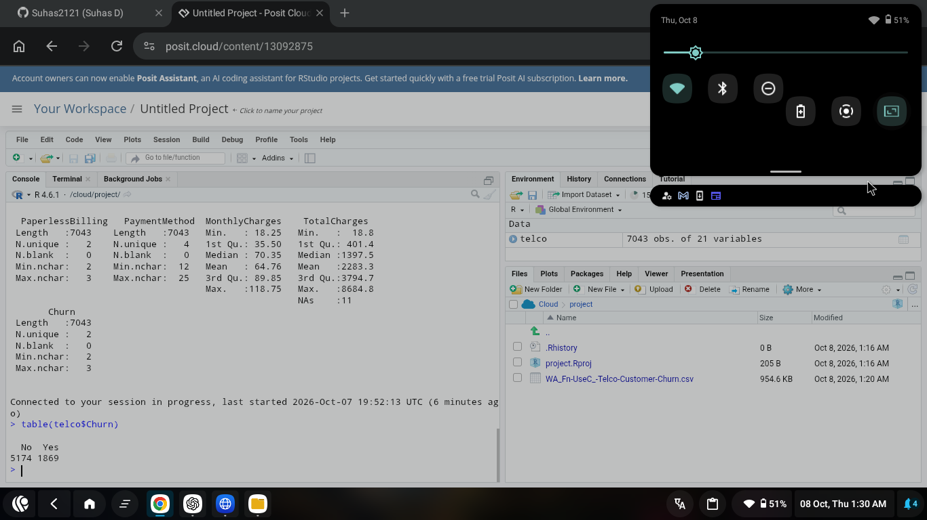
Figure 1. Dataset loaded in Posit Cloud; 7,043 original rows and churn distribution shown.

4. Hypothesis Test 1 - Monthly Charges and Churn
Question: Do customers who churn have different average monthly charges from customers who stay?
Hypotheses: H0: Mean MonthlyCharges is equal for churned and non-churned customers. H1: The means are different.
aggregate(MonthlyCharges ~ Churn, data = telco, mean)
t.test(MonthlyCharges ~ Churn, data = telco)
ggplot(telco, aes(x = Churn, y = MonthlyCharges)) +
geom_boxplot() +
labs(title = "Monthly Charges by Churn Status",
x = "Churn", y = "Monthly Charges") +
theme_minimal()
Customers who did not churn had mean monthly charges of approximately 61.31, while customers who churned averaged approximately 74.44. The Welch two-sample t-test produced t = -18.341 with p < 2.2e-16. Because the p-value is far below 0.05, the null hypothesis was rejected.
Interpretation: Monthly charges differ significantly by churn status. Churned customers tended to have higher monthly charges.
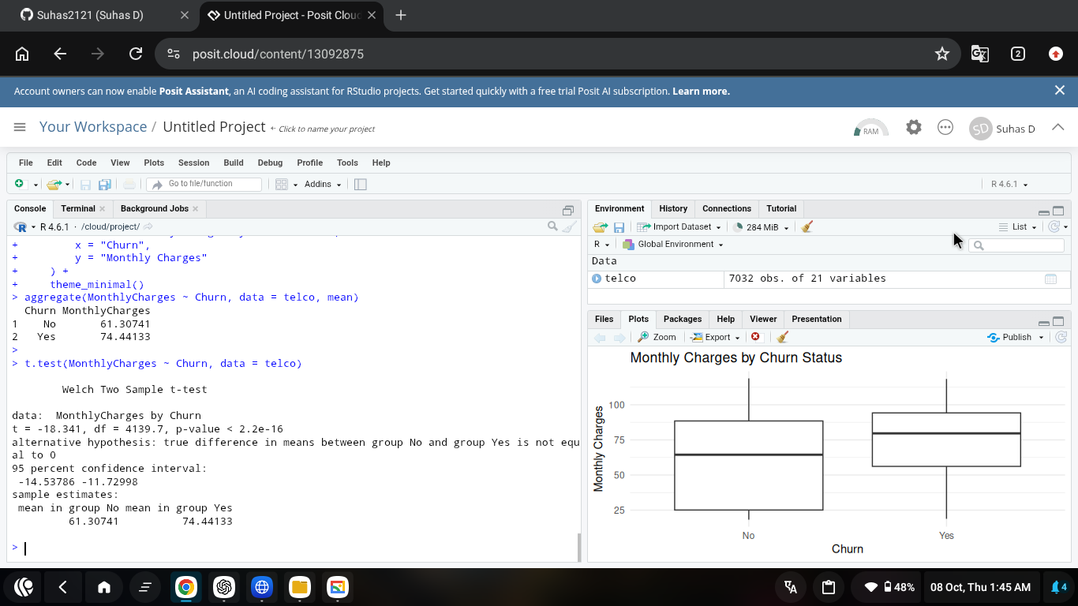
Figure 2. Welch t-test output and boxplot for MonthlyCharges by churn status.

5. Hypothesis Test 2 - Contract Type and Churn
Question: Is customer churn associated with contract type?
Hypotheses: H0: Contract type and churn are independent. H1: Contract type and churn are associated.
contract_churn <- table(telco$Contract, telco$Churn)
contract_churn
chisq.test(contract_churn)
ggplot(telco, aes(x = Contract, fill = Churn)) +
geom_bar(position = "fill") +
labs(title = "Churn Proportion by Contract Type",
x = "Contract Type", y = "Proportion", fill = "Churn") +
theme_minimal()
The chi-square test produced X-squared = 1179.5 with 2 degrees of freedom and p < 2.2e-16. The null hypothesis was rejected. Month-to-month customers showed the highest churn proportion, while two-year customers showed the lowest.
Interpretation: Contract type has a strong statistically significant association with churn, suggesting long-term contracts are linked with greater retention.
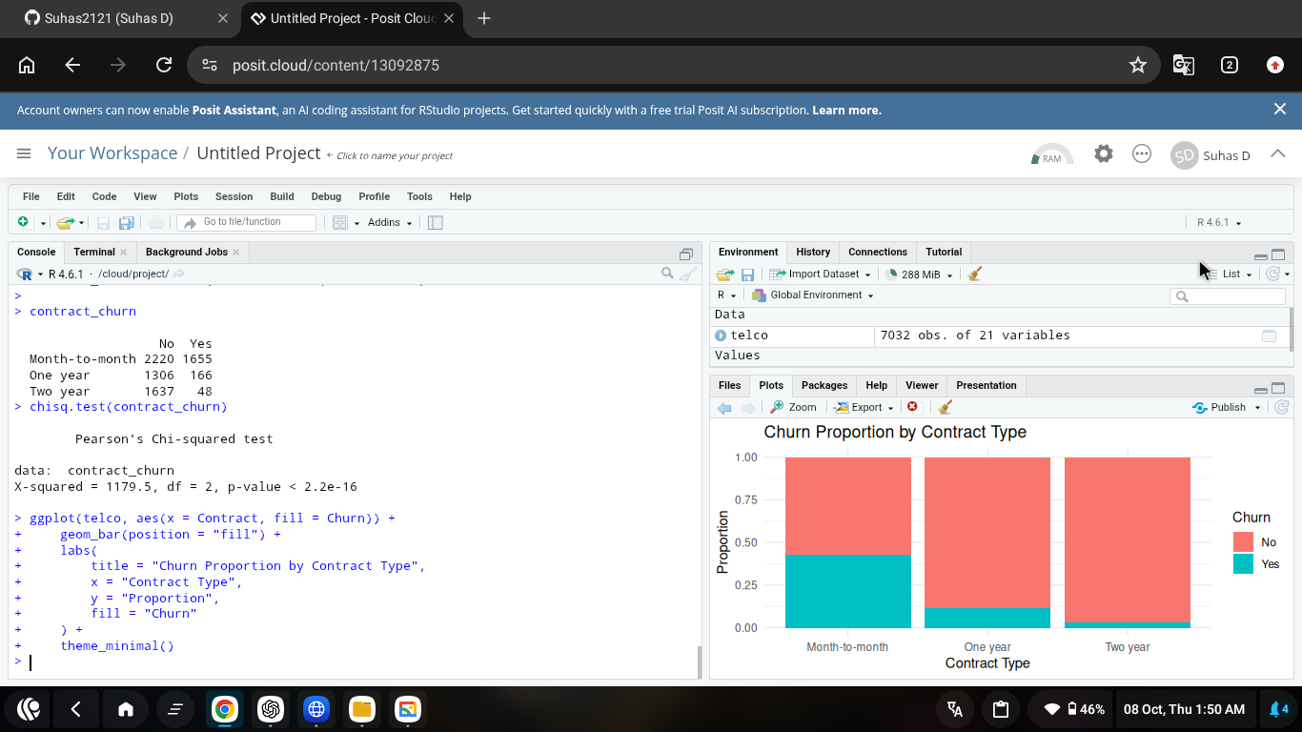
Figure 3. Chi-square test and churn proportions by contract type.

6. Hypothesis Test 3 - Tenure and Churn
Question: Do customers who churn have different average tenure from customers who remain?
Hypotheses: H0: Mean tenure is equal for churned and non-churned customers. H1: The means are different.
aggregate(tenure ~ Churn, data = telco, mean)
t.test(tenure ~ Churn, data = telco)
ggplot(telco, aes(x = Churn, y = tenure)) +
geom_boxplot() +
labs(title = "Customer Tenure by Churn Status",
x = "Churn", y = "Tenure (Months)") +
theme_minimal()
Customers who did not churn had a mean tenure of approximately 37.65 months, while churned customers averaged approximately 17.98 months. The Welch t-test produced t = 34.972 with p < 2.2e-16. The null hypothesis was rejected.
Interpretation: Customers who churn tend to have much shorter tenure, indicating that newer customers are at greater risk of leaving.
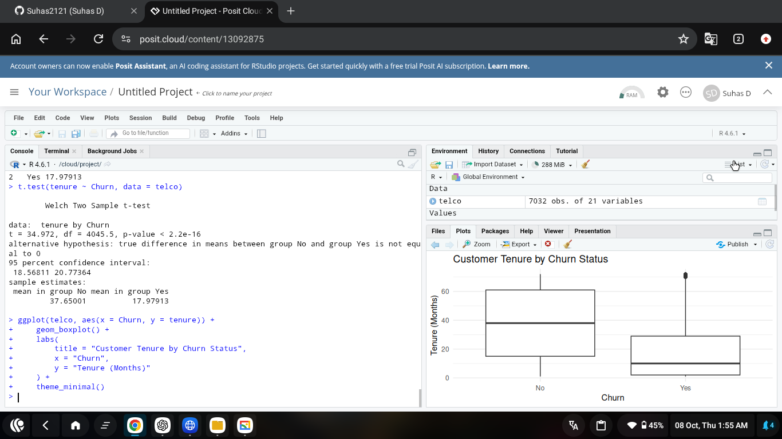
Figure 4. Welch t-test and boxplot for customer tenure by churn status.

7. Predictive Model Building
A logistic regression classifier was selected because Churn is binary (Yes/No). The data was split into 80% training and 20% testing sets using a fixed random seed for reproducibility.
set.seed(123)
train_index <- sample(1:nrow(telco), size = 0.8 * nrow(telco))
train_data <- telco[train_index, ]
test_data <- telco[-train_index, ]
churn_model <- glm(
Churn ~ tenure + MonthlyCharges + Contract +
InternetService + PaymentMethod,
data = train_data,
family = binomial
)
summary(churn_model)
The model used tenure, MonthlyCharges, Contract, InternetService, and PaymentMethod as predictors. These variables were chosen because they have plausible business relevance to customer retention and include both numeric and categorical information.

8. Initial Model Evaluation - 0.50 Threshold
churn_prob <- predict(churn_model, newdata = test_data, type = "response")
churn_pred <- ifelse(churn_prob >= 0.5, "Yes", "No")
churn_pred <- factor(churn_pred, levels = c("No", "Yes"))
confusion_matrix <- table(
Actual = test_data$Churn,
Predicted = churn_pred
)
confusion_matrix
Actual / Predicted | No | Yes
No | 952 | 91
Yes | 175 | 189

Metric | 0.50 threshold
Accuracy | 81.1%
Precision | 67.5%
Recall | 51.9%
Specificity | 91.3%
F1 Score | 58.7%
Observation: Accuracy was strong, but recall was only 51.9%, meaning many actual churners were missed.
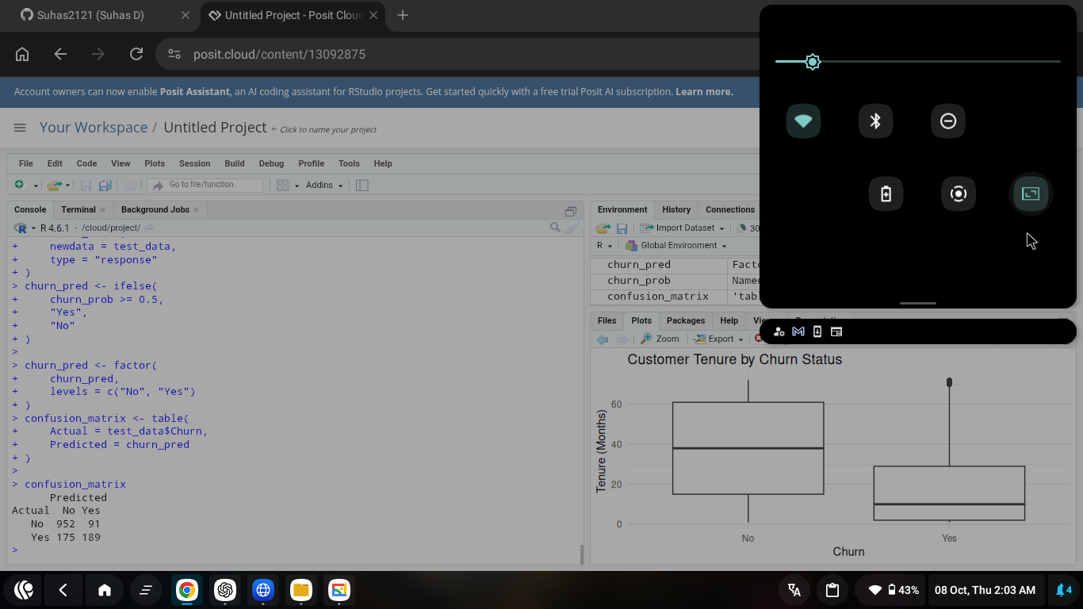
Figure 5. Test-set confusion matrix at the default 0.50 probability threshold.

9. ROC-AUC Diagnostic
library(pROC)
roc_result <- roc(
test_data$Churn,
churn_prob,
levels = c("No", "Yes")
)
auc(roc_result)
plot(roc_result, main = "ROC Curve - Logistic Regression")
The Area Under the ROC Curve (AUC) was 0.8477. An AUC above 0.80 indicates good discrimination: the model can meaningfully separate customers likely to churn from customers likely to stay.
Diagnostic result: AUC = 0.8477, indicating good classification performance.

10. Threshold Optimization - 0.40
Because churn prediction often prioritizes finding more at-risk customers, the classification threshold was reduced from 0.50 to 0.40. This trades some precision and specificity for higher recall.
churn_pred_40 <- ifelse(churn_prob >= 0.40, "Yes", "No")
churn_pred_40 <- factor(churn_pred_40, levels = c("No", "Yes"))
confusion_matrix_40 <- table(
Actual = test_data$Churn,
Predicted = churn_pred_40
)
confusion_matrix_40
Actual / Predicted | No | Yes
No | 889 | 154
Yes | 128 | 236
Metric | 0.50 cutoff | 0.40 cutoff
Accuracy | 81.1% | 80.0%
Precision | 67.5% | 60.5%
Recall | 51.9% | 64.8%
Specificity | 91.3% | 85.2%
F1 Score | 58.7% | 62.6%
Optimization decision: The 0.40 threshold is preferred for churn detection because recall improved from 51.9% to 64.8% and F1 score improved from 58.7% to 62.6%, while accuracy remained close to 80%.
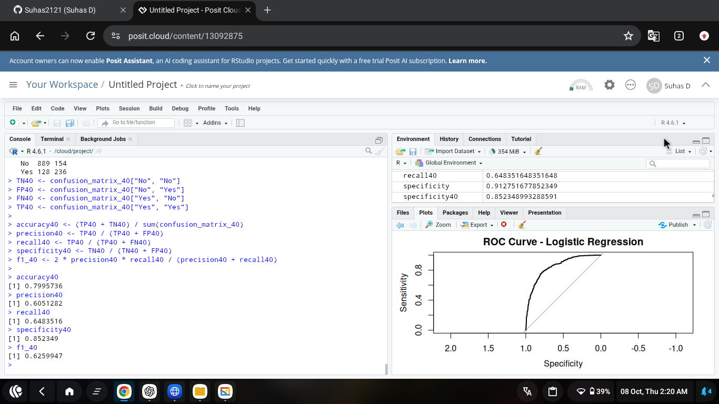
Figure 6. ROC curve and optimized 0.40-threshold performance metrics.

11. Final Model Interpretation
The optimized logistic regression model achieved approximately 80.0% accuracy, 60.5% precision, 64.8% recall, 85.2% specificity, and an F1 score of 62.6%. Its AUC of 0.8477 indicates good separation between churners and non-churners. The lower 0.40 threshold is more appropriate when the business objective is to identify as many potential churners as possible.

12. Model Strengths
- Good overall discrimination, supported by an AUC of 0.8477.
- Interpretable model structure using meaningful customer variables.
- Threshold optimization improves churn recall and F1 score.
- Uses a separate test set, reducing the risk of reporting training-only performance.
- Supports actionable retention decisions by identifying customers at higher risk.

13. Limitations
- The target classes are imbalanced: non-churners outnumber churners.
- The optimized model still misses 128 actual churners in the test set.
- Logistic regression may not capture complex nonlinear relationships or interactions.
- Only a selected subset of available predictors was used.
- A single 80/20 split can produce performance estimates that vary with the random split.

14. Potential Improvements
- Use k-fold cross-validation for more robust performance estimation.
- Compare logistic regression with Decision Tree, Random Forest, and Gradient Boosting models.
- Use class weighting or resampling techniques to address class imbalance.
- Perform feature engineering and interaction testing.
- Tune the probability threshold based on the real business cost of false positives and false negatives.
- Evaluate calibration and additional metrics such as PR-AUC.

15. Key Findings
- Churned customers had significantly higher monthly charges than non-churned customers.
- Contract type was strongly associated with churn; month-to-month customers had the highest churn proportion.
- Churned customers had substantially shorter tenure.
- The default model achieved about 81.1% accuracy but relatively low recall.
- Reducing the threshold to 0.40 increased recall to 64.8% and F1 score to 62.6%.
- AUC of 0.8477 shows good predictive discrimination.

16. Conclusion
This project demonstrated a complete workflow for statistical analysis and predictive modelling in R. Formal hypothesis tests identified meaningful differences and associations between churn and monthly charges, contract type, and tenure. A logistic regression model was then trained and evaluated on a held-out test set. Threshold optimization improved the model's ability to detect customers at risk of leaving, while ROC-AUC confirmed good overall discrimination. The results can support targeted retention campaigns, early intervention, and customer relationship management.

17. Dataset Source
IBM Telco Customer Churn dataset (publicly available sample data). Commonly distributed as WA_Fn-UseC_-Telco-Customer-Churn.csv.
Reference: IBM sample data / public mirrors including Kaggle.
Prepared by Suhas D

