WEEK 1 PROJECT REPORT

Titanic Data Cleaning and
Preliminary Analysis
R / RStudio • Data Cleaning • Exploratory Data Analysis

Prepared by | Suhas D
Project | Week 1 - Titanic Dataset
Tool | R / RStudio (Base R)
Date | October 2026
Project deliverables: cleaned dataset, analysis tables, visualizations, and reproducible R script.

1. Executive Summary
This Week 1 project cleans and analyzes the Titanic passenger dataset using base R. The workflow validates records, identifies missing values and duplicates, imputes selected fields, engineers useful features, detects outliers, creates scaled variables, produces descriptive statistics, examines survival patterns, and exports a fully cleaned dataset with supporting tables and plots.
After validation, the final dataset contains 891 unique passenger records with no missing values. The clearest preliminary finding is the large survival difference by sex: 74.2% of female passengers survived compared with 18.75% of male passengers. Survival also decreased substantially from first class to third class.

2. Project Objectives
- Import and inspect the raw Titanic dataset in R.
- Identify malformed records, duplicate rows, and missing values.
- Clean and transform the dataset while preserving meaningful information.
- Detect potential outliers using the IQR rule.
- Create useful derived and encoded features for later analysis.
- Summarize survival patterns and numerical variables.
- Export reproducible tables, charts, and a cleaned CSV dataset.

3. Dataset and Tools
The analysis uses the Titanic passenger dataset. Core variables include PassengerId, Survived, passenger class (Pclass), Name, Sex, Age, family counts (SibSp and Parch), Ticket, Fare, Cabin, and Embarked. The project was implemented in base R and exported as a self-contained project folder.
The script uses only base R functions, which keeps the workflow reproducible without additional package installation.

4. Data Cleaning Workflow

4.1 Record validation and duplicate checking
Records were considered valid when PassengerId was numeric and Survived and Pclass were present. One malformed row was rejected. Exact duplicate rows were checked and removed if present. PassengerId was converted to integer, and a final validation confirmed 891 unique passengers.

4.2 Missing-value treatment
Missingness was measured before imputation. Cabin had the highest missing rate (77.10%), followed by Age (19.87%). Embarked had 0.34% missing, while Name and Sex each had 0.11%.
variable | missing | percent
PassengerId | 0 | 0.00%
Survived | 0 | 0.00%
Pclass | 0 | 0.00%
Name | 1 | 0.11%
Sex | 1 | 0.11%
Age | 177 | 19.87%
SibSp | 0 | 0.00%
Parch | 0 | 0.00%
Ticket | 0 | 0.00%
Fare | 0 | 0.00%
Cabin | 687 | 77.10%
Embarked | 3 | 0.34%
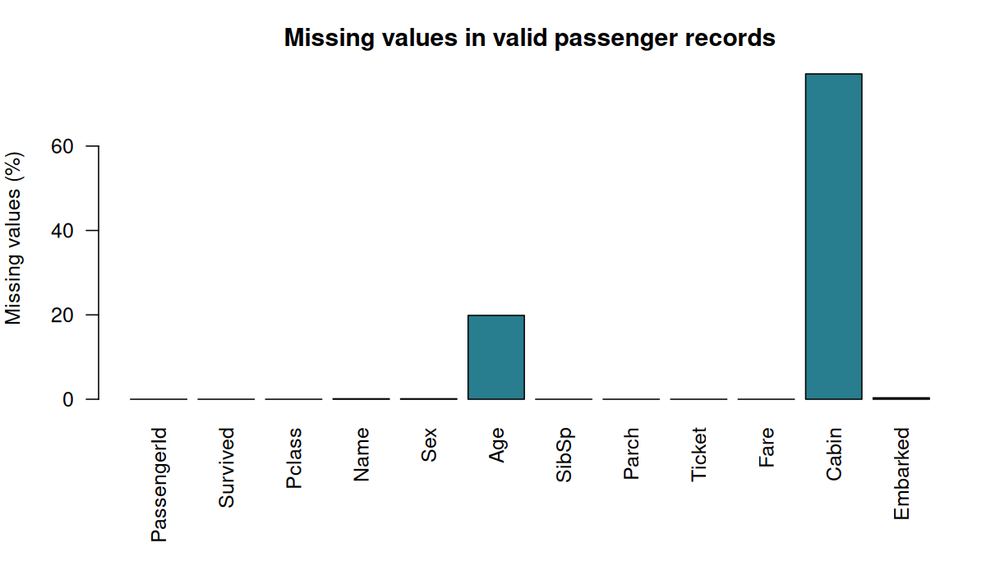
Figure 1. Missing-value percentages before cleaning
Age was imputed with the median, Embarked with its mode, and missing Sex values were labelled "Unknown". Missingness indicator variables were created before imputation. Because Cabin was highly incomplete, the original Cabin field was removed after creating a HasCabin indicator.

4.3 Feature engineering and transformations
- Extracted passenger Title from Name and grouped uncommon titles as Other.
- Removed Name, Ticket, and Cabin after extracting useful information.
- Converted Survived, Pclass, Sex, Embarked, and Title to factors.
- Created indicator columns for Sex, Embarked, and Title.
- Created Pclass_enc as a numeric class encoding.
- Created capped, min-max scaled, and z-score versions of Age and Fare while preserving original values.

5. Outlier Assessment
Potential outliers were identified using the 1.5 × IQR rule. The analysis flagged 66 Age values, 116 Fare values, 46 SibSp values, and 213 Parch values relative to their calculated fences. For Age and Fare, capped versions were created as optional transformed features rather than overwriting the original observations.
variable | lower | upper | count
Age | 2.50 | 54.50 | 66
Fare | -26.72 | 65.63 | 116
SibSp | -1.50 | 2.50 | 46
Parch | 0.00 | 0.00 | 213
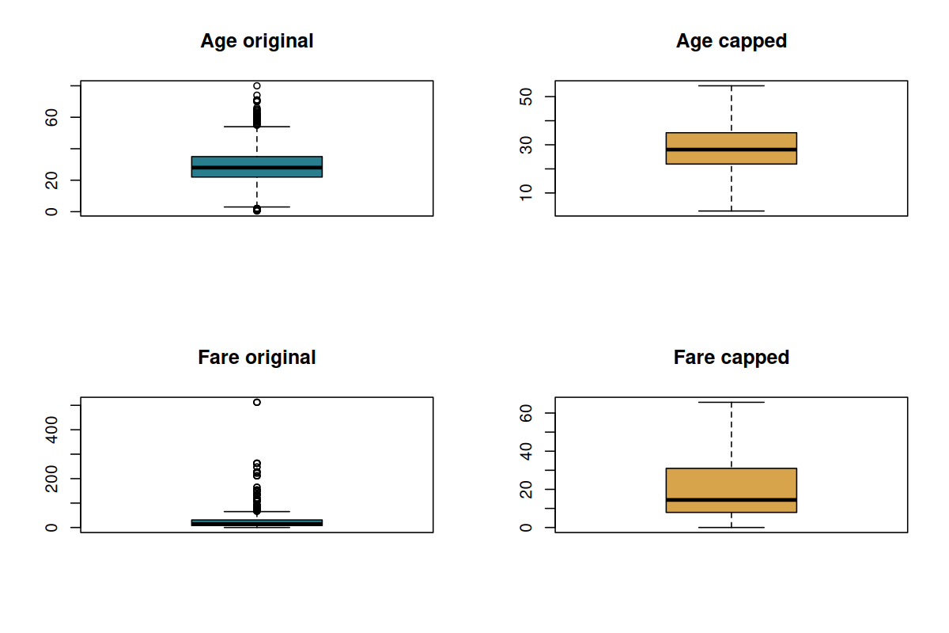
Figure 2. Original and capped Age/Fare distributions

6. Descriptive Statistics
The average passenger age was approximately 29.36 years, with a median of 28 years. Average fare was 32.20, although the much lower median of 14.45 indicates a right-skewed fare distribution with some very high fares.
variable | mean | median | sd | min | max
Age | 29.36 | 28.00 | 13.02 | 0.42 | 80.00
Fare | 32.20 | 14.45 | 49.69 | 0.00 | 512.33
SibSp | 0.52 | 0.00 | 1.10 | 0.00 | 8.00
Parch | 0.38 | 0.00 | 0.81 | 0.00 | 6.00
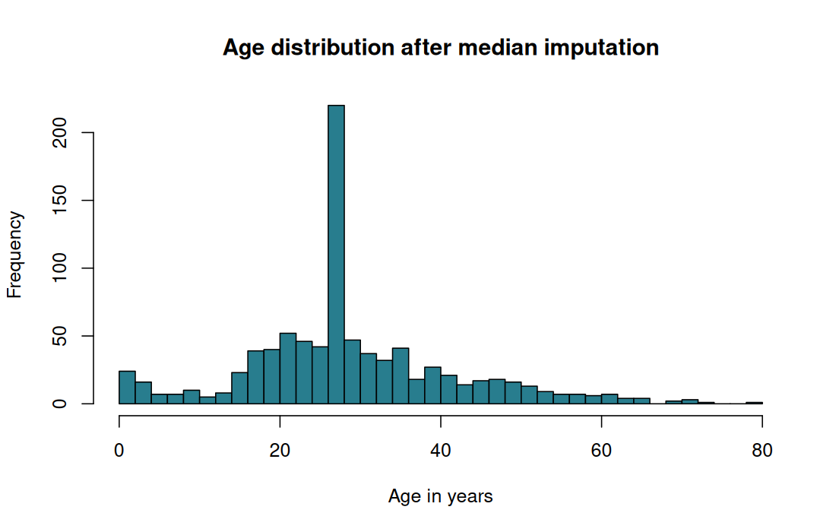
Figure 3. Age distribution after median imputation

7. Survival Analysis

7.1 Survival by sex
Sex showed the strongest visible difference among the grouped survival summaries. Female passengers had a 74.20% survival rate, compared with 18.75% for male passengers. One record with unknown sex survived; because this group contains only one passenger, it should not be interpreted as a meaningful population pattern.
group | n | survived | percent
female | 314 | 233 | 74.20%
male | 576 | 108 | 18.75%
Unknown | 1 | 1 | 100.00%
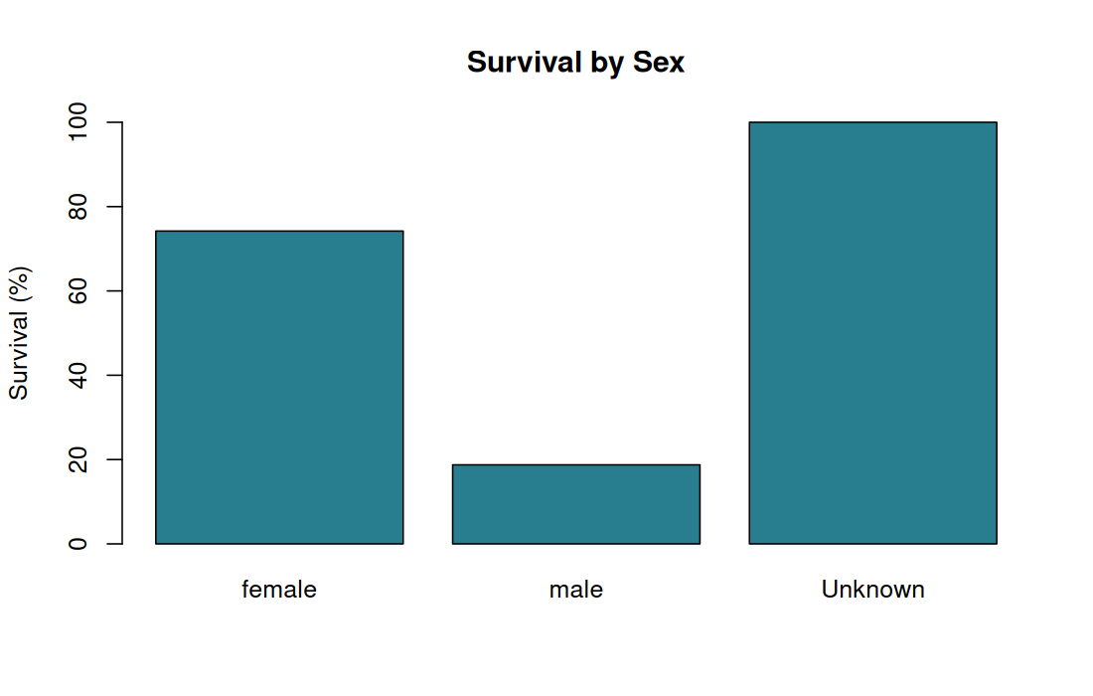
Figure 4. Survival percentage by sex

7.2 Survival by passenger class
Passenger class was also strongly associated with survival in this preliminary analysis. First-class passengers had a 62.96% survival rate, second-class passengers 47.28%, and third-class passengers 24.24%.
group | n | survived | percent
1 | 216 | 136 | 62.96%
2 | 184 | 87 | 47.28%
3 | 491 | 119 | 24.24%
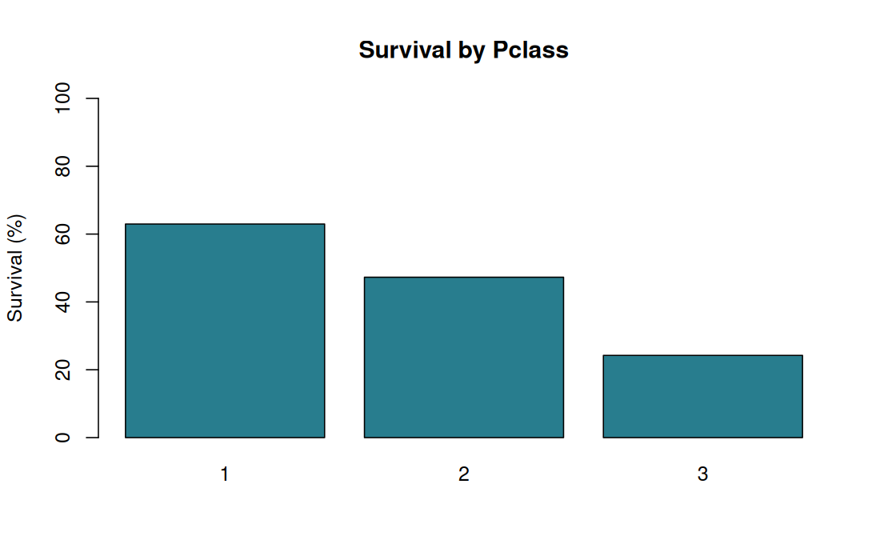
Figure 5. Survival percentage by passenger class

7.3 Survival by embarkation port
Passengers embarking at C had the highest observed survival rate at 55.69%, followed by Q at 38.96% and S at 33.85%. These are descriptive associations and should not be interpreted as causal effects without further modeling and control for related variables.
group | n | survived | percent
C | 167 | 93 | 55.69%
Q | 77 | 30 | 38.96%
S | 647 | 219 | 33.85%
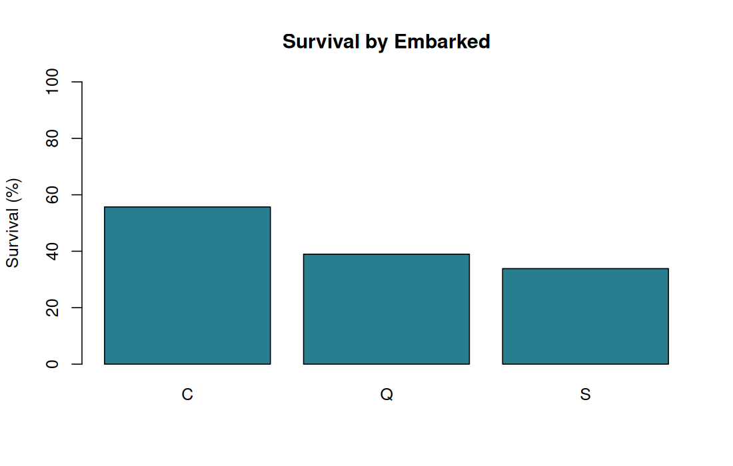
Figure 6. Survival percentage by embarkation port

8. Correlation Analysis
Pearson correlations were calculated for selected numeric and encoded variables. Survival had a negative correlation with Pclass_enc (-0.338), meaning higher class numbers (lower travel class) were associated with lower survival. HasCabin had a positive correlation with survival (0.317), while Fare had a positive correlation of 0.257. These correlations describe association only and do not establish causation.
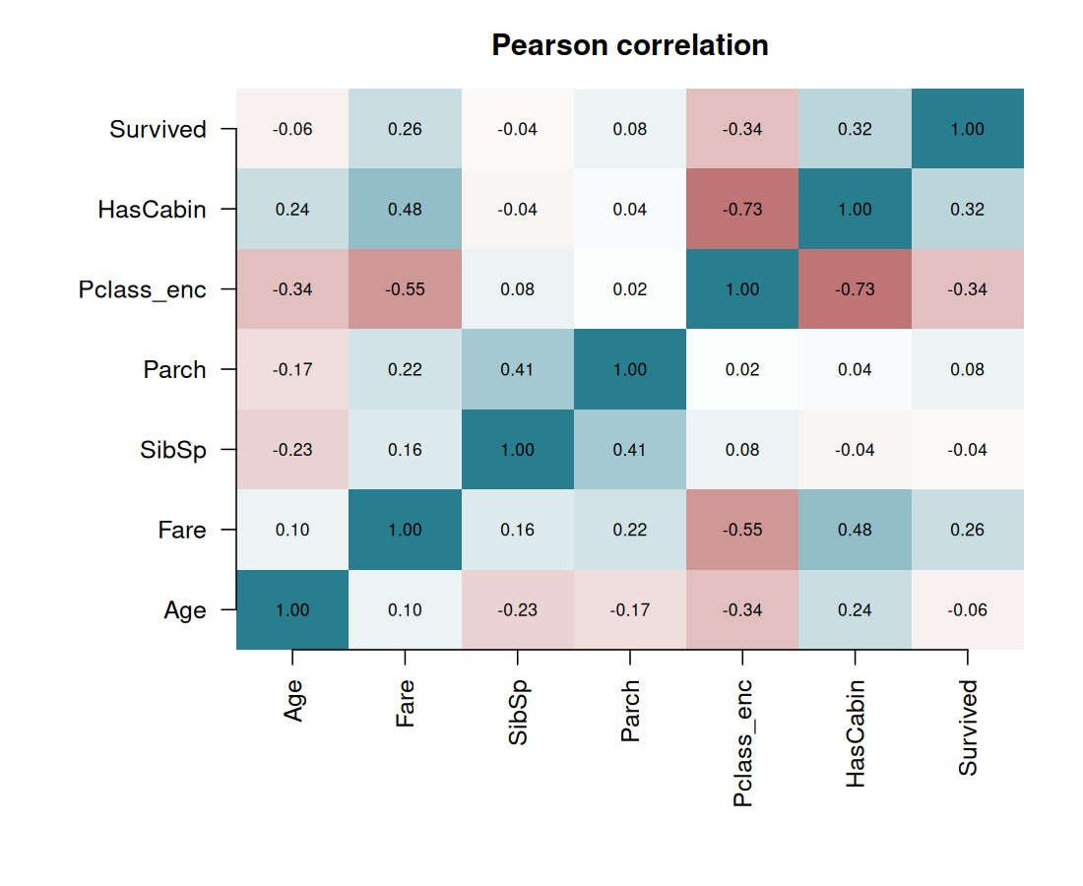
Figure 7. Pearson correlation heatmap

9. Final Output and Quality Checks
The cleaned dataset was exported as titanic_cleaned.csv. The R script includes a stopifnot quality check requiring exactly 891 rows, no remaining missing values, and no duplicated PassengerId values. The project also exports rejected records, missing-value summaries, outlier summaries, descriptive statistics, grouped survival tables, a correlation matrix, and seven PNG visualizations.
- Final valid passenger records: 891
- Remaining missing values after cleaning: 0
- Passenger IDs: unique
- Original Age and Fare retained alongside transformed versions
- Analysis outputs saved to tables/ and plots/ folders

10. Conclusion
The Week 1 project successfully demonstrates a complete introductory data-cleaning workflow in R: inspection, validation, missing-value handling, feature engineering, outlier assessment, scaling, descriptive analysis, visualization, and export. The cleaned data are ready for more advanced exploratory analysis or predictive modeling in later project stages.
The preliminary results suggest that sex and passenger class are especially important variables for understanding Titanic survival patterns. Further work could test these relationships jointly using statistical or machine-learning models rather than relying only on one-variable summaries.

Appendix A. Reproducibility
Main script: week1_data_cleaning.R. The script reads the input CSV, creates tables/ and plots/ directories, performs all cleaning and analysis steps, and writes titanic_cleaned.csv. It is designed to run with base R.
Project files generated by the workflow include: titanic_cleaned.csv; tables/missing_values.csv; tables/outliers.csv; tables/descriptive_statistics.csv; survival summary tables; tables/correlation_matrix.csv; tables/rejected_rows.csv; and seven PNG plots.

