DATA ANALYTICS INTERNSHIP
Week 2 Project
Data Visualization and Insight Communication Using R
Real-World Online Retail Sales Analysis

Prepared by | Suhas D
Dataset | UCI Online Retail
Analysis tool | R / Posit Cloud
Sample size | 60,000 transaction records

Objective: Transform transaction data into clear business insights through meaningful visualizations and interpretation.

1. Project Overview
This project analyzes a real-world online retail dataset using R. The focus is on data visualization, pattern discovery, and business-oriented insight communication. The original UCI Online Retail dataset contains more than half a million transaction records. Because the analysis was carried out in a resource-limited Posit Cloud session, a reproducible 60,000-row sample was used for the Week 2 visual analysis.
Project goal: Use multiple chart types to identify sales trends, high-performing products and markets, customer patterns, transaction behavior, and cancellation activity.

2. Dataset Overview
Field | Meaning | Use in analysis
InvoiceNo | Invoice / transaction identifier | Cancellation flag
StockCode | Product code | Product identification
Description | Product description | Product ranking
Quantity | Units purchased | Quantity distribution
InvoiceDate | Transaction date and time | Monthly and weekday trends
UnitPrice | Price per unit | Revenue calculation
CustomerID | Customer identifier | Customer ranking
Country | Customer country | Geographic sales analysis

Derived variable: Sales = Quantity × UnitPrice.

3. Data Preparation in R
The CSV sample was loaded into R, a Sales field was created, dates were converted for time-based analysis, and focused subsets were created where necessary to keep charts readable.
library(dplyr)
library(ggplot2)
retail <- read.csv("Online_Retail_60k_Sample.csv")
retail <- retail %>%
mutate(Sales = Quantity * UnitPrice)

4. Visualization 1 - Monthly Sales Trend
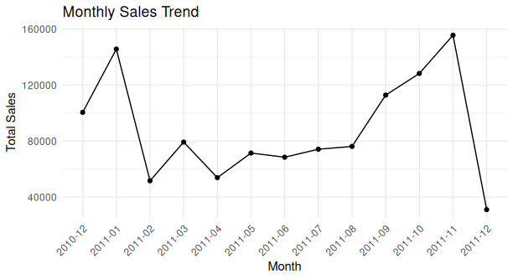
Figure 1. Monthly Sales Trend

R code
retail <- retail %>%
mutate(Month = format(as.POSIXct(InvoiceDate), "%Y-%m"))
monthly_sales <- retail %>%
group_by(Month) %>%
summarise(Total_Sales = sum(Sales, na.rm = TRUE))
ggplot(monthly_sales, aes(x = Month, y = Total_Sales, group = 1)) +
geom_line() +
geom_point() +
labs(title = "Monthly Sales Trend",
x = "Month", y = "Total Sales") +
theme_minimal() +
theme(axis.text.x = element_text(angle = 45, hjust = 1))

Interpretation
Sales varied substantially across the period. January 2011 was strong, sales weakened in February, and then generally strengthened toward the end of 2011. November 2011 recorded the highest sampled monthly sales at approximately 155,706. December 2011 appears sharply lower because the source dataset ends on 9 December 2011, so that month is incomplete.
Business significance: The chart highlights seasonality and identifies periods when demand and revenue were strongest.

5. Visualization 2 - Top 10 Products by Revenue
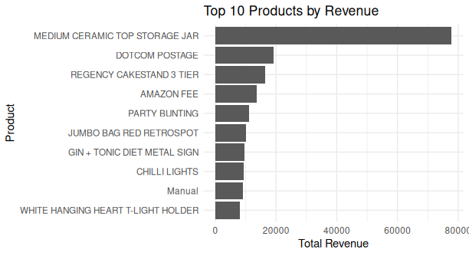
Figure 2. Top 10 Products by Revenue

R code
top_products <- retail %>%
filter(!is.na(Description), Sales > 0) %>%
group_by(Description) %>%
summarise(Total_Revenue = sum(Sales, na.rm = TRUE)) %>%
arrange(desc(Total_Revenue)) %>%
slice_head(n = 10)
ggplot(top_products,
aes(x = reorder(Description, Total_Revenue),
y = Total_Revenue)) +
geom_col() +
coord_flip() +
labs(title = "Top 10 Products by Revenue",
x = "Product", y = "Total Revenue") +
theme_minimal()

Interpretation
MEDIUM CERAMIC TOP STORAGE JAR was the leading revenue-generating item in the sample at about 77,811, far ahead of the remaining entries. DOTCOM POSTAGE, REGENCY CAKESTAND 3 TIER and AMAZON FEE followed. Some descriptions, such as postage and fees, are service-related entries rather than physical merchandise.
Business significance: Product ranking can support inventory planning, merchandising, and promotional decisions.

6. Visualization 3 - Top 10 Countries by Sales
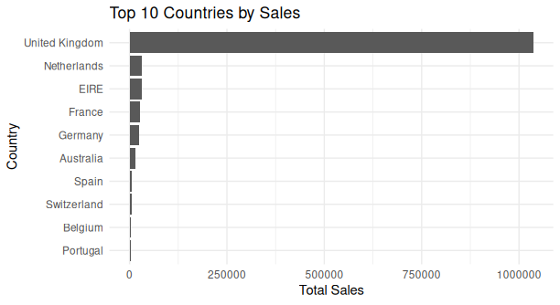
Figure 3. Top 10 Countries by Sales

R code
country_sales <- retail %>%
filter(Sales > 0) %>%
group_by(Country) %>%
summarise(Total_Sales = sum(Sales, na.rm = TRUE)) %>%
arrange(desc(Total_Sales)) %>%
slice_head(n = 10)
ggplot(country_sales,
aes(x = reorder(Country, Total_Sales),
y = Total_Sales)) +
geom_col() +
coord_flip() +
labs(title = "Top 10 Countries by Sales",
x = "Country", y = "Total Sales") +
theme_minimal()

Interpretation
The United Kingdom overwhelmingly dominated positive sales in the sample, with approximately 1.04 million in sales. The Netherlands, EIRE, France, Germany and Australia formed the next tier but were much smaller.
Business significance: The retailer is strongly concentrated in its domestic UK market, while several international markets provide secondary revenue.

7. Visualization 4 - Sales by Day of Week
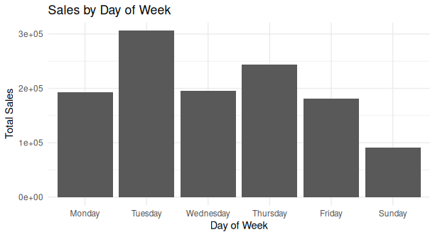
Figure 4. Sales by Day of Week

R code
retail <- retail %>%
mutate(
InvoiceDate = as.POSIXct(InvoiceDate),
Day = weekdays(InvoiceDate)
)
day_sales <- retail %>%
filter(Sales > 0) %>%
group_by(Day) %>%
summarise(Total_Sales = sum(Sales, na.rm = TRUE))
day_sales$Day <- factor(
day_sales$Day,
levels = c("Monday","Tuesday","Wednesday",
"Thursday","Friday","Saturday","Sunday")
)
ggplot(day_sales, aes(x = Day, y = Total_Sales)) +
geom_col() +
labs(title = "Sales by Day of Week",
x = "Day of Week", y = "Total Sales") +
theme_minimal()

Interpretation
Tuesday generated the highest positive sales in the sample at approximately 305,896, followed by Thursday. Sunday was the weakest day among those represented. Saturday is absent because the sampled data contained no Saturday transactions.
Business significance: Weekday patterns can inform staffing, campaign timing, and inventory readiness.

8. Visualization 5 - Distribution of Purchase Quantity
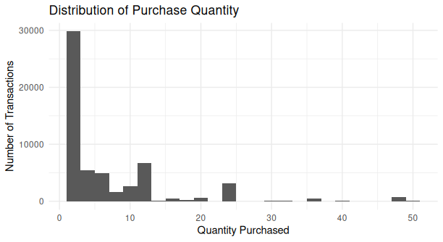
Figure 5. Distribution of Purchase Quantity

R code
quantity_data <- retail %>%
filter(Quantity > 0, Quantity <= 50)
ggplot(quantity_data, aes(x = Quantity)) +
geom_histogram(binwidth = 2) +
labs(title = "Distribution of Purchase Quantity",
x = "Quantity Purchased",
y = "Number of Transactions") +
theme_minimal()

Interpretation
The distribution is strongly right-skewed. Most transaction records involve relatively small purchase quantities, while large quantities are much less common. Limiting the chart to quantities between 1 and 50 makes the typical purchasing pattern easier to see.
Business significance: Understanding the typical order size helps with packaging, stock replenishment, and operational planning.

9. Visualization 6 - Sales vs Purchase Quantity
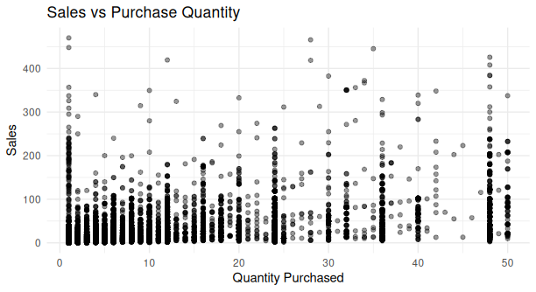
Figure 6. Sales vs Purchase Quantity

R code
scatter_data <- retail %>%
filter(
Quantity > 0,
Quantity <= 50,
Sales > 0,
Sales <= 500
)
ggplot(scatter_data, aes(x = Quantity, y = Sales)) +
geom_point(alpha = 0.4) +
labs(title = "Sales vs Purchase Quantity",
x = "Quantity Purchased", y = "Sales") +
theme_minimal()

Interpretation
Higher quantities can produce higher sales, but the relationship is not strongly linear. Transactions with the same quantity often have very different sales values because products have different unit prices.
Business significance: Revenue depends on both quantity and unit price, so quantity alone is not sufficient to predict transaction value.

10. Visualization 7 - Completed vs Cancelled Transactions
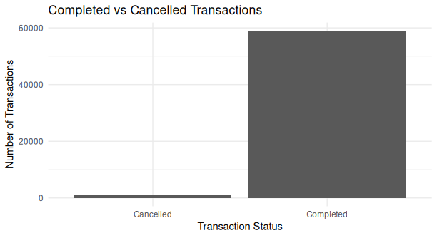
Figure 7. Completed vs Cancelled Transactions

R code
retail <- retail %>%
mutate(
Cancelled = ifelse(substr(InvoiceNo, 1, 1) == "C",
"Cancelled", "Completed")
)
cancellation_summary <- retail %>%
group_by(Cancelled) %>%
summarise(Transactions = n())
ggplot(cancellation_summary,
aes(x = Cancelled, y = Transactions)) +
geom_col() +
labs(title = "Completed vs Cancelled Transactions",
x = "Transaction Status",
y = "Number of Transactions") +
theme_minimal()

Interpretation
Completed transaction records accounted for the overwhelming majority of the sample: 58,945 records versus 1,055 cancelled records. This visualization counts transaction rows rather than unique invoices.
Business significance: Although cancellations are a small share, tracking them can help identify revenue leakage, return behavior, and service issues.

11. Visualization 8 - Top 10 Customers by Revenue
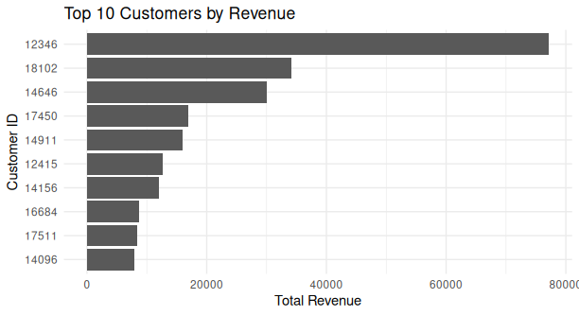
Figure 8. Top 10 Customers by Revenue

R code
top_customers <- retail %>%
filter(!is.na(CustomerID), Sales > 0) %>%
group_by(CustomerID) %>%
summarise(Total_Revenue = sum(Sales, na.rm = TRUE)) %>%
arrange(desc(Total_Revenue)) %>%
slice_head(n = 10)
ggplot(top_customers,
aes(x = reorder(as.factor(CustomerID), Total_Revenue),
y = Total_Revenue)) +
geom_col() +
coord_flip() +
labs(title = "Top 10 Customers by Revenue",
x = "Customer ID", y = "Total Revenue") +
theme_minimal()

Interpretation
Customer 12346 generated the highest positive revenue in the sample at approximately 77,184, followed by Customers 18102 and 14646. The ranking indicates that a small group of customers contributes a substantial amount of revenue.
Business significance: High-value customer identification can support retention programs, loyalty initiatives, and targeted relationship management.

12. Key Findings
- Sales strengthened notably toward the final months of 2011, with November the strongest complete month in the sample.
- Revenue is concentrated in a small number of high-performing products and customers.
- The United Kingdom is the dominant geographic market in the sampled data.
- Tuesday and Thursday were the strongest sales days, while Sunday was weaker.
- Most purchases involve small quantities, creating a right-skewed quantity distribution.
- Sales value is influenced by both quantity and product price, not quantity alone.
- Cancelled transaction records form only a small share of the sample.

13. Conclusion
The Week 2 analysis demonstrates how R and ggplot2 can convert raw retail transactions into clear visual insights. The selected visualizations cover time trends, product performance, geographic markets, customer behavior, purchase quantities, transaction value relationships, and cancellations. Together they show how visualization supports practical business decisions by making patterns, concentration, and anomalies easier to understand.

14. Limitations
- The analysis uses a 60,000-row sample rather than the full 541,909-row dataset because of cloud memory constraints.
- The final month, December 2011, is incomplete because the original dataset ends on 9 December 2011.
- Some high-revenue descriptions represent fees or service entries rather than physical products.
- Cancellation analysis is based on transaction records, not a count of unique invoices.

15. Tools and Technologies
Tool / Package | Purpose
R | Data analysis and transformation
Posit Cloud | Cloud-based R environment
dplyr | Filtering, grouping, summarising and feature creation
ggplot2 | Data visualization
UCI Online Retail | Real-world retail transaction dataset

16. Dataset Source
UCI Machine Learning Repository - Online Retail dataset. The dataset contains transactions from a UK-based non-store online retailer and is distributed under the CC BY 4.0 license.
Source: https://archive.ics.uci.edu/dataset/352/online+retail

Prepared by Suhas D

