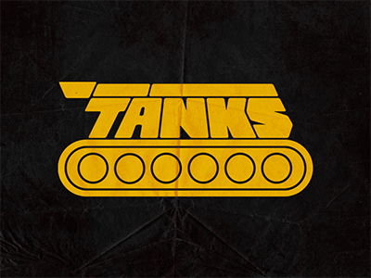*TANKS*

Suhas Raja & Diana Shao

# Overview

TANKS is a 2D strategy game, where players can set mines for others, shoot, and move about a stage.

## Basic Rules

1. Players start with 3 mines, each hit does 2 damage.
2. Players may be hit up to 3 times
3. Players must recharge if projectiles are shot too rapidly.
4. Players can select the number of rounds

## Features

1. Simple Controls- One joystick, 2 buttons
   1. Joystick controls both moving and aiming
   2. Button A shoots, Button B sets a mine
2. Multiplayer functionality
3. Multiple modes of attack
4. PowerUps (lasts for remainder of round)
   1. Increased Speed
   2. Additional mines

## Difficulty

Depending on the variations you add to the game, this could be a hard game given the following items.

1. Collision Detection with walls, bullets
2. Heads Up Displays
3. Interfacing external controllers
4. Multiplayer
5. Maintaining traps, and all power ups across stage

## Requirements

* Controllers satisfy button/slidepot requirements (joysticks)
* Tanks and projectiles respond to users/time
* Music, sound effects for starting/ending game, being hit, picking up powerup
* Stage is displayed on main screen, scores and player info stored on HUD
* Interrupts will be used to update displays periodically/process frames, output sound, respectively

## Extra Credit

Multiplayer, Graphics Layering, Soldered, UART (HUD), Double Buffering, Edge-Triggered Interrupts (Pausing functionality),