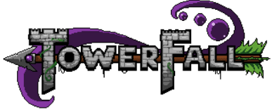
TowerFall
Suhas Raja & Diana Shao

Overview
TowerFall is a multiplayer combat platformer with relatively simple controls.

Basic Rules
- Once a player wins 10 kills (>2 players), or 5 rounds (2 players), they win the game
- Per each round, a player is eliminated if they are hit once.
- Each round will start to close in on players as a time limit is reached
- Players can eliminate other players by jumping on their head or by shooting them with an arrow
- Arrows may be picked up from around the stage

Features
- Simple Controls- One joystick, 2 buttons
  - Joystick controls both moving and aiming
  - Button A jumps, holding Button B initiates/terminates stationary aiming
- Walljumping Functionality
- Toroid Geometry- Players, arrows, or other objects may fall off one side of the screen and appear on the other. This means that arrows may traverse the edge of the screen to hit another player.
- Special arrows- The original game implemented a wide variety of special powered arrows, varying in speed, landing behavior, and blast radius. We plan to implement as many arrow types as time permits. Arrows are obtained through chests.
  - Feather arrows- travel fast without arcing
  - Bomb arrows- explode on a timer
  - Trigger arrows -explode on command
  - Laser Arrows- Bounce 6 times then disappear
  - Bramble arrows- traps immediate ground area
- Multiplayer plug and play functionality

Difficulty
Depending on the variations you add to the game, this could be a hard game given the following items.
- Physics
- Control of speed/frame rate, unfamiliar display
- Multiple players, edge triggered interrupts
- Special arrow dynamic behavior simulation
- Art design
- Collision detection

