Table of Contents

Handicraft Price Prediction — Final Report
Course: Artificial Intelligence & Machine Learning (20-mark project component) Author: Utsav · Branch: ai-ml-price-extension of Suhas910/Karigari_Connect, folder ml_price/ Date: 2026-10-04 · Format: Markdown (Word conversion only on request)
Every number here comes from a committed result file. The detailed report for each part is linked in its section.

Summary
Task. Estimate the market listing price of an Indian handicraft product from its title, description, art-form labels and photo, and turn that estimate into a price advisor that never undercuts a fair-wage floor.
Data. 37,273 product listings from one Indian handicraft retailer (Kaggle, MIT licence). 37,257 remain after cleaning, along with 37,282 product photos.
Best model. Ridge regression on log price, using TF-IDF text, LLM-extracted materials, knowledge-graph rule features, size words, K-Means segment and CNN photo embeddings (stage S12-img). On a frozen test set of 7,452 products from product families never seen in training:
Metric | Start (S0) | Final (S12-img) | Change
R² | 0.269 | 0.806 | +0.537
MAE | ₹1,506 | ₹612 | −59%
MAPE | 152% | 34.2% | −118 points
Price-band macro-F1 (low / mid / high) | 0.534 | 0.821 | +0.287
Main findings
- The split matters more than any model. Near-copy listings made a random split look far better than reality (R² 0.86 under split v2). An honest family-grouped split (v3) was the most important decision in the project.
- Text is the main signal. Removing the TF-IDF words drops cross-validated R² from 0.74 to 0.39. Every other feature group adds less than 0.01, except photos (+0.026).
- Better inputs beat cleverer models. An LLM reading descriptions (prompt-engineered, F1 0.98 vs 0.76 for keywords) and a pretrained CNN reading photos each improved the model more than any change of algorithm.
- The model learns what the market charges, not what the work is worth. It pulls prices toward the middle, and a few crafts (hand painting, blue pottery, kalamkari block printing, Bengal jamdani, Lucknowi chikankari) are under-priced across several product families. So the advisor treats the model as evidence and lets the Karigari Connect fair-wage floor override it.
- Count product families, not rows. One bag sold in 453 prints first made Pochampally ikat and Kutch embroidery look undervalued. Auditing per family removed that artefact, just as grouping by family fixed the test split.

1. Problem and data
Source | Kaggle: Indian Handicraft Products, MIT licence
Files | 3 CSVs (37,273 rows, 5 columns) + 37,282 photos (1.1 GB, 512 × 512)
Columns | product_title, product_description, price, image_paths, artform (1–6 labels)
Integrity | SHA-256 checksums for all raw files and photos (data/raw/*SHA256SUMS.txt)
Limits | Asking prices, not sale prices · one retailer · currency inferred as INR · no labour hours or material costs
As a well-posed learning problem (Mitchell): Task T = predict a listing's price (and its price band) from text, labels and photo; Performance P = R², MAE, MAPE and band F1 on unseen product families; Experience E = 29,805 priced training listings. It is supervised learning (regression + classification), with unsupervised parts (segmentation, rules, anomalies) and a knowledge-based layer around it.
Details: data card, raw audit.

2. Tools and record-keeping
Tool | Used for
OpenRefine 3.10 | All cleaning: 18 operations, saved as a replayable Undo/Redo recipe
Orange 3.40 (+ Text, Associate, Explain, Image Analytics) | Raw-audit cross-check, model cross-check (Test and Score), EDA box plot, CNN image embedding
Protégé format (OWL) with owlready2 + HermiT, rdflib | Knowledge graph, SWRL rules, reasoning, SPARQL
Google Gemini (3.5 Flash / Flash-Lite) | LLM attribute extraction with prompt engineering
scikit-learn, FAISS, SHAP, mlxtend, Streamlit | Models, vector search, explanations, Apriori, demo
Records kept for every step:
- Before / middle / after snapshots (data/stages/S01 … S06)
- Tool exports (tool_exports/)
- A dated project log
- Method notes in PROCESSING_STEPS
- The scoreboard in EXPERIMENTS
- One git commit per stage

3. Data cleaning (Part 1)
Stage | Change | Rows
S00 raw | — | 37,273
S01 types | Price → number; image_file extracted | 37,273
S02 missing | 16 rows with no art form removed (0.04%) | 37,257
S03 variants | variant_group ids for 6,911 rows in 2,010 design-variant groups (kept, not removed) | 37,257
S04 art forms | 3 spelling merges; primary_artform = first non-generic label; 65 rare → other (129 classes) | 37,257
S05 derived | log_price, title/description length, description-repeat count | 37,257
S06 fix | A zero-width-space merge had silently failed (the data held the literal text \u200b); fixed with 4 more operations | 37,257
- 0 exact duplicates and 0 invalid prices. No price was ever imputed.
- Outliers (training rows only):
  - flagged: IQR 0, z-score 12, Isolation Forest 293
  - removing them made R² and MAE slightly worse, and the flagged rows are real high-end crafts
  - all kept (step 09)
- The price distribution barely moved (median ₹850 before and after). Cleaning fixed structure, not prices.
Details: CLEANING_REPORT.

4. The frozen test split: three versions
Version | Grouped by | Problem found | Inflated score
v1 | design-variant group | 71% of test rows shared an exact description with training | RF R² 0.788
v2 | + identical description | 72% of test rows had a ≥ 0.9-similar training row | copy-nearest-price R² 0.841
v3 | + near-identical text (TF-IDF cosine ≥ 0.8, union-find into 2,575 families) | — | copy-nearest-price falls to 0.255
The v3 split: 29,805 train / 7,452 test (20%), stratified by primary art form, seed 42, never changed afterwards. All tuning uses GroupKFold by family on training rows. v1 and v2 scores were discarded. Details: EXPERIMENTS.

5. Statistics and EDA (Part 2)
Training rows only.
Finding | Evidence
Price is strongly right-skewed | skewness 3.50, excess kurtosis 18.6; log price: 0.49 and −0.60
Sellers use price points | 61.4% of prices end in 90 (₹390, ₹590, ₹990)
Art form changes price | Kruskal-Wallis H = 13,304, p < 10⁻³⁰⁰. Effect ε² = 0.45 on all rows, 0.35 with one row per family (variants inflate evidence)
ANOVA's assumptions fail | Levene p < 10⁻³⁰⁰ (unequal spreads), so Kruskal-Wallis is the main test
Correlations are moderate | strongest: title length, Spearman ρ = 0.51; every link is stronger on log price
Words separate price bands | low: hair clip, keychain · mid: bag, sling · high: saree, kurta, dress material, silk, wool
Technique × band | χ² = 7,567, Cramér's V = 0.356 (weaving, tie-dye lean high; bead work, wood lean low)
Orange Box Plot cross-check included. Details: EDA_REPORT.

6. Knowledge graph and rule-based reasoning (Parts 3–4)
- Ontology: 68 classes, 201 art forms, technique and material trees, 3,964 triples. Saved as tool_exports/protege/craft_kg.owl.
- Skill knowledge comes from the Karigari Connect app's technique table, written as a class axiom (Weaving ⊑ requiresSkill value skilled). Subtypes such as ikat inherit it.
- 5 SWRL rules, forward chaining:
  - R1 textile
  - R2 handwoven silk
  - R3 zari
  - R4 metal
  - R5 skilled labour
- Verification: the HermiT reasoner and an independent pandas version agree on all 5 classes (0 disagreements).
- 4 SPARQL questions, e.g. "which art forms use any textile technique at any depth" → 94.
- Value: rule-flagged handwoven silk / zari products have a median ₹4,890 (5.8× overall). Without text, the 37 KG features lift Random Forest R² from 0.110 to 0.527.
Details: KG_REPORT.

7. Unsupervised learning (Parts 5–7)
Part | Method | Result
5 Segmentation | TF-IDF → SVD (100) → K-Means / Hierarchical / DBSCAN; PCA map | K-Means k = 17 (silhouette 0.164); segments are product types with medians ₹250–₹3,850. As a feature (S8): Ridge 0.707 → 0.714
6 Apriori | baskets of labels, materials, techniques, price band | 1,083 rules, e.g. Wool + Weaving → high (conf. 0.995, lift 3.05). Exposed keyword errors: kalamkari → "bamboo" (the pen), block printing → "wood" (the blocks), "German silver" → silver
7 Underpricing detector | out-of-fold expected price; flag if actual < 50% | 6.5% flagged, symmetric with 7.0% over. Mostly model error on small items: a review queue, not a verdict
Details: UNSUPERVISED_REPORT.

8. Supervised learning: how the score improved
Ridge on the frozen test set unless noted. The full table, with Linear, Random Forest and baselines, is in EXPERIMENTS.
Stage | Change | R² | MAE ₹ | Band F1
S0 | raw art-form text only (best model: RF) | 0.269 | 1,506 | 0.534
S5 | log(price) target (RF) | 0.270 | 1,304 | 0.478
S6b | + TF-IDF words of title + description | 0.707 | 730 | 0.767
S7 | + knowledge-graph features | 0.698 | 749 | 0.780
S8 | + K-Means segment | 0.714 | 735 | 0.786
S9 | + numeric features standardised | 0.752 | 691 | 0.770
S10-swap | keyword materials replaced by LLM materials, + title size | 0.773 | 681 | 0.789
S12 | tuned: TF-IDF 20k terms, min_df 2, α = 1 | 0.790 | 646 | 0.811
S12-img | + CNN photo embeddings (128 PCA components) | 0.806 | 612 | 0.821
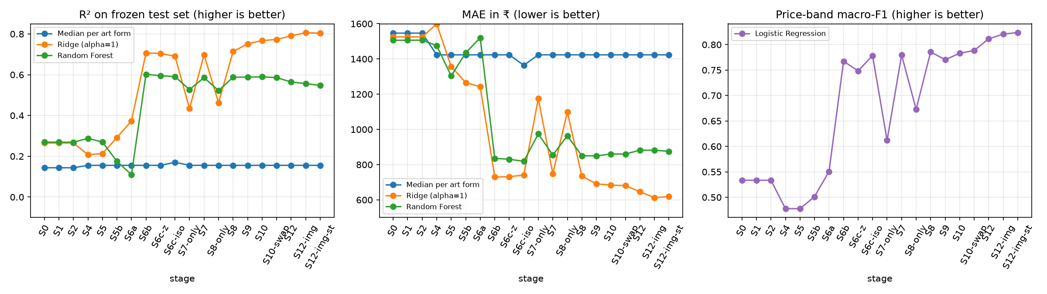
Model comparisons (each tuned with grouped 5-fold CV, test used once)
- Regressors (Part 8, S9 features):
  - Ridge 0.748
  - Gradient Boosting 0.675
  - KNN 0.633
  - Random Forest 0.608
  - Polynomial (deg 2) 0.577
  - Decision Tree 0.413
  - Linear 0.347
  - median baseline −0.146
- Regularised linear models win on 5,000+ sparse word features. Ensembles beat a single tree (0.413 → 0.608 → 0.675).
- Price range (Part 9): raw quantile Gradient Boosting promises 80% coverage but delivers 58% (overconfident on new families). Conformal calibration fixes it (83%). A simple Ridge ± out-of-fold error band gives 77% and is used by the advisor.
- Classifiers (Part 10):
  - Gradient Boosting F1 0.810, AUC 0.925
  - Random Forest 0.805
  - Logistic 0.777
  - Linear SVM 0.767
  - KNN 0.721
  - Naive Bayes 0.703
  - Decision Tree 0.669
- Errors are almost always between neighbouring bands (low ↔ high only 6 / 7,452 times).
- Similar items (Part 11): a FAISS vector index over the training listings. The median of the 10 nearest neighbours' prices gives R² 0.613. Weak matches (low similarity) mean about 1.5× larger errors, which the advisor turns into a caution.
Details: PARTS_8_14_16, PARTS_9_11.

9. LLM, CNN, transformer embeddings, RAG, ablation and tuning (Parts 12, 13, 17, 18, 8b)
Part 12, LLM attribute extraction (prompt engineering). An 80-product gold set was built around the keyword traps that Apriori found.
Extractor | Precision | Recall | F1 | Exact match
Keywords (KG rules) | 0.638 | 0.926 | 0.755 | 0.425
Gemini zero-shot | 0.798 | 1.000 | 0.888 | 0.738
Gemini engineered prompt (6 rules + 3 examples) | 0.979 | 0.979 | 0.979 | 0.950
Flash-Lite, engineered (used for the full run) | 0.967 | 0.916 | 0.941 | 0.875
- The zero-shot prompt marked every "German silver" product as silver (0/10). The engineered prompt got 8/10 right.
- All 12,875 unique descriptions were then extracted, with 0 failures; no prices are sent.
- Replacing the keyword materials beat adding beside them (0.768 vs 0.773).
- PART12_REPORT
Part 13, CNN image features (transfer learning).
- Orange's Image Analytics ran SqueezeNet (pretrained on ImageNet) locally on all 37,282 photos: 1,000 numbers each, nothing retrained. The default embedder (Inception) would have uploaded the photos, so it was not used.
- PCA was fitted on training photos only.
- Photos alone: R² 0.375. Added to S12: CV R² 0.754 → 0.780 and test 0.790 → 0.806. The photos add size and detail that titles rarely state (only 3,075 of 37,257 give a size).
- PART13_IMAGES
Part 8b, ablation and tuning.
- Removing one group at a time (grouped CV): TF-IDF −0.343; every other group under 0.01, with CV and test disagreeing in sign. All groups kept.
- Tuning over 24 settings chose TF-IDF 20k terms and α = 1. 50k was worse, so the optimum isn't at the edge of the grid.
- PART8B
Part 17, transformer sentence embeddings (MiniLM, 6 attention layers, 384 numbers).
- Learned embeddings see meaning without shared words: saree ≈ sari 0.73, handwoven ≈ handloom 0.63, where TF-IDF scores 0. They know Indian craft terms poorly: earrings ≈ jhumka only 0.16.
- For similar-item search the in-domain LSA vectors beat MiniLM (R² 0.613 vs 0.545).
- Added to S12-img: CV R² +0.004 and MAE slightly worse, inside the noise band. Not adopted (decided on CV); scored once as stage S12-img-st for the record.
- PART17
Part 18, retrieval-augmented generation. FAISS retrieves 10 similar training listings; Gemini estimates the price using only that evidence, cites the listings it relied on and labels the match quality. 40 test products, one per family:
Method | R² | Median error
LLM without retrieval | 0.34 | 41.7%
RAG | 0.73 | 24.6%
Neighbour median, no LLM | 0.73 | 31.4%
Ridge S12-img | 0.85 | 26.7%
- Retrieval more than doubles the LLM's R².
- Citations are valid in 100% of answers, and every estimate lies inside the evidence's price span.
- The model's own "good / partial / poor" label predicts its error (median 18% / 34% / 178%).
- Its ranges are overconfident (52.5% coverage).
- Added to the advisor as an optional explanation.
- PART18

10. Explainability and ethics (Parts 14–15)
SHAP (Part 14).
- The Ridge SHAP values computed by hand match shap.LinearExplainer exactly (max difference 0.0).
- Influence by group: words 2.73 ≫ KG 0.85 > segment 0.50 > labels 0.40.
- Words that raise price: saree, necklace, set, 3pc, heavy. Words that lower it: keychain, nosepin, fabric, art silk (imitation silk).
- A per-product explanation is given as % effects on the price.
Bias audit (Part 15), on the part 8 Ridge and on the final S12-img model. Ratio = predicted ÷ actual price, 1.0 = fair.
- First version (per product): kalamkari screen printing ×0.46, Kutch embroidery ×0.53, Pochampally ikat ×0.68 looked systematically undervalued.
- Revision (per product family): every one of those art forms had a median test price of exactly ₹1,590. 453 of the 524 test products at ₹1,590 are one product line, "Handcrafted Fabric Jhola Bag", in hundreds of prints labelled with different crafts. Counted once per family:
  - Pochampally ikat ×1.04 (25 families) and Kutch embroidery ×1.10: no craft-wide bias
  - kalamkari screen printing: only 2 families, one of them the bag; no conclusion possible
  - kalamkari block printing ×0.74 (final model) holds up, with hand painting ×0.73, blue pottery ×0.74, Bengal jamdani ×0.80 and Lucknowi chikankari ×0.83
- Pull toward the middle, confirmed per family: cheapest fifth of families ×1.31 (part 8) → ×1.13 (final); dearest fifth ×0.86 → ×0.89. Across all 510 test families the final model's median ratio is 1.017, so the bias is at the price extremes and in a few crafts, not general.
- Ethical position: a model trained on market prices repeats the market's undervaluation, so it may never set the floor. The advisor applies the app's fair-wage floor and warns when an art form is one the audit found under-priced.
- The data itself is a limitation: asking prices from one retailer, no costs or hours, generic labels on 6,434 rows.

11. The price advisor agent (Part 16)
PEAS
Performance | A range that holds the market price about 80% of the time; never below the fair-wage floor; cautions where the model is weak
Environment | A new listing; knowledge from 29,805 training listings + the app's wage tables
Actuators | Range, point estimate, verdict on a listed price, cautions, evidence table, explanation
Sensors | Title, description, art-form labels; optional listed price, material cost, hours, state, skill
Architecture (knowledge-based + learned):
- KG rules fire (R1–R5).
- Ridge gives the estimate, with an 80% band (×0.586 – ×1.713).
- FAISS shows the 10 most similar listings as evidence.
- The Karigari Connect calculate_price gives the fair-wage floor, imported read-only. If no verified wage rate exists, the floor is "unavailable", never guessed.
- The floor always overrides the market range.
Example: a Pochampally silk ikat saree listed at ₹4,500.
- Market range ₹13,840 – ₹40,430; floor ₹6,558 (40 h × ₹88.94/h skilled, Telangana + ₹3,000 materials).
- Verdict: below the fair-wage floor.
- Cautions: few similar products. (An earlier version also warned "Pochampally ikat is under-priced". That came from the per-product audit and was removed by the family-level revision: the advisor now warns only for crafts with at least 5 families of evidence, e.g. kalamkari block printing.)
- Optional RAG explanation (Part 18): Gemini cites listings 4–6, handloom silk Pochampally sarees with zari, and gives ₹37,990 as a zero-width range (the overconfidence measured in Part 18).
The screenshot was retaken after both changes, with the page opened as ?demo=1&rag=1 so the example runs by itself.
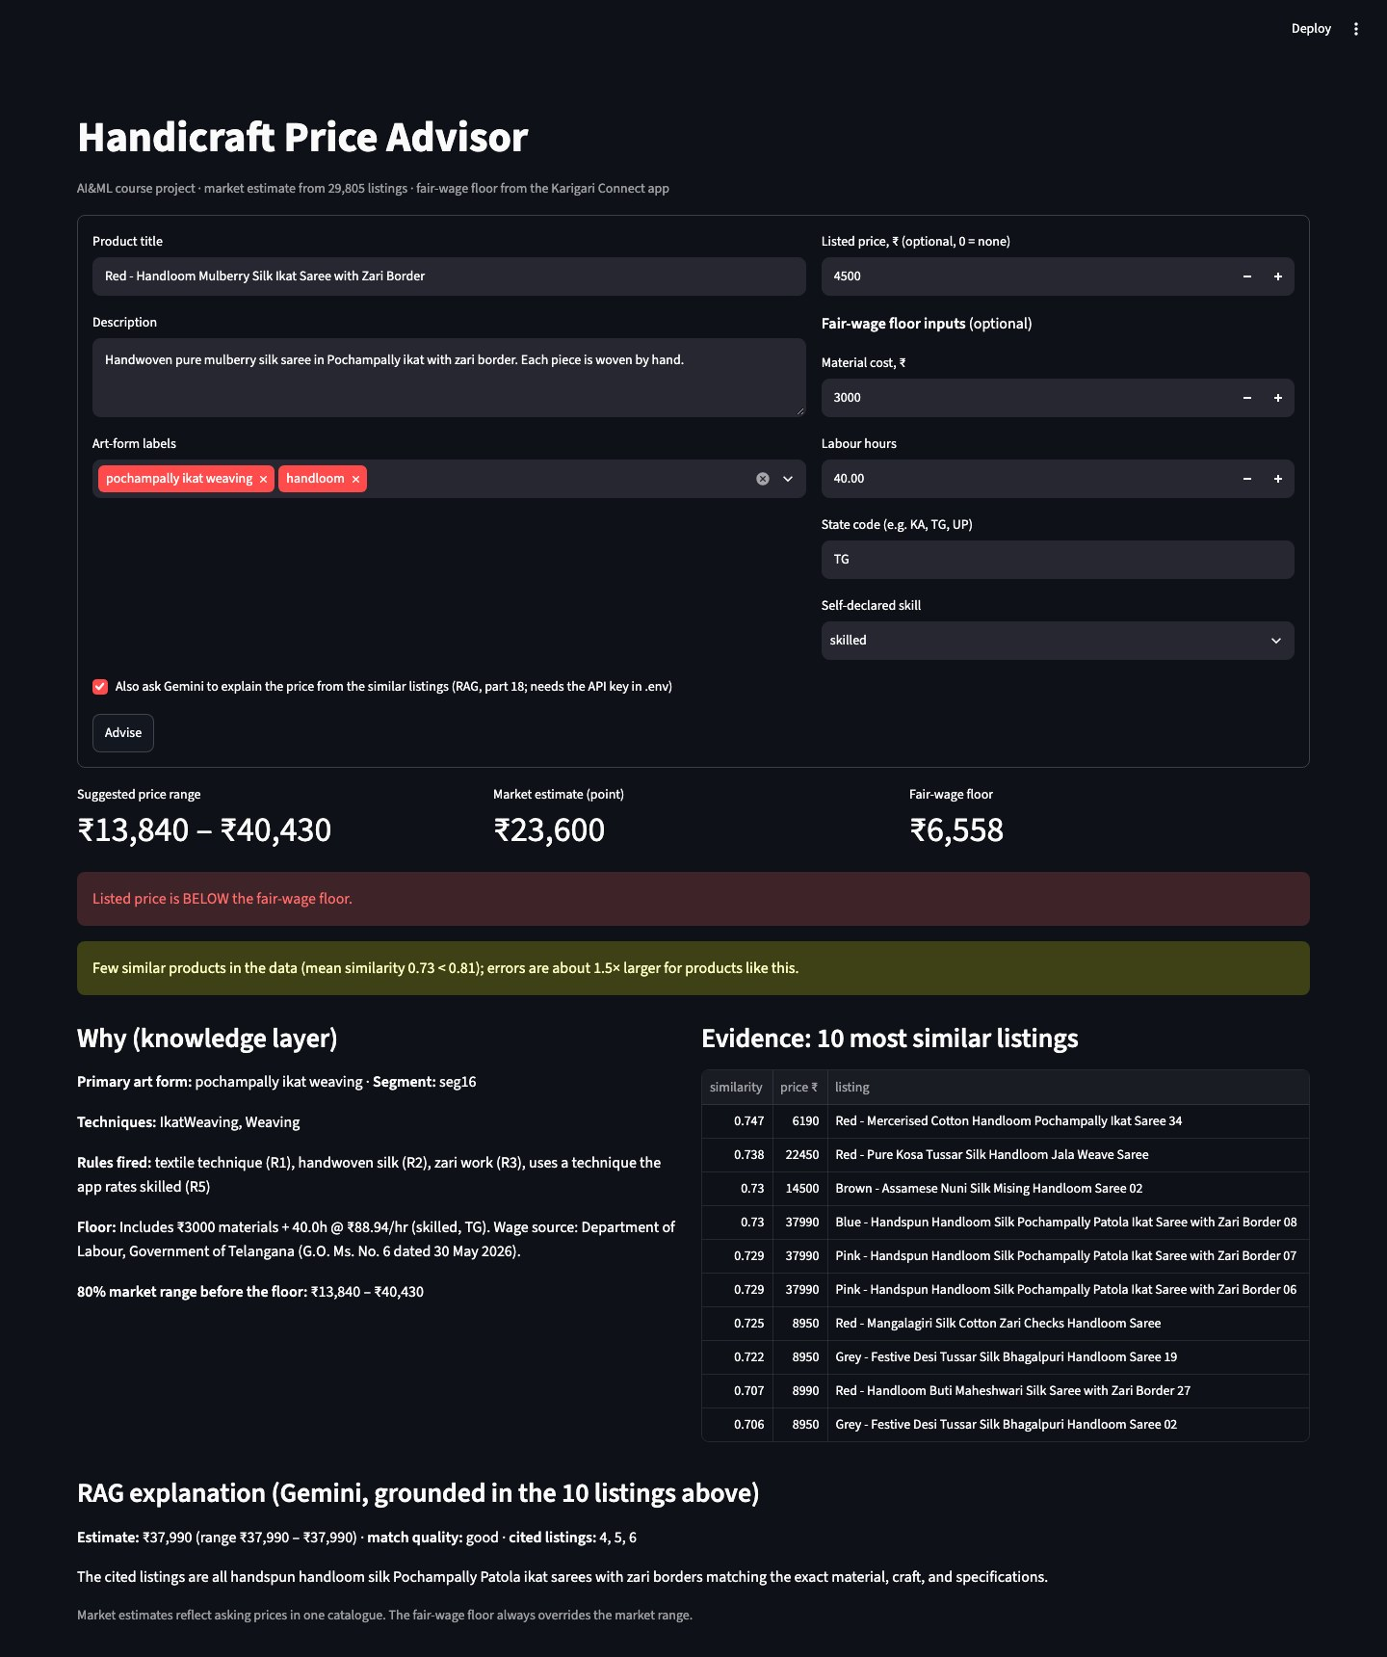

12. Syllabus coverage
Checked against the official syllabus text. ✅ covered with evidence · ◐ touched, not developed · ❌ not covered (reason given).
Unit | Syllabus topic |  | Where / evidence
I | What is AI; intelligent agents, environments, rationality, agent structure | ✅ | Part 16: PEAS table; knowledge-based + learned agent
I | Problem solving by search (uninformed, informed, heuristics) | ❌ | Pricing has no state space or goal to search. Hyperparameter grid search is exhaustive search over settings, but isn't claimed as this topic
I | Logical agents, knowledge-based agents | ✅ | The advisor's knowledge layer (KG rules, wage-floor tables) decides cautions and the floor
I | Wumpus world; propositional logic reasoning patterns | ❌ | Not applicable to the task
I | First-order logic, knowledge engineering in FOL | ◐ | SWRL rules are first-order Horn clauses over variables (?p ?a ?t); building the ontology is knowledge engineering (Parts 3–4)
II | Knowledge graphs, ontologies, RDF triples, entities and relationships | ✅ | Part 3: 68 classes, 201 art forms, 3,964 triples (craft_kg.owl)
II | Ontology reasoning, rule-based inference, semantic relationships | ✅ | Part 4: HermiT + 5 SWRL rules; class axiom inheritance; 0 disagreements with pandas
II | Applications in question answering and intelligent agents | ✅ | 4 SPARQL questions; KG rules inside the advisor agent
II | Inference in FOL: unification and lifting, forward chaining | ✅ / ◐ | Forward chaining: axiom → inherited skill → R5 fires. Unification happens inside the reasoner when rule variables bind to individuals (not implemented by hand)
II | Backward chaining, resolution | ❌ | Not used: the reasoner materialises all facts forward
II | Uncertainty, conditional probability, Bayes' theorem, Naive Bayes | ✅ | Part 10: Multinomial NB (F1 0.703) and why its independence assumption over-counts correlated words; Part 9 prediction intervals as quantified uncertainty
II | Bayesian networks | ❌ | Not built
II | Intro to ML: terminology, key tasks, well-posed learning problems, types of ML | ✅ | §1 (T, P, E); supervised (Parts 8–10), unsupervised (5–7), knowledge-based (3–4)
III | Classification: Logistic Regression, SVM, Naive Bayes, KNN | ✅ | Part 10: all four, plus trees and ensembles
III | Regression: Linear, Polynomial | ✅ | Part 8: Linear 0.347 vs Polynomial 0.577 on the same inputs; Ridge (regularised) 0.748
III | Decision Trees, Random Forest, Gradient Boosting | ✅ | Parts 8 and 10: tree 0.413 → RF 0.608 → GB 0.675 (regression)
III | Cross-validation, hyperparameter tuning | ✅ | GroupKFold everywhere; Parts 8, 8b (grid-edge check), 10, 13
III | Accuracy, precision, recall, F1, ROC-AUC, confusion matrix, R² | ✅ | Part 10 table and confusion matrices; R² / MAE / MAPE in every stage
IV | Unsupervised learning: need, characteristics, vs supervised | ✅ | Part 5 groups products from text alone, with no target; Part 6 mines rules with no chosen target (price band is just one more item in the basket); contrast with Parts 8–10
IV | Euclidean, Manhattan, cosine; intra- and inter-cluster distance | ✅ | Part 5: metric agreement table; intra 0.690 vs inter-centroid 0.885
IV | K-Means, Hierarchical, DBSCAN | ✅ | Part 5: all three compared (silhouette, noise share)
IV | Principal Component Analysis | ✅ | Part 5 map; Part 13 PCA on CNN embeddings (fitted on train)
IV | Apriori; support, confidence, lift | ✅ | Part 6: 1,083 rules
IV | Anomaly detection: concepts, need, approaches | ✅ | Step 2.9 (IQR, z-score, Isolation Forest) and Part 7 (model-residual detector)
V | Neural networks, CNNs for computer vision | ✅ | Part 13: SqueezeNet embeddings of 37,282 photos (transfer learning), +0.016 test R²
V | Transformers; attention; transformer architecture | ✅ | Part 17: MiniLM (6 self-attention layers) encodes all texts, with the mechanism explained; Gemini (transformer LLM) in Parts 12, 18
V | Word embeddings | ✅ | Part 17: learned embeddings vs TF-IDF on word pairs (saree ≈ sari 0.73 vs 0); count-based LSA vectors in Parts 5, 11 for contrast
V | Large language models, prompt engineering | ✅ | Part 12: zero-shot vs engineered few-shot, F1 0.888 → 0.979 on a gold set
V | Retrieval-augmented generation | ✅ | Part 18: FAISS retrieval + grounded Gemini generation; R² 0.34 → 0.73 with retrieval; citation and grounding checks; optional in the advisor
V | Vector databases (FAISS / Chroma) | ✅ | Part 11: FAISS IndexFlatIP over 29,805 listings
V | Reinforcement learning (MDP, Q-learning, exploration) | ❌ | No sequential decisions or rewards in a one-shot pricing task
V | Explainable AI | ✅ | Part 14: SHAP (exact linear check + tree explainer)
V | Ethics, bias, responsible AI | ✅ | Part 15: family-level bias audit; fair-wage floor overrides the model
— | Supporting work (not a named syllabus topic) | — | Part 2 statistics (Kruskal-Wallis, χ², correlation); leakage-aware splitting
Remaining gap that could be closed cheaply, if needed: a small hand-built Bayesian network (e.g. technique → material → price band) with probabilities from the training data.

13. Problems found and corrected
Recorded because each one changed a conclusion:
Problem | How it was found | Fix
Split leakage (twice) | Test scores too good; nearest-neighbour checks | v3 family-grouped split; old scores discarded
Zero-width-space merge silently failed | A later re-check of the raw label text | Literal \u200b replaced; stages re-scored
Keyword materials catch tools and alloys | Apriori rules (bamboo, wood, silver) | LLM extraction with an engineered prompt (Part 12)
Skill not inherited by technique subtypes | Reasoner count 98 vs expected 103 | Class axiom instead of a single fact
Linear Regression collapse | R² −7.5 × 10⁸ after scaling | Explained (duplicate KG columns, no penalty); Ridge used
Raw quantile ranges overconfident | 58% coverage instead of 80% | Conformal calibration
Progress chart unreadable since S9 | Linear's collapse flattened every line; Ridge missing | Chart redrawn with Ridge, RF, baseline and F1
Bias audit dominated by one product line | All "undervalued" crafts had a median test price of exactly ₹1,590 | Audit per product family; advisor caution needs ≥ 5 families
PyTorch + FAISS crash (exit 139) | Part 17 died after encoding | The two OpenMP runtimes clash on macOS; encode and evaluate run as separate processes
Tuning optimum at the grid edge (twice) | Best value = largest value tried | Grid widened (TF-IDF 50k, PCA 256); optimum confirmed inside

14. Limitations
- Asking prices from one retailer. The model learns this store's pricing, not the market's or a fair price.
- No costs or labour hours in the data, so the fair-wage floor can only be applied when the user supplies them.
- Labels and gold set by Claude, not a domain expert. The 80-product LLM gold set and the technique map were labelled against written rules.
- The advisor uses the part 8 Ridge (R² 0.748), not S12-img. Using S12-img live would need a Gemini call and a SqueezeNet run per query. The bias audit was run on both models.
- Few families per craft. Family-level bias results rest on 5–25 families per art form, so they are indications, not proofs.
- A typical error is still about one third of the price (MAPE 34%). Good enough for a suggested range with evidence, not for an automatic price.

15. Demo walkthrough
cd ml_price
.venv/bin/streamlit run app/streamlit_app.py
- Paste a product title and description, and pick its art-form labels.
- Optionally add the listed price, material cost, labour hours, state and skill.
- Read the result:
  - the rules that fired
  - the market estimate and 80% range
  - the fair-wage floor and verdict
  - cautions
  - the 10 similar listings as evidence
To reproduce any stage score: PYTHONPATH=scripts .venv/bin/python scripts/evaluate_stage.py S12-img (stage names in EXPERIMENTS).

16. File index
What | Where
Start here | README, TODO
Scoreboard | EXPERIMENTS, reports/models/experiments.csv
Chronological log | PROJECT_LOG
Part reports | reports/cleaning/, reports/eda/, reports/knowledge_graph/, reports/unsupervised/, reports/llm/, reports/models/
Tool exports | tool_exports/openrefine/, tool_exports/orange/, tool_exports/protege/
Viva preparation | VIVA_CHEATSHEET
Python environment | requirements.txt (pinned versions)

