28) We define an employee's *total earnings* to be their monthly  worked, and the *maximum total earnings* to be the maximum total earnings for any employee in the **Employee** table. Write a query to find the *maximum total earnings* for all employees as well as the total number of employees who have maximum total earnings. Then print these values as  space-separated integers.

**Input Format**

The **Employee** table containing employee data for a company is described as follows:

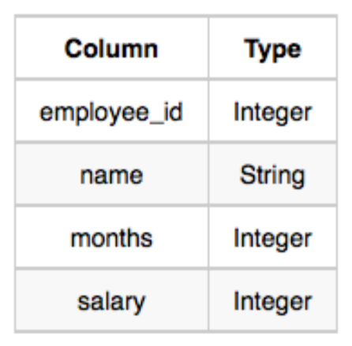Solution:

SELECT salary * months, count(*) from Employee

group by salary * months

order by salary * months DESC Limit 1;

29) Query the following two values from the **STATION** table:

1. The sum of all values in *LAT_N* rounded to a scale of  decimal places.
2. The sum of all values in *LONG_W* rounded to a scale of  decimal places.

**Input Format**

The **STATION** table is described as follows:

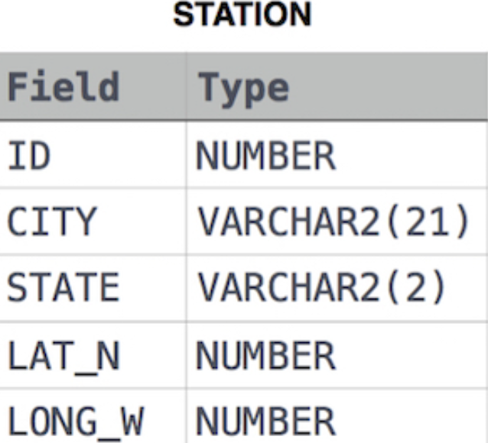

Solution:

SELECT ROUND(SUM(LAT_N),2), ROUND(SUM(LONG_W),2) from STATION;

30) Query the sum of *Northern Latitudes* (*LAT_N*) from **STATION** having values greater than  and less than . Truncate your answer to  decimal places.

**Input Format** The **STATION** table is described as follows:



Solution:

SELECT ROUND(SUM(LAT_N),4) FROM STATION WHERE LAT_N > 38.7880 AND LAT_N < 137.2345;

31) Query the greatest value of the *Northern Latitudes* (*LAT_N*) from **STATION** that is less than . Truncate your answer to  decimal places.

**Input Format**

The **STATION** table is described as follows:



Solution:

SELECT ROUND(MAX(LAT_N),4) FROM STATION WHERE LAT_N < 137.2345

32) Query the *Western Longitude* (*LONG_W*) for the largest *Northern Latitude* (*LAT_N*) in **STATION** that is less than . Round your answer to  decimal places.

**Input Format**

The **STATION** table is described as follows:



Solution:

SELECT ROUND(LONG_W,4) FROM STATION WHERE LAT_N < 137.2345 ORDER BY LAT_N DESC LIMIT 1

33) Query the smallest *Northern Latitude* (*LAT_N*) from **STATION** that is greater than . Round your answer to  decimal places.

**Input Format**

The **STATION** table is described as follows:



Solution:

SELECT ROUND(MIN(LAT_N),4) FROM STATION WHERE LAT_N > 38.7780

34) Query the *Western Longitude* (*LONG_W*)where the smallest *Northern Latitude* (*LAT_N*) in **STATION** is greater than . Round your answer to  decimal places.

**Input Format**

The **STATION** table is described as follows:



Solution:

SELECT ROUND(LONG_W,4) FROM STATION WHERE LAT_N > 38.7780 ORDER BY LAT_N LIMIT 1

35) Given the **CITY** and **COUNTRY** tables, query the sum of the populations of all cities where the *CONTINENT* is *'Asia'*.

**Note:** *CITY.CountryCode* and *COUNTRY.Code* are matching key columns.

**Input Format**

The **CITY** and **COUNTRY** tables are described as follows:

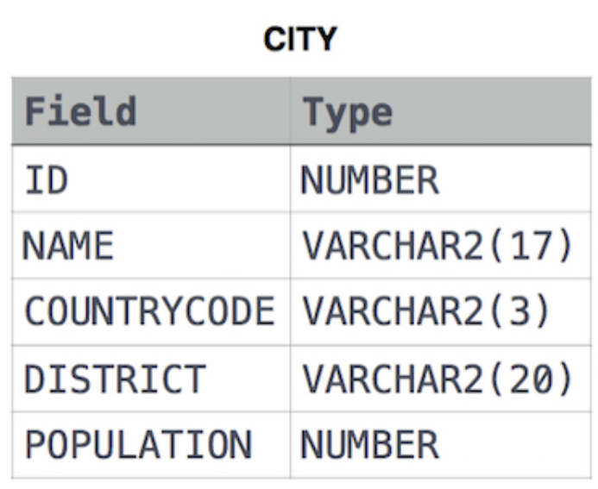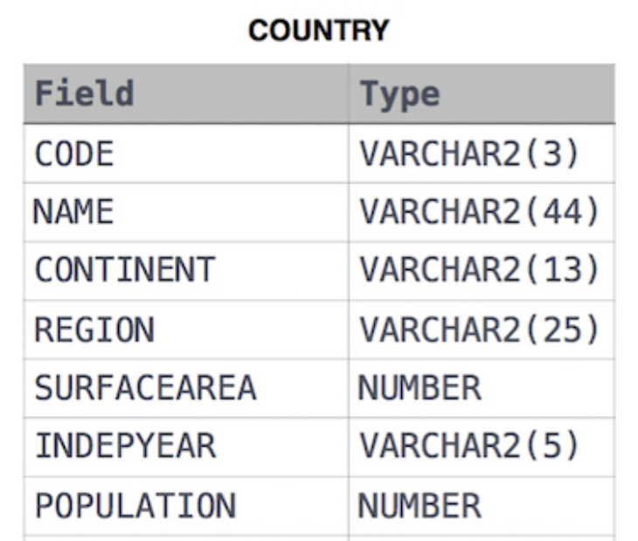

Solution:

SELECT SUM(CITY.Population)

FROM CITY

INNER JOIN COUNTRY ON CITY.CountryCode = COUNTRY.Code

WHERE COUNTRY.Continent = 'Asia';

36) Given the **CITY** and **COUNTRY** tables, query the names of all cities where the *CONTINENT* is *'Africa'*.

**Note:** *CITY.CountryCode* and *COUNTRY.Code* are matching key columns.

**Input Format**

The **CITY** and **COUNTRY** tables are described as follows:



Solution:

Select CITY.Name From CITY

Inner Join COUNTRY

On CITY.Countrycode = COUNTRY.Code

Where COUNTRY.Continent = 'Africa';

37) Given the **CITY** and **COUNTRY** tables, query the names of all the continents (*COUNTRY.Continent*) and their respective average city populations (*CITY.Population*) rounded *down* to the nearest integer.

**Note:** *CITY.CountryCode* and *COUNTRY.Code* are matching key columns.

**Input Format**

The **CITY** and **COUNTRY** tables are described as follows:



Solution:

SELECT COUNTRY.Continent,

FLOOR(AVG(CITY.Population))

FROM COUNTRY

JOIN CITY ON COUNTRY.Code = CITY.CountryCode

GROUP BY COUNTRY.Continent;