CineVerse
An IMDb/Netflix-Inspired Explainable Movie Database System
Comprehensive Project Requirements, Design, Dataset, and Interface Blueprint
ISE 503: Data Management — Spring 2026
Prepared May 2, 2026
Project Positioning
This design satisfies the course requirement to resemble IMDb or Netflix by implementing the expected movie catalog, cast/crew, genres, ratings, reviews, search, recommendations, and watchlist features. It becomes unique by adding explainable recommendations, mood-based discovery, group-watch planning, streaming availability, awards, and movie-industry analytics.
Recommended project title: CineVerse: An Explainable Movie Recommendation and Industry Analytics Database

Table of Contents
1. Executive Summary
2. Course Requirement Interpretation
3. Why This Satisfies the IMDb/Netflix Requirement
4. Unique Implementation Direction
5. Functional and Non-Functional Requirements
6. Dataset Strategy and Merge Plan
7. Proposed Relational Schema
8. Constraints and Data Modeling Quality
9. ETL and Data Preparation Workflow
10. Complex SQL Query Plan
11. Optional Interface Design
12. Implementation Roadmap
13. Risk Management and Scope Control
14. Final Grading Alignment Checklist
15. References

1. Executive Summary
The Movie Database System project can be implemented as more than a basic IMDb-style catalog. The proposed system, CineVerse, is an IMDb/Netflix-inspired relational database application that manages movies, cast and crew, genres, user ratings, reviews, watchlists, streaming availability, awards, and personalized recommendations. The database remains grounded in classical relational modeling while adding modern discovery features that make the project stand out from typical student implementations.
The main differentiator is explainability. Instead of returning recommendations as a black box, the system stores the reason behind recommendations: shared genres, matching mood tags, actor/director overlap, platform availability, rating patterns, and user preference history. This makes the database useful for both end users and administrators.
Core Idea
Build the required IMDb/Netflix-style movie platform first, then layer unique analytical and recommendation features on top. This protects grading alignment while still making the implementation original.

Recommended Scope
- Core database: 500–1,000 movies, 1,000–5,000 people, and enough related rows to support realistic joins.
- Required tables: Movie, Person, MovieCredit, Genre, Rating, Review, User, Watchlist, Distributor/Availability.
- Unique tables: MovieTagRelevance, UserPreferenceTag, RecommendationLog, WatchParty, MovieAward, ExternalRating.
- Interface: A focused UI with search, movie details, recommendations, watchlist, and admin transactions.
- Queries: 10 complex SQL queries covering joins, aggregations, nested logic, ranking, and analytics.

2. Course Requirement Interpretation
The course project asks students to design and implement a relational database system that models real-world data and supports common transaction operations. For the Movie Database System topic, the database should manage data related to movies and resemble systems such as IMDb or Netflix. The suggested entities include movies, actors, directors, producers, and distributors, but the schema can be extended creatively as long as it remains grounded in sound data modeling and SQL implementation.
Requirement | Meaning | CineVerse response
Relational schema | Define entities, attributes, primary keys, foreign keys, domain constraints, and relationships. | Use normalized tables for movie metadata, people, credits, genres, users, ratings, reviews, platforms, awards, and recommendations.
SQL implementation | Create and populate the database using SQL scripts. | Submit create_tables.sql, insert_data.sql/load_data.sql, and query_examples.sql.
Complex queries | Include 10 complex queries involving joins. | Use multi-table joins for collaboration analysis, recommendation ranking, streaming availability, and critic-audience gaps.
Sample data | At least 30 records per table on average. | Use a controlled subset from IMDb, MovieLens, TMDb, and optional enrichment datasets.
Optional interface | A basic interface or demo can simulate transactions. | Build a Streamlit, Flask, FastAPI, JavaScript, or JDBC-backed demo.
Originality | All work must be original. | Use public datasets, but design your own schema, ETL, queries, UI, and explanations.

3. Why This Satisfies the IMDb/Netflix Requirement
The phrase 'resemble platforms like IMDb or Netflix' should be interpreted as a functional resemblance, not a requirement to copy either platform exactly. The system should provide the recognizable database features of a movie platform: movie catalog, people pages, cast/crew relationships, genres, ratings, reviews, search, and recommendations. CineVerse covers these directly and then extends them.
Reference feature | How CineVerse implements it
IMDb movie pages | Movie table with title, release date, runtime, language, country, plot, ratings, cast, crew, awards, and external IDs.
IMDb cast/crew listings | Person, RoleType, and MovieCredit tables represent actors, directors, producers, writers, and characters.
IMDb ratings/reviews | UserRating, Review, and ExternalRating tables support user scores, written reviews, and outside rating sources.
Netflix search/discovery | Genre, tag, rating, and platform filters allow users to discover titles through multiple criteria.
Netflix recommendations | MovieTagRelevance, UserPreferenceTag, and RecommendationLog support personalized recommendations.
Netflix watchlist | Watchlist and WatchlistItem allow users to save, track, and mark movies as watched.
Streaming availability | StreamingPlatform and MovieAvailability show where a title can be watched by region and access type.
Best wording for your report
CineVerse is an IMDb/Netflix-inspired Movie Database System. It supports movie metadata, cast and crew relationships, genres, ratings, reviews, search, watchlists, and recommendations. Its unique extensions are explainable recommendations, mood-based discovery, group-watch planning, and industry analytics.

4. Unique Implementation Direction
Many students will likely implement a straightforward schema with Movie, Actor, Director, Producer, Distributor, Genre, and Rating. To make the project stand out, CineVerse should be positioned as a movie discovery and analytics system rather than a plain catalog.
Unique feature | Database-driven implementation idea
Explainable recommendations | Store why a movie was recommended: matching tags, shared actors, preferred genres, high rating, platform availability, or user similarity.
Mood-based discovery | Allow filters such as mind-bending, dark, funny, romantic, suspenseful, feel-good, slow-burn, family-friendly, and visually stunning.
Group-watch planning | Combine preferences from multiple users and recommend movies no one in the group has already watched.
Collaboration network | Analyze frequent actor-director pairs, recurring casts, and cross-genre performers.
Critic vs audience gap | Identify movies with strong audience scores but weak critic scores, or the reverse.
Streaming-aware discovery | Recommend only movies available on selected platforms or in a chosen region.
Industry analytics | Compare budget, revenue, awards, ratings, genres, and production companies.

Feature Layers
Layer | Contents
Layer 1: Required IMDb/Netflix Foundation | Movies, people, cast/crew, genres, ratings, reviews, search, watchlist, distributor/platform availability.
Layer 2: Differentiation | Mood tags, explainable recommendations, group-watch logic, collaboration analytics, critic-audience comparison, awards/prestige analytics.
Layer 3: Interface Polish | Poster-based UI, movie detail pages, dashboard cards, recommendation explanation panel, admin form, and filterable query outputs.

5. Functional and Non-Functional Requirements

Functional Requirements
ID | Requirement | Description
FR1 | Movie catalog management | Store and search movie title, release date, runtime, genre, language, country, plot, budget, revenue, and external IDs.
FR2 | Cast and crew management | Store people and link them to movies by role type, character, and billing order.
FR3 | Ratings and reviews | Allow users to rate and review movies; support external rating sources.
FR4 | Watchlist management | Allow users to add, remove, and mark movies as watched.
FR5 | Recommendation generation | Generate recommendations based on tags, genres, ratings, availability, and user preferences.
FR6 | Search and filtering | Search by title, actor, director, genre, release year, rating, mood tag, and streaming platform.
FR7 | Streaming availability | Track which platforms carry a movie, by region and access type.
FR8 | Analytics | Support dashboard queries about popularity, profitability, collaborations, and rating gaps.
FR9 | Admin operations | Allow adding/updating movies, people, credits, genres, tags, and availability records.
FR10 | Group-watch planning | Recommend titles for a party based on combined preferences and watched history.

Non-Functional Requirements
Requirement type | Design implication
Data integrity | Primary keys, foreign keys, uniqueness constraints, NOT NULL constraints, and CHECK constraints should prevent invalid records.
Usability | The optional interface should make it easy to search, inspect movie details, add watchlist entries, and view recommendation explanations.
Performance | Indexes should support common filters on title, release year, genre, person, rating, platform, and tag relevance.
Maintainability | Separate SQL scripts, ETL scripts, and application files clearly.
Reproducibility | Dataset cleaning steps should be documented so the database can be rebuilt.
Originality | The schema, UI, and query set should be independently designed even if public datasets are used.

System Architecture Overview
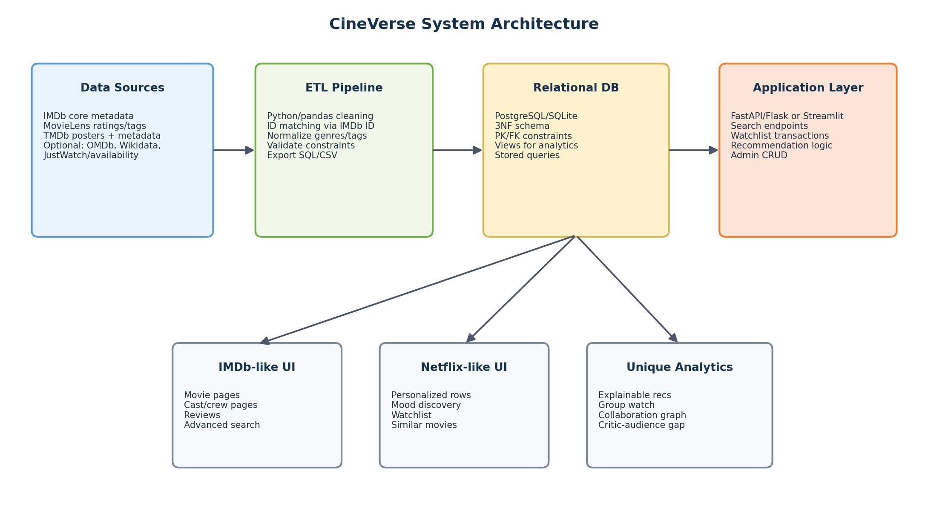
Figure 1. High-level architecture from datasets to ETL, relational database, application layer, and user-facing features.

6. Dataset Strategy and Merge Plan
The strongest approach is to combine a few complementary datasets rather than relying on one source. IMDb should anchor the system because its title and person identifiers are widely used. MovieLens adds user ratings and recommendation value. TMDb adds posters and richer visual metadata for the optional interface. Tag Genome adds the mood/theme layer that makes the project unique.
Dataset/source | Use | Likely key | Recommendation
IMDb Non-Commercial Datasets | Core movies, names, cast/crew, ratings | tconst, nconst | Primary source for movie/person identity and credits.
MovieLens Latest Small | User ratings, tags, movie links | movieId, imdbId, tmdbId | Useful for ratings/recommendation features without huge data volume.
MovieLens Tag Genome 2021 | Mood/theme tags and relevance scores | movieId, tagId | Best source for explainable mood-based recommendations.
TMDb API | Posters, overview, popularity, budget, revenue, companies | tmdb_id, imdb_id | Makes UI visually polished and enriches metadata.
Kaggle The Movies Dataset | Pre-merged movie metadata and ratings | tmdbId/title/year | Optional shortcut if direct API integration is too time-consuming.
OMDb API | IMDb lookup, simple movie fields, external ratings | imdbID | Optional fallback for external rating/plot data.
Wikidata | Awards, countries, notable facts | IMDb ID, Wikidata ID | Optional enrichment for awards/prestige analytics.
JustWatch availability data | Streaming availability by platform/country | IMDb/TMDb/title matching | Optional if you want a JustWatch-like availability layer.

Recommended Merge Strategy
- Central movie key: Use IMDb title ID (tconst) as the master external identifier whenever possible.
- Central person key: Use IMDb name ID (nconst) for actors, directors, producers, and writers.
- MovieLens bridge: Use MovieLens links.csv to connect MovieLens movieId with IMDb ID and TMDb ID.
- TMDb enrichment: Use TMDb ID or IMDb ID to add poster path, overview, popularity, budget, revenue, production companies, and images.
- Tag/mood layer: Use MovieLens Tag Genome relevance scores to populate MovieTagRelevance.
- Controlled subset: Filter to a manageable set such as movies from 1990–2025 or the top 500–1,000 movies by rating/votes.

Suggested Data Volume
Area | Recommended count | Reason
Movie | 500–1,000 | Large enough for meaningful search and recommendation, small enough to clean.
Person | 1,000–5,000 | Actors, directors, producers, and writers connected to selected movies.
MovieCredit | 5,000–20,000 | Core many-to-many relationship table.
Genre / MovieGenre | 20 genres / 1,000–3,000 links | Supports filters and joins.
UserProfile | 50–600 | Can use MovieLens user IDs or generate demo users.
UserRating | 5,000–100,000 | Use MovieLens subset for realistic recommendation data.
Tag / MovieTagRelevance | 100–1,000 tags / 10,000+ relevance rows | Enables explainable recommendations.
StreamingPlatform / Availability | 10–30 platforms / 500+ rows | Can be real, synthetic, or partially enriched.
Awards | 20–100 awards / 100+ rows | Optional but useful for unique analytics.

7. Proposed Relational Schema
The schema is designed to be normalized, flexible, and query-rich. The core relationship is Movie to Person through MovieCredit, which allows the same person to be an actor, director, producer, writer, or multiple roles. Genres, tags, ratings, reviews, availability, awards, and watchlists are modeled as separate tables to avoid repeating values and to support complex joins.
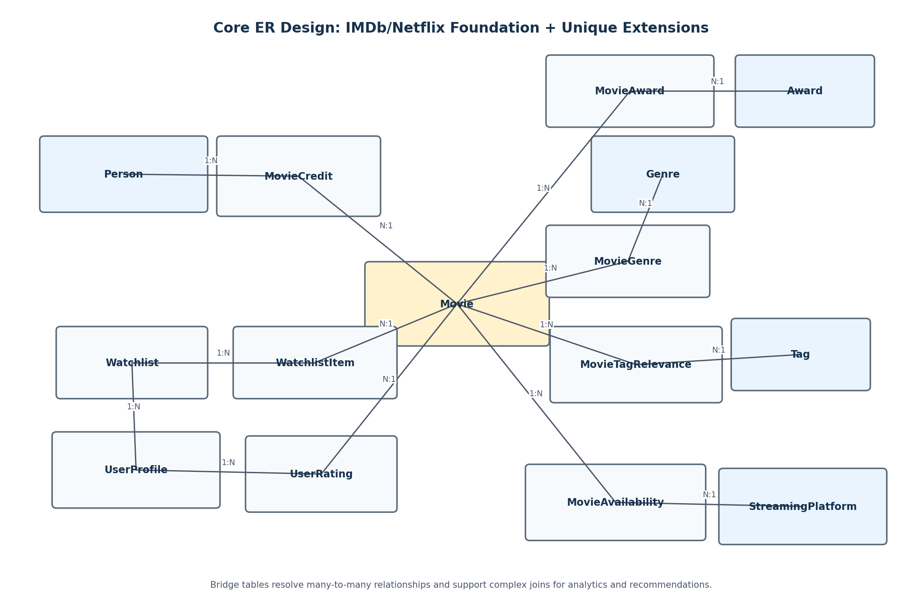
Figure 2. Simplified ER diagram showing the foundation and unique extensions.

Core Tables
Table | Key attributes | Purpose
Movie | movie_id PK; imdb_id; tmdb_id; title; release_date; runtime_minutes; language; country; plot; budget; revenue | Stores the primary movie catalog.
Person | person_id PK; imdb_person_id; name; birth_year; death_year; primary_profession | Represents actors, directors, producers, writers, and other people.
RoleType | role_type_id PK; role_name | Normalizes roles such as actor, director, producer, writer.
MovieCredit | movie_id FK; person_id FK; role_type_id FK; character_name; billing_order | Bridge table for cast and crew relationships.
Genre | genre_id PK; genre_name | Stores normalized genres.
MovieGenre | movie_id FK; genre_id FK | Bridge table between movies and genres.

User, Rating, and Review Tables
Table | Key attributes | Purpose
UserProfile | user_id PK; username; age_group; preferred_language; created_at | Stores application users or MovieLens-style demo users.
UserRating | user_id FK; movie_id FK; rating; rating_date | Stores one rating per user/movie pair.
Review | review_id PK; user_id FK; movie_id FK; review_text; sentiment; review_date | Stores written reviews and optional sentiment category.
ExternalRating | movie_id FK; source_name; score; vote_count | Stores IMDb, Rotten Tomatoes, Metacritic, OMDb, or other source scores.

Recommendation and Mood Tables
Table | Key attributes | Purpose
Tag | tag_id PK; tag_name | Stores mood/theme tags such as dark, funny, tense, romantic, cerebral.
MovieTagRelevance | movie_id FK; tag_id FK; relevance_score | Stores how strongly a tag applies to a movie.
UserPreferenceTag | user_id FK; tag_id FK; preference_weight | Stores explicit or derived user preferences.
RecommendationLog | recommendation_id PK; user_id FK; movie_id FK; score; explanation; generated_at | Stores explainable recommendations.

Availability, Awards, and Watchlist Tables
Table | Key attributes | Purpose
StreamingPlatform | platform_id PK; name; country | Represents Netflix, Hulu, Prime Video, Disney+, Max, etc.
MovieAvailability | movie_id FK; platform_id FK; region; access_type; start_date; end_date | Tracks where a title is available.
ProductionCompany | company_id PK; name; country | Stores studios and production companies.
MovieProductionCompany | movie_id FK; company_id FK | Bridge between movies and production companies.
Distributor | distributor_id PK; name; address | Satisfies the suggested distributor entity and supports release/availability logic.
Award | award_id PK; award_name; category | Stores award names and categories.
MovieAward | movie_id FK; award_id FK; award_year; result | Links awards to movies.
Watchlist | watchlist_id PK; user_id FK; name | Allows users to create watchlists.
WatchlistItem | watchlist_id FK; movie_id FK; added_at; watched_status | Stores saved and watched movies.
WatchParty | party_id PK; host_user_id FK; planned_date | Represents a group-watch event.
WatchPartyMember | party_id FK; user_id FK | Stores group members.
WatchPartySuggestion | party_id FK; movie_id FK; group_score | Stores group recommendation results.

8. Constraints and Data Modeling Quality
A strong project should demonstrate relational discipline. The schema should not only create tables, but also enforce realistic constraints. This will show that the database is designed for data integrity rather than simply storing CSV files.

Recommended Constraints
Constraint type | Recommended use
Primary keys | Every entity table should have a surrogate or natural primary key, such as movie_id, person_id, user_id, genre_id, and platform_id.
Foreign keys | All bridge tables must reference their parent tables, such as MovieCredit(movie_id) referencing Movie(movie_id).
Composite keys | Use composite primary keys for pure bridge tables, such as MovieGenre(movie_id, genre_id) and WatchlistItem(watchlist_id, movie_id).
Uniqueness | imdb_id and imdb_person_id should be unique; UserRating should be unique on user_id + movie_id.
Domain checks | Ratings must be within allowed ranges; runtime, budget, and revenue must be non-negative or positive as appropriate.
Referential actions | Use ON DELETE CASCADE carefully for child records like watchlist items, but avoid deleting core movie/person records accidentally.

Example SQL Constraint Snippets
CREATE TABLE Movie (
movie_id SERIAL PRIMARY KEY,
imdb_id VARCHAR(20) UNIQUE NOT NULL,
tmdb_id INTEGER UNIQUE,
title VARCHAR(255) NOT NULL,
release_date DATE,
runtime_minutes INTEGER CHECK (runtime_minutes > 0),
budget NUMERIC(14,2) CHECK (budget >= 0),
revenue NUMERIC(14,2) CHECK (revenue >= 0)
);
CREATE TABLE UserRating (
user_id INTEGER REFERENCES UserProfile(user_id),
movie_id INTEGER REFERENCES Movie(movie_id),
rating NUMERIC(3,1) NOT NULL CHECK (rating BETWEEN 0 AND 10),
rating_date DATE DEFAULT CURRENT_DATE,
PRIMARY KEY (user_id, movie_id)
);
CREATE TABLE MovieAvailability (
movie_id INTEGER REFERENCES Movie(movie_id),
platform_id INTEGER REFERENCES StreamingPlatform(platform_id),
region VARCHAR(50) NOT NULL,
access_type VARCHAR(20) NOT NULL CHECK (access_type IN ('subscription', 'rent', 'buy', 'free', 'theater')),
start_date DATE,
end_date DATE,
PRIMARY KEY (movie_id, platform_id, region, access_type)
);

9. ETL and Data Preparation Workflow
The ETL process should be simple, repeatable, and documented. Because the original datasets can be large, the project should import a curated subset that is rich enough for queries but small enough to debug.
- Step 1 — Filter movies: Keep movies only, exclude TV series/episodes, and select a target range such as 1990–2025 or top-rated titles with enough votes.
- Step 2 — Normalize IDs: Create internal movie_id/person_id values while preserving imdb_id, tmdb_id, and MovieLens movieId as external reference columns.
- Step 3 — Load people and credits: Join IMDb principals/crew/name data to populate Person, RoleType, and MovieCredit.
- Step 4 — Load genres: Split genre lists into normalized Genre and MovieGenre rows.
- Step 5 — Load ratings: Map MovieLens movieId to IMDb ID and import a subset of ratings into UserProfile and UserRating.
- Step 6 — Load tags: Import high-relevance Tag Genome values to MovieTagRelevance, such as relevance_score >= 0.50 or top N tags per movie.
- Step 7 — Enrich metadata: Use TMDb or OMDb to add posters, overviews, popularity, budget, revenue, and optional external ratings.
- Step 8 — Validate: Run constraint checks, missing-key checks, duplicate checks, row counts, and sample join queries.

ETL Quality Checks
- No movie rows with duplicate IMDb IDs.
- No MovieCredit row referencing a missing movie or person.
- No rating outside the selected scale.
- No empty required titles or person names.
- At least 30 records per table on average across the submitted schema.
- All 10 complex queries return meaningful rows after population.

10. Complex SQL Query Plan
The project requires 10 complex queries involving joins. The following query set is designed to look more advanced than a basic movie database because it combines catalog, user, availability, recommendation, and analytics features.
ID | Query | Main joins | Business purpose
Q1 | Top-rated movies by genre | Movie + MovieGenre + Genre + UserRating | Find top movies per genre with minimum rating count.
Q2 | Most frequent actor-director collaborations | MovieCredit self-join + Person + Movie | Identify recurring creative partnerships.
Q3 | Audience-loved, critic-disliked movies | Movie + UserRating + ExternalRating | Find high user score but low external/critic score.
Q4 | Mood-based recommendation | UserPreferenceTag + MovieTagRelevance + Movie | Recommend movies matching a user's preferred tags.
Q5 | Hidden gems | Movie + UserRating + ExternalRating/TMDb popularity | High rating, lower popularity, enough votes.
Q6 | Actors with the widest genre range | Person + MovieCredit + MovieGenre + Genre | Rank actors by distinct genres.
Q7 | Most profitable directors | Movie + MovieCredit + Person | Calculate revenue, budget, and ROI by director.
Q8 | Streaming availability search | Movie + MovieAvailability + StreamingPlatform + Genre | Find available movies by region, platform, genre, and access type.
Q9 | Award-winning movies on streaming | Movie + MovieAward + Award + MovieAvailability + Platform | Find prestige titles users can watch now.
Q10 | Group-watch recommendation | WatchParty + Members + UserRating + Tags + Movie | Rank movies for a group while excluding already watched titles.

Example Complex Query: Explainable Mood-Based Recommendation
SELECT
m.movie_id,
m.title,
ROUND(SUM(upt.preference_weight * mtr.relevance_score), 3) AS recommendation_score,
STRING_AGG(t.tag_name, ', ' ORDER BY mtr.relevance_score DESC) AS explanation_tags
FROM UserPreferenceTag upt
JOIN Tag t
ON t.tag_id = upt.tag_id
JOIN MovieTagRelevance mtr
ON mtr.tag_id = upt.tag_id
JOIN Movie m
ON m.movie_id = mtr.movie_id
LEFT JOIN WatchlistItem wi
ON wi.movie_id = m.movie_id
LEFT JOIN Watchlist w
ON w.watchlist_id = wi.watchlist_id
AND w.user_id = upt.user_id
WHERE upt.user_id = 101
AND mtr.relevance_score >= 0.50
AND (wi.watched_status IS NULL OR wi.watched_status <> 'watched')
GROUP BY m.movie_id, m.title
ORDER BY recommendation_score DESC
LIMIT 10;

Example Complex Query: Actor-Director Collaboration
SELECT
actor.name AS actor_name,
director.name AS director_name,
COUNT(DISTINCT m.movie_id) AS movies_together,
STRING_AGG(m.title, '; ' ORDER BY m.release_date) AS shared_movies
FROM Movie m
JOIN MovieCredit ac
ON ac.movie_id = m.movie_id
JOIN RoleType ar
ON ar.role_type_id = ac.role_type_id
AND ar.role_name = 'Actor'
JOIN Person actor
ON actor.person_id = ac.person_id
JOIN MovieCredit dc
ON dc.movie_id = m.movie_id
JOIN RoleType dr
ON dr.role_type_id = dc.role_type_id
AND dr.role_name = 'Director'
JOIN Person director
ON director.person_id = dc.person_id
GROUP BY actor.name, director.name
HAVING COUNT(DISTINCT m.movie_id) >= 2
ORDER BY movies_together DESC, actor_name, director_name;

11. Optional Interface Design
The interface does not need to be large, but it should demonstrate real transactions against the database. A focused, clean UI will make the project feel like a working system rather than only a SQL assignment.
Page | What it demonstrates
Home dashboard | Trending/highest-rated movies, latest additions, top genres, quick search.
Movie search | Search by title, genre, actor, director, release year, rating, platform, and mood tag.
Movie detail page | Poster, plot, cast, crew, genres, ratings, awards, platforms, similar movies.
Recommendation lab | User chooses mood/preferences and receives explained recommendations.
Watchlist | Add/remove movies, mark watched, show saved titles by genre/platform.
Group watch | Select members and generate a group recommendation.
Admin panel | Insert/update movies, people, credits, genres, availability, and awards.

Recommended Technology Stack
Option | Stack | When to use
Fastest option | Streamlit + SQLite/PostgreSQL + pandas | Best if the deadline is close; very quick UI development.
More professional web app | Flask or FastAPI backend + HTML/Bootstrap or React frontend + PostgreSQL | Best if you want a polished application architecture.
Java-oriented option | Java + JDBC + MySQL/PostgreSQL | Matches traditional database courses and demonstrates transaction handling.

Recommended UI Transactions
- Search movies and view details using joins across Movie, Genre, Person, Rating, and Availability.
- Create a user rating and update the movie's aggregated rating view.
- Add a movie to a user's watchlist.
- Mark a watchlist item as watched.
- Generate recommendations and store them in RecommendationLog.
- Admin inserts a new movie and assigns genres/cast/crew.
- Admin updates streaming platform availability.

12. Implementation Roadmap
Phase | Focus | Deliverable
Phase 1 | Finalize scope | Choose final datasets, DBMS, schema scope, and unique features.
Phase 2 | Design schema | Create ER model, table definitions, keys, constraints, and indexes.
Phase 3 | Build ETL | Clean selected datasets, map IDs, create CSVs or insert scripts.
Phase 4 | Create database | Run create_tables.sql and populate with cleaned data.
Phase 5 | Validate data | Check row counts, constraints, duplicates, and foreign key coverage.
Phase 6 | Write queries | Implement and test 10 complex join queries.
Phase 7 | Build optional UI | Implement search, movie detail, recommendation, watchlist, and admin functions.
Phase 8 | Prepare submission | Package schema, scripts, sample output, screenshots/demo, and report.

Recommended File Structure
/movie-database-system
/data_raw
imdb_title_basics.tsv
imdb_title_ratings.tsv
movielens_ratings.csv
movielens_links.csv
tag_genome.csv
/data_clean
movies.csv
people.csv
movie_credit.csv
user_rating.csv
movie_tag_relevance.csv
/sql
01_create_tables.sql
02_load_data.sql
03_constraints_indexes.sql
04_complex_queries.sql
/etl
clean_imdb.py
merge_movielens.py
enrich_tmdb.py
/app
app.py
pages/
/docs
schema_diagram.png
final_report.pdf
demo_screenshots/

13. Risk Management and Scope Control
Risk | Impact | Mitigation
Datasets are too large | Slow import and debugging problems. | Use a curated subset of 500–1,000 movies.
ID matching becomes messy | Movies may not join cleanly across datasets. | Use IMDb ID as the master key and MovieLens links.csv as bridge.
Too many optional features | Project becomes unfinished. | Implement foundation first, then add one or two unique features fully.
UI consumes too much time | SQL/database deliverables may suffer. | Use Streamlit if time is short; keep UI pages focused.
Sparse recommendation data | Some movies have few ratings/tags. | Filter for movies with enough ratings/tags and add synthetic demo preferences if needed.
Plagiarism concerns | Public schemas or code copied from online can be risky. | Use public data only; write your own schema, SQL, ETL, and UI.

Recommended Scope Decision
Minimum impressive version
Implement the IMDb/Netflix foundation, add MovieLens ratings, add Tag Genome mood tags, and create explainable recommendations plus watchlist. This is unique but still realistic. Add streaming availability or awards only if time permits.

14. Final Grading Alignment Checklist
Requirement | Status | Evidence
Identify entities | Yes | Movie, Person, RoleType, Genre, UserProfile, Review, Platform, Award, Watchlist, etc.
Define attributes | Yes | Each table has clear attributes, domains, and keys.
Establish relationships | Yes | MovieCredit, MovieGenre, MovieTagRelevance, WatchlistItem, MovieAvailability, MovieAward.
Implement constraints | Yes | PK, FK, UNIQUE, NOT NULL, CHECK, and composite keys.
Develop SQL implementation | Yes | Create, populate, constraints/indexes, and query scripts.
10 complex join queries | Yes | Query plan includes analytics and recommendation joins.
30 records per table on average | Yes | Dataset plan exceeds this when using a controlled imported subset.
Optional interface | Yes | Search, movie detail, recommendation lab, watchlist, group watch, admin panel.
Resemble IMDb/Netflix | Yes | Movie catalog, people, cast/crew, genres, ratings, reviews, recommendations, watchlist.
Originality | Yes | Explainable recommendations, mood discovery, group watch, collaboration analytics.

15. References
Course document
- ISE 503: Data Management — Spring 2026 Course Project PDF provided by the user. The document states the project workflow, suggested Movie Database entities, deliverables, sample data requirement, optional interface/demo, and academic integrity expectations.
Dataset and API references
- IMDb Non-Commercial Datasets: https://developer.imdb.com/non-commercial-datasets/
- MovieLens Latest Datasets: https://grouplens.org/datasets/movielens/latest/
- MovieLens Tag Genome Dataset 2021: https://grouplens.org/datasets/movielens/tag-genome-2021/
- TMDb API Documentation: https://developer.themoviedb.org/
- TMDb Image Basics: https://developer.themoviedb.org/docs/image-basics
- Kaggle The Movies Dataset: https://www.kaggle.com/datasets/rounakbanik/the-movies-dataset
- OMDb API: https://www.omdbapi.com/
- Wikidata SPARQL Query Service Examples: https://www.wikidata.org/wiki/Wikidata:SPARQL_query_service/queries/examples
- JustWatch Streaming API and data intelligence: https://www.justwatch.com/us/JustWatch-Streaming-API

Appendix A: Final Project Pitch Paragraph
Use this in your report introduction
CineVerse is an IMDb/Netflix-inspired relational movie database system that supports movie metadata, cast and crew relationships, genres, user ratings, reviews, watchlists, streaming availability, and personalized discovery. Unlike a basic movie catalog, CineVerse includes explainable recommendations, mood-based discovery using tag relevance, group-watch planning, and industry analytics such as actor-director collaboration, critic-audience disagreement, awards, and profitability. The system uses SQL-based relational modeling with primary keys, foreign keys, domain constraints, bridge tables, and complex joins to support both user-facing transactions and analytical queries.

