React
- React
  - JS library
  - Framework
  - UI (Frontend)
  - Meta (FB)
  - Jsx
  - Component based architecture
  - Virtual DOM

- Import and export
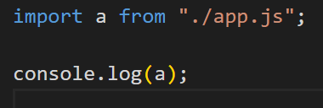
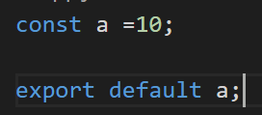
Output: 10

- Creation
  - npm create-react-app (or)
  - npm create vite (use this)
  - cd folder-name
  - npm install
  - npm run dev

- main.jsx
  - 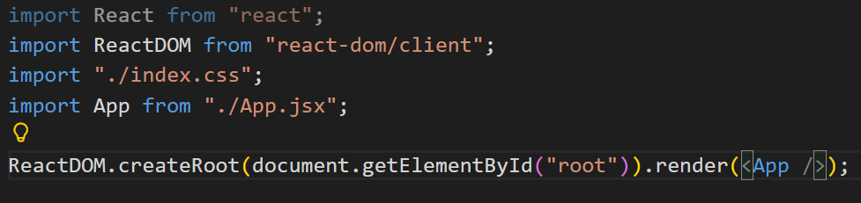
  - App.jsx: son
Main.jsx: father
Index.html: grandfather
  - rafce: shortcut react body

- Component
  - App.jsx: all components calling is done here

- Props
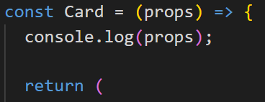
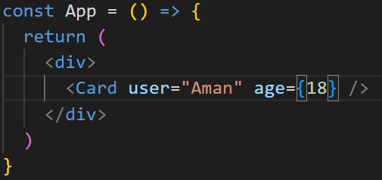
Output: {user: 'Aman', age: 18}
- Console.log(props.age);
  - Output: 18
- 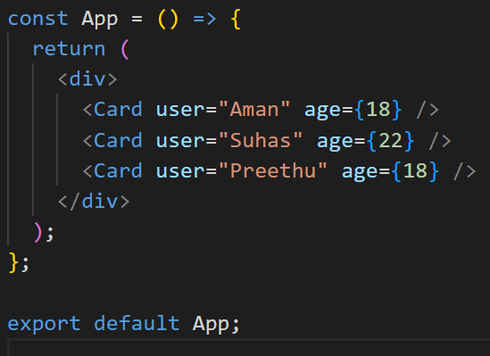
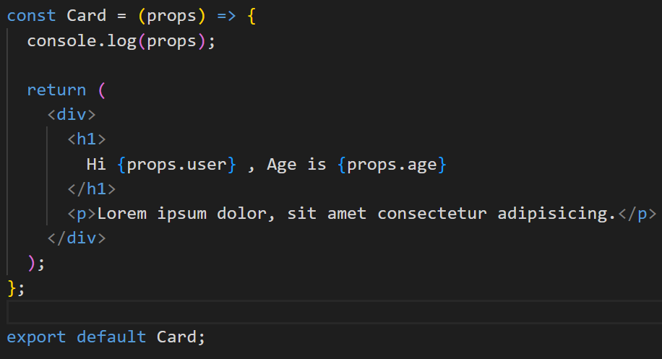
Output:
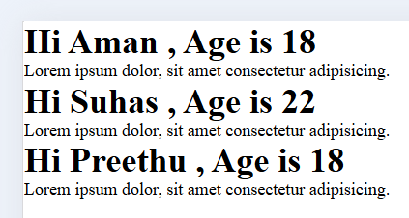

- Icons:
  - Material ui
  - Remix icons
  - luicide

EXAMPLES
- 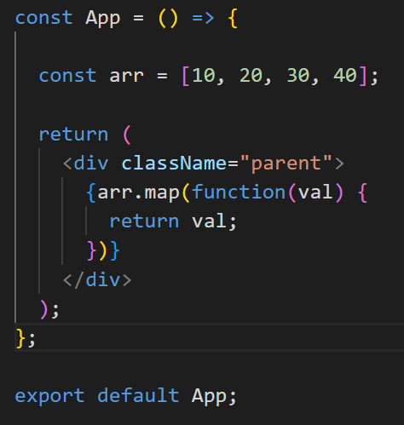
Output: 10203040

- 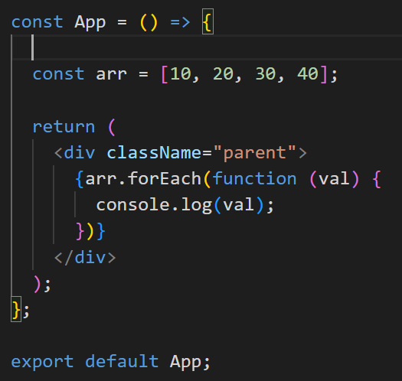
Output: 10 20 30 40

- 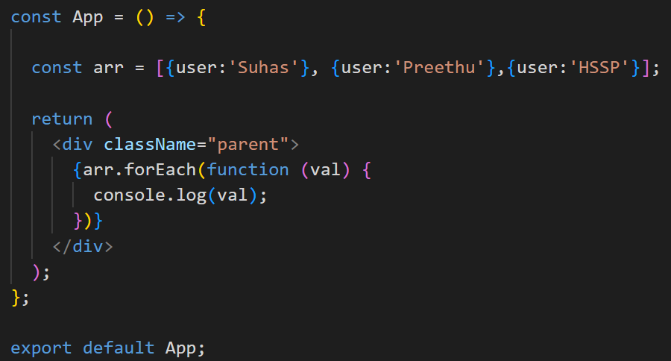
Output: 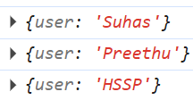
- Props example
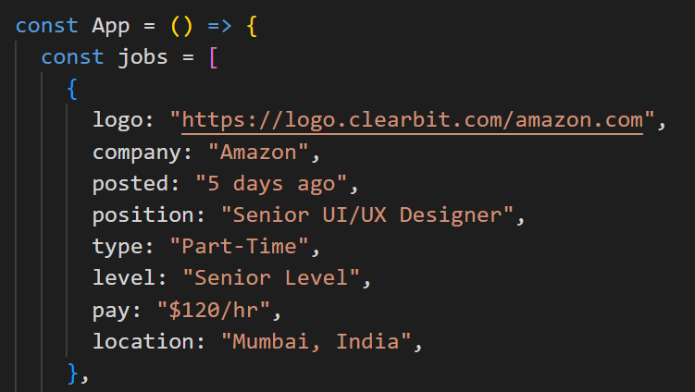
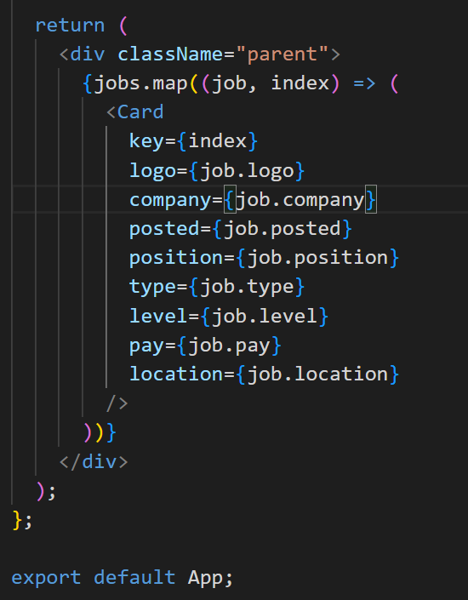
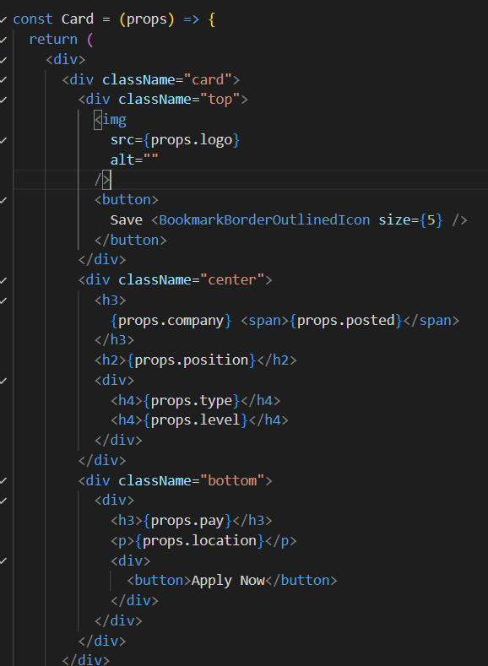
Output:
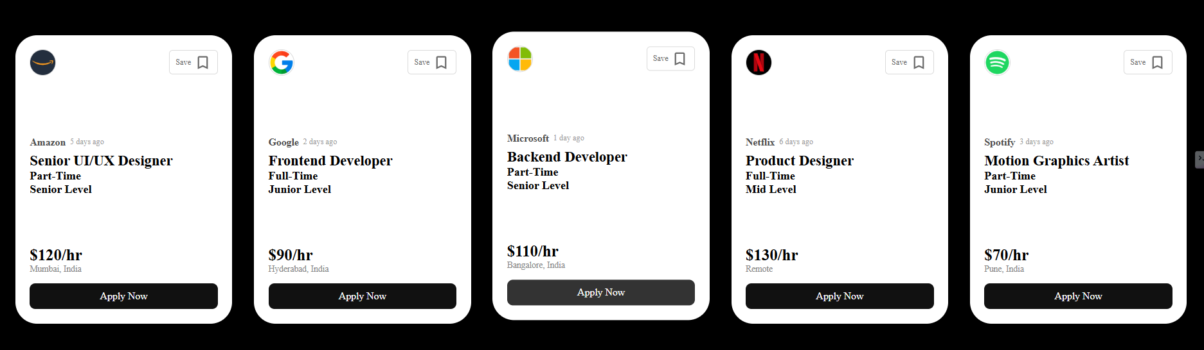
NOTE:
  - Use key={index}
  - Users.map(function((user, index) (……..

- CSS
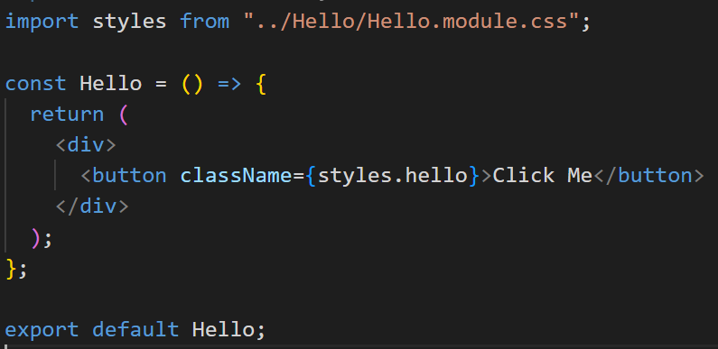
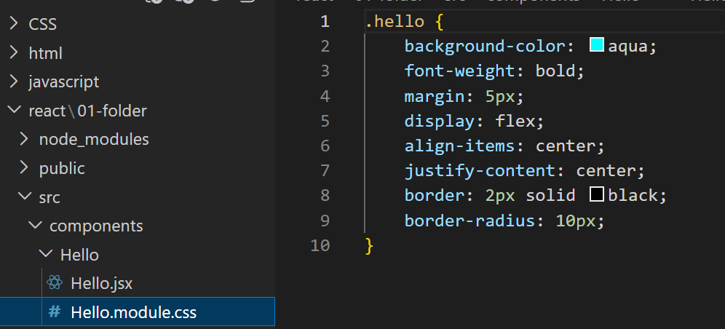

- Tailwind CSS
  - Utility first library
  - npm install tailwindcss @tailwindcss/vite
  - Inside vite.config.js
import tailwindcss from "@tailwindcss/vite";

// https://vite.dev/config/
export default defineConfig({
plugins: [tailwindcss()],
});
- Inside index.css
  - @import “tailwindcss”;

- Function
- 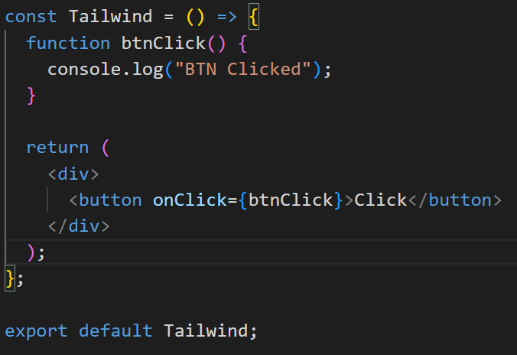
Output:
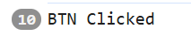
- elem.target.value

- Hooks
  - useState: used to manage state
  - useEffect: in side effects handle (API call, DOM manipulation, event listener)
  - useReducer: manage complex state management
  - useRef: select DOM elements
  - useContext: manage global state without prop drilling
  - useMemo: optimization in rendering, unnecessary re-renders
  - useCallback: optimization in rendering, unnecessary re-renders

- useState
  - 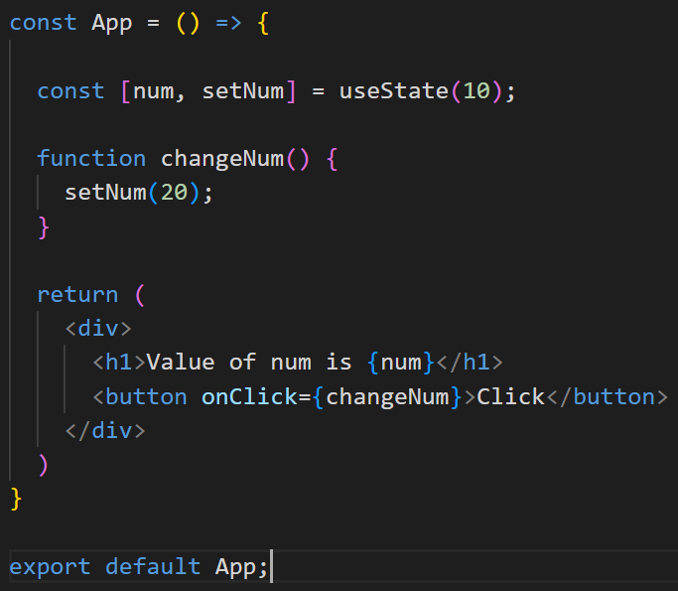
Output:
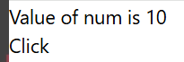
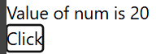
  - 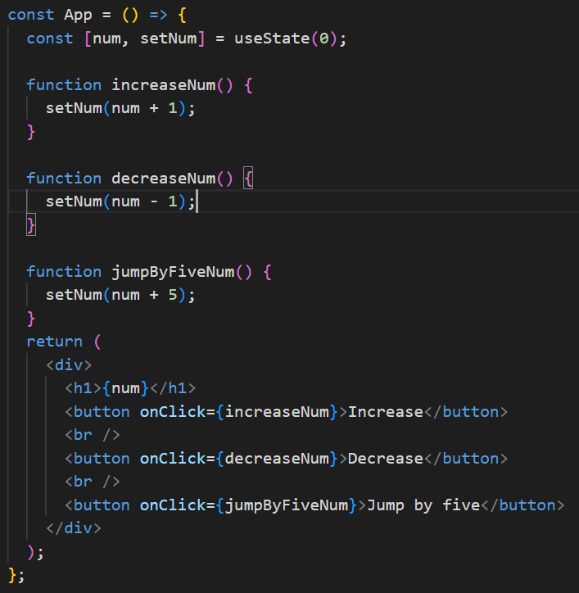
Output:
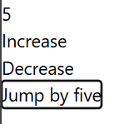
  - Object
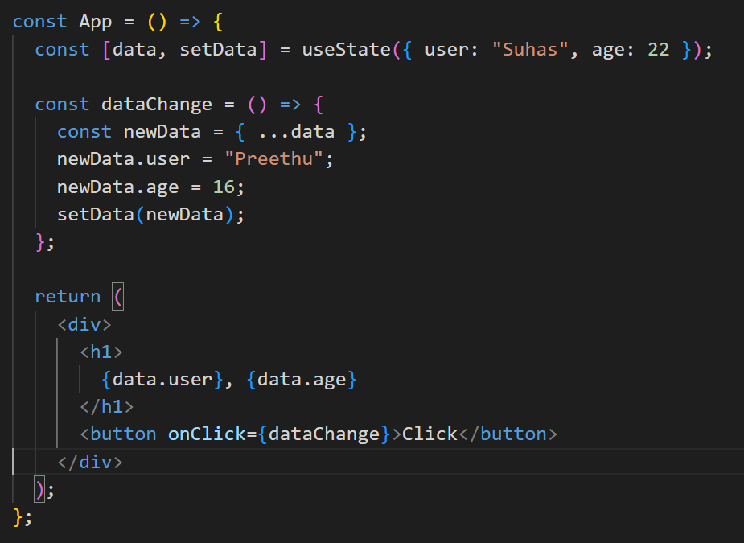
Output:
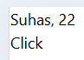
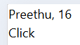

  - 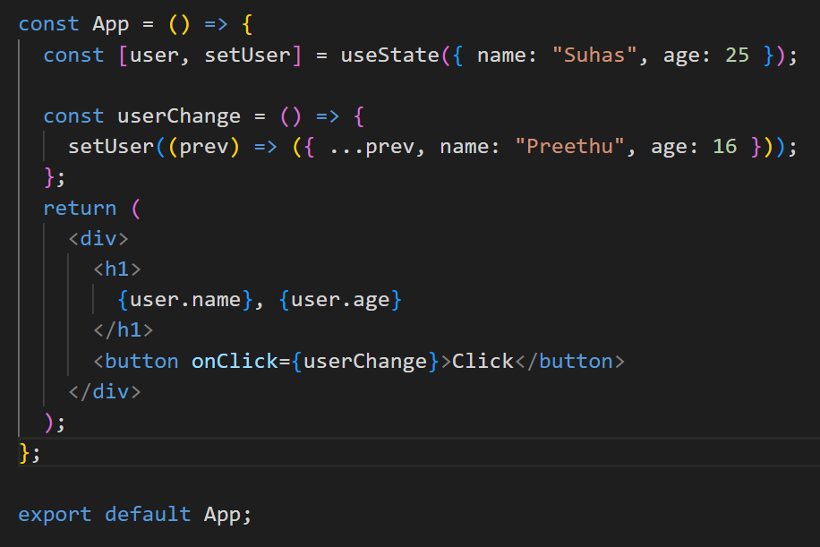
Output:
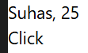
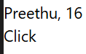

- Form Handling
  - 2 way binding
  - preventDefault
  - 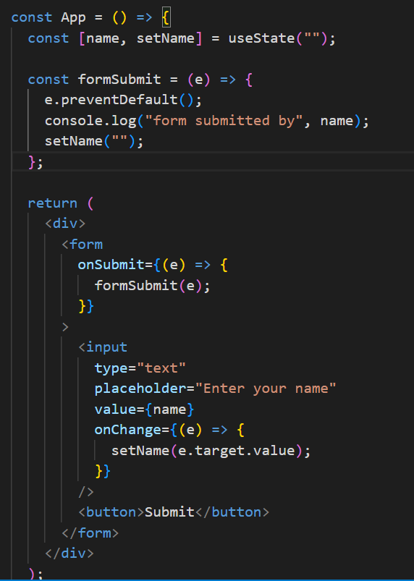
Output;
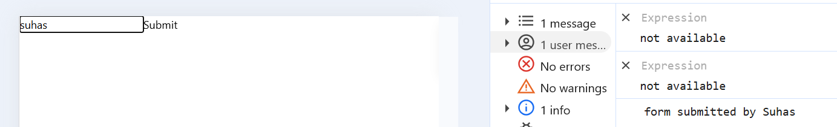

NOTES EXAMPLE
- 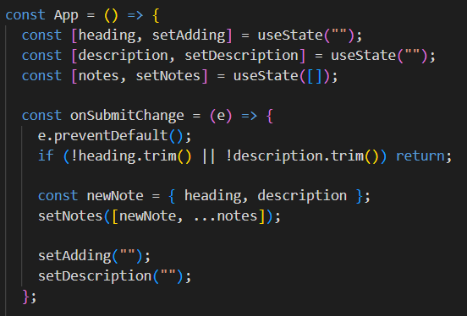
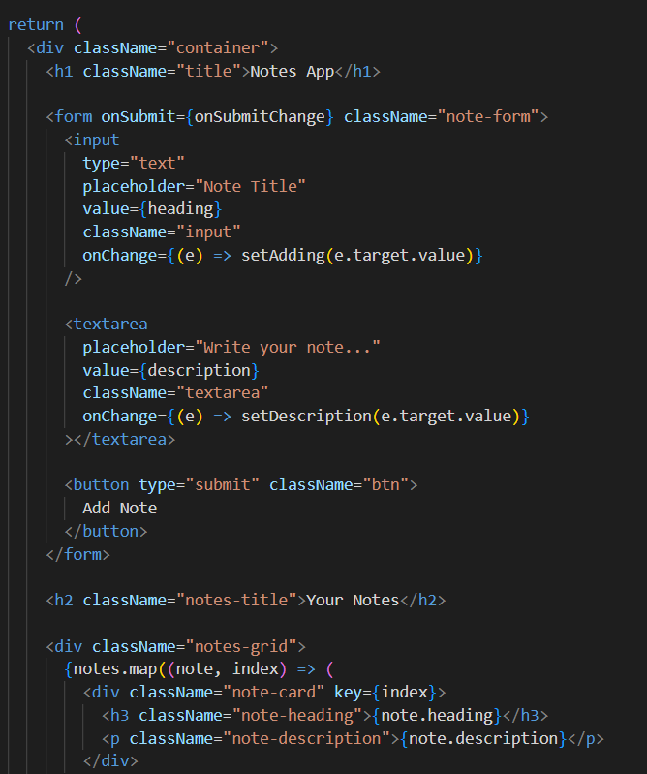
Output:
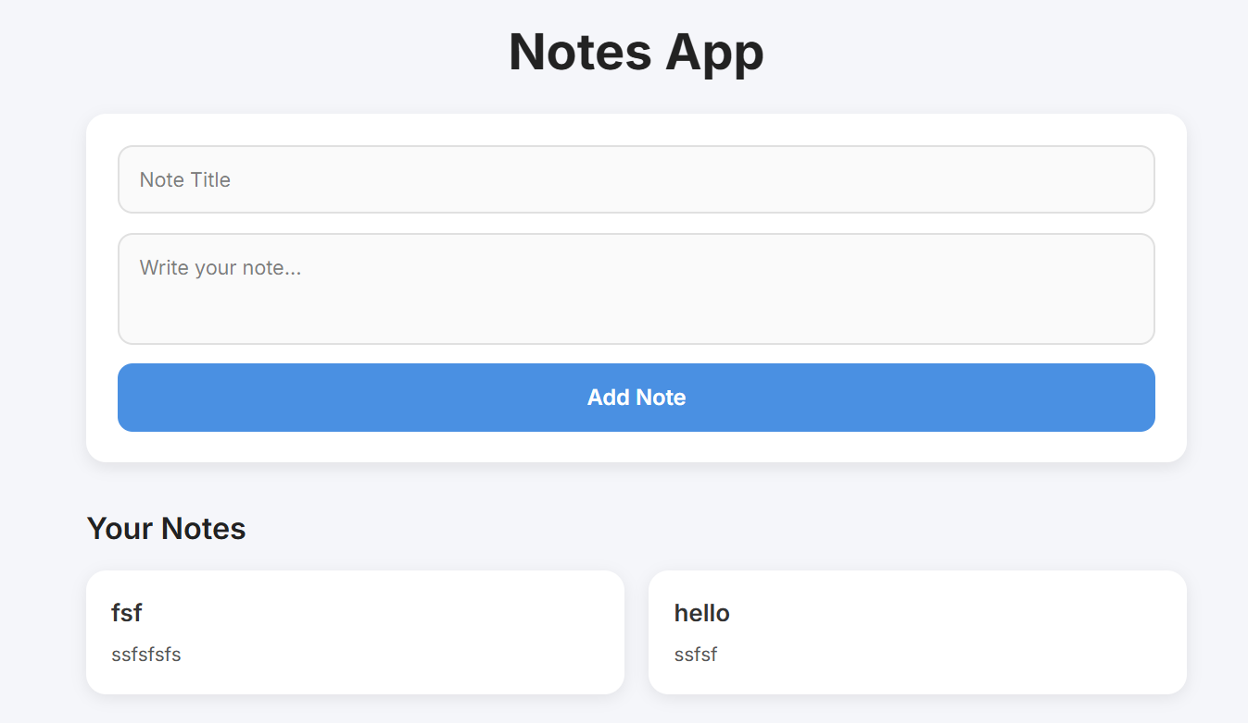

- Local storage & session storage (setItem, getItem, removeItem, clear)
  - localStorage.clear()
    - clears localstorage
  - sessionStorage.clear()
    - clears sessionstorage
  - 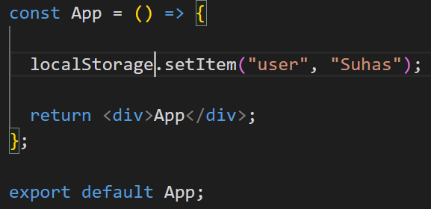
Output:
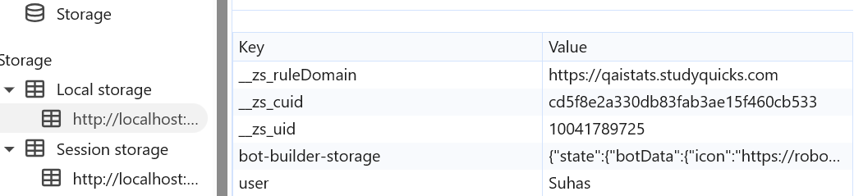
  - localStorage.setItem(“user”, “Suhas”);
  - sessionStorage.setItem(“user”, “Suhas”);
  - localStorage.getItem(“user”); //output get this in console using console.log
  - sessionStorage.getItem(“user”); //output get this in console using console.log
  - localStorage.removeItem(“user”);
  - sessionStorage.removeItem(“user”);

- API Calling
  - Json placeholder: fake api site
  - Lorem picsum: fake api along with images
  - 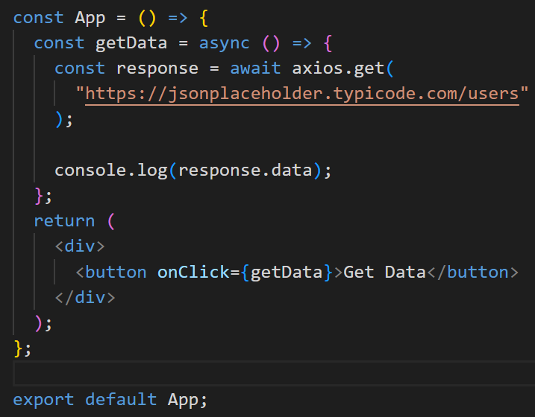
  - 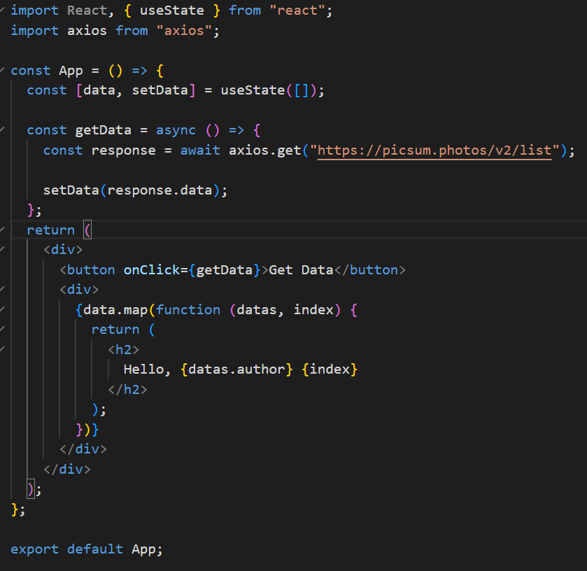
Output:
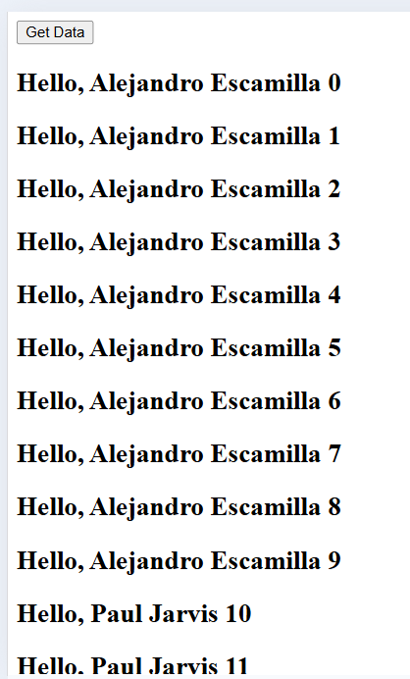
- UseEffect
  - Dependency: []
  - 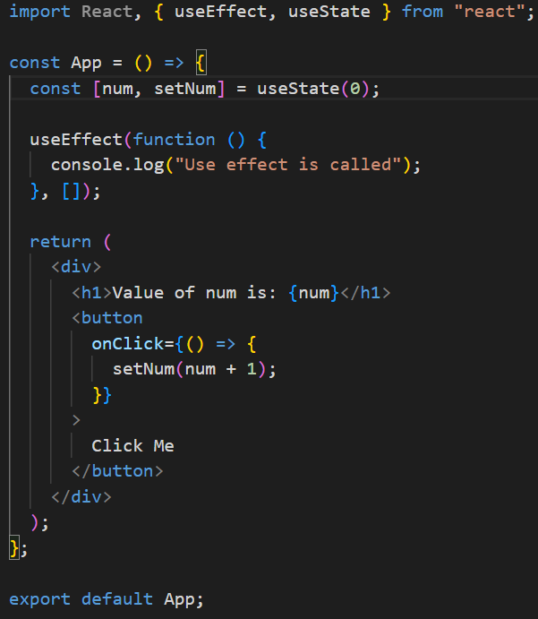
Output:
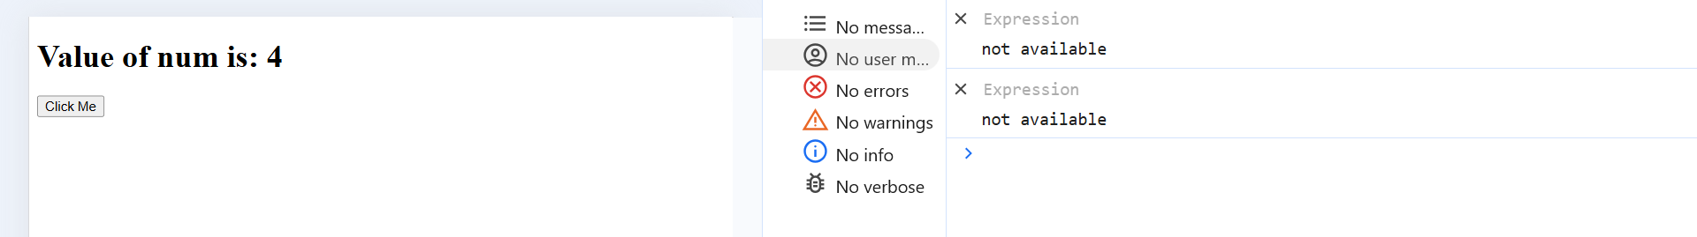
  - 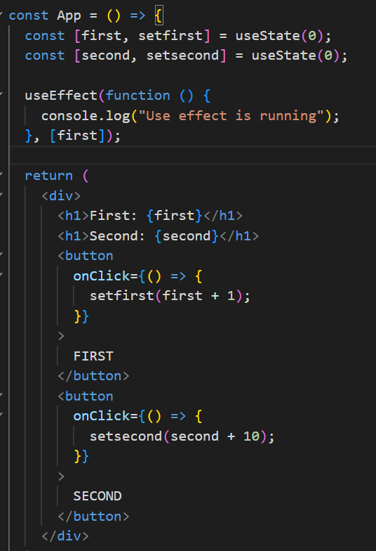
Output:
When I click FIRST button, this will occur
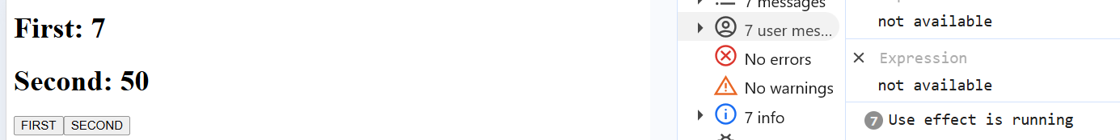

Gallery App EXAMPLE
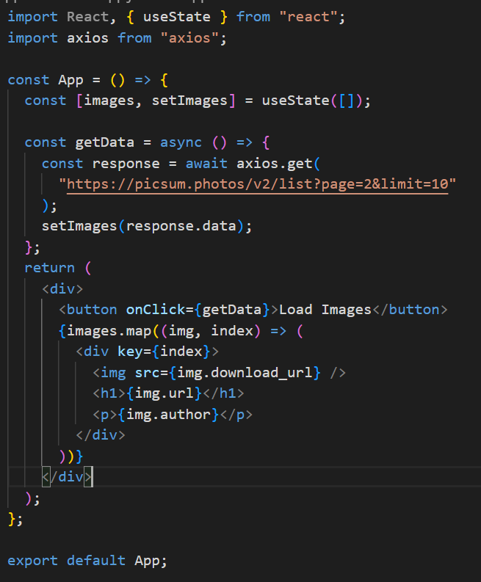

- React Router DOM
  - npm i react-router-dom
  - BrowserRouter
  - HashRouter
  - MemoryRouter
  - StaticRouter
  - In main.jsx:
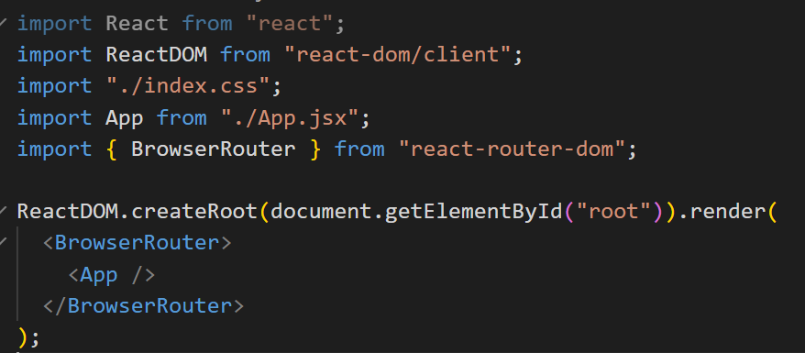
  - 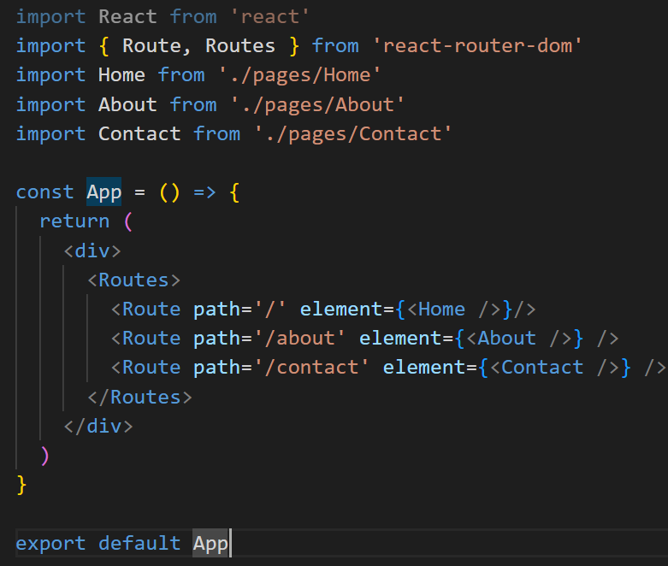
  - 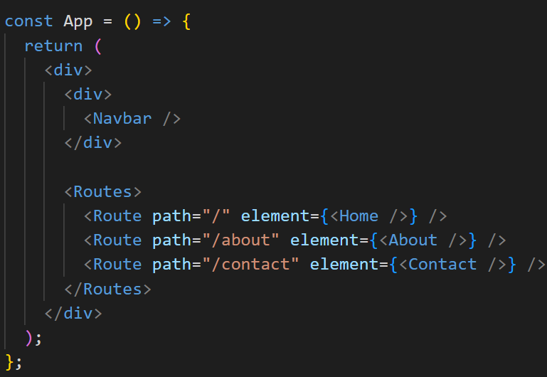
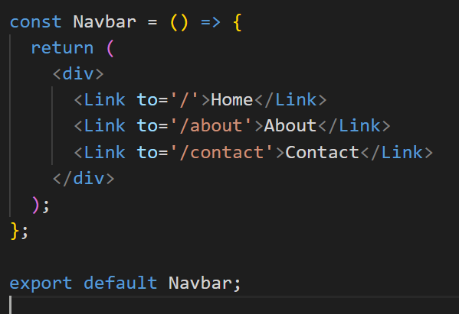
- Advance Routing
  - 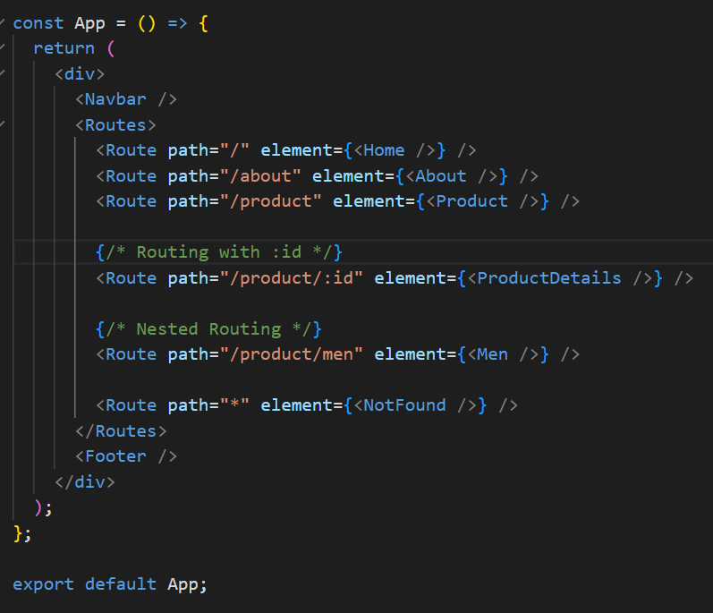
  - 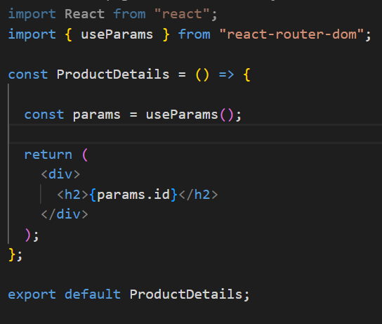
Output: in URL: http://localhost:5173/product/one
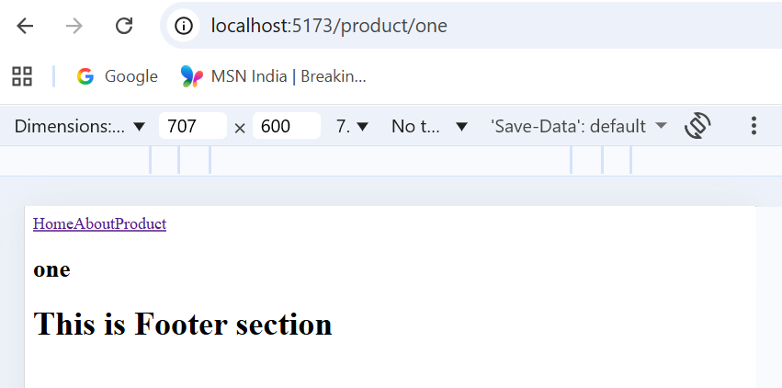

  - UseNavigate
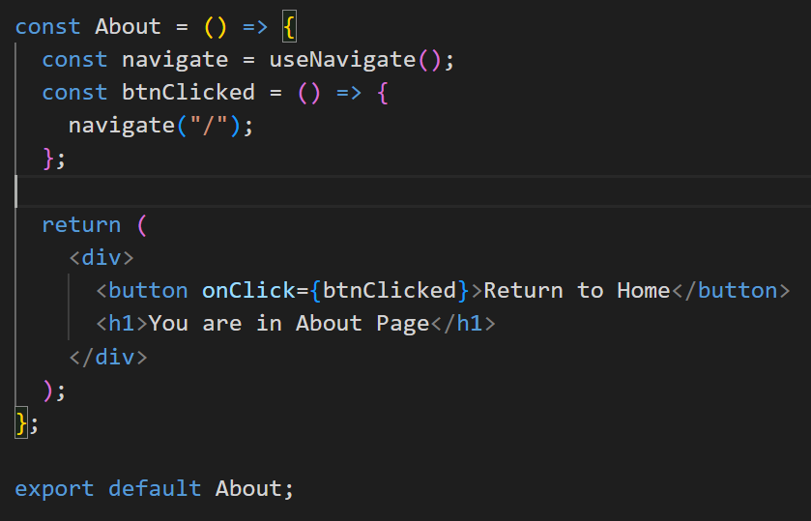
Output:
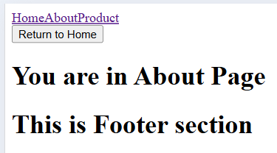
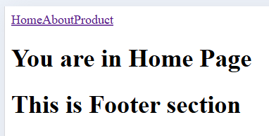

EXAMPLES
  - 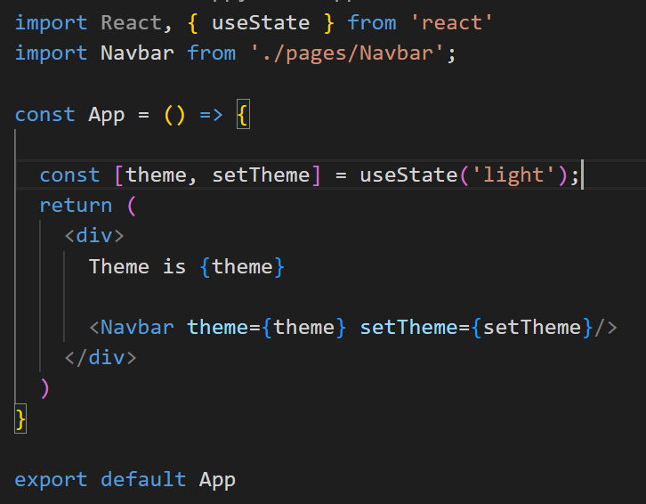
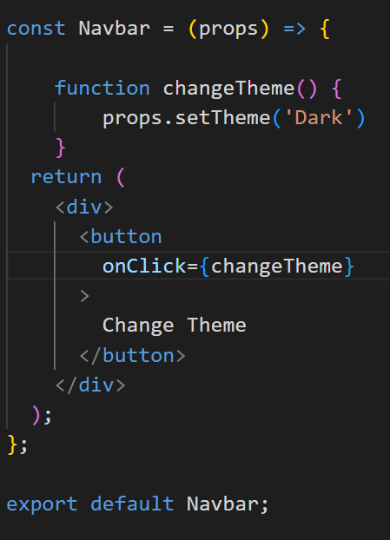
Output:
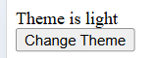
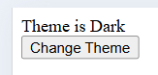

- useContext
  - data centralization
  - 3 things: Context, Provider, useContext
  - Wrap in main.jsx
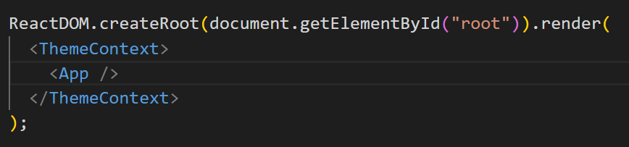
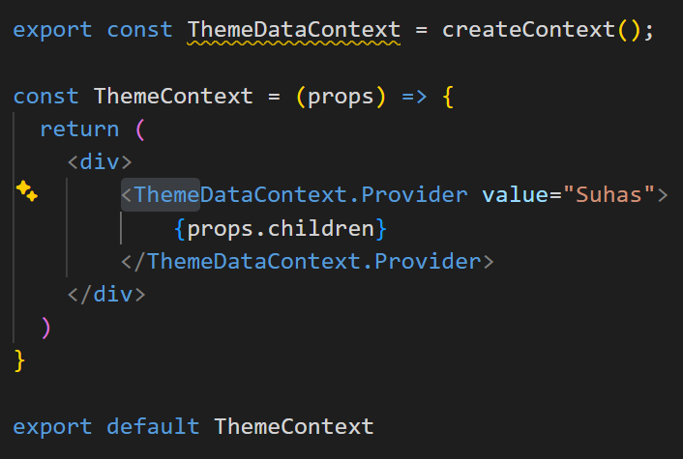
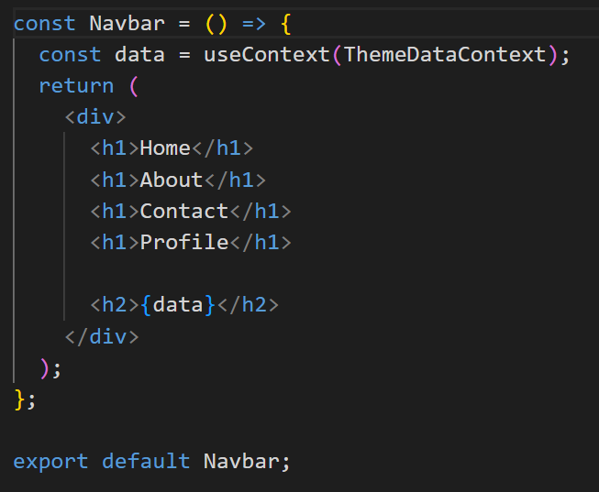
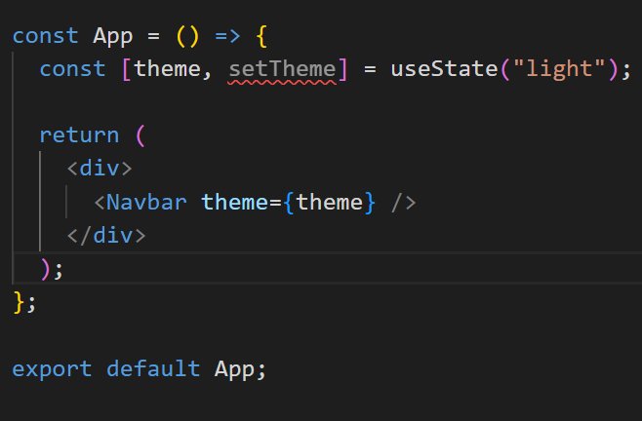
Output:
