**Activity – 4**

**Box Plot**

**[34, 6, 7, 8, 9, 90, 23]:**

**Step 1: Understand the Components of a Box Plot**

A box plot consists of the following components:

1. **Minimum**: The smallest value in the dataset, excluding outliers.
2. **First Quartile (Q1)**: The value below which 25% of the data falls.
3. **Median (Q2)**: The middle value of the dataset (50th percentile).
4. **Third Quartile (Q3)**: The value below which 75% of the data falls.
5. **Maximum**: The largest value in the dataset, excluding outliers.
6. **Interquartile Range (IQR)**: The difference between Q3 and Q1 (IQR=Q3−Q1\text{IQR} = Q3 - Q1).
7. **Outliers**: Any data point that lies beyond 1.5×IQR1.5 \times \text{IQR} from Q1 or Q3.

**Step 2: Organize the Data**

Sort the data in ascending order: [6, 7, 8, 9, 23, 34, 90]

**Step 3: Calculate Key Statistics**

1. **Median (Q2):**
   * Find the middle value in the sorted data.
   * Since there are 7 data points (odd number), the middle value is the 4th one: Q2=9
2. **First Quartile (Q1):**
   * Q1 is the median of the lower half of the data (excluding Q2):

Lower half = [6,7,8]

* + The median of this subset is: Q1=7

1. **Third Quartile (Q3):**
   * Q3 is the median of the upper half of the data (excluding Q2):

Upper half = [23,34,90]

* + The median of this subset is: Q3=34

1. **Interquartile Range (IQR):**

IQR=Q3−Q1=34−7=27

1. **Lower Fence (to detect outliers):**

Lower Fence=Q1−1.5×IQR=7−1.5×27=7−40.5=−33.5

Since no data point is less than −33.5, there are no lower outliers.

1. **Upper Fence (to detect outliers):**

Upper Fence=Q3+1.5×IQR=34+1.5×27=34+40.5=74.5

Any value greater than 74.574.5 is an outlier. Here, 9090 is the only outlier.

**Step 4: Identify Minimum and Maximum Values (Excluding Outliers)**

* **Minimum (Non-Outlier):** 66 (smallest value in the dataset within the fences).
* **Maximum (Non-Outlier):** 3434 (largest value in the dataset within the fences).

**Step 5: Summary of Key Values**

* Minimum: 66
* Q1: 77
* Median (Q2): 99
* Q3: 3434
* Maximum: 3434 (excluding outlier)
* 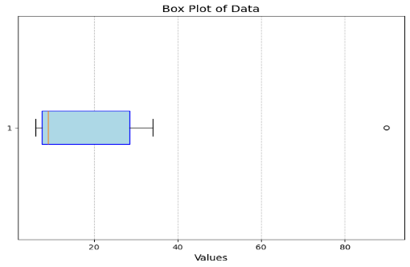Outlier: 9090

**Step 6: Draw the Box Plot**

1. **Draw a box** from Q1 (77) to Q3 (3434).
2. **Draw a line** inside the box at the Median (99).
3. **Add whiskers:**
   * Left whisker starts from the Minimum (66) to Q1 (77).
   * Right whisker starts from Q3 (3434) to the Maximum (3434).
4. **Plot outliers** as individual points (here, 9090).