PIZZA-SALES-ANALYSIS SQL REPORT

KPI’s

Total Revenue:
SELECT
SUM(total_price) AS total_revenue
FROM
pizza_sales;

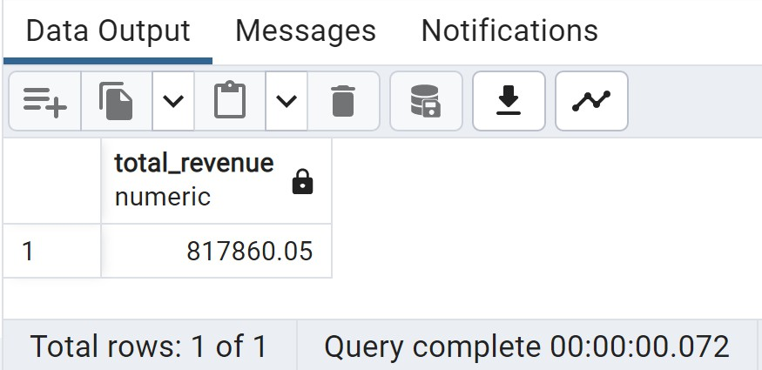

Average Order Value:
SELECT
SUM(total_price) / COUNT (DISTINCT order_id) AS AVG_Order_Value

FROM
pizza_sales;

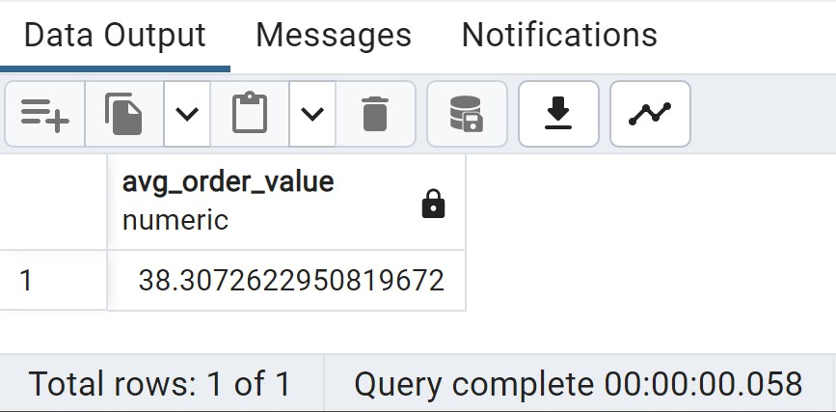

Total Pizza Sold

SELECT
SUM(quantity) AS Total_Pizza_Sold

FROM
pizza_sales;

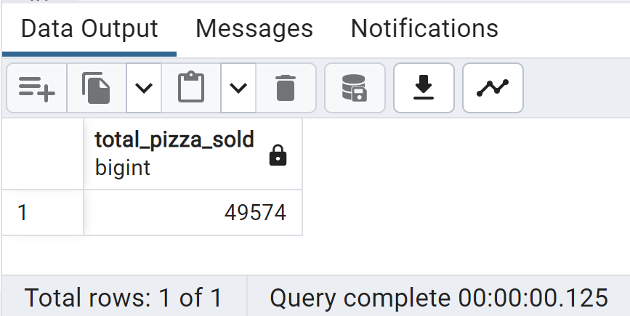

Total Orders

SELECT
COUNT(DISTINCT order_id) AS Total_Orders

FROM
pizza_sales;

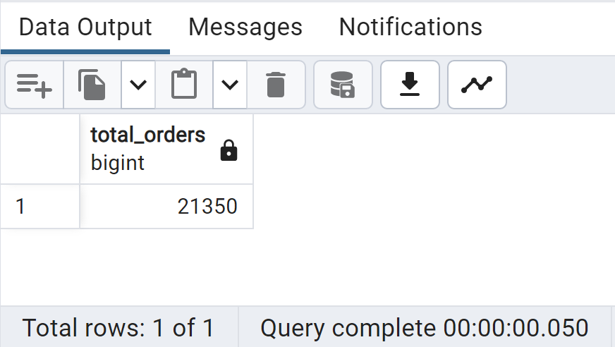

Average Pizzas Per Order

SELECT
ROUND(

ROUND(SUM(quantity),2) / ROUND(COUNT(DISTINCT order_id),2)

FROM
,2) AS Average_pizza_per_order pizza_sales;

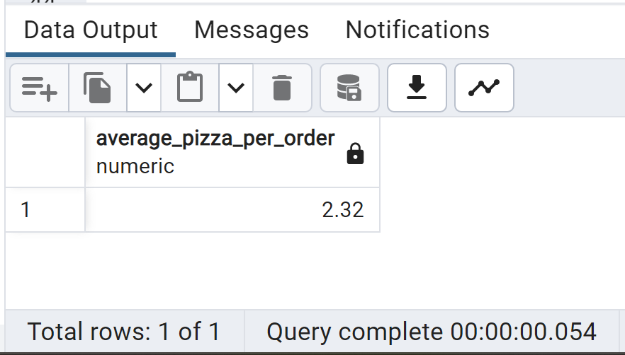

Daily Trend for Total Orders

SELECT

FROM

DAYNAME(order_date) AS order_day, COUNT(DISTINCT order_id) AS Total_Orders

pizza_sales

GROUP BY
order_day ORDER BY
Total_Orders DESC
;

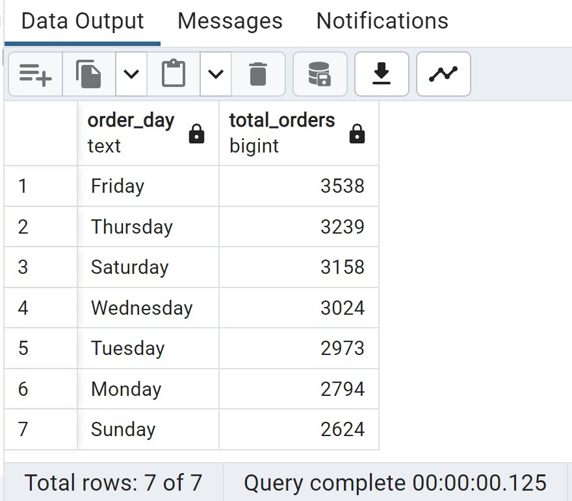

Monthly Trend for Total Orders

SELECT

FROM

MONTHNAME(order_date) AS Month_Name, COUNT(DISTINCT order_id) AS Total_Orders

pizza_sales

GROUP BY
Month_Name ORDER BY
Total_Orders DESC
;

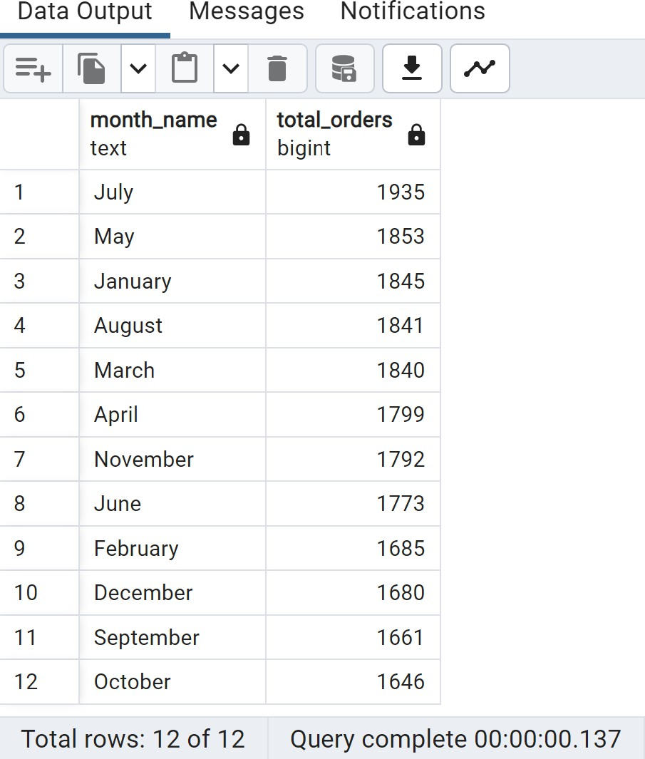

% of Sales by Pizza Category

SELECT

pizza_category,
ROUND(SUM(total_price) *100 / (SELECT SUM(total_price)
FROM pizza_sales
),2)

FROM
AS percent_of_Sales

pizza_sales

GROUP BY
pizza_category
;

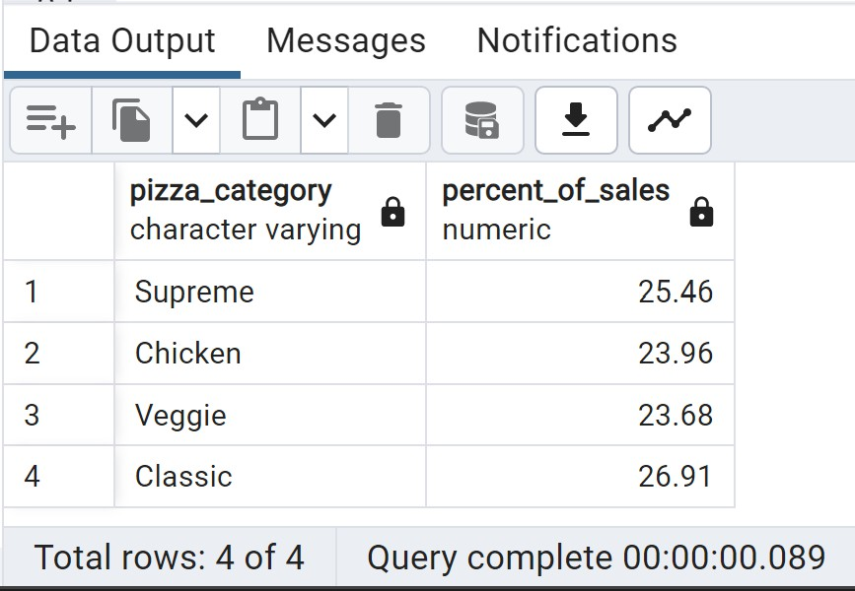

% of Sales by Pizza Size

SELECT

pizza_size,
ROUND(SUM(total_price)*100 / (SELECT SUM(total_price)
FROM pizza_sales
),2)

FROM
AS percent_of_sales

pizza_sales

GROUP BY
pizza_size ORDER BY
percent_of_sales DESC;
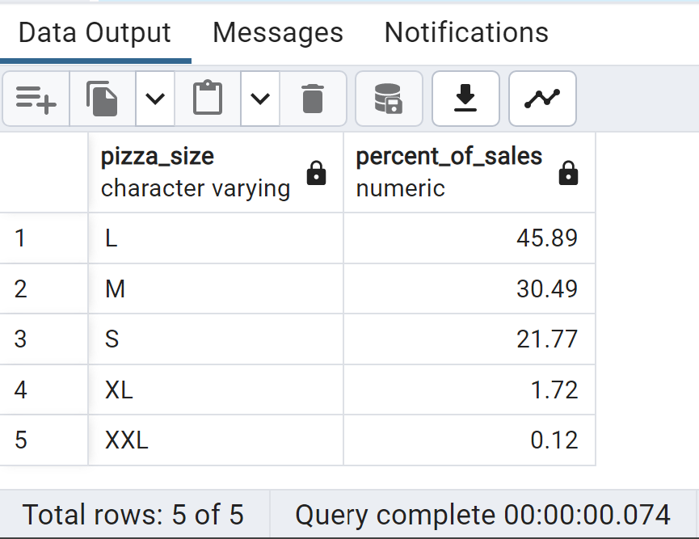

Top 5 Best Sellers by Revenue, Total Quantity & Total Orders Top 5 Best Sellers by Revenue

SELECT
pizza_name, SUM(total_price) AS Total_Revenue

FROM
pizza_sales

GROUP BY
pizza_name ORDER BY
Total_Revenue DESC

LIMIT
5
;

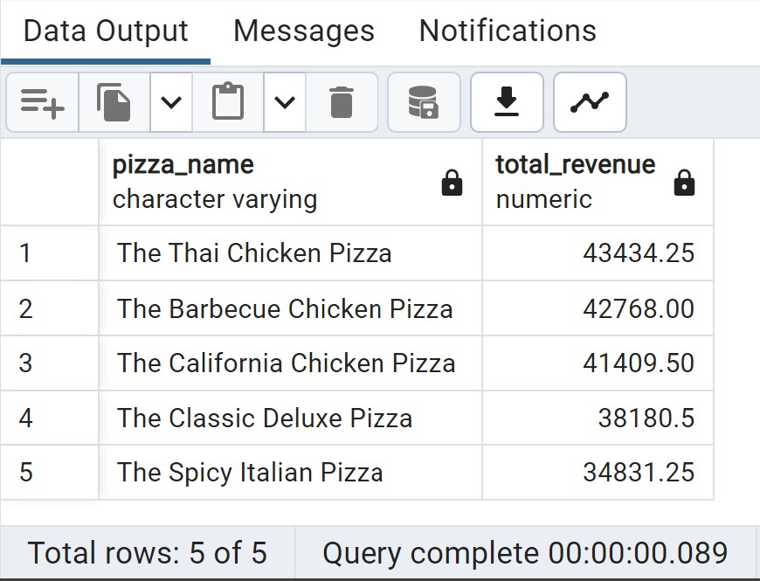

Bottom 5 Sellers by Revenue

SELECT
pizza_name, SUM(total_price) AS Total_Revenue

FROM

pizza_sales GROUP BY
pizza_name ORDER BY
Total_Revenue

LIMIT
5
;
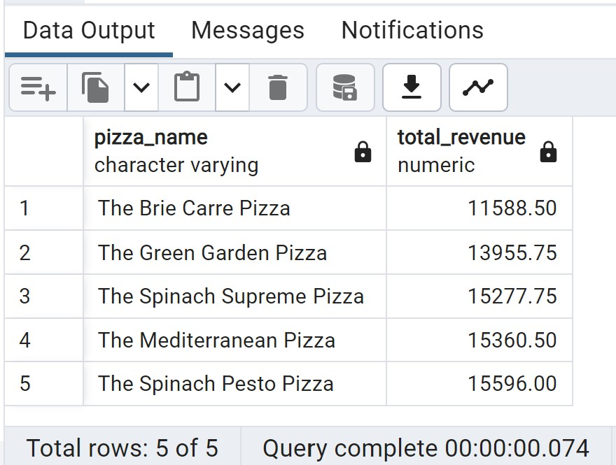

Top 5 Best Sellers by Quantity

SELECT
pizza_name, SUM(quantity) AS Total_Quantity

FROM
pizza_sales

GROUP BY
pizza_name ORDER BY
Total_Quantity DESC

LIMIT
5
;

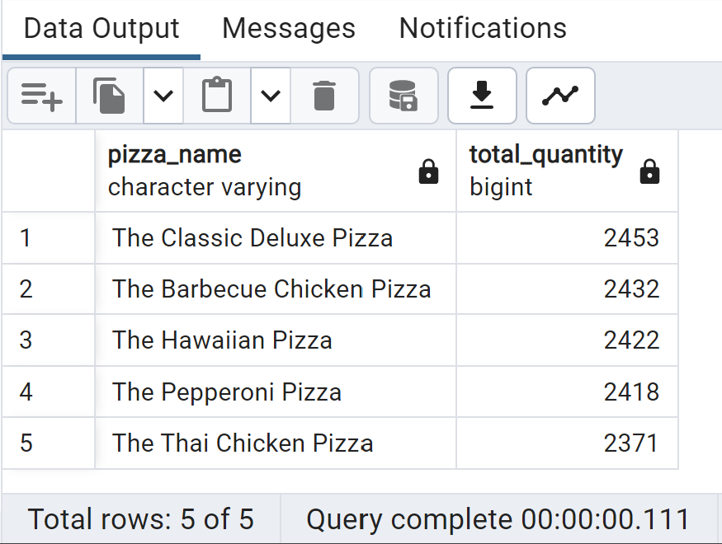

Bottom 5 Sellers by Revenue

SELECT
pizza_name, SUM(quantity) AS Total_Quantity

FROM
pizza_sales

GROUP BY
pizza_name ORDER BY
Total_Quantity

LIMIT
5
;
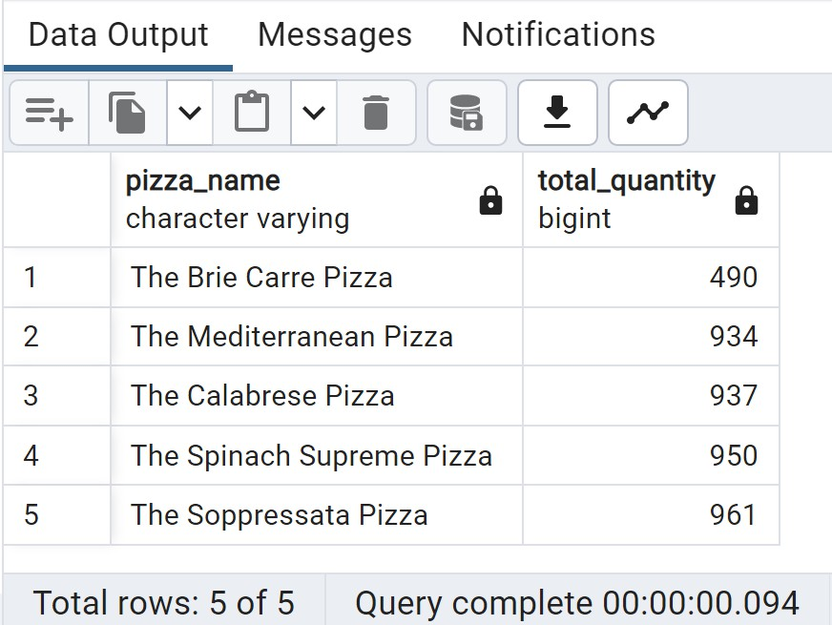

Top 5 Best Sellers by Total Orders

SELECT
pizza_name, COUNT(DISTINCT order_id) AS Total_Orders

FROM
pizza_sales

GROUP BY
pizza_name ORDER BY
Total_Orders DESC

LIMIT
5
;
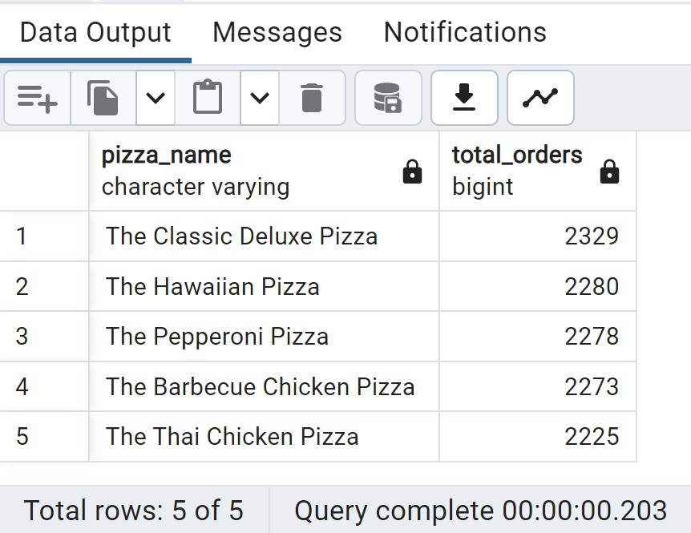

Bottom 5 Sellers by Total Orders

SELECT
pizza_name, COUNT(DISTINCT order_id) AS Total_Orders

FROM
pizza_sales

GROUP BY
pizza_name ORDER BY
Total_Orders

LIMIT
5
;
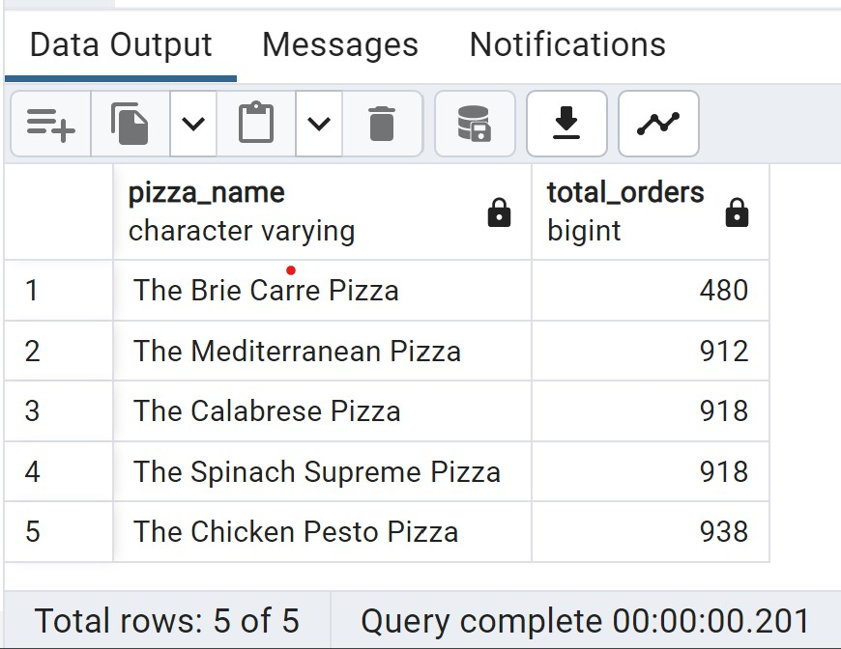

Number of Customers each day & Busiest hours

SELECT
order_date,
COUNT(DISTINCT order_id) AS num_customers FROM
pizza_sales GROUP BY
order_date ORDER BY
order_date;

SELECT
HOUR( order_time) AS order_hour, COUNT(DISTINCT order_id) AS num_orders

FROM
pizza_sales

GROUP BY
order_hour ORDER BY
num_orders DESC;

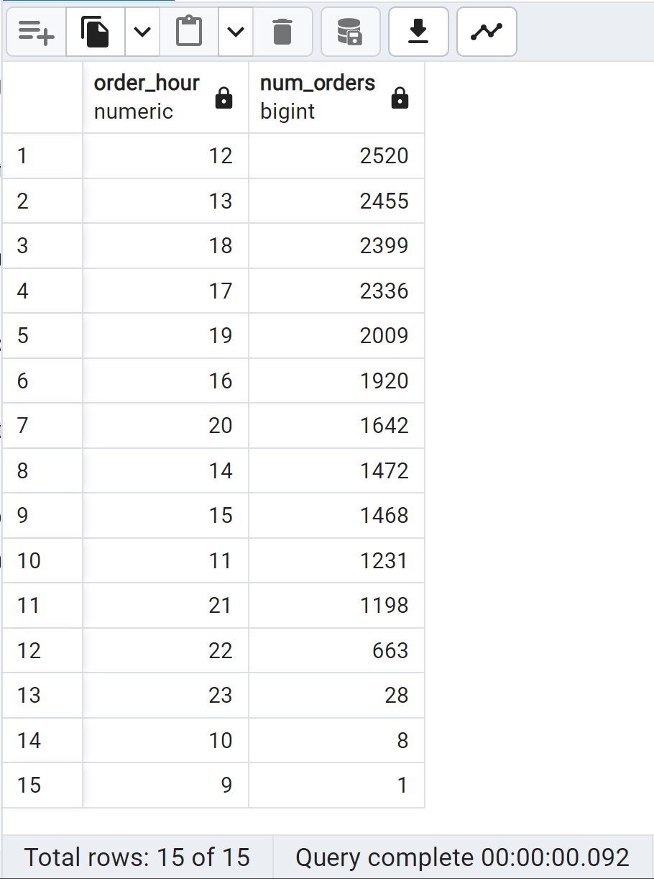

Seasonality Trends

SELECT
MONTH(order_date) AS month, COUNT(DISTINCT order_id) AS total_orders

FROM
pizza_sales GROUP BY
month

ORDER BY
month;
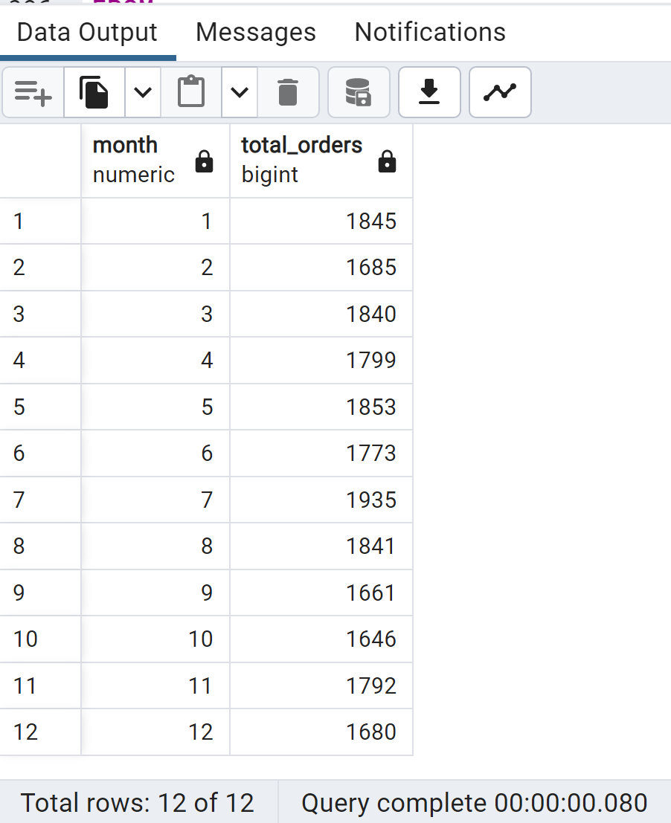

Average Orders per Day
WITH daily_orders AS ( SELECT
order_date,
COUNT(DISTINCT order_id) AS daily_order_count FROM
pizza_sales GROUP BY
order_date

) SELECT
AVG(daily_order_count) AS avg_orders_per_day FROM
daily_orders;

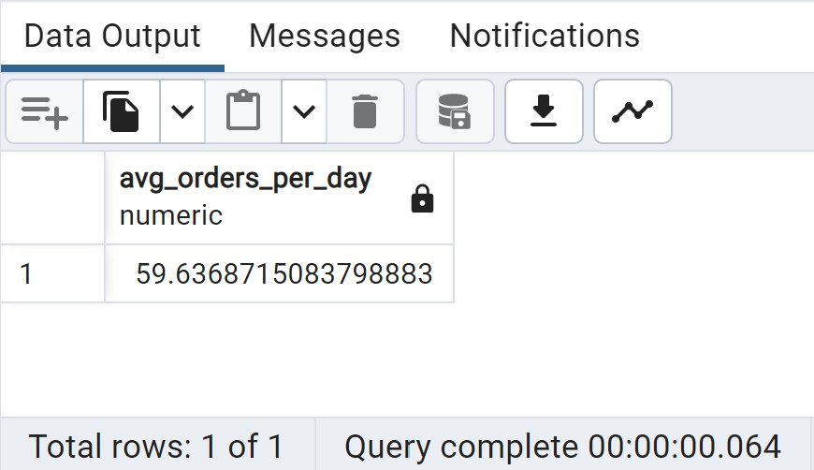

Most occupied Days & Month
Days-Orders are highest on Friday & Saturday evenings
Month-Orders are highest on January & July

Sales Performance
Category-Classical contributes maximum to Sales & Total Orders
Size-Large pizza contributes maximum to Sales

Best Sellers
Revenue-Thai Chicken Pizza contribute maximum to Revenue
Quantity-Classical Deluxe Pizza contributes maximum to Total Quantities
Total Orders-Classic Deluxe Pizza contributes maximum to Total Orders

Lowest Sellers
Revenue-Brie Carre Pizza contribute minimum to Revenue Quantity-Brie Carre Pizza contribute minimum to Total Quantities Total Orders-Brie Carre Pizza contribute minimum to Total Orders
Most occupied Time
Lunch-12 P.M. - 1:30 P.M., Dinner-6 P.M. - 8 P.M.

