Project 1: Healthcare – Persistence of Drug

Team Details:

Group Name: Data hacks

Team member: Suhas Yogeshwara

Country: Germany

Email: [Suhas.gys1996@gmail.com](mailto:Suhas.gys1996@gmail.com)

College: SRH University of Applied Sciences Berlin

Specialization: Data Science

Problem Description:

The major challenges faced by almost all of the Pharmaceutical Companies is that they are trying to find an analytical solution for automating the problems involved in finding the persistence of drug as per the physician prescription.

Data Understanding:

Medical prescription Dataset based on the person age, race, sex, problem, prescribed medicine. It is an Excel .xlsx file format with total of 891kb of file storage with 3424 rows and 69 columns. Solution is to build a Classification for the Dataset for the better overview for each of the patient details.

Problems and approach to solve it in Dataset:

NA Values = 0 (as per the instructive algorithm isnull and iloc )

Count of Risk

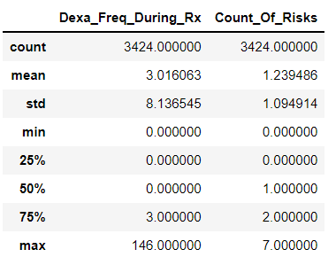

It refers to that almost 25% of the risk Factors are considered to be null value and not the exact risk state of the patient.