A Residual 3D-CNN–BiLSTM–Attention Framework for Hyperspectral Image Classification with PCA-Based Spectral Compression
Sriramaneni Suhas  School of Computer Science and Engineering  VIT-AP University  Amaravati, Andhra Pradesh, India  Reg. No. 23BCE7367 | Srishanth Patel Komirishetty  School of Computer Science and Engineering  VIT-AP University  Amaravati, Andhra Pradesh, India  Reg. No. 23MLC7105 | P. Karthik  School of Computer Science and Engineering  VIT-AP University  Amaravati, Andhra Pradesh, India  Reg. No. 24BCA8063

Abstract—Hyperspectral image (HSI) classification must cope with very high spectral dimensionality, strong inter-band correlation, and scarce labeled pixels. Recent PCA–LSTM pipelines reduce dimensionality but process only a unidirectional, unweighted spectral sequence and do not model local spatial context. This paper proposes a hybrid framework that first compresses each 9×9 neighborhood to 30 principal components and then combines a residual 3D convolutional front-end with squeeze-and-excitation (SE) channel recalibration, a two-layer bidirectional LSTM (BiLSTM) over the spectral axis, and an additive attention layer that weights the informative components before classification. Under a 5%/5%/90% train/validation/test protocol, the model attains an overall accuracy (OA) of 98.68%, average accuracy (AA) of 97.94% and Cohen’s κ of 0.9825 on Pavia University, and 94.46% OA, 91.25% AA and κ of 0.9382 on Kennedy Space Center (KSC). In our own controlled runs it outperforms a PCA–LSTM baseline by 15.82 OA points on Pavia University and a Spectral Transformer by 13.24 OA points on KSC, using only 0.22–0.68 million parameters and 1.5–11 minutes of training. We also analyze per-class errors and the learned spectral attention weights, and we discuss the limitations of the evaluation protocol.
Index Terms—hyperspectral image classification, principal component analysis, 3D CNN, bidirectional LSTM, attention mechanism, squeeze-and-excitation, Pavia University, Kennedy Space Center.
I. INTRODUCTION
Hyperspectral sensors record hundreds of narrow, contiguous spectral bands per pixel, which allows materials that look alike in RGB imagery to be separated by their reflectance signatures. Pixel-wise HSI classification underpins applications such as precision agriculture, environmental monitoring, mineral exploration and land-cover mapping. Two difficulties dominate: (i) the Hughes-type problem of high dimensionality combined with very few labeled samples, and (ii) the large spectral variability caused by illumination, atmosphere and season [1], [5].
Deep learning has largely replaced hand-crafted features in this area. Convolutional networks learn spatial–spectral features directly from image patches [3], [4], while recurrent networks treat the spectrum as a sequence and model dependencies between bands [2]. A recent framework by Dash et al. [1] applies principal component analysis (PCA) to compress the spectral dimension and then classifies the reduced data with an LSTM, reporting 90% accuracy on Pavia University and KSC. That design is attractive because PCA lowers the computational cost, but it has three weaknesses: the LSTM reads the sequence in one direction only, every position in the sequence contributes equally to the decision, and no explicit local spatial feature extractor precedes the recurrent layer.
We address these weaknesses with a CNN–BiLSTM–Attention architecture. A residual 3D CNN with SE recalibration extracts joint spatial–spectral features from each PCA-reduced patch; a BiLSTM models dependencies along the spectral axis in both directions; and an additive attention layer learns which spectral steps matter for each pixel. The contributions of this work are:
1) A compact hybrid architecture (0.68 M parameters for Pavia University, 0.22 M for KSC) that couples residual 3D convolution, SE channel attention, a BiLSTM and spectral attention on a 30-component PCA representation.
2) A leakage-free preprocessing and evaluation pipeline in which the standardizer and PCA are fitted on training pixels only, using the same 5%/5%/90% split ratio as the base paper [1].
3) A controlled comparison against a PCA–LSTM baseline (Pavia University) and a Spectral Transformer (KSC) trained on identical splits, with OA, AA, κ, macro precision/recall/F1 and per-class results.
4) An analysis of residual errors and of the learned spectral attention distribution.
II. RELATED WORK
Spectral dimensionality reduction. PCA [15] projects the bands onto orthogonal directions of maximal variance and is the most widely used preprocessing step for HSI, usually retaining only a few tens of components. It is cheap and unsupervised, but it discards information that may be discriminative for minority classes.
CNN-based classifiers. Hu et al. [3] applied 1D CNNs to the spectrum of each pixel, and Chen et al. [4] introduced 3D CNNs that convolve jointly over the two spatial axes and the spectral axis. Residual connections [6] and batch normalization [17] make such networks easier to optimize, and SE blocks [7] add inexpensive channel-wise recalibration.
Recurrent and attention models. Mou et al. [2] showed that an RNN over the spectral bands is an effective HSI classifier. LSTM [8] cells mitigate vanishing gradients, and bidirectional recurrence [9] lets each position see both lower and higher bands. Additive attention [10] lets a network weight sequence positions explicitly. Transformers [11] replace recurrence with self-attention; SpectralFormer [12] adapts this idea to HSI, and we use a spectral Transformer as a comparison model.
PCA–LSTM. Dash et al. [1] combine PCA with an LSTM and report 90.00% accuracy on both Pavia University and KSC, ahead of SAE, ensemble, KNN and SVM baselines. Our work keeps the PCA front-end but replaces the plain LSTM with a hybrid CNN–BiLSTM–attention network.
III. DATASETS AND PREPROCESSING
A. Datasets
Pavia University was acquired by the ROSIS sensor over northern Italy. After removing noisy bands the cube has 610×340 pixels and 103 bands, with nine classes (asphalt, meadows, gravel, trees, painted metal sheets, bare soil, bitumen, self-blocking bricks and shadows) and 42,776 labeled pixels. Kennedy Space Center (KSC) was acquired by NASA AVIRIS over Florida; the cube has 512×614 pixels and 176 bands after discarding water-absorption and low-SNR bands, with 13 vegetation and wetland classes and 5,211 labeled pixels. Table I summarizes both datasets.
TABLE I. Dataset summary and data split
Property | Pavia Univ. | KSC
Sensor | ROSIS | AVIRIS
Spatial size | 610×340 | 512×614
Spectral bands | 103 | 176
Labeled pixels | 42,776 | 5,211
Classes | 9 | 13
Train / Val. samples | 2,138 / 2,138 | 260 / 260
Test samples | 38,500 | 4,691
PCA components | 30 | 30
PCA explained variance | 99.96% | 72.76%

B. Preprocessing pipeline
The same pipeline is applied to both datasets. (1) The cube is reflect-padded by four pixels and a 9×9 neighborhood is extracted around every pixel; background pixels are discarded. (2) The labeled patches are split with a stratified random split (seed 42) into 5% training, 5% validation and 90% test, matching the protocol of [1]. (3) Each band is standardized to zero mean and unit variance, and (4) PCA is fitted on the training pixels only and used to project all splits to 30 components, giving 9×9×30 input patches. Fitting the scaler and PCA on the training split alone prevents test-set information from leaking into the representation. The 30 components retain 99.96% of the variance on Pavia University but only 72.76% on KSC, whose raw digital numbers have a much wider and noisier dynamic range; this indicates that a part of the KSC spectral information is lost before the network sees it.
IV. PROPOSED METHOD
A. Overview
Fig. 1 shows the architecture. A 9×9×30 patch is rearranged to a single-channel volume of size 30×9×9 (spectral×height×width). Two residual 3D blocks extract local spatial–spectral features while preserving the length of the spectral axis, so that each of the 30 PCA components yields a 32-dimensional feature vector after global spatial pooling. These 30 vectors form a sequence that is read by a BiLSTM, summarized by attention, and classified by a small fully connected head.
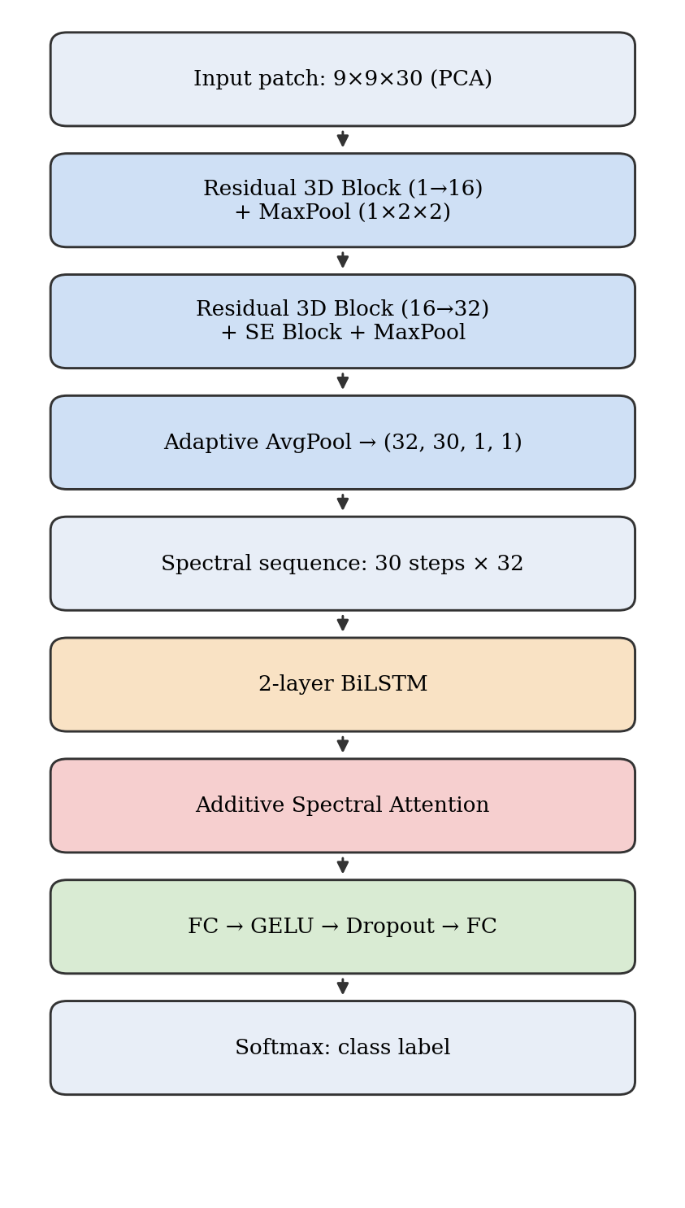
Fig. 1. Architecture of the proposed CNN–BiLSTM–Attention network.
B. Residual 3D CNN with SE recalibration
Each residual block contains two 3×3×3 convolutions with batch normalization and GELU activation [16], plus a 1×1×1 convolutional shortcut when the channel count changes (1→16 in the first block, 16→32 in the second):
y = GELU( BN(Conv₂(GELU(BN(Conv₁(x))))) + S(x) ) (1)
where S(·) is the shortcut. After the second block, an SE block [7] computes channel descriptors by global average pooling, passes them through a bottleneck (reduction ratio 8) and a sigmoid, and rescales the feature maps:
s = σ(W₂ ReLU(W₁ z)), x̃_{c} = s_{c} · x_{c} (2)
Spatial pooling uses (1×2×2) kernels and therefore never shortens the spectral axis. For Pavia University two max-pooling stages (9→4→2) precede an adaptive average pool; for KSC the adaptive average pool is applied directly. The output is a tensor of shape 32×30×1×1, i.e. a sequence of 30 vectors of dimension 32, with 25% 3D dropout applied for regularization.
C. Bidirectional LSTM
The sequence is fed to a two-layer BiLSTM [8], [9] with inter-layer dropout of 0.3. At step t the forward and backward hidden states are concatenated:
h_{t} = [ →h_{t} ; ←h_{t} ] ∈ ℝ^{2H} (3)
with H = 128 for Pavia University and H = 64 for KSC. Bidirectionality lets each spectral step be contextualized by both lower- and higher-ranked components.
D. Additive spectral attention
Instead of keeping only the last hidden state, an additive attention layer [10] scores every step and forms a weighted context vector:
e_{t} = v^{T} tanh(W h_{t} + b), α_{t} = exp(e_{t}) / Σ_{k} exp(e_{k}), c = Σ_{t} α_{t} h_{t} (4)
E. Classifier and training objective
The context vector c passes through dropout and a classification head: a two-layer MLP (2H→128→C with GELU and dropout) for Pavia University, and a single linear layer (2H→C) for KSC. Pavia University is trained with standard cross-entropy. Because KSC has strong class imbalance and only 260 training pixels, it uses class-weighted cross-entropy with weights w_{c} = N/(C·n_{c}) and label smoothing ε = 0.05, together with random horizontal and vertical flips of the training patches:
L = −(1/N) Σ_{i} w_{yᵢ} Σ_{c} q_{i,c} log p_{i,c} (5)
where q is the (smoothed) target distribution. Both models are optimized with AdamW [13] (weight decay 10⁻⁴), cosine-annealed learning rate [14] decaying to 10⁻⁶, gradient clipping at 1.0 and early stopping on validation accuracy. The checkpoint with the best validation accuracy is evaluated once on the held-out test set. Table II lists all settings.
TABLE II. Training configuration
Setting | Pavia Univ. | KSC
Input patch | 9×9×30 | 9×9×30
BiLSTM hidden / layers | 128 / 2 | 64 / 2
Classifier head | MLP 256-128-9 | Linear 128-13
Optimizer | AdamW | AdamW
Learning rate | 1×10⁻³ | 3×10⁻⁴
Batch size | 128 | 32
Max epochs / patience | 100 / 15 | 150 / 20
Loss | Cross-entropy | Weighted CE + LS 0.05
Augmentation | None | H/V flips
Trainable parameters | 678,158 | 217,746
Hardware | GPU (AMP) | CPU
Epochs run / best | 62 / 47 | 150 / 130
Training time | 1 m 29 s | 11.0 min

V. EXPERIMENTAL RESULTS
A. Evaluation protocol and baselines
We report overall accuracy (OA), average accuracy (AA, the mean of per-class recall), Cohen’s κ [18] and macro-averaged precision, recall and F1, all on the 90% test split, with seed 42 throughout:
κ = (p_{o} − p_{e}) / (1 − p_{e}) (6)
Two comparison models were trained on exactly the same preprocessed splits. On Pavia University, the PCA–LSTM baseline is a two-layer unidirectional LSTM (hidden size 128, 241,289 parameters) that reads the 30 PCA components as a sequence, each step being the 81 spatial values of that component, followed by a linear classifier. On KSC, the Spectral Transformer uses 3 encoder layers, 4 heads, embedding size 128 and feed-forward size 256 (422,049 parameters). Each baseline was run on one dataset, so the cross-dataset comparison is not symmetric.
B. Pavia University
TABLE III. Test results on Pavia University
Metric | PCA–LSTM | Proposed
OA (%) | 82.86 | 98.68
AA (%) | 77.69 | 97.94
Kappa (κ) | 0.7725 | 0.9825
Macro precision | 0.7807 | 0.9808
Macro recall | 0.7769 | 0.9794
Macro F1 | 0.7776 | 0.9800
Parameters | 241,289 | 678,158

The proposed network improves OA by 15.82 points, AA by 20.25 points and κ by 0.21 over the PCA–LSTM baseline (Table III). Fig. 2 shows smooth convergence: training accuracy approaches 100% while validation accuracy stabilizes near 98–99% after about 35 epochs, with some transient dips during the high-learning-rate phase. Early stopping ended training at epoch 62, and the whole run took under 90 seconds on a GPU.
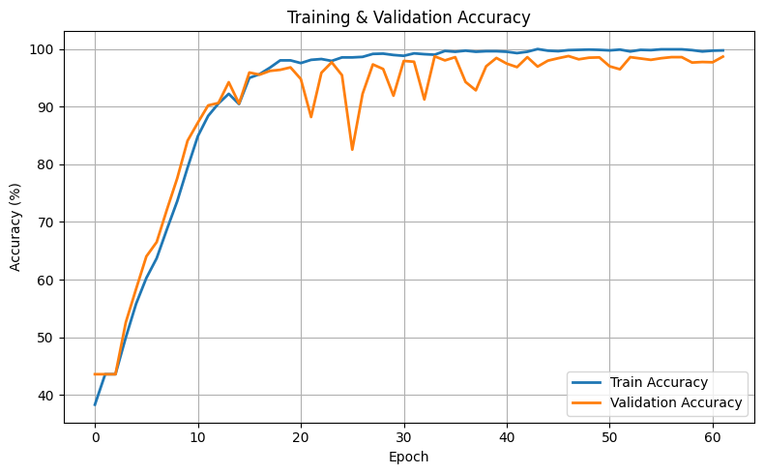
Fig. 2. Training and validation accuracy on Pavia University.
Per-class results are given in Table IV. Eight of nine classes exceed 97% recall; the weakest is Gravel (90.74% recall, F1 0.9257). The confusion matrix (Fig. 3) shows that the main residual error is a Gravel/Self-blocking-bricks confusion: 173 gravel pixels are labeled as bricks and 84 brick pixels as gravel. These two materials are spectrally similar, and neither is helped by additional spatial context at a 9×9 window.
TABLE IV. Per-class results on Pavia University
Class | Test px | LSTM F1 | Prop. recall | Prop. F1
Asphalt | 5,967 | 0.7656 | 99.21 | 0.9942
Meadows | 16,785 | 0.9264 | 99.57 | 0.9963
Gravel | 1,889 | 0.6558 | 90.74 | 0.9257
Trees | 2,758 | 0.8695 | 97.21 | 0.9858
Painted metal | 1,211 | 0.7947 | 99.83 | 0.9934
Bare soil | 4,527 | 0.7124 | 99.38 | 0.9854
Bitumen | 1,196 | 0.7224 | 99.50 | 0.9892
Self-block. bricks | 3,314 | 0.7217 | 97.31 | 0.9581
Shadows | 853 | 0.8300 | 98.71 | 0.9918

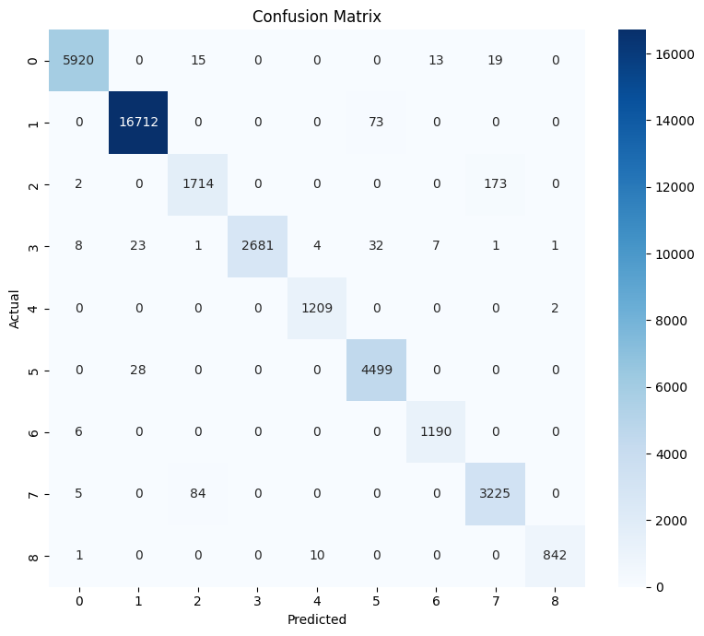
Fig. 3. Confusion matrix on Pavia University (classes 0–8 in the order of Table IV).
C. Kennedy Space Center
TABLE V. Test results on KSC
Metric | Spectral Transf. | Proposed
OA (%) | 81.22 | 94.46
AA (%) | 71.56 | 91.25
Kappa (κ) | 0.7906 | 0.9382
Macro precision | 0.7359 | 0.9177
Macro recall | 0.7156 | 0.9125
Macro F1 | 0.6829 | 0.9137
Parameters | 422,049 | 217,746

On KSC, with only 260 training pixels, the proposed model improves OA by 13.24 points, AA by 19.69 points and macro-F1 by 0.231 over the Spectral Transformer (Table V), while using about half as many parameters. The Transformer collapses on several minority classes (Table VI): recall is 2.8% for Oak/Broadleaf and 22.8% for Willow swamp. The hybrid model, whose convolutional front-end supplies a strong inductive bias, is much more robust in this small-sample regime. Fig. 4 shows the learning curves.
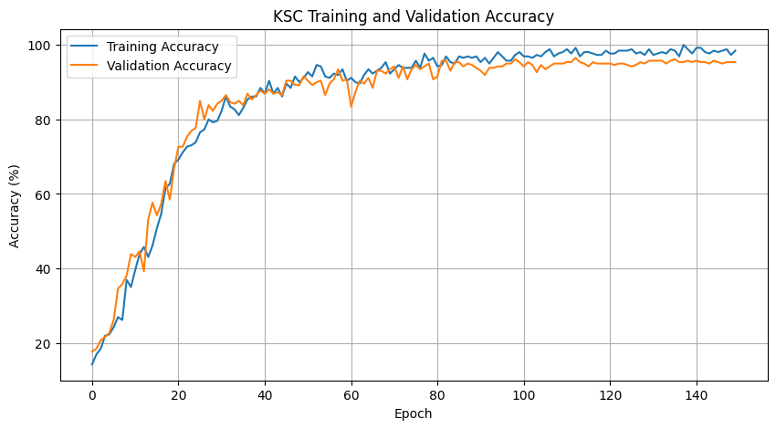
Fig. 4. Training and validation accuracy on KSC.
TABLE VI. Per-class results on KSC
Class | Test px | Transf. F1 | Prop. P | Prop. R | Prop. F1
Scrub | 685 | 0.9296 | 0.9716 | 1.0000 | 0.9856
Willow swamp | 219 | 0.3676 | 0.9548 | 0.9635 | 0.9591
CP hammock | 230 | 0.6798 | 0.9136 | 0.9652 | 0.9387
Slash pine | 226 | 0.4036 | 0.8023 | 0.6283 | 0.7047
Oak/Broadleaf | 145 | 0.0491 | 0.6460 | 0.7172 | 0.6797
Hardwood | 207 | 0.5916 | 0.8404 | 0.7633 | 0.8000
Swamp | 95 | 0.5629 | 1.0000 | 1.0000 | 1.0000
Graminoid marsh | 387 | 0.7967 | 0.9556 | 1.0000 | 0.9773
Spartina marsh | 468 | 0.8714 | 0.9398 | 1.0000 | 0.9689
Cattail marsh | 364 | 0.8062 | 0.9199 | 0.9148 | 0.9174
Salt marsh | 377 | 0.9798 | 1.0000 | 0.9761 | 0.9879
Mud flats | 453 | 0.8484 | 0.9953 | 0.9338 | 0.9636
Water | 835 | 0.9910 | 0.9905 | 1.0000 | 0.9952

The hardest KSC classes are Slash pine (recall 62.8%) and Oak/Broadleaf (F1 0.68). Fig. 5 shows that Slash pine is confused mostly with Oak/Broadleaf (37 pixels) and CP hammock (19 pixels), and Oak/Broadleaf with Slash pine (27 pixels). These are all upland vegetation types with similar spectra, and Oak/Broadleaf has only 161 labeled pixels in total (about 8 in the training split). Wetland and water classes are classified almost perfectly.
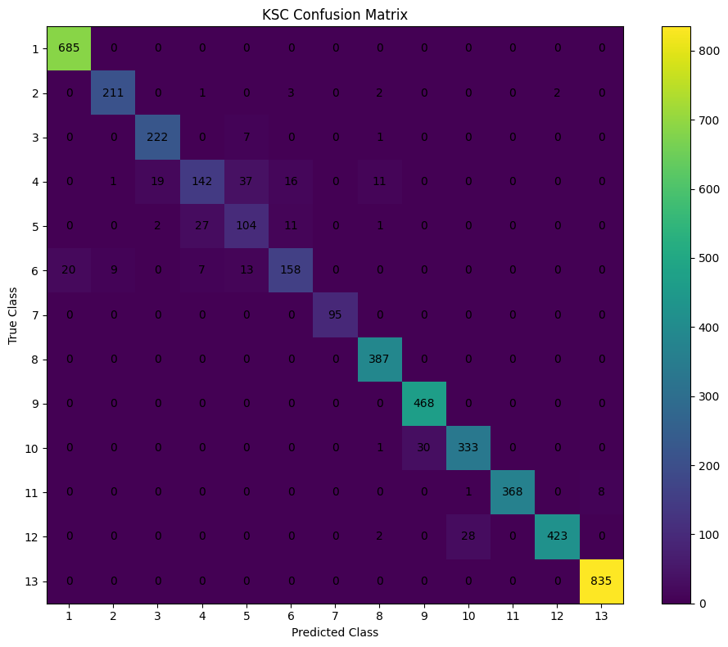
Fig. 5. Confusion matrix on KSC (class numbers as in Table VI).
D. Comparison with published results
Table VII places our measured results next to the accuracies published in [1]. The published figures are quoted rather than re-run, and the implementation details of the methods in [1] are not fully specified, so this table should be read as indicative; the controlled comparisons in Tables III and V are the stricter evidence.
TABLE VII. Overall accuracy (%) versus published results
Method | KSC | Pavia U.
SAE [1] | 65.11 | 62.11
Ensemble (EN) [1] | 66.24 | 59.73
KNN [1] | 67.70 | 61.19
SVM [1] | 78.14 | 63.89
PCA–LSTM [1] (reported) | 90.00 | 90.00
PCA–LSTM (our run) | — | 82.86
Spectral Transformer (our run) | 81.22 | —
Proposed | 94.46 | 98.68

Relative to the 90.00% reported in [1], the proposed model is 4.46 points higher on KSC and 8.68 points higher on Pavia University.
E. Spectral attention analysis
Fig. 6 plots the mean attention weight assigned to each of the 30 spectral steps over the KSC test set. Attention is concentrated on the first ~12 components, with the largest weight on the first component and a secondary peak around components 4–6; weights fall to near zero beyond component 15. Since PCA orders components by explained variance, this suggests that the network relies mainly on the high-variance components and largely ignores the low-variance tail, which is the part most likely to contain noise. This is an observation about learned weights, not a causal proof of importance; an ablation that removes the attention layer would be needed to quantify its contribution.
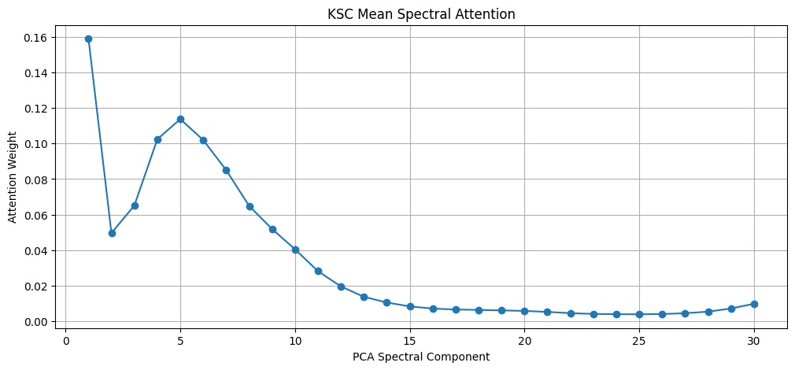
Fig. 6. Mean spectral attention weight per PCA component on the KSC test set.
VI. DISCUSSION AND LIMITATIONS
The results indicate that combining local spatial–spectral convolution with bidirectional, attention-weighted sequence modeling is substantially better than either a plain PCA–LSTM or a small Transformer on the same 30-component input. Several caveats apply. First, every number comes from a single run with seed 42, so no confidence intervals are available. Second, the split is a random pixel-level split of overlapping 9×9 patches; a test patch can share pixels with a training patch, which is known to make accuracy optimistic compared with spatially disjoint splits. Third, the baselines are each evaluated on one dataset, the two datasets use different hyperparameters, and the baselines were not separately tuned. Fourth, no ablation study has been run, so the individual contributions of the residual blocks, SE module, bidirectionality and attention are not isolated. Fifth, the PCA step retains only 72.76% of the variance on KSC, which may cap performance on spectrally similar vegetation classes. Finally, Pavia University was trained on GPU with mixed precision and KSC on CPU, so the reported training times are not directly comparable.
VII. CONCLUSION
We presented a CNN–BiLSTM–Attention framework for HSI classification on PCA-reduced patches. Using a residual 3D CNN with SE recalibration, a two-layer BiLSTM along the spectral axis and additive attention, the model reached 98.68% OA on Pavia University and 94.46% OA on KSC with 5% labeled training data, outperforming a PCA–LSTM baseline and a Spectral Transformer trained on the same splits. Remaining errors concentrate on spectrally similar classes (Gravel vs. bricks; Slash pine vs. Oak/Broadleaf). Future work includes ablation studies, repeated runs with spatially disjoint train/test splits, supervised or nonlinear dimensionality reduction to replace PCA on KSC, and evaluation on additional benchmarks such as Indian Pines and Salinas.
ACKNOWLEDGMENT
The authors thank the School of Computer Science and Engineering, VIT-AP University, for academic support.
REFERENCES
[1] S. Dash, S. Chakravarty, S. Vadhri, and V. V. B. R. Sanikommu, “A deep learning framework for hyperspectral image classification using PCA and spectral LSTM networks,” in Proc. 2023 IEEE 2nd Int. Conf. Industrial Electronics: Developments & Applications (ICIDeA), 2023, pp. 70–75, doi: 10.1109/ICIDeA59866.2023.10295231.
[2] L. Mou, P. Ghamisi, and X. X. Zhu, “Deep recurrent neural networks for hyperspectral image classification,” IEEE Trans. Geosci. Remote Sens., vol. 55, no. 7, pp. 3639–3655, Jul. 2017.
[3] W. Hu, Y. Huang, L. Wei, F. Zhang, and H. Li, “Deep convolutional neural networks for hyperspectral image classification,” J. Sensors, vol. 2015, Art. no. 258619, 2015.
[4] Y. Chen, H. Jiang, C. Li, X. Jia, and P. Ghamisi, “Deep feature extraction and classification of hyperspectral images based on convolutional neural networks,” IEEE Trans. Geosci. Remote Sens., vol. 54, no. 10, pp. 6232–6251, Oct. 2016.
[5] S. Li, W. Song, L. Fang, Y. Chen, P. Ghamisi, and J. A. Benediktsson, “Deep learning for hyperspectral image classification: An overview,” IEEE Trans. Geosci. Remote Sens., vol. 57, no. 9, pp. 6690–6709, Sep. 2019.
[6] K. He, X. Zhang, S. Ren, and J. Sun, “Deep residual learning for image recognition,” in Proc. IEEE Conf. Computer Vision and Pattern Recognition (CVPR), 2016, pp. 770–778.
[7] J. Hu, L. Shen, and G. Sun, “Squeeze-and-excitation networks,” in Proc. IEEE/CVF Conf. CVPR, 2018, pp. 7132–7141.
[8] S. Hochreiter and J. Schmidhuber, “Long short-term memory,” Neural Comput., vol. 9, no. 8, pp. 1735–1780, 1997.
[9] M. Schuster and K. K. Paliwal, “Bidirectional recurrent neural networks,” IEEE Trans. Signal Process., vol. 45, no. 11, pp. 2673–2681, Nov. 1997.
[10] D. Bahdanau, K. Cho, and Y. Bengio, “Neural machine translation by jointly learning to align and translate,” in Proc. Int. Conf. Learning Representations (ICLR), 2015.
[11] A. Vaswani et al., “Attention is all you need,” in Proc. Adv. Neural Inf. Process. Syst. (NeurIPS), 2017, pp. 5998–6008.
[12] D. Hong et al., “SpectralFormer: Rethinking hyperspectral image classification with transformers,” IEEE Trans. Geosci. Remote Sens., vol. 60, 2022, Art. no. 5518615.
[13] I. Loshchilov and F. Hutter, “Decoupled weight decay regularization,” in Proc. ICLR, 2019.
[14] I. Loshchilov and F. Hutter, “SGDR: Stochastic gradient descent with warm restarts,” in Proc. ICLR, 2017.
[15] I. T. Jolliffe, Principal Component Analysis, 2nd ed. New York, NY, USA: Springer, 2002.
[16] D. Hendrycks and K. Gimpel, “Gaussian error linear units (GELUs),” arXiv:1606.08415, 2016.
[17] S. Ioffe and C. Szegedy, “Batch normalization: Accelerating deep network training by reducing internal covariate shift,” in Proc. Int. Conf. Machine Learning (ICML), 2015, pp. 448–456.
[18] J. Cohen, “A coefficient of agreement for nominal scales,” Educ. Psychol. Meas., vol. 20, no. 1, pp. 37–46, 1960.

