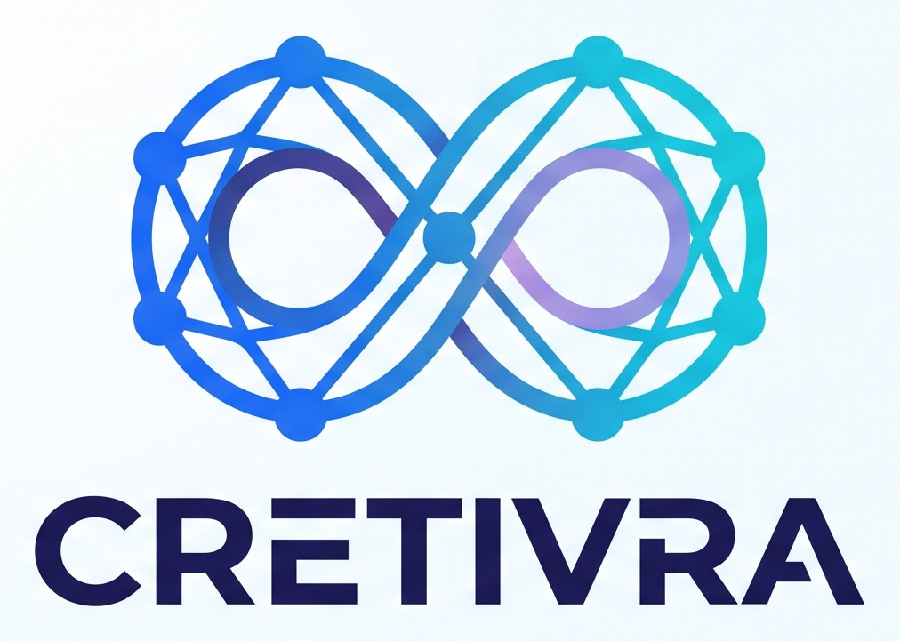 | COMPANY PROFILE  Generative AI for real-world progress

To Whom It May Concern,
CRETIVRA is a next-generation Generative AI platform committed to delivering intelligent, practical, and innovative AI solutions for students, professionals, educators, startups, and enterprises. Our purpose is to make artificial intelligence accessible, practical, and impactful through secure, scalable, and user-friendly products that advance learning, productivity, and digital transformation.
Our Solutions
- AI-powered conversational assistants
- Intelligent content generation and summarization
- Coding and software development assistance
- Research and productivity tools
- AI workflow automation
- Custom AI solutions for businesses and educational institutions
VISION  To become a globally recognized AI company that empowers individuals and organizations through intelligent, ethical, and scalable Generative AI solutions. | MISSION  To simplify complex tasks through AI, accelerate innovation, enhance productivity, and deliver reliable AI solutions that create real-world impact.
Who We Serve
Students • Professionals • Educators • Researchers • Startups • Small & Medium Businesses • Enterprises • Educational Institutions
Leadership Team
Suhash M | Founder & Chief Executive Officer (CEO)
Siva N | Chief Technology Officer (CTO)
Ajay Babu | Technical Support Engineer
Core Values
Innovation • Accessibility • Reliability • Security • Customer Success • Responsible AI
At CRETIVRA, we combine cutting-edge Generative AI with practical real-world applications to enhance education, streamline software development, automate business processes, and empower organizations to innovate faster and achieve more.

