WEEK 1 REPORT
DATA ACQUISITION, CLEANING AND PREPROCESSING
Dataset: Titanic – Machine Learning from Disaster
Public source: Kaggle
Prepared using Python, Pandas, NumPy and Matplotlib

1. Objective
The objective of this task is to demonstrate the complete process of acquiring a publicly available dataset, exploring its structure and quality, identifying missing values and inconsistent records, detecting outliers, and preparing a clean dataset for future analysis or machine-learning tasks.

2. Dataset Selection and Data Collection
The Titanic dataset was selected because it is a well-known public dataset containing both numerical and categorical attributes. It includes passenger information such as class, sex, age, number of siblings/spouses, parents/children, fare, ticket and port of embarkation. The dataset is suitable for demonstrating missing-value treatment, validation, outlier detection and feature preprocessing.
Source: Kaggle – Titanic: Machine Learning from Disaster
URL: https://www.kaggle.com/competitions/titanic/data
Data collection method: download the train.csv file from Kaggle and load it into Python using pandas.read_csv().

3. Tools and Libraries
- Python 3.x
- Pandas – data loading and manipulation
- NumPy – numerical operations
- Matplotlib – visualization
- Jupyter Notebook / VS Code – execution environment

4. Initial Data Exploration
The original dataset contains 891 rows and 12 columns. Initial inspection was performed using head(), shape, dtypes, describe(), isna().sum() and duplicated().
Check | Result | Purpose
Rows | 891 | Number of passenger records
Columns | 12 | Number of variables
Missing Age | 177 | Requires imputation
Missing Cabin | 687 | Very high missingness
Missing Embarked | 2 | Small missing count
Duplicate rows | 0 | Duplicate check
Initial inspection code:
import pandas as pd
df = pd.read_csv("train.csv")
print(df.shape)
print(df.head())
print(df.dtypes)
print(df.describe(include="all"))
print(df.isna().sum())
print("Duplicate rows:", df.duplicated().sum())
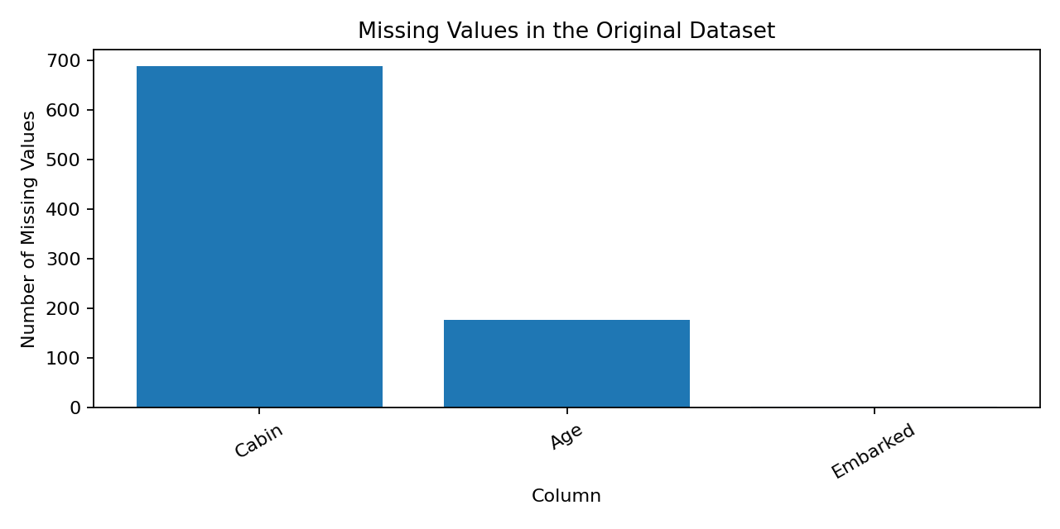
Figure 1. Missing values in the original dataset.

5. Missing Value Analysis and Treatment
The main missing-value problem occurs in Cabin (687 values), Age (177 values), and Embarked (2 values). Cabin has approximately 77.1% missing data, so dropping this column is more reasonable than filling most of the column with artificial values.
Age is imputed using the median of passengers having the same passenger class and sex. Median is preferred to mean because it is less sensitive to extreme values. Embarked has only two missing values, so the mode is used.
Column | Missing | Action | Reason
Cabin | 687 | Drop column | ~77.1% missing
Age | 177 | Group median | Preserves class/sex differences
Embarked | 2 | Mode | Only two missing values

6. Consistency and Erroneous Entry Checks
Categorical and numerical validation checks were performed before imputation. Valid Sex values were male/female and valid Embarked values were S/C/Q. No invalid Sex values (0) or invalid Embarked values (0) were found. There were 0 impossible age values outside 0–100, 0 negative fares, and 0 invalid passenger-class values.
Text columns were stripped of leading/trailing whitespace and blank strings were converted to missing values. This prevents apparently different values from being treated as different categories.

7. Outlier Detection
The Fare variable was examined using the Interquartile Range (IQR) method. Q1 = 7.9104, Q3 = 31.0000, and IQR = 23.0896. The calculated upper bound is 65.6344. 116 observations were identified as high-fare outliers.
These observations were not deleted because a high ticket fare can be a genuine observation rather than an error. Instead, Fare values were capped at the IQR upper boundary. Age values such as 80 were retained because they are plausible.
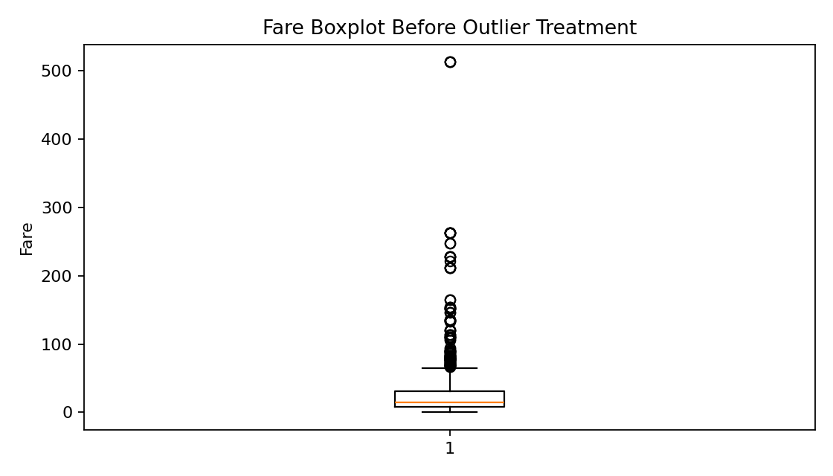
Figure 2. Fare distribution before outlier treatment.
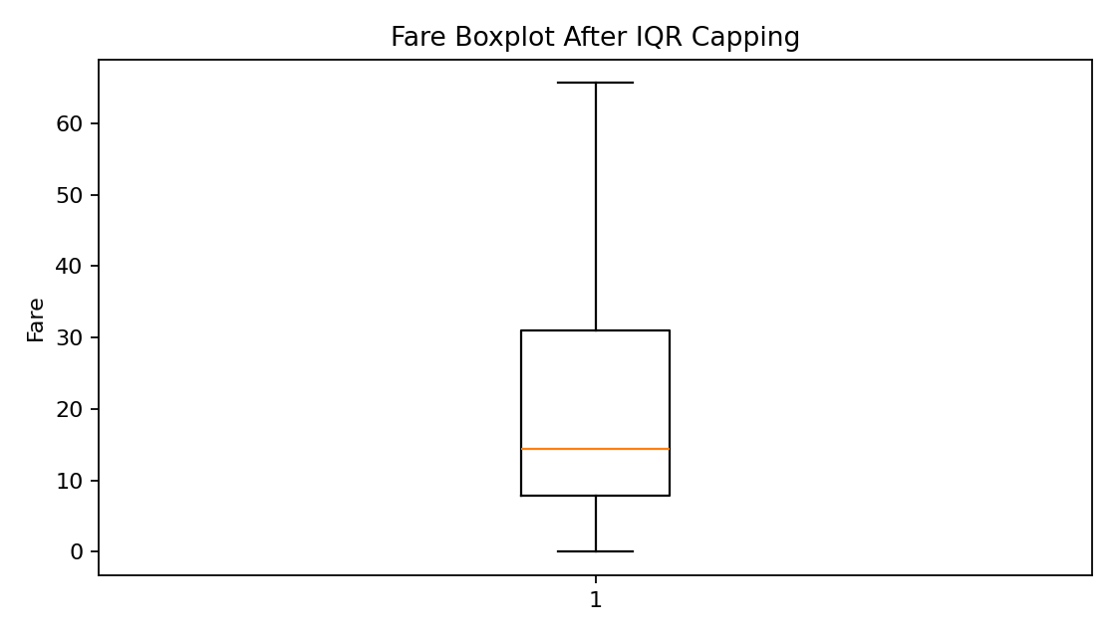
Figure 3. Fare distribution after IQR capping.

8. Preprocessing and Feature Engineering
After cleaning, two simple derived features were created. FamilySize is the total number of family members travelling with the passenger plus the passenger. IsAlone is a binary indicator equal to 1 when FamilySize is 1. Categorical variables Sex and Embarked were one-hot encoded for a model-ready version.
These transformations do not change the original meaning of the records; they make the data easier to use in subsequent statistical analysis or machine-learning models.

9. Complete Core Cleaning Code
clean = df.copy()
clean = clean.drop_duplicates()
for col in ["Sex", "Embarked", "Cabin"]:
clean[col] = clean[col].astype("string").str.strip()
clean = clean.replace(r"^\s*$", np.nan, regex=True)
clean = clean.drop(columns=["Cabin"])
group_medians = clean.groupby(["Pclass", "Sex"])["Age"].transform("median")
clean["Age"] = clean["Age"].fillna(group_medians)
clean["Age"] = clean["Age"].fillna(clean["Age"].median())
clean["Embarked"] = clean["Embarked"].fillna(clean["Embarked"].mode()[0])
Q1 = clean["Fare"].quantile(0.25)
Q3 = clean["Fare"].quantile(0.75)
IQR = Q3 - Q1
upper = Q3 + 1.5 * IQR
clean["Fare"] = clean["Fare"].clip(upper=upper)
clean["FamilySize"] = clean["SibSp"] + clean["Parch"] + 1
clean["IsAlone"] = (clean["FamilySize"] == 1).astype(int)
model_ready = pd.get_dummies(
clean, columns=["Sex", "Embarked"], drop_first=True, dtype=int
)
clean.to_csv("titanic_cleaned.csv", index=False)
model_ready.to_csv("titanic_model_ready.csv", index=False)

10. Final Data Quality Check
After preprocessing, the cleaned dataset contains 891 rows and 13 columns. All missing Age and Embarked values have been treated, Cabin has been removed because of excessive missingness, and extreme Fare values have been capped. The model-ready dataset additionally contains one-hot encoded categorical variables and has 14 columns.
Final missing-value check:
PassengerId 0
Survived 0
Pclass 0
Name 0
Sex 0
Age 0
SibSp 0
Parch 0
Ticket 0
Fare 0
Embarked 0
FamilySize 0
IsAlone 0
dtype: int64

11. Challenges Faced and Solutions
Challenge | Solution
Large number of missing Cabin values | Dropped Cabin instead of creating unreliable artificial values.
Missing Age values | Used grouped median imputation based on Pclass and Sex.
Extreme Fare values | Detected using IQR and capped instead of deleting potentially valid passengers.
Categorical consistency | Trimmed whitespace and checked allowed category values.
Choosing a suitable preprocessing method | Selected conservative transformations that preserve as much original information as possible.

12. Impact of Preprocessing on Future Analysis
- Handling missing values prevents statistical calculations and machine-learning algorithms from failing or being biased by incomplete records.
- Removing Cabin reduces dimensionality and avoids introducing a large amount of artificial information.
- Median imputation reduces the influence of extreme ages compared with mean imputation.
- Outlier capping reduces the influence of unusually high fares on statistical models.
- One-hot encoding converts categorical information into numerical form suitable for many machine-learning algorithms.
- Feature engineering such as FamilySize and IsAlone may provide useful predictive information that is not directly available from individual family-count columns.

13. Conclusion
The Titanic dataset was successfully inspected, cleaned and preprocessed. The process included data acquisition, structural exploration, missing-value analysis, categorical validation, numerical range checks, IQR-based outlier detection, conservative outlier treatment, feature engineering and one-hot encoding. The resulting cleaned dataset is more consistent and suitable for the next stages of analysis. The decisions were made with the objective of reducing data-quality problems while avoiding unnecessary deletion of potentially meaningful observations.

14. Files Submitted
- week1_data_cleaning.py
- titanic_cleaned.csv
- titanic_model_ready.csv
- 01_age_distribution.png
- 02_fare_boxplot_before.png
- 03_fare_boxplot_after.png
- 04_missing_values.png

Appendix A – Installation and Execution
Install the required packages with: pip install pandas numpy matplotlib scikit-learn
Then place train.csv in the same folder as week1_data_cleaning.py and run: python week1_data_cleaning.py

