WEEK 5 – DEEP LEARNING APPLICATION IN DATA SCIENCE
Titanic Passenger Survival Classification using PyTorch
Python • PyTorch • Multilayer Perceptron • Adam • Dropout • Early Stopping
1. Executive Summary
This report presents a practical deep learning application for predicting Titanic passenger survival. The project formulates survival prediction as a binary classification problem and implements a multilayer perceptron (MLP) using PyTorch. The cleaned and feature-engineered Titanic dataset developed in earlier weeks is reused so that the project forms a continuous data-science workflow.
The neural network uses 10 standardized input features, two hidden fully connected layers with ReLU activations, dropout regularization, and a single output logit. Adam optimization and binary cross-entropy loss are used for training. A separate validation set is monitored for early stopping to reduce overfitting. On the held-out test set, the model achieved 0.804 accuracy, 0.815 precision, 0.638 recall, 0.715 F1-score, and 0.855 ROC-AUC.
2. Problem Statement
The objective is to predict whether a passenger survived the Titanic disaster based on passenger class, age, family structure, fare, sex and embarkation information. The target variable is Survived, where 0 represents non-survival and 1 represents survival. A neural network is used to demonstrate how deep learning can learn non-linear combinations of tabular features.
3. Why Deep Learning for This Problem?
The Titanic dataset is small and does not require deep learning for a strong baseline. However, it is useful pedagogically because it allows the complete neural-network workflow to be demonstrated on a manageable public dataset. The MLP can learn non-linear feature interactions while keeping the architecture compact enough to train on CPU. This choice also makes resource constraints and overfitting visible, which are important practical deep-learning considerations.
4. Dataset and Feature Preparation
The model uses 891 Titanic records from the Kaggle public dataset after the preprocessing workflow established in Week 1. Ten predictors are used: Pclass, Age, SibSp, Parch, Fare, FamilySize, IsAlone, Sex_male, Embarked_Q and Embarked_S.
- FamilySize captures the total travelling family group.
- IsAlone indicates whether the passenger travelled without recorded family members.
- Categorical variables are represented numerically through encoded indicator columns.
- StandardScaler is fitted only on the training partition and then applied to validation and test partitions to prevent data leakage.
- The target variable Survived is never included among the model inputs.
5. Dataset Split
The dataset was split into 80% training and 20% test data using stratification. The training portion was then divided into 80% training and 20% validation. The resulting proportions are approximately 64% training, 16% validation and 20% test. The test set remained untouched during training and early-stopping decisions.
6. Network Architecture
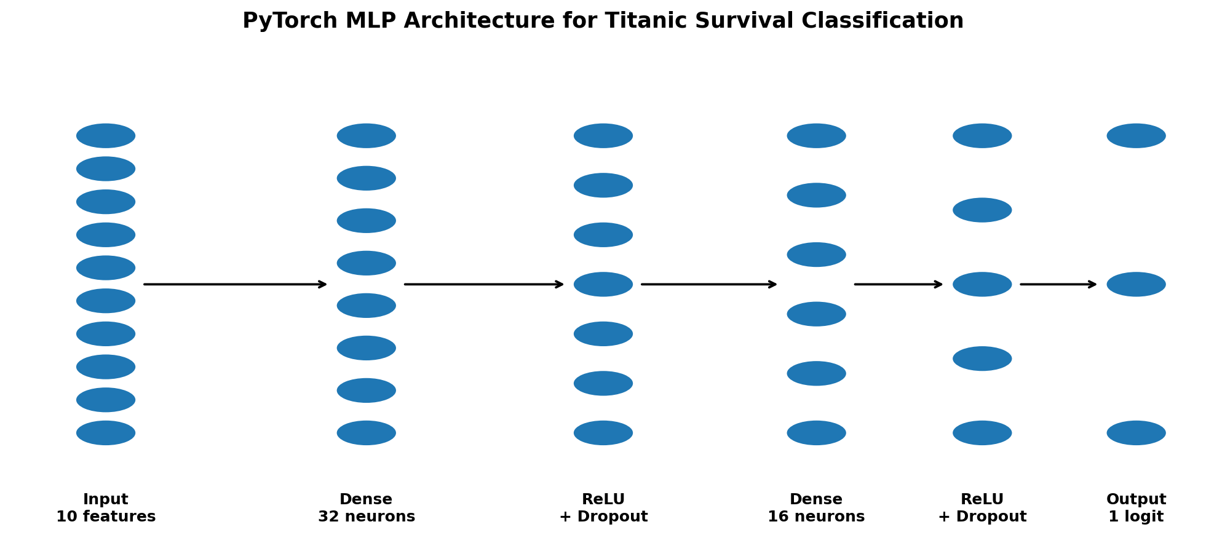
Architecture: 10 input features → Dense(32) → ReLU → Dropout(0.25) → Dense(16) → ReLU → Dropout(0.15) → one output logit. The final sigmoid probability is applied during inference.
7. Design Decisions and Hyperparameters
Component | Choice | Justification
Hidden layers | 32 → 16 neurons | Compact capacity for a small tabular dataset.
Activation | ReLU | Efficient non-linear activation that reduces vanishing-gradient issues.
Dropout | 0.25 and 0.15 | Regularization to reduce overfitting.
Output | 1 logit | Appropriate for binary classification.
Loss | BCEWithLogitsLoss | Numerically stable binary classification loss.
Optimizer | Adam | Adaptive and practical optimizer for neural networks.
Learning rate | 0.001 | Common stable starting point for Adam.
Batch size | 32 | Balances gradient stability and CPU memory use.
Early stopping | Patience 12 | Stops training when validation loss stops improving.
Random seed | 42 | Improves reproducibility.
8. Training Process
Training was performed using mini-batch gradient descent with the Adam optimizer. Each epoch processes the training batches, calculates binary cross-entropy loss, computes gradients through backpropagation, and updates the network weights. After each epoch, validation loss and validation accuracy are measured. The best model state is retained and training stops early if validation loss fails to improve for 12 consecutive epochs.
9. Key Code Segments
Model definition
class TitanicMLP(nn.Module):
def __init__(self, input_dim=10):
super().__init__()
self.net = nn.Sequential(
nn.Linear(input_dim, 32),
nn.ReLU(),
nn.Dropout(0.25),
nn.Linear(32, 16),
nn.ReLU(),
nn.Dropout(0.15),
nn.Linear(16, 1)
)
Training configuration
criterion = nn.BCEWithLogitsLoss()
optimizer = torch.optim.Adam(
model.parameters(), lr=0.001, weight_decay=1e-4
)
Prediction
with torch.no_grad():
probability = torch.sigmoid(model(X_test)).numpy().ravel()
prediction = (probability >= 0.5).astype(int)
10. Training Curves
Training and validation loss
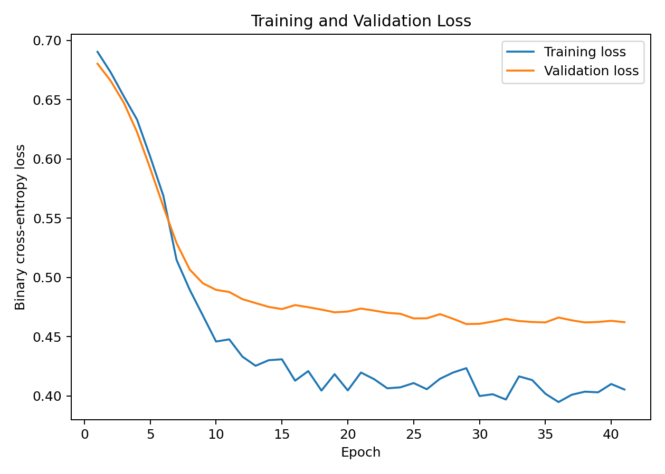
Training and validation accuracy
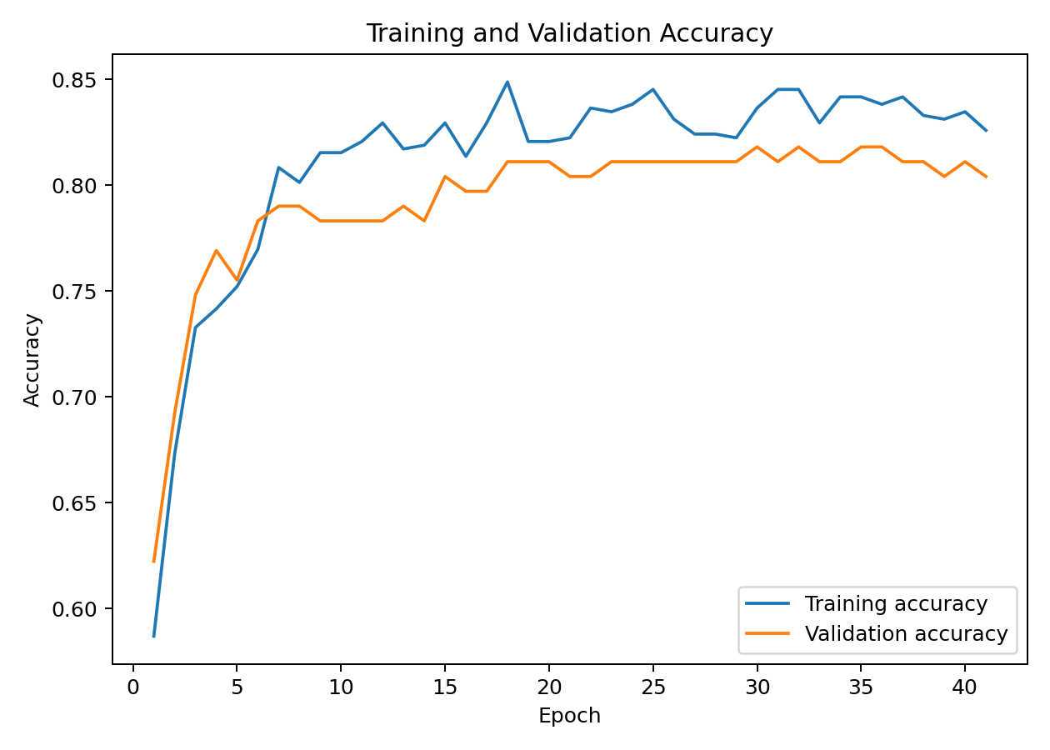
The training curves are important for diagnosing overfitting. If training loss continues to decrease while validation loss begins to rise, the model is memorizing training examples rather than improving generalization. Dropout, weight decay and early stopping were used together to control this risk.
11. Test Evaluation
Metric | Value
Accuracy | 0.8045
Precision | 0.8148
Recall | 0.6377
F1 | 0.7154
ROC_AUC | 0.8555
Confusion Matrix
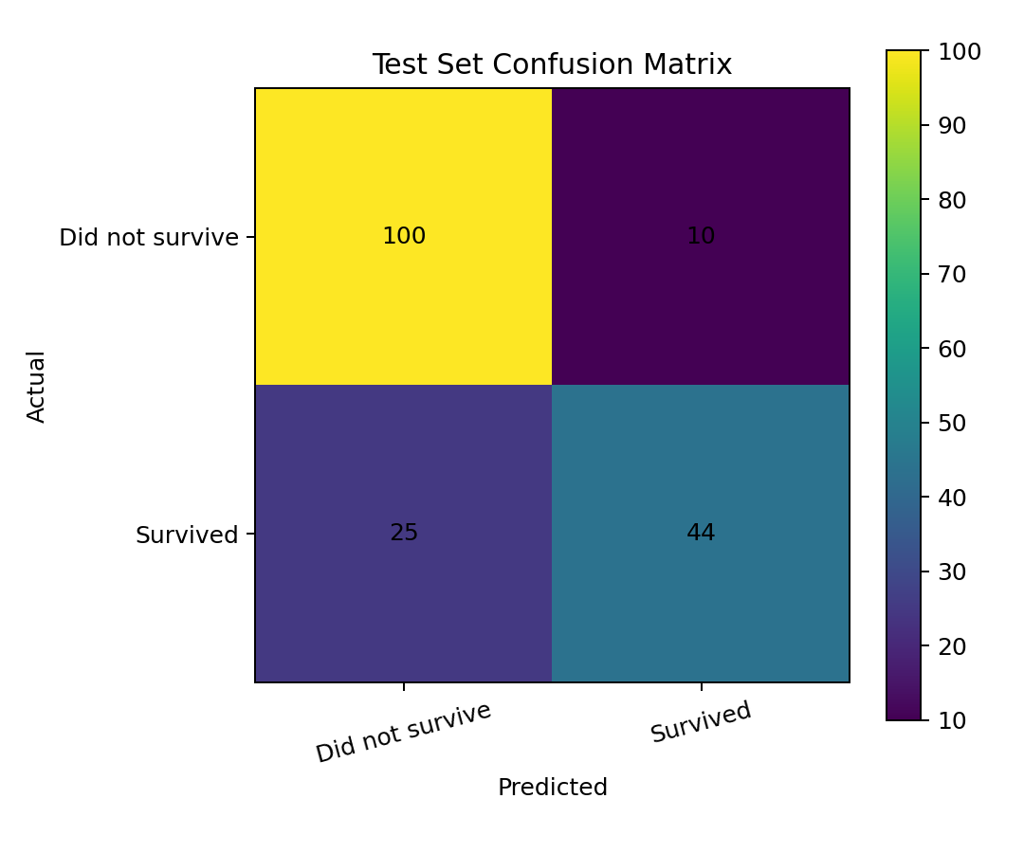
ROC Curve
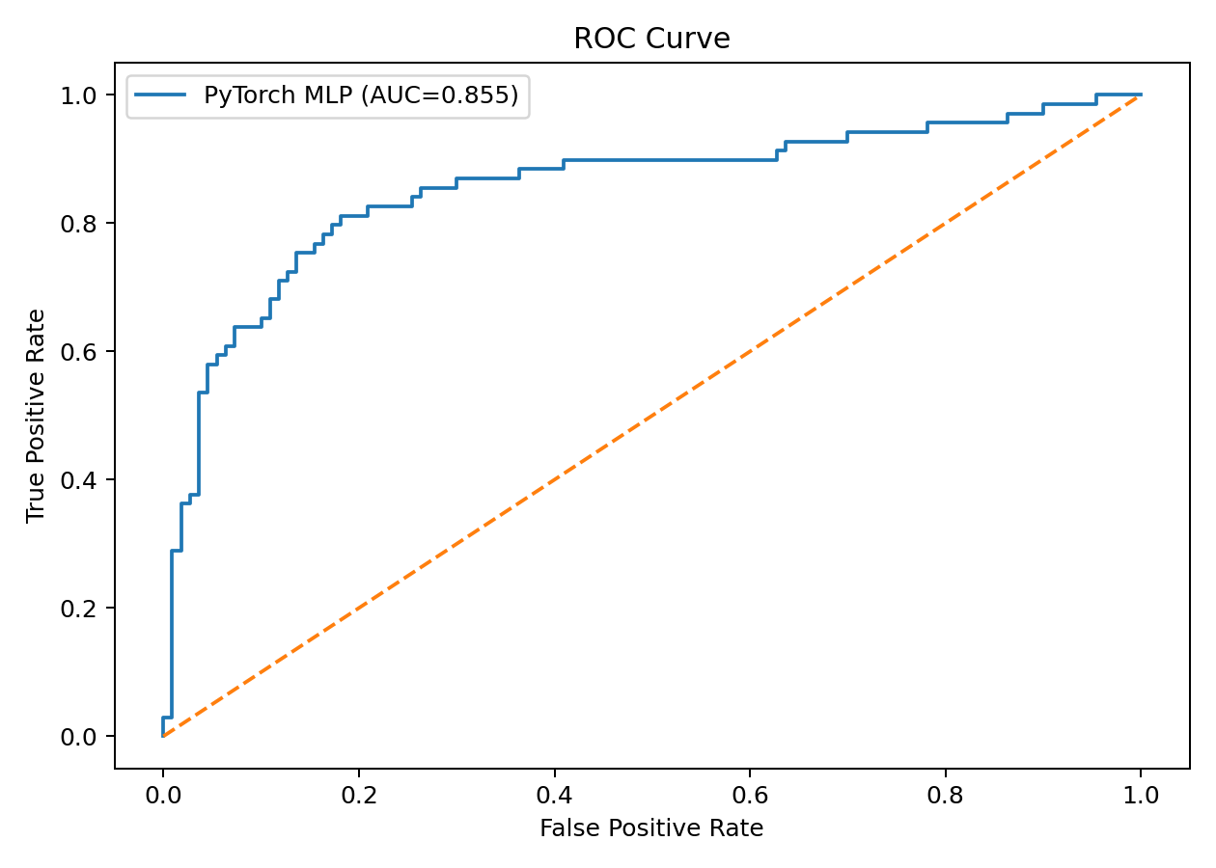
12. Critical Analysis of Results
The final neural network achieved 80.45% accuracy on the unseen test set. Precision was 81.48%, indicating the proportion of predicted survivors that were actually survivors. Recall was 63.77%, measuring how many actual survivors were successfully identified. The F1-score of 0.715 balances these two measures, while the ROC-AUC of 0.855 indicates useful ranking ability across thresholds.
The model should not be interpreted as a causal explanation of survival. Neural networks identify statistical patterns in the available variables. Because the Titanic dataset is relatively small and structured, the benefit of a neural network over simpler models may be limited. The main value of this task is demonstrating a complete deep-learning pipeline and understanding how architecture, regularization and validation affect performance.
13. Challenges Encountered and Solutions
Small tabular dataset: A large network could easily overfit. A compact 32→16 architecture, dropout and weight decay were used.
Overfitting risk: Validation monitoring and early stopping were added so the best validation model is restored.
Feature scale differences: StandardScaler was fitted on training data and reused on validation/test data.
Resource constraints: PyTorch was used with a small MLP that can run on CPU; no GPU is required.
Data leakage risk: The test set was isolated and the scaler was fitted only on training data.
Model interpretability: Evaluation uses confusion matrix and ROC curve, while the report explicitly distinguishes prediction from causation.
14. Strengths
- Uses a genuine neural-network framework (PyTorch) and a reproducible architecture.
- Separates training, validation and test data.
- Uses regularization and early stopping to address overfitting.
- Reports multiple evaluation metrics instead of accuracy alone.
- Includes architecture, training curves, confusion matrix and ROC analysis.
- Keeps preprocessing reproducible and avoids test-set leakage.
15. Limitations
- The Titanic dataset is small for deep learning, so a neural network is not necessarily the optimal production model.
- The feature set is mainly tabular and does not exploit unstructured data such as images or natural language.
- The model's internal decisions are less interpretable than a simple linear model.
- Results can vary with random initialization, train/validation splits and hyperparameter choices.
- The dataset represents a historical event and should not be used to make real-world safety decisions.
16. Possible Improvements
- Compare the MLP with deeper or wider architectures using systematic hyperparameter search.
- Use batch normalization or learning-rate scheduling where justified.
- Experiment with class weighting or threshold tuning if recall is prioritized.
- Add carefully justified engineered features such as passenger title and ticket-group information.
- Use repeated runs with multiple random seeds and report mean and standard deviation.
- For a stronger deep-learning demonstration, move to an image dataset and evaluate a CNN or transfer-learning model.
17. Conclusion
This project demonstrates the complete application of deep learning to a supervised data-science problem. A compact PyTorch multilayer perceptron was designed, trained and evaluated for Titanic survival classification. The workflow includes feature preparation, standardized inputs, architecture design, Adam optimization, dropout regularization, early stopping, validation monitoring and multi-metric test evaluation. The analysis also highlights an important practical lesson: deep learning is a tool, not automatically the best model for every dataset. For small structured datasets, simpler models may remain competitive, while neural networks become especially valuable when data volume, complexity or unstructured inputs justify their additional capacity.
18. Repository Contents
The accompanying repository contains the PyTorch source code, scaled train/validation/test datasets, standardization parameters, training history, test predictions, evaluation metrics, confusion matrix, architecture diagram, training plots, ROC curve and this complete report.

