WEEK 4 – SUPERVISED LEARNING MODEL IMPLEMENTATION
Titanic Passenger Survival Classification
Python • Pandas • Scikit-learn • Cross-Validation • Random Forest • Model Evaluation
1. Executive Summary
This report presents a complete supervised learning workflow for predicting passenger survival in the Titanic dataset. The problem is formulated as a binary classification task in which the target variable is Survived. The workflow continues the cleaned and engineered dataset prepared in Week 1 and follows a reproducible machine-learning pipeline: problem definition, feature selection, stratified train/test splitting, preprocessing, baseline modeling, hyperparameter tuning, cross-validation, test-set evaluation, visualization, interpretation, and discussion of limitations and improvements.
The analysis compares an interpretable Logistic Regression baseline with a tuned Random Forest classifier. The final Random Forest achieved a test accuracy of 0.799 and a 5-fold cross-validation accuracy of 0.824. Feature importance analysis was used to understand which passenger characteristics contributed most to predictions.
2. Problem Definition and Objective
The objective is to build a supervised classification model that predicts whether a passenger survived the Titanic disaster. This is a binary classification problem because the target has two outcomes: 0 (did not survive) and 1 (survived). The model can be viewed as an educational decision-support system for learning how demographic and travel-related variables can be used for prediction.
Research question: Can passenger characteristics such as class, age, fare, family structure, sex, and embarkation information predict survival with useful accuracy?
3. Dataset and Data Preparation
The public Titanic dataset was originally obtained from Kaggle and was cleaned during Week 1. The modeling dataset contains 891 passenger records. The target variable is Survived. The selected predictors were Pclass, Age, SibSp, Parch, Fare, FamilySize, IsAlone, Sex_male, Embarked_Q, and Embarked_S.
PassengerId was excluded because it is an identifier rather than a meaningful predictive feature. Name and Ticket were also excluded because they are high-cardinality text fields and were not required for this modeling workflow. The survival label was strictly excluded from the feature matrix to prevent target leakage.
4. Feature Engineering
- FamilySize = SibSp + Parch + 1, representing the total immediate travelling family group.
- IsAlone indicates whether the passenger travelled without recorded family members.
- Sex and Embarked were converted into numeric indicator variables during the previous preprocessing stage.
- Age was already imputed during Week 1; the modeling pipeline also contains a median imputer as a safety layer.
- Numerical scaling was applied to Logistic Regression because it is sensitive to feature magnitude. Random Forest does not require scaling.
5. Model Selection Rationale
Logistic Regression was selected as a baseline because it is simple, fast, interpretable, and appropriate for binary classification. It provides a useful reference point before applying a more flexible non-linear model.
Random Forest was selected as the final candidate because it can model non-linear relationships and interactions, handles mixed numerical and binary features well, is relatively robust to outliers, and provides feature-importance estimates. A small grid search was used to tune tree depth, minimum split size, minimum leaf size, and number of trees.
6. Training and Validation Strategy
The dataset was divided into 80% training data and 20% test data using a fixed random state of 42. Stratification was used so that the survival-class distribution remained similar in both subsets. The test set was kept unseen until final evaluation.
Within the training set, Stratified 5-Fold Cross-Validation was used. Each fold preserves the class proportions. GridSearchCV selected the Random Forest configuration with the best mean validation accuracy. This reduces dependence on a single validation split and gives a more reliable estimate of generalization.
7. Key Code Segments
Data split
X_train, X_test, y_train, y_test = train_test_split(
X, y, test_size=0.20, random_state=42, stratify=y
)
Logistic Regression pipeline
logistic = Pipeline([
("imputer", SimpleImputer(strategy="median")),
("scaler", StandardScaler()),
("model", LogisticRegression(max_iter=1000, random_state=42))
])
Random Forest tuning
params = {
"model__n_estimators": [200],
"model__max_depth": [None, 8, 12],
"model__min_samples_split": [2, 5],
"model__min_samples_leaf": [1, 2]
}
search = GridSearchCV(rf, params, cv=cv, scoring="accuracy", n_jobs=-1)
Evaluation
pred = best_model.predict(X_test)
prob = best_model.predict_proba(X_test)[:, 1]
print(accuracy_score(y_test, pred))
print(precision_score(y_test, pred))
print(recall_score(y_test, pred))
print(f1_score(y_test, pred))
print(roc_auc_score(y_test, prob))
8. Model Performance
Model | Accuracy | Precision | Recall | F1 | ROC-AUC
Logistic Regression | 0.804 | 0.783 | 0.681 | 0.729 | 0.844
Tuned Random Forest | 0.799 | 0.762 | 0.696 | 0.727 | 0.827
Best Random Forest parameters: {'model__max_depth': 12, 'model__min_samples_leaf': 1, 'model__min_samples_split': 2, 'model__n_estimators': 200}. The tuned model obtained a mean 5-fold cross-validation accuracy of 0.824 (standard deviation 0.021).
Figure 1. Model accuracy comparison
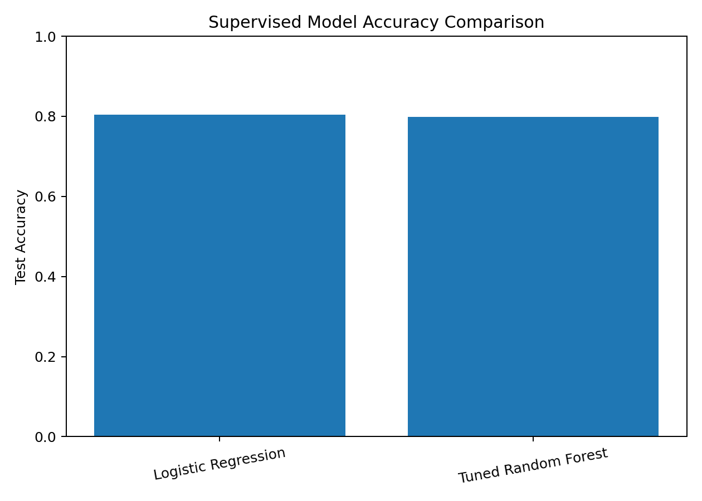
Figure 2. Random Forest confusion matrix
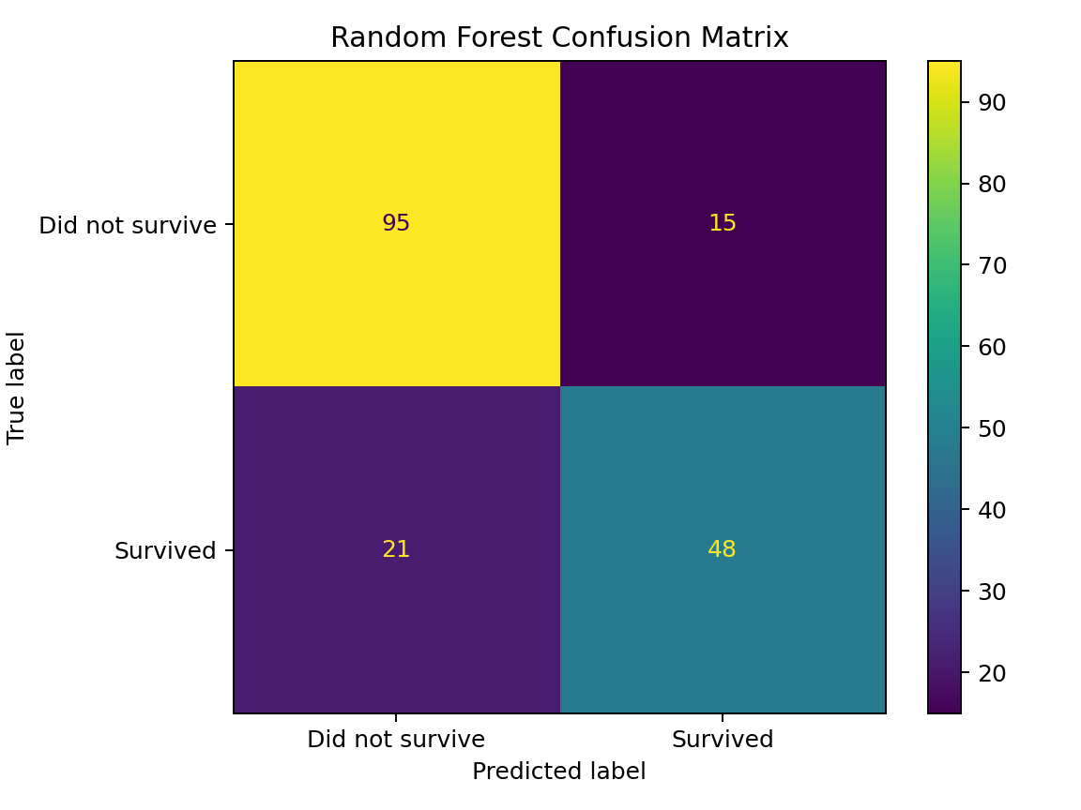
Figure 3. ROC curve comparison
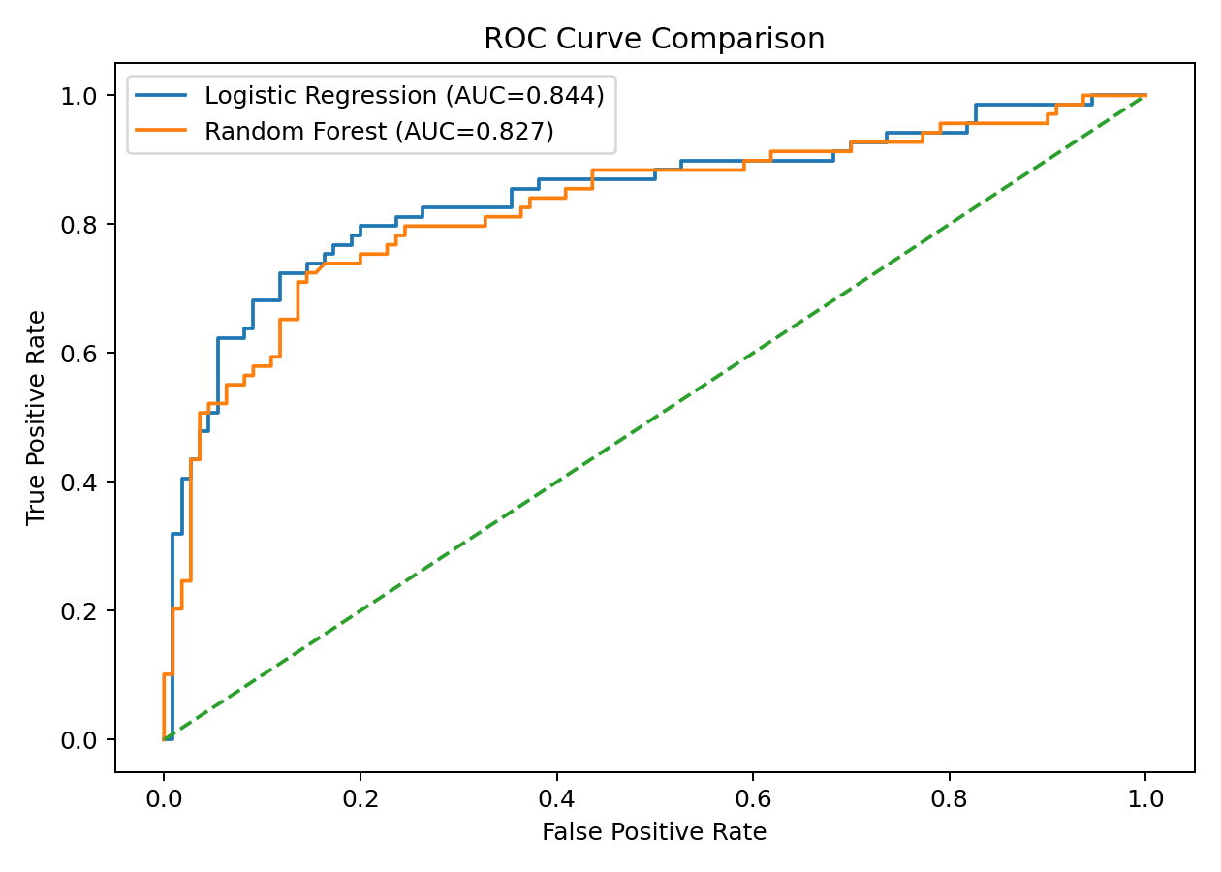
Figure 4. Random Forest feature importance
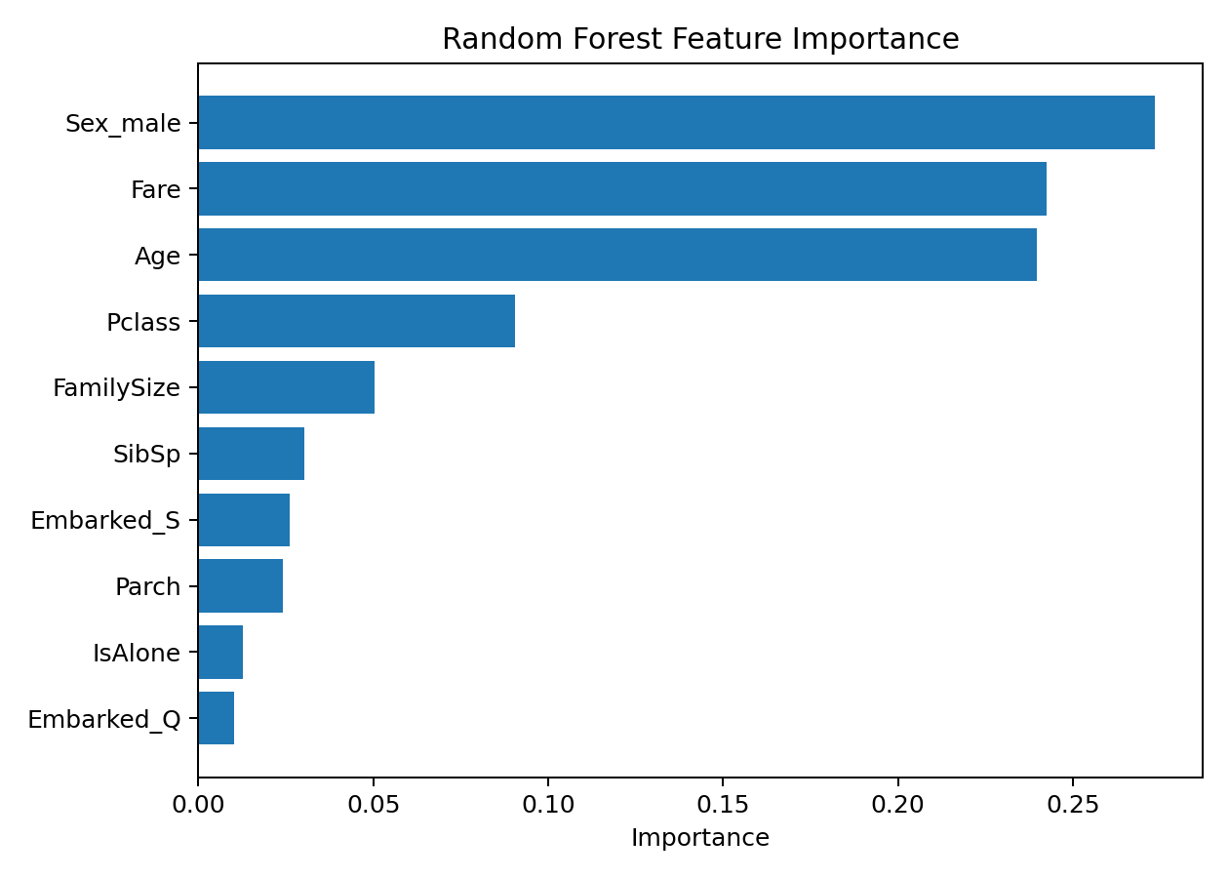
Figure 5. Cross-validation performance
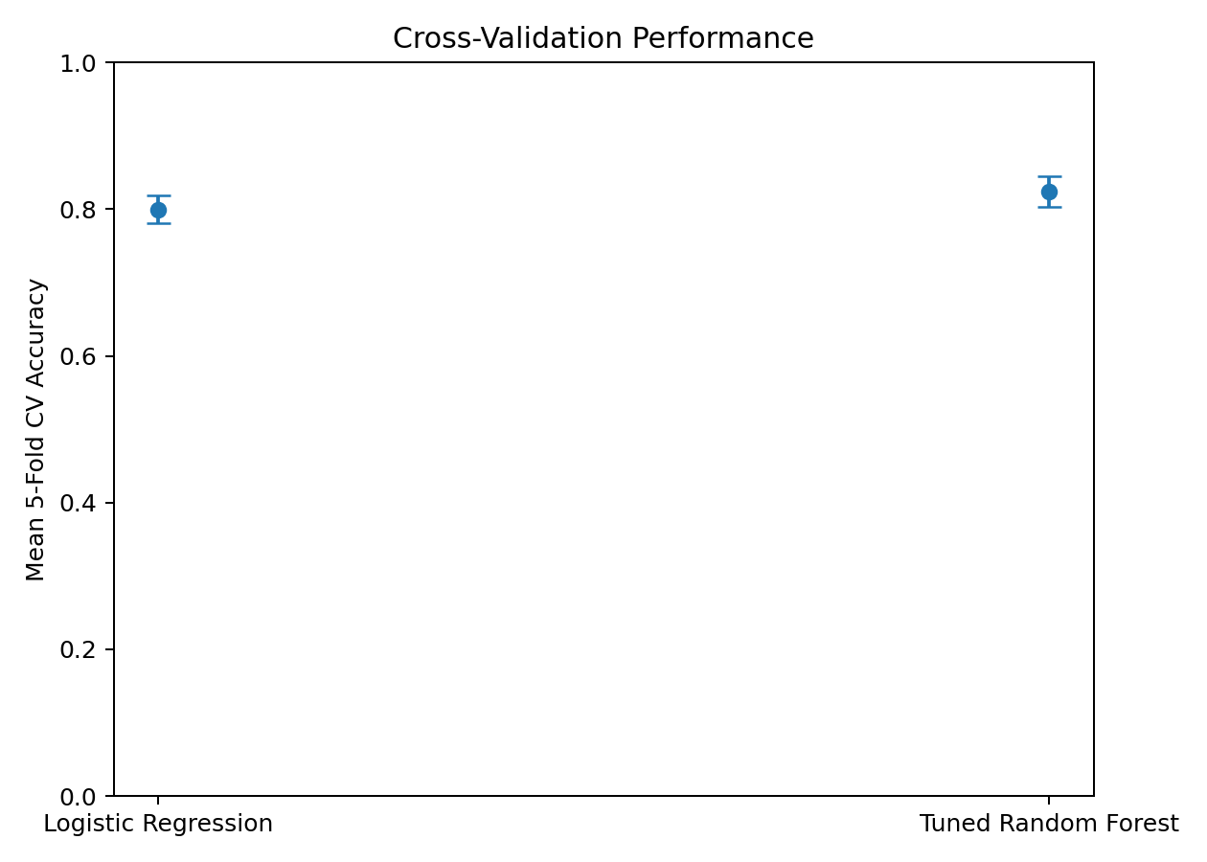
9. Performance Analysis and Interpretation
The Random Forest produced an accuracy of 0.799, precision of 0.762, recall of 0.696, F1-score of 0.727, and ROC-AUC of 0.827 on the unseen test set. The Logistic Regression baseline achieved an accuracy of 0.804. The comparison demonstrates the value of testing both an interpretable linear model and a flexible non-linear ensemble model.
Accuracy alone should not be treated as the complete measure of quality. Precision indicates how often predicted survivors were correct, while recall measures how many actual survivors were identified. F1-score balances precision and recall. ROC-AUC summarizes the model's ability to rank positive cases above negative cases across classification thresholds.
10. Feature Importance
- Sex_male: 0.2735
- Fare: 0.2425
- Age: 0.2397
- Pclass: 0.0905
- FamilySize: 0.0503
- SibSp: 0.0302
- Embarked_S: 0.0262
The feature-importance results provide an interpretable view of which variables the Random Forest used most strongly. In this dataset, passenger class, sex-related information, fare, age, and family-related variables are expected to be particularly informative. Feature importance indicates predictive contribution within the model; it does not establish causation.
11. Strengths of the Approach
- Uses a clear binary classification formulation with a well-defined target.
- Builds on a documented preprocessing pipeline rather than training on raw, inconsistent data.
- Uses stratified splitting and stratified 5-fold cross-validation to reduce validation bias.
- Includes an interpretable Logistic Regression baseline and a stronger non-linear ensemble model.
- Uses multiple evaluation metrics rather than relying only on accuracy.
- Provides confusion matrix, ROC curve, cross-validation analysis, and feature-importance visualizations.
- Keeps the final test set separate from hyperparameter tuning.
12. Limitations
- The Titanic dataset is historical and relatively small, so results should not be generalized to modern passenger-safety problems.
- Some potentially useful information, such as detailed ticket-group or title information, was excluded to keep the feature set compact.
- Random Forest feature importance can be affected by correlated predictors and should not be interpreted as causal evidence.
- The model was optimized mainly using accuracy; different applications could require cost-sensitive metrics or threshold optimization.
- The public dataset contains historical reporting limitations and does not represent a controlled experiment.
13. Possible Improvements
- Engineer additional features such as passenger title, ticket-group size, family survival aggregates, and cabin/deck information where justified.
- Compare additional algorithms such as Gradient Boosting, XGBoost/LightGBM where permitted, Support Vector Machines, or calibrated classifiers.
- Use randomized hyperparameter search for a larger search space.
- Tune the probability threshold according to the relative cost of false positives and false negatives.
- Use permutation importance or SHAP-style explanations for deeper interpretability.
- Evaluate repeated cross-validation and confidence intervals for more robust performance estimates.
14. Reproducibility
All analysis code, model data, metrics, predictions, figures, and this report are included in the Week 4 repository package. The workflow uses fixed random states so that the train/test split and model results can be reproduced in the same software environment.
15. Conclusion
This Week 4 task demonstrates a complete supervised learning workflow using the Titanic dataset. The project moves beyond preprocessing and exploratory analysis into predictive modeling, validation, and quantitative evaluation. Logistic Regression provides a transparent baseline, while the tuned Random Forest captures non-linear relationships and produces feature-importance insights. The final analysis shows how careful preprocessing, feature engineering, cross-validation, model selection, and multi-metric evaluation work together to create a reliable machine-learning workflow. The project also establishes a strong foundation for future work involving model interpretation, improved feature engineering, and more advanced ensemble methods.
16. Appendix – Full Implementation
The complete executable implementation is provided in the repository as `code/week4_supervised_learning.py`.

