Week 3 Task: Unsupervised Learning and Clustering Analysis
Titanic Dataset – K-Means Clustering

1. Introduction
This report applies unsupervised learning to the cleaned Titanic dataset used in Weeks 1 and 2. The objective is to segment passengers into groups with similar characteristics using K-Means clustering. Unlike supervised learning, clustering does not use the survival outcome to form the groups. Instead, it discovers structure from passenger characteristics such as class, age, family size, fare and family relationships.

2. Dataset and Objective
The Titanic dataset was obtained from Kaggle's Titanic: Machine Learning from Disaster competition. The Week 1 cleaned dataset is reused to maintain continuity. The objective of this task is to identify meaningful passenger segments and describe the characteristics of each segment.
Dataset source: https://www.kaggle.com/competitions/titanic/data

3. Why K-Means Clustering?
K-Means was selected because it is a simple, widely used clustering algorithm that partitions observations into K groups by minimizing the distance between observations and their assigned cluster centroids. It is appropriate for this dataset after numerical features are standardized. Standardization is important because variables such as Fare can have a larger numerical scale than variables such as Pclass or IsAlone.

4. Features Used for Clustering
The following passenger-level variables were used: Pclass, Age, SibSp, Parch, Fare, FamilySize, IsAlone. The Survived variable was deliberately excluded from the clustering input because it is an outcome/target variable. Using it would make the analysis less genuinely unsupervised.
- Pclass
- Age
- SibSp
- Parch
- Fare
- FamilySize
- IsAlone

5. Preprocessing
The selected numerical features were converted to numeric form and rows with unresolved missing values were removed for the clustering stage. The features were standardized using StandardScaler so that each feature contributes on a comparable scale. This prevents a high-magnitude feature such as Fare from dominating Euclidean distance calculations.

6. Choosing the Number of Clusters
K-Means requires the number of clusters to be specified. To avoid selecting K arbitrarily, models with K values from 2 to 6 were compared. The analysis used the elbow method through inertia and the silhouette score. A higher silhouette score generally indicates better separation and cohesion of the clusters. The selected value was K=6, which produced the highest silhouette score among the tested values.
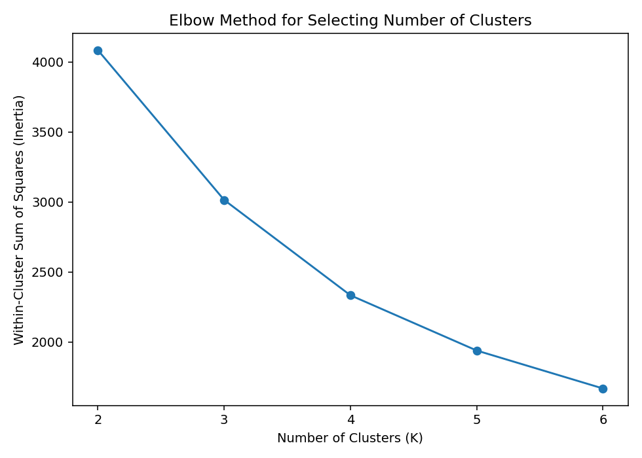
Figure 1. Elbow method comparison of K values.
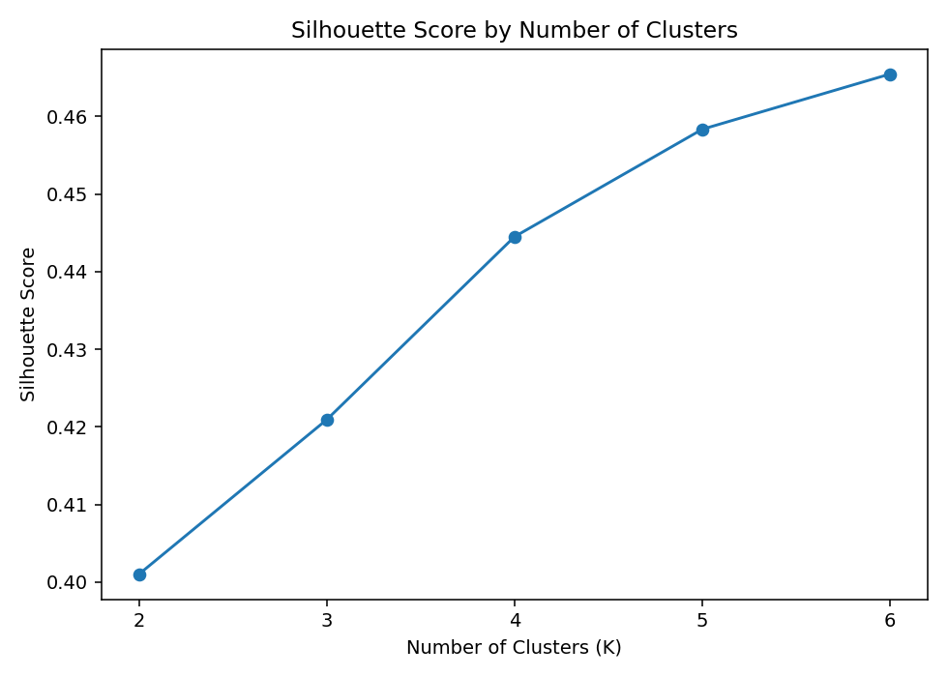
Figure 2. Silhouette scores for K=2 to K=6.

7. K-Means Results
The final K-Means model used K=6, random_state=42 and n_init=10. The best tested silhouette score was 0.465. The resulting cluster labels were added to the EDA-ready passenger data for interpretation.
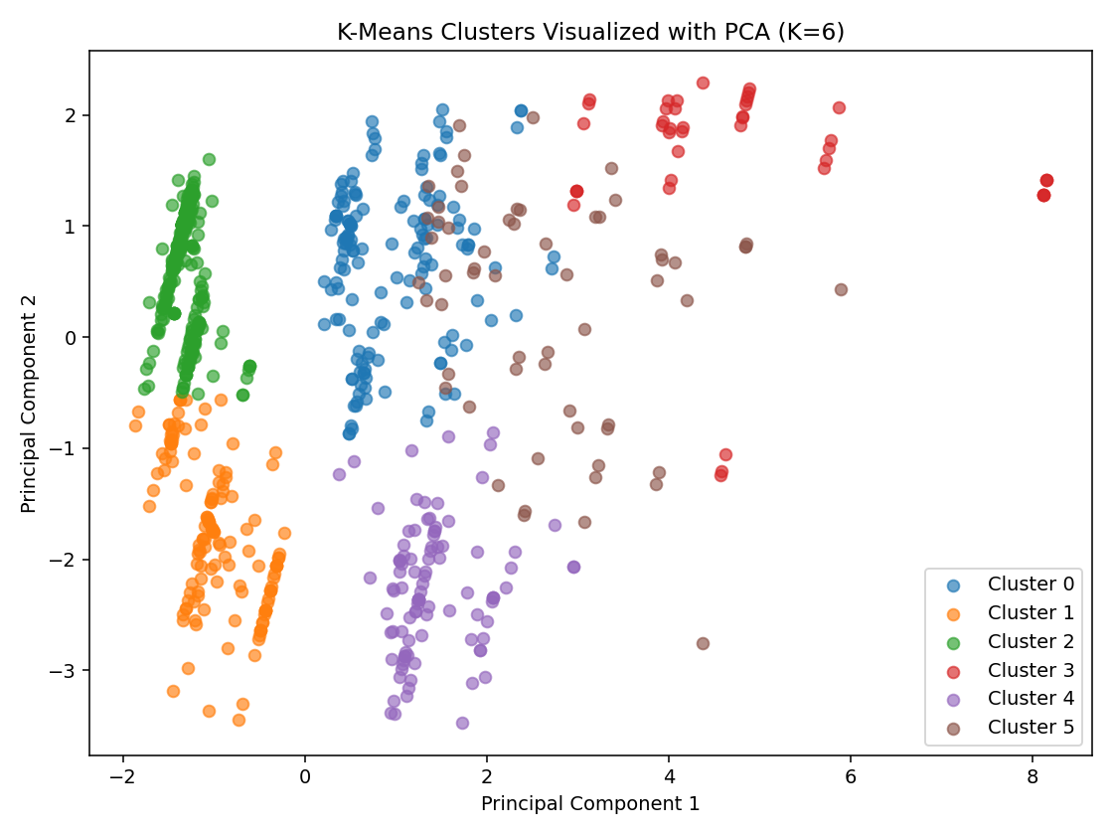
Figure 3. Two-dimensional PCA visualization of the K-Means clusters.

8. Cluster Characteristics
Cluster 0: 151 passengers. Average profile: Pclass=2.64, Age=23.25, SibSp=1.02, Parch=0.45, Fare=18.63, FamilySize=2.47, IsAlone=0.00.
Cluster 1: 139 passengers. Average profile: Pclass=1.23, Age=42.54, SibSp=0.00, Parch=0.00, Fare=35.67, FamilySize=1.00, IsAlone=1.00.
Cluster 2: 398 passengers. Average profile: Pclass=2.81, Age=26.98, SibSp=0.00, Parch=0.00, Fare=9.80, FamilySize=1.00, IsAlone=1.00.
Cluster 3: 44 passengers. Average profile: Pclass=2.86, Age=12.18, SibSp=4.43, Parch=1.64, Fare=39.57, FamilySize=7.07, IsAlone=0.00.
Cluster 4: 99 passengers. Average profile: Pclass=1.08, Age=38.96, SibSp=0.82, Parch=0.48, Fare=60.26, FamilySize=2.30, IsAlone=0.00.
Cluster 5: 60 passengers. Average profile: Pclass=2.28, Age=23.08, SibSp=0.60, Parch=2.53, Fare=34.12, FamilySize=4.13, IsAlone=0.00.
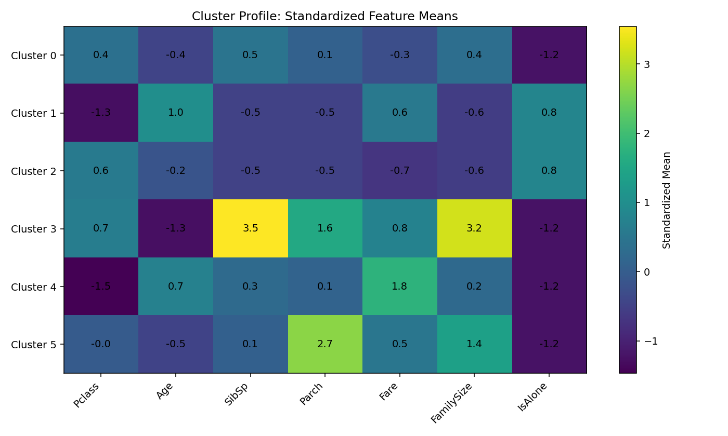
Figure 4. Standardized cluster feature profiles. Positive values indicate above-average feature values within the overall dataset, while negative values indicate below-average values.

9. Post-Clustering Interpretation Using Survival
Survival was not used to create the clusters. It was examined afterward only as an interpretive variable to understand whether the naturally formed passenger segments also differed in survival outcomes. This preserves the unsupervised nature of the clustering stage.
- Cluster 0: survival rate 47.02%
- Cluster 1: survival rate 48.20%
- Cluster 2: survival rate 24.12%
- Cluster 3: survival rate 11.36%
- Cluster 4: survival rate 69.70%
- Cluster 5: survival rate 56.67%
These survival differences are descriptive and should not be interpreted as proof that cluster membership causes survival. The clusters summarize combinations of passenger characteristics.

10. Business and Research Implications
Although the Titanic dataset is historical, the clustering workflow demonstrates a general segmentation approach applicable to modern datasets. For example, the same method could segment customers by spending and engagement, patients by clinical measurements, or products by usage patterns. In this project, the clusters provide a compact way to describe passenger groups with different class, age, fare and family profiles.

11. Core Code
# Week 3: Unsupervised Learning and Clustering Analysis
import pandas as pd
import matplotlib.pyplot as plt
from sklearn.preprocessing import StandardScaler
from sklearn.cluster import KMeans
from sklearn.metrics import silhouette_score
from sklearn.decomposition import PCA
df = pd.read_csv("data/titanic_eda_dataset.csv")
features = ['Pclass', 'Age', 'SibSp', 'Parch', 'Fare', 'FamilySize', 'IsAlone']
X_df = df[features].apply(pd.to_numeric, errors="coerce").dropna()
# Scale features because K-Means is distance-based.
scaler = StandardScaler()
X = scaler.fit_transform(X_df)
# Compare K=2 to K=6 using inertia and silhouette score.
scores = []
models = {}
for k in range(2, 7):
model = KMeans(n_clusters=k, random_state=42, n_init=10)
labels = model.fit_predict(X)
scores.append((k, model.inertia_, silhouette_score(X, labels)))
models[k] = model
scores_df = pd.DataFrame(scores, columns=["K", "Inertia", "Silhouette"])
best_k = int(scores_df.loc[scores_df["Silhouette"].idxmax(), "K"])
# Final K-Means model
model = models[best_k]
X_df["Cluster"] = model.labels_
print(scores_df)
print(X_df.groupby("Cluster")[features].mean())
# PCA visualization
pca = PCA(n_components=2, random_state=42)
X_pca = pca.fit_transform(X)
plt.scatter(X_pca[:, 0], X_pca[:, 1], c=model.labels_)
plt.title(f"K-Means Clusters Visualized with PCA (K={best_k})")
plt.xlabel("Principal Component 1")
plt.ylabel("Principal Component 2")
plt.show()
The complete executable code is included in the GitHub repository as code/week3_clustering.py.

12. Challenges and Solutions
- K-Means requires a predefined K, so multiple K values were evaluated instead of choosing one arbitrarily.
- Features had different numerical scales, so StandardScaler was applied before clustering.
- The survival outcome was excluded from the clustering input to preserve the unsupervised-learning objective.
- Cluster labels themselves do not have an inherent order; interpretation was therefore based on feature profiles rather than label numbers.
- PCA was used only for visualization because the original clustering was performed in the standardized multi-dimensional feature space.

13. Limitations
K-Means assumes relatively compact, distance-based groups and can be sensitive to feature selection and scaling. The Titanic dataset is also a historical passenger dataset, so its clusters should not be generalized to unrelated populations. The selected K is dependent on the candidate range tested and the chosen evaluation metric.

14. Conclusion
This task successfully applied K-Means unsupervised learning to the Titanic dataset. After preprocessing and standardization, multiple cluster counts were evaluated using inertia and silhouette score, and K=6 was selected for the final model. The resulting clusters provide interpretable passenger segments based on demographic, class, fare and family-related characteristics. The analysis demonstrates the complete workflow of selecting features, preprocessing, choosing cluster count, fitting K-Means, visualizing results, and interpreting cluster profiles.

15. Files Included
- code/week3_clustering.py
- data/titanic_clustered_data.csv
- data/k_selection_metrics.csv
- data/cluster_summary.csv
- data/cluster_survival_rates.csv
- 01_elbow_method.png
- 02_silhouette_scores.png
- 03_pca_clusters.png
- 04_cluster_profile_heatmap.png
- report/Week3_Unsupervised_Learning_Clustering_Report.docx

