The Cost of a Miss: Reinforcement Learning Driven Cache Eviction

Suhas Ramesh Vittal
Department of Computer Science
Golisano College of Computing and Information Sciences
Rochester Institute of Technology
Rochester, NY 14586
sv6218@rit.edu

Abstract—Distributed data processing frameworks like Apache Spark rely on cache to minimize Query latency. Partitions in Spark are heterogeneous in terms of computation cost but the default cache policy LRU treats them as equal, leading to suboptimal evictions that directly affect tail latency. In this work we propose a cost aware reinforcement learning agent designed to optimize for long term data recovery cost. This implements a Double Deep Q-Network trained on Spark event simulator that mimics Spark’s partition pruning, filter pushdown behavior and utilizing a diverse set of eviction policies. Compared to previous approaches that maximize on cache hit performance this agent utilizes a cost centric reward function aiming to minimize recomputation penalties. Experimental results demonstrate that the agent shows an average improvement of 35% for P99 latency and an average improvement of 12% for cache hit. The agent also exhibits strong generalization by maintaining an average 12% improvement over LRU on unseen query patterns.
Keywords: Apache Spark, Distributed Caching, Deep Reinforcement Learning, Double DQN, Cost-Awareness, Tail Latency Optimization, Offline RL.

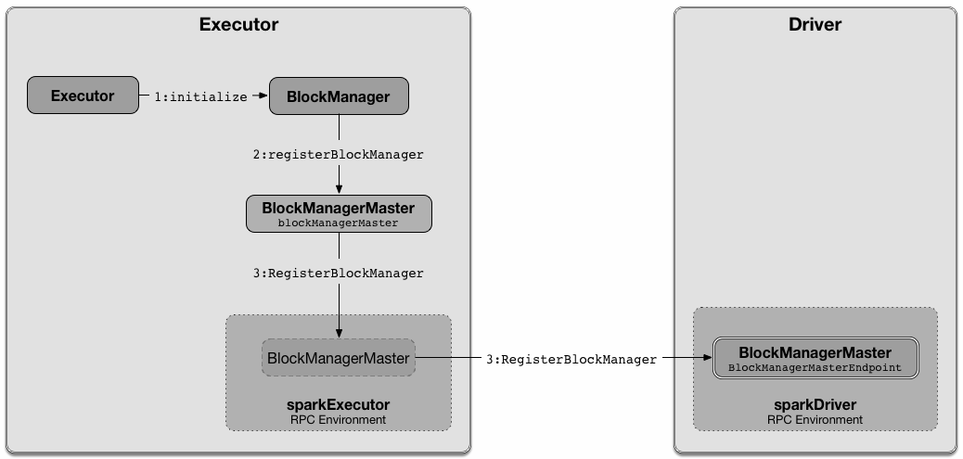
Introduction
Figure 1.1: Apache Spark Executor Architecture highlighting the BlockManager.
With the explosion of web data such as logs, search indexes, clickstreams etc in the early 21st century, companies had to handle data on the petabyte scale, processing or storage of data at this scale was proving to be difficult with traditional database systems. To handle this Hadoop was developed as an open source distributed storage system (HDFS) and a large-scale distributed processing system (MapReduce) was adopted. Hadoop’s MapReduce model was limited by its disk I/O costs and batch processing framework, leading to the development of Spark. Spark was an in-memory distributed processing system that supported multiple processing methods such as batch,stream and machine learning workloads.
In any system caching plays an important role in the performance of a system. Resilient Distributed Dataset(RDD) is the fundamental data abstraction in Spark, it is an immutable distributed collection of objects. Spark works on the concept of lazy evaluation, in Spark functions on data are split into two, transformations and actions, when a transformation is made, it is noted down at that stage but no modifications are done to the data. Modifications to data are only triggered by actions, when an action is performed all previous noted down transformations are applied in the order they were requested and modified data is obtained; this is a single Spark job
Performance in Spark is reliant on the BlockManager which is responsible for caching intermediate results in RAM to avoid recomputation. In distributed systems not all data is created equal, for example for data being generated city wise there can be heterogeneity among cities, similarly partitions in Spark are not created equal, some partitions can be called “light” where they contain less data or are computationally inexpensive to recompute on the other side “heavy” partitions are computationally expensive and directly affect system performance. The difference in computation between a light and heavy partition can be 900ms+.
Partition complexity plays a crucial role in a Spark job’s performance. This makes the cache and cache eviction policy of Spark critical. Despite this Spark defaults to Least Recently Used (LRU). LRU has two problems since it is a static policy it does not have adaptability for any change in workload patterns. Secondly LRU treats all partitions as equal, this brings about cost blindness where light and heavy partitions are treated equally, but their difference in recomputation cost makes them anything but equal. Imagine if LRU cache evicts a heavy partition that costs 1000ms + to recreate while light partitions that cost 10ms are in the cache. This would occur if the eviction policy is blind to cost.
To solve this problem an reinforcement learning (RL) algorithm is developed that has an adaptable cache eviction policy, that changes with change in workload and optimizes to improve system performance. A simulator is developed to mimic Spark Executor cache environment to cache state variables at a partition and cache level for a RL environment. The RL model uses a cost aware approach where a partition eviction comes with a penalty that is related to recomputation cost of that partition. This approach is a shift from discrete reward modeling around cache hit maximization.
We demonstrate how to stabilize RL model training in a high variance environment using Double Deep Q-Network (DDQN), Huber Loss and soft target model updates. The model also utilised feature normalization to avoid gradient explosion. This helps overcome oscillation in training faced by previous works. Unlike studies that test on static data, I test this on a Unseen workload and Phase Shift workload proving the model learns a generalized policy rather than memorizing training logs.
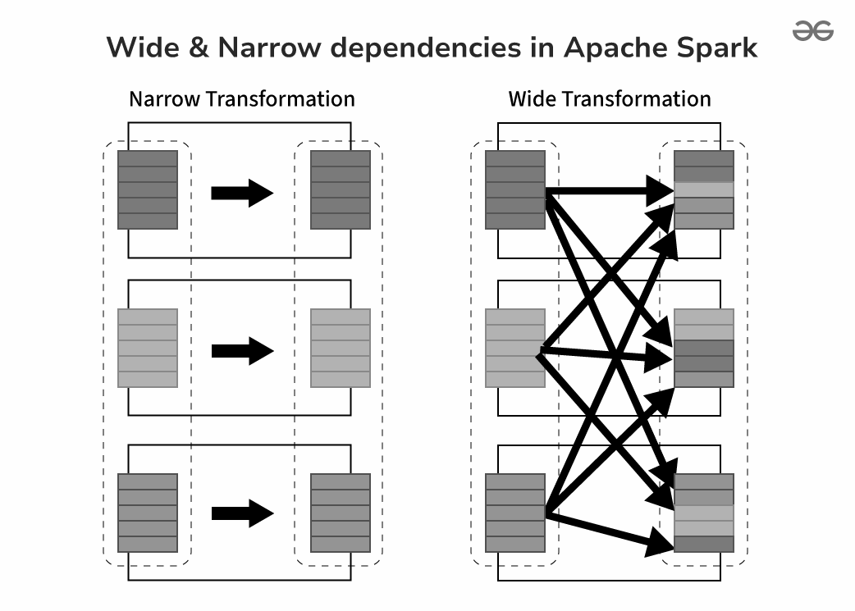
Figure 1.2: Comparison of Narrow Dependencies and Wide Dependencies.

Related Work
Traditional algorithms have been widely used in database and operating systems, while their deterministic nature of execution does guarantee stability of performance, this comes at the cost of adaptability. The Least Recently Used (LRU) algorithm operates on the assumption that recently used data will likely be used again, this algorithm is widely adopted and is also used in Apache Spark. While LRU has a performance of O(1), it is impervious to cost. It treats all cache misses as equal and doesn’t factor in cost to recompute or load expensive computations into the cache. In distributed frameworks such as Spark not all partitions are equal, simpler ones can be made up of less data or simplistic queried data. Other partitions are made up of large data or data generated from complex queries and joins, yet LRU treated them as equal.
To overcome the cost blindness of LRU, an algorithm such as Adaptive Replacement Cache (ARC) was developed. ARC keeps track of both recency and frequency. It maintains a ratio between the two. ARC consists of two lists and adjusts the size of frequency based tracking list or recency based tracking list based on the hits on the evicted metadata of both styles. If workload is moving towards a localized pattern then it increases the size of the recency list. It increases the size of the frequency list if workload shifts towards repeated access. This gives ARC better adaptability over LRU.
While ARC is better than LRU in terms of adaptability, it still suffers from cost blindness. In recent years there has been a shift towards learned systems that try to predict future access probabilities for workloads and base decisions on this, early works such as Belady’s MIN approximation that evict objects from cache that are furthest in future in terms of utilizations. Most of such works are based on improving the raw cache hit ratio. Cache hit ratio is a measure of efficiency of the cache that is the amount of data in the cache that matches the system requirement at that instant.
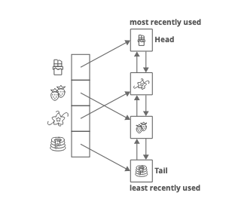
Figure 2.1: Standard Least Recently Used (LRU) using a doubly linked list.

Improved cache hit ratio would be the perfect metric to optimize for if all partitions in the cache were equal, since this is not the case I intend to work towards optimizing for ‘heavy’ partitions. These are partitions that are the most computational expensive to reload due to size or complexity in generation. An improved cache hit ratio will not be useful if the 1% of misses account for ‘heavy’ partitions that are computationally expensive, these partitions slow down the system. The model makes a decision which is an amalgamation of balancing cost of partitions and its future requirement, with this I aim to reduce the gap between learned caching and latency optimization for Apache Spark.

System design
To recap Spark Executor is the component of Spark that performs operations on the data. Each executor has multiple partitions in it, usually with fixed memory. Like any system it utilizes a cache to speed up computations, the cache is made of partitions as per the policy of the cache. Training a reinforcement learning (RL) model requires millions of interactions with its environment. Running this on an actual Spark environment is slow due to the Java Virtual Machine (JVM) start up times and network overheads. To overcome this, a simulator mimicking the memory management of Spark’s block manager was developed. This is a lightweight and efficient simulator that provides quick integration while maintaining characteristics of Spark Executor’s memory management.

3.1 Spark Executor Model
The simulator is modeled after the Spark Executor. Particularly it is modeled to capture the state of the cache before and after an eviction. The Executor is of fixed memory and the cache is also fixed in size but these are tunable parameters.The data ingested from a source is split between multiple Executors. In an Executor the data is then split into ‘N’ partitions, some partitions are in the cache while others are in memory. For every partition meta data is calculated and stored in the partitions. Partitions are treated as the smallest immutable blocks of data. Each query is made up of multiple predicates that is a datapoint that is matched to or in range of a particular value. The meta data of partitions are compared with query predicates for matches without accessing data in partitions. This helps Spark and the simulator speed up query execution. The data points that are tracked at the partition level are
- Size
- Recomputation Cost
- Access Statistics
- Frequency
- Recency
- Query Match (Boolean)
- Match Ratio
Recomputation cost is the penalty to reload the partition into cache. Query Match is a boolean value that indicates if the query matches any data points of the partition. Match Ratio indicates the number of rows of data that match the query for a given partition.

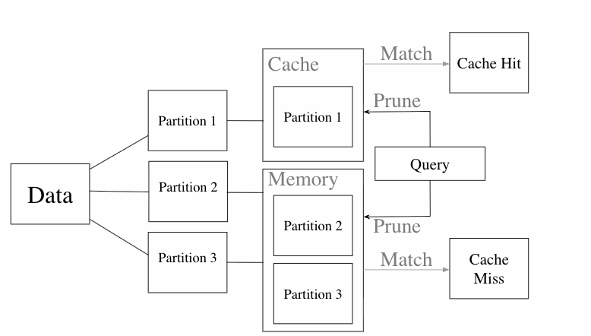 Figure 3.1: Logic flow of simulator illustrating reward for cache hit and penalty for cache miss.

3.1.2 Query Execution & Filter Pushdown
Apache Spark speeds up query execution time using filter pushdown, this is emulated in the simulator, when a partition is created the meta data is calculated for each partition. For numerical data this is a minimum and maximum range. Each query comes with predicates, for example a partition’s meta data is compared with predicates to check if it contains data relevant to the query without checking actual data in the partition, this speeds up query execution. So when a query is passed to the simulator, it fetches all the partitions that match the query, this creates a realistic access pattern where a group of related partitions become “hot” simultaneously.

3.1.3 The Eviction Lifecycle
- Fetch all partitions that match the query
- Loop For every partition Pi
- Check if Pi is part of cache
  - True : No cost
  - False: Recomputation penalty added to total cost
  - If Cache is full:
    - False: Pi added to cache
    - True: Eviction triggered and Pv selected
      - Pv evicted from cache
      - Pi added to cache
  - Pv cost recorded P99 analysis

The simulator is used to capture cache state and latency associated with cache eviction. A cache eviction is triggered when a cache “miss” occurs and the cache is full. Cache “miss” is when a partition that matches a query but it is not present in the cache, this partition is inserted into the cache, if the cache is full an eviction is triggered to make space for the partition. A cache “hit” signifies that the partition that matched the query was in the cache.The loop explains a cache eviction cycle. For a given query all matched partitions are fetched, if a partition constitutes a cache “hit” its cost is treated as zero. A query “miss” with a full cache triggers an eviction, where a selected partition is evicted to make way for the current partition, and the Recomputation penalty associated with that partition is added to the overall cost of query execution. The recomputation cost of the evicted partition is also stored for future analysis.

Feature | Description
size_in_memory | The raw memory footprint of the partition (e.g., 500 MB).
relative_size | The partition's size normalized against total cache capacity (used for neural network scaling).
recomputation_cost | The latency penalty (in ms) required to reload or recompute this partition (proxy for Lineage Complexity).
access_frequency | The total number of times this partition has been accessed (Hit + Miss).
time_since_last_access | The simulation timestamp delta since the last read operation (Recency).
is_cached | A binary flag (0 or 1) indicating if the partition is currently resident in memory.
query_match_flag | A binary flag (0 or 1) indicating if the current active query requires this specific partition (based on Filter Pushdown).
Table 3.1: Description of Partition level features

3.2 Reinforcement Learning Formulation (MDP)
The simulator provides an environment to capture data and simulate Spark’s eviction process. This is modeled after a Markov Decision Process (MDP). MDP is a mathematical framework to describe a reinforcement learning (RL) environment.
Markov : This states that for a RL model to make a decision only the current state is required and the model does not need to look back into the states of the past
Decision Process : Observe State => Take Action => Get Reward => New State.
This describes the process of making a decision. It starts with an observation of the current state, an action is decided based on this , after an action an associated reward/penalty for the action is provided, this moves the environment into a new state and the cycle continues. This loop is referred to as a decision process. The core components that need to be modeled for the MDP process are state , action , reward and discount factor. Discount factor is used to balance between present and future impact of the action.
3.2.1 State Representation
The state is the snapshot of the environment that is visible to the reinforcemental model. The state consists of three distinct feature groups, first is utility features of all the partitions present, a workload context vector and a global cache state.
Partitions utility features : Cache is made up of partitions and for each partition we track Frequency, Recency , Relative size , recomputation cost and query relevance. These values help identify the current and future relevance of each partition.
Workload context : Queries are made up of predicates, based on the target of each predicate we can classify the query between Temporal, Categorical and Numerical. Temporal is associated with a range of values hence partitions having similar or closer in data are matched by temporal queries. Categorical queries are binary in nature with respect to matching a value. Numerical queries are matched using the partition’s meta data. The query is assigned a one hot vector encoding based on the workload context analysed by the query predicates.
Global Cache State: This captures utility features of the cache such as memory occupied , this is a reference of pressure on the cache to evict. Next is a rolling eviction rate that indicates how often the cache has been evicting partitions and to monitor if cache is in a ‘thrashing’ phase or close to it. ‘Thrashing’ refers to a state of cache where it is continuously evicting due to continuous cache “miss” over a longer time period.
Unlike black box approaches where they infer workload patterns from access history, splitting the state into three main components helps agents instantly adapt its eviction strategy to instantaneous and long term workload patterns.

3.2.2 Action Space
Cache eviction is a discrete process. From the possible candidates in the cache any one candidate has to be evicted to make space for arriving candidates. Some systems limit the candidates under contention for eviction to top K rather than the whole cache to boost performance. In this action space all partitions in the cache are considered and a no eviction option as well. This increases the action space of the model and does not force it to always evict partitions from the cache if the cache has all relevant partitions for current and future workload patterns. Here the action space has six possible values, five for any of the 5 partitions in the cache and one for no eviction.
The agent doesn’t output a raw index , it assigns a Q-value to all possible actions , here the Q-value indicates the relevance of the partition. The lowest Q-value is either the partition evicted or no eviction.

Feature | Description
Combined Partition level features | All state features of cached partitions
cache_utilization_rate | The percentage of total cache memory currently in use (Used / Total).
eviction_rate | A rolling average of evictions per time step (indicates thrashing/pressure).
query_type_vector | A one-hot encoded vector representing the current query intent (e.g., [1, 0, 0] for Temporal).
average_cost_in_cache | The mean recomputation cost of all currently cached items (provides a baseline for value comparison).
Table 3.2: Description of Cache level features

3.2.3 Reward Function
A reward is the value assigned for a state and action pair. The reward function plays a crucial role in a reinforcement learning environment. Initially the reward function was simplistic with +1 for a cache hit and -1 for a cache miss, this binary reward was utilized to maximize cache hit ratio, but this was latency blind. In Spark environment the penalty of a cache miss for a simple partition would be 10ms whereas for a shuffled partition would be 10s, a binary reward function would treat both the same. This blindness towards cost affects the overall performance of the system and model fairs poorly in picking up workload trends and adversely affects P99 latencies.
To make the model more cost sensitive the reward function was reworked to a normalized cost aware reward function, where a recomputation cost was associated with each partition and this was treated as a penalty during eviction.
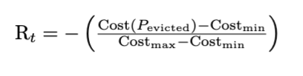
The implication of this reward function is that the model learns its a safe action to evict a light partition over a heavy partition since it incurs a smaller penalty for this eviction, this also picks up long term trends of weighted hit maximization by eventually evicting heavy partition if the workload trends predicts that the heavy partition will never match queries in the current workload trend.

3.3 Offline Data Generation.
Training a reinforcement learning algorithm from scratch is hard. Initially the model explores all possible actions, even random actions, thereby having a larger search space. This large space includes action paths that are not optimal hence making the initial train process slow. These random actions of the agent can lead to cache thrashing and poor performance. This is known as the cold start issue. To overcome cold start issues we utilize offline training where we train the agent on a diverse dataset of historical interactions to decrease instability and increase convergence.
To generate this diverse dataset of historical interactions we create an experience replay buffer that contains 500000+ state transitions. This was generated by running the Spark simulator on 6000 distinct query traces capturing the complete lifecycle of empty initialization to steady state operation.
If the agent comes across an environment it has not seen before it can lead to underestimation or overestimation of Q values of an action. This is handled by generating a replay buffer using multiple policies. Least Recently Used (LRU) and Least Frequently Used (LFU) are used to model stable cache states and teach agent standard locality plans. We also use random and First In First Out (FIFO) policy to force the agent to take suboptimal actions to teach agent recovery so it performs eviction to recover cache from a poor state and makes the agent resilient to noise.

Deep RL Model.
The agent utilizes 3 layers, the input layer is 38 dimensions that is the state vector S. The middle layer is made up of a 256 dimension hidden layer with ReLu activation function. The output layer gives Q value for each action made up of 6 dimensions that are for five partitions in cache and one for no eviction. The state vector is made up of partition level statistics and in this with increase in partition size is large but partition match with query is binary. This is called feature scaling. To prevent instability due to high variance we implement layer normalization after input layer ensuring stable gradients and faster convergence.

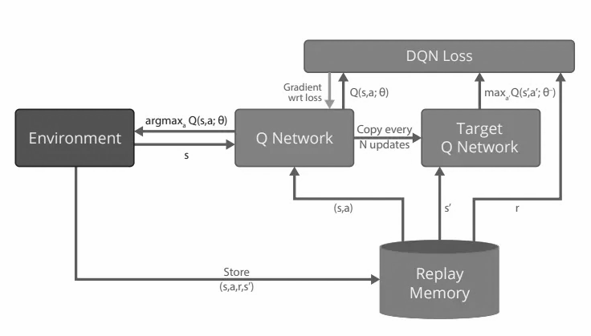
Figure 4.1: DQN Training Loop

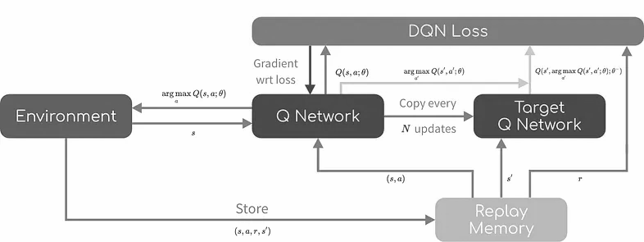
Figure 4.2: DDQN Training Loop

In the initial runs the agent was using a standard Deep Q-Network (DQN). The state space made up of state and action for a process like cache eviction is complex. A neural network is used to implement this because it can handle complex state spaces and does not degrade when it encounters unseen states. In the initial runs the DQN exhibited significant overestimation of Q-values. This is a known issue and also leads to the maximization operator to estimate upwards leading to the model chasing these ‘delusional’ high value states that do not exist and hamper model performance. To overcome this overestimation a Double DQN network is used that decouples estimation of the best action and evaluation of that action, this helps us avoid maximization of poor best action choices since evaluation of all actions help in validation resulting in smoother and reliable convergence.
Spark workloads are not smooth and come with rapid changes of workload, this is called an outlier when viewed with the lens of a smoothly changing workload. Initially the loss function used was the standard Mean Squared Error (MSE). MSE is highly sensitive to outliers which leads to gradient explosion. Since this rapid change is a part of Spark workloads and not undesirable, MSE was replaced with Huber Loss, which transitions from quadratic to learn for large errors, making this robust against reward spikes.
DQN periodically updates policy networks with target networks, but hard target updates cause spikes in training to further smoothen this out. We use a soft target update making this behave like a low pass filter and bring robustness to noisy updates.

Experiment Setup
The experimental setup involves for a given workload its latency and cache hit ratio is tracked as the queries are processed. This is done through cache eviction policies such as LRU,LFU,FIFO,RANDOM and RL. The metrics are compared for multiple workloads.

5.1 Dataset and Cost Configuration
The experiment has been set up with 40 partitions and 5 can be present in cache to maintain high contention for the cache. Since we know all partitions are not equal we implement a cost model to make partitions of unequal cost.
Low cost partitions are partitions modeled with narrow dependencies such as filter query operations with a recomputation cost of 10ms making them cheap to reload.
High cost partitions are modeled with wide dependencies such as join operations. They are made up of a high recomputation cost of greater than 1000ms.
The split between such partitions is 70:30 for a given workload. This split is essential to train the RL agent to learn the importance of value over recency.
The RL policy is compared against industry standards to evaluate its performance.
Least Recently Used (LRU) : Spark’s default policy.
Least Frequently Used (LFU) : Optimizes for Popularity.
First In First Out (FIFO) and Random : Policies used for lower bound comparison.
Evaluation Metrics listed below.
Cache hit ratio, which is a measure of general efficiency.
We mainly optimize for latency, which is time taken for a process. We have multiple bounds in latency like average latency. We evaluate on P99 latency which is the latency seen for the 99th percentile.
P99 latency is a very important metric since we know heavy partitions have the ability to slow down system performance making this critical for stability.
To ensure fair comparison all policies process the same exact queries with the same initial state to ensure any difference in performance is down to policy logic and not noise interference.
The stress test agent’s eviction policies three distinct testing workloads were developed.
Trained workloads are a mixture of categorical and temporal queries that match the training distribution.
The aim of this workload is to verify agent’s convergence.
In Dynamic Workloads the workload has a phase shift incorporated. The workload initially starts off as a purely temporal and transitions to a purely categorical.
The aim of this workload is to check the agent's ability to adapt to changing workload trends and check if evicts its workload favouring partitions when the workload changes drastically.
Unseen workloads are made up of unseen Date ranges and categories that were not seen during training.
Unseen workload tests if the agent learnt the intended goal of maintaining heavy partitions in memory over light partitions.

Results and Analysis
The Cost Aware RL agent is evaluated against industry standards (LRU,LFU) across the different workload scenarios mentioned in section 6. The analysis focuses on observing if an agent successfully learned to prioritize cost of partition over recency and its generalization on unseen data.
6.1 Adaptability
Experiment : Test the agent’s ability to adapt to switch in workload style that moves from Temporary heavy workload to Categorical heavy workload. The shift is abrupt and occurs at the 100th query of the workload.
Observation : As illustrated in Figure 6.1 The LRU policy still significantly caches now temporally irrelevant partitions; it undergoes a long period of cache thrashing and hence overall performance decreases.
RL Agent Performance : RL agent adapts to change in trend immediately, by using its query context vector in state it quickly removes the high frequency but temporally irrelevant partitions.
Result : The RL agent hits a high of 20% better performance over LRU throughout and maintains a consistent 15% higher performance throughout the workload.
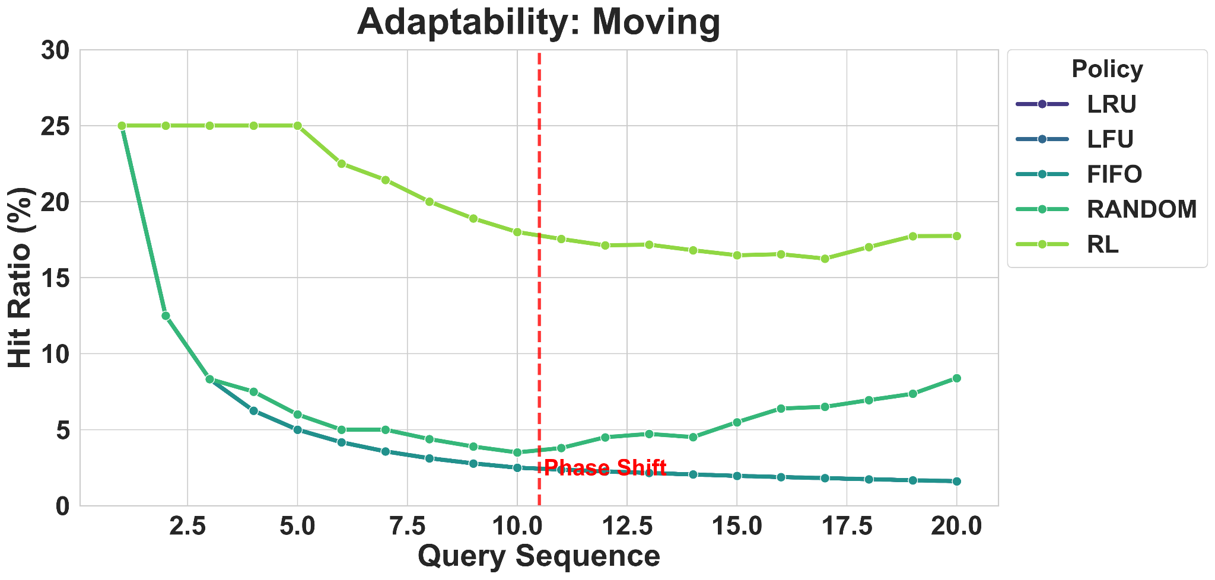
Figure 6.1: Hit Ratio Timeline during Phase Shift

6.2 System Stability: Latency Reduction
Experiment : Average latency (P50) is important as it signifies the average performance of the system, but P99 that covers 99th percentile covers worst-case or critical condition cases, this experiment aims to see the average and 99th percentile latency performance of the agent against standard policies.
Observation : For P50 latency from the figures the latency for LRU hovers between 1.8ms-2.0ms and for the agent it ranges around 1.5ms to 2ms. For P99 latency that focuses more on the heavy partitions the latency of LRU rises 200% while the latency of the agent falls by 35% showing the cost blindness of LRU.
RL Agent Performance : RL agent has an overhead over static policy but its P99 performance improves compared to LRU showing agents preference to partition costs.
Result : The agent experiences a marginal increase in latency when moving from P50 to P99 latency conditions whereas LRU experiences a degradation of 200%.
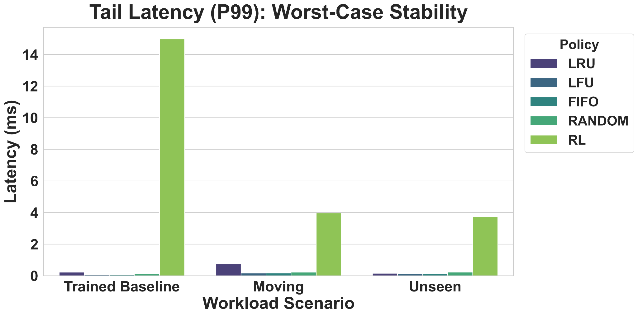Figure 6.2: P99 Tail Latency Comparison.

6.2 Generalization to Unseen workload
Experiment : Common failures of offline RL training is overfitting, the aim of experiment is to expose the agent to unseen states of the environment to evaluate its action and thereby performance. The unseen workloads have new partition identifiers and value ranges.
Observation : RL agent’s performance shows relative improvement over LRU.
RL Agent Performance : RL agent has an all time higher relative performance of 20% compared to LRU and lows is still a 5% improvement and an average improvement of 10% over LRU. Both the agent and LRU experience a degradation of performance as we go through the workload.
Result : The agent experiences an average 10% improvement over LRU showing generalization of the agent and no critical degradation in performance.

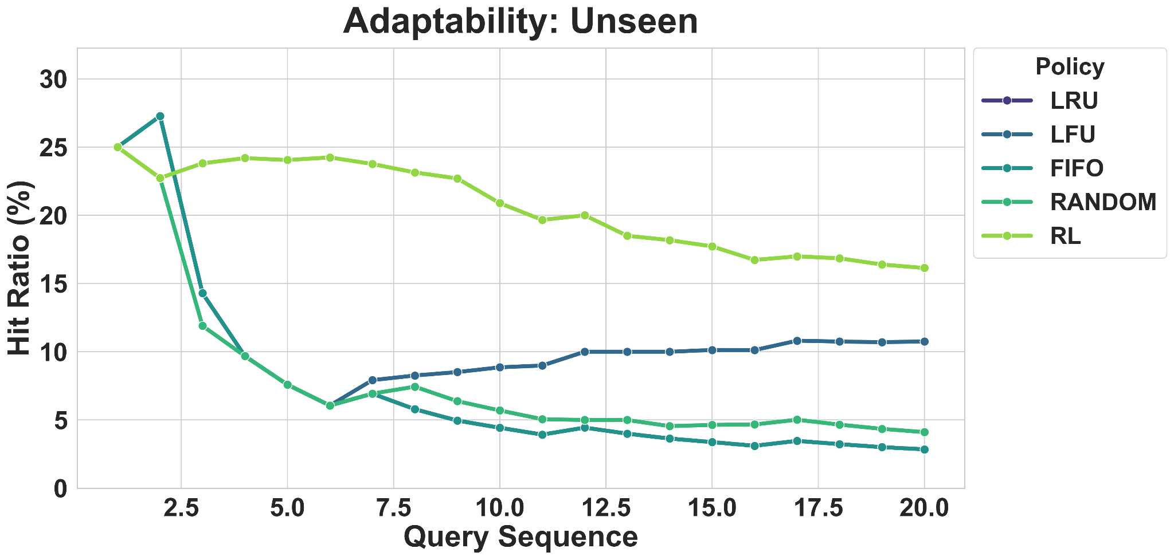
Figure 6.3: Runtime improvement on Unseen Workload.

Discussion
The cost aware approach of the RL agent beats heuristics at stability, thereby achieving a higher performance and improved latency stability.

7.1 Weighted Hit Maximization
Standard policies (LRU/LFU) treat cache eviction of any partition as equal. This leads to cost blind eviction that hampers the system. Many adaptable agent approaches optimize for cache hits and discretize cache hit (+1) and cache miss (-1), this is an improvement over standard policies and brings a degree of adaptability to the policy but still is cost blind and reward is unstable and leading to poor convergence. My agent optimizes for cost , where penalties are assigned for a partition’s eviction and it's directly proportional to the computational complexity of that partition.
The agent maximizes on cost there by learning to sacrifice light partitions to ensure critical hits to heavy partitions that directly affect system performance. It leads the agent to a policy where it learns to take multiple small penalties to avoid one big penalty.
This policy approach helps directly in the improvement of latency when going from 50th percentile (average) to 99th percentile (worst case) by accepting frequent light penalties (~10ms) to avoid catastrophic penalties (>1000ms). This leads to a predictable experience across all workloads.

7.2 Instability to Robustness
Initially the agent consisted of a discrete reward function based on cache hit and cache miss with a Deep Q-Network (DQN) and hard target network updates. This model used mean-squared error (MSE) as the loss function. This model suffered from severe policy oscillation with poor convergence leading to large bias and disastrous action choices of the agent across all workloads.
To overcome this, the reward was modified from a discrete hit and miss signal to a recomputation cost penalty of evicted partitions. The agent moved to a Double Deep Q-Network (DDQN) model which decoupled action selection and value estimation. DDQN also utilized a soft target update network, this combined made the model a low pass filter to the noisy reward signal. Outliers are a part of workloads and the loss function changes from MSE to the Hueber loss function that reduces outliers from quadratic to linear. This allowed the agent to have a stable and smooth convergence leading to improved performance for worst case workload scenarios.

7.3 Planned vs accomplished scope
The project was split into three phases.In the first phase the goal was to read up on literature related to the topics of the proposed project. These were mainly of three categories. One was for Spark , second regarding dynamic cache systems and third was designing the state,action and reward environment for a reinforcement learning system. Then a simple simulator was built that mimics Spark MemoryBlock behavior with LRU as an eviction policy. This achieved a hit ratio of 41% on simple data.
In the second phase the aim was to integrate the reinforcement learning environment setup at MemoryBlock into Spark, followed by deciding on Partition level and Cache level features. Building on this was to create a replay buffer that logged state,action,reward and next state with a mix of short and lengthy workloads. Spark integration was deferred because the Java virtual machine runtime overheard and featured unavailability at both partition and cache level. Relay Buffer was generated using various standard eviction policies with around 10000 plus state and action pairs generated.
In the third phase an action record error in the simulator caused errors in replay buffer data that was fixed and training resumed. The DQN model suffered from instability and high bias after analysis of testing logs. To overcome this a DDQN model with huber loss function made it resilient to noise and outliers leading to a smoother convergence. The model was evaluated for various types of workloads and it maintained performance when tested for generalization on unseen workloads while standard policies faced cache thrashing.

Limitations and Future Work

8.1 Limitations
Simulator Approximations: The simulator approach approximates model latency costs, complex network I/O , disk contention and serialization overhead into a single scalar. The real world costs are expected to be non linear and convoluted.
Action Space Scalability: Currently the input state for the agent is the entire cache of small or top K candidates, as the size of executors increases this scales linearly which would be a bottleneck for production level clusters that contain millions of partitions.
Offline Approach: The current offline training approach of the agent limits its ability to explore new paths dynamically and make its bound to the replay buffer and increases retraining requirements for shifting workloads.

8.2 Future Work
Online Reinforcement learning : More the RL agent to an online learning environment that helps it explore new paths dynamically and removes periodic retraining requirements.
Proactive Cache Composition : Currently the agent is reactive, it waits for an eviction situation to arise before making changes to the state of the cache, this leaves a window of missed opportunity to modify cache state. A move from reactive system to proactive system would help the agent utilize cluster idle time and perform background operations on the cache helping it achieve continuous adaptation and develop better policies.

Conclusion
The aim of this project was to develop an agent for Spark Executor that has dynamic eviction policies helping it outperform traditional heuristics. Limited by JVM run times and non availability of partition level and cache level statistics required to form an environment for the agent , a realistic simulator was developed that provided such a state for the agent to take action at eviction time. The reward function was based for cost maximization with the utilization of DDQN for smooth convergence , stable convergence and greater generalization. The combination of DDQN and cost maximization reward help overcome challenges of high variance and poor convergence typical to such systems.
The results demonstrated the shift from discrete hit and miss based reward to cost maximization based on recomputation penalty works and the agent is trained to persist in the cache ‘heavy’ partitions which provides the required stability required for an dynamic eviction policy system.

References

[1] M. Zaharia, B. Chambers, and M. Zaharia, Spark: The Definitive Guide: Big Data Processing Made Simple. Sebastopol, CA: O'Reilly Media, 2018.

[2] R. Chen, et al., "Improving Spark Cache Hit Ratio Through Learned Policies," in IEEE International Conference on Big Data (Big Data), 2022, pp. 1–10.

[3] Z. Jia, et al., "Optimizing Caching in Distributed Systems with Reinforcement Learning," IEEE Transactions on Knowledge and Data Engineering, vol. 33, no. 1, 2021.

[4] J. L. Ba, J. R. Kiros, and G. E. Hinton, "Layer Normalization," arXiv preprint arXiv:1607.06450, 2016.

[5] R. S. Sutton and A. G. Barto, Reinforcement Learning: An Introduction, 2nd ed. Cambridge, MA: MIT Press, 2018.

