Criteria D: Product Design

Entity Relationship Diagram

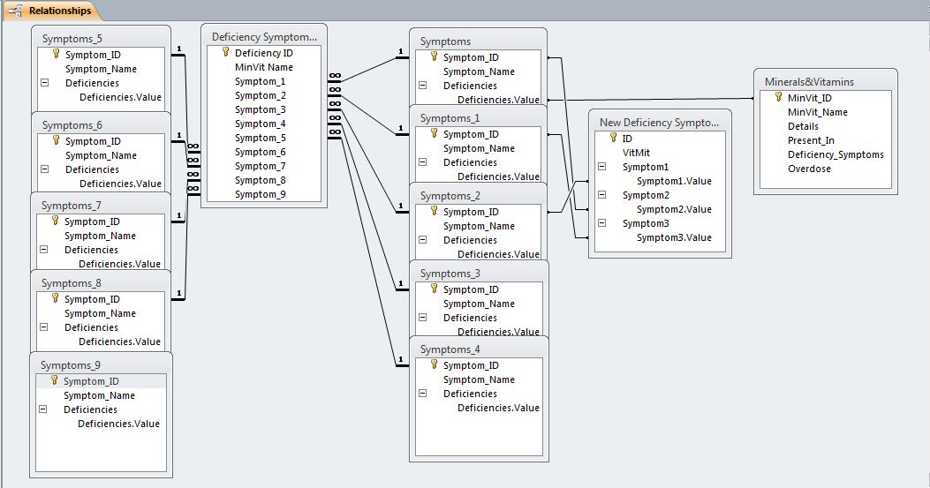

Overall Structure

The following diagram is the brief sum up of the structure of the entire database. However, this is not the official screen layout.

Home Page

Search/Display Deficiency Using Multiple Symptom Input

Symptoms List

Mineral/Vitamin List

Deficiency List

Edit Mineral/Vitamin information

Search/Display Deficiency and List of Symptoms

Search/Display Deficiencies Caused by Symptom

Search/Display Individual Mineral/Vitamin Information

List of Tables, Data Types and Formatting

The following is the complete details of the tables within the database, along with the type of data that will be input.

|  |  |  |  |
| --- | --- | --- | --- |
| ***Deficiency Symptoms List*** | | | |
| **Field Name** | **Data Type** | **Description** | **Other Information** |
| Deficiency ID | AutoNumber | Unique number assigned to deficiency listed | Primary Key |
| MinVit Name | Short Text | Name of the Mineral/Vitamin of which there is a deficiency | - |
| Symptom_1 | Lookup Field | A possible symptom of the deficiency | Foreign Key from  ‘Symptoms’ |
| Symptom_2 | Lookup Field | A possible symptom of the deficiency | Foreign Key from  ‘Symptoms’ |
| Symptom_3 | Lookup Field | A possible symptom of the deficiency | Foreign Key from  ‘Symptoms’ |
| Symptom_4 | Lookup Field | A possible symptom of the deficiency | Foreign Key from  ‘Symptoms’ |
| Symptom_5 | Lookup Field | A possible symptom of the deficiency | Foreign Key from  ‘Symptoms’ |
| Symptom_6 | Lookup Field | A possible symptom of the deficiency | Foreign Key from  ‘Symptoms’ |
| Symptom_7 | Lookup Field | A possible symptom of the deficiency | Foreign Key from  ‘Symptoms’ |
| Symptom_8 | Lookup Field | A possible symptom of the deficiency | Foreign Key from  ‘Symptoms’ |
| Symptom_9 | Lookup Field | A possible symptom of the deficiency | Foreign Key from  ‘Symptoms’ |

|  |  |  |  |
| --- | --- | --- | --- |
| ***Minerals&Vitamins*** | | | |
| **Field Name** | **Data Type** | **Description** | **Other Information** |
| MinVit_ID | Autonumber | Unique number assigned to Mineral/Vitamin listed | Primary Key |
| MinVit_Name | Short Text | Name of the Mineral/Vitamin | - |
| Details | Long Text | Description of the Mineral/Vitamin and its benefits | - |
| Present_In | Long Text | List of where this Mineral/Vitamin is present |  |
| Deficiency_Symptoms | Long Text | List of possible symptoms that can occur with the deficiency of the Mineral/Vitamin | - |
| Overdose | Long Text | Description of what happens if the Mineral/Vitamin is overdosed | - |

|  |  |  |  |
| --- | --- | --- | --- |
| ***New Deficiency Symptom list*** | | | |
| **Field Name** | **Data Type** | **Description** | **Other Information** |
| ID | Autonumber | Unique number assigned to Mineral/Vitamin listed | Primary Key |
| MinVit | Short Text | Name of the Mineral/Vitamin listed | - |
| Symptom1 | Lookup Field | Complete list of all possible symptoms of the deficiency | Foreign Key from  ‘Symptoms’ |
| Symptom2 | Lookup Field | Complete list of all possible symptoms of the deficiency | Foreign Key from  ‘Symptoms’ |
| Symptom3 | Lookup Field | Complete list of all possible symptoms of the deficiency | Foreign Key from  ‘Symptoms’ |

|  |  |  |  |
| --- | --- | --- | --- |
| ***Symptoms*** | | | |
| **Field Name** | **Data Type** | **Description** | **Other Information** |
| Symptom_ID | Autonumber | Unique number assigned to symptom listed | Primary Key |
| Symptom_Name | Short Text | Name of the symptom listed | - |
| Deficiencies | Lookup Field | List of which deficiencies can possibly result in the listed symptom | Foreign Key from  ‘Minerals&Vitamins’ |

Grey Background with Text (Black)

Form Design

Title of Form

Command Buttons (Light Blue) with Darker Outline and Text (White)

White Background (Form)

Next Record

Previous Record

Back

Save and Update

White Background with Text (black)

Mineral Name

Details

Source

Possible Symptoms

ID

Possible Overdoses

Report Design

White Background (Form)

Back

White Background with Text (black)

Grey Background with Text (Black)

Possible Overdoses

Possible Symptoms

Source

Details

Mineral Name

ID

Title of Form

Command Buttons (Light Blue) with Darker Outline and Text (White)

Return to Main Menu

Print Report

List of Techniques Used

|  |  |
| --- | --- |
| **Technique Used** | **Description** |
| Form/Report Navigation via Buttons | Macros were embedded within buttons to enable the user to navigate to different forms and reports |
| Use of an Auto Execution Macro | A macro was setup that will immediately direct the user to the homepage as soon as the database application is opened |
| Structured Form/Report Designing | The forms and reports were constructed so that the user can view the data in a proper organized manner. |
| Record Searching Through the Use of Complex Queries | Various complex search queries were created using the fields of tables that would prompt the user to input particular information and retrieve and display the complete corresponding record for that information |
| Linkages and Relationships Between Tables were Established | Many relationships between tables were created in form of lookup fields so that information entered in one table can directly be accessed in another table, thus reducing the need to type in the information again |
| Use of Various Data Types | In the tables of this database, different data types such as AutoNumber, Short Text, Long Text, and Lookup were used |

System Test Plan

|  |  |  |
| --- | --- | --- |
| **Test** | **Description** | **Example** |
| Data Search Test | The queries that have been created to output corresponding information once a record is input, need to be checked to see if they perform their function properly and output the information of the record entered and no other. Additionally, another thing that needs to be seen is whether the system will output data of a record if abnormal or extreme data is input or not. | The Query that prompts the user to input the ‘Symptom ID’. The user inputs ‘1’ into the prompt. The system then creates a report which lists the complete details of the symptom and which deficiencies it can cause with ‘Symptom ID’ as ‘1’ i.e Infertility. The next step of the check is to use an abnormal value. In the user prompt asking to input the ‘Symptom ID’, we can check by entering ‘Infertility’. Since this is not the numerical ID but an alphabetical entry, there will be no result of the search query. The final test is of extreme data, where when ‘107’ is entered in the user prompt, the search algorithm gives no result. This is because there is no Symptom with the ‘Infertility ID’ of 107 in the database. |
| Editing and Updating Information with Forms | A test has to be performed to see that is the user allowed to properly edit the data stored in the database. Additionally, once the data is edited, it also needs to be updated in the table as well. | In the Edit MinVit form, the user can access records stored in the database and edit the stored data. The user can navigate between records using the ‘Next Record’ and ‘Previous Record’ buttons. Additionally, once the user has edited the data, they can update the information in the database through the ‘Save and Update’ button. |
| Testing Functions in User Interface Forms/Reports | Buttons on forms and reports have macros embedded within that enable them to perform a function. A test has to be run to ensure all buttons run the designated macros and perform their function properly. | On the home page, the button ‘Minerals List’ should direct the user towards the ‘List of Vitamins and Minerals’ report by opening it and closing the home page. Another function is to ‘Print Report’, visible on many reports, which once clicked initiates the print command to print the report. |

Client Signature:



Date: 02.11.17