## Criterion F: Feedback from client

*Transcript of interview with Dr. Asma Tanvir*

1. **Does this product help you with your initial problem?**

Yes

1. **Did the database contain all data you asked to be put in?**

Yes. Also, due to the ‘Edit MinVit’ function, it was very easy to edit and add data as well.

1. **Was the database easy to use?**

Definitely. The forms and buttons were clear and well placed. The background pictures also helped make usage interesting and fun.

1. **Were you able to get relevant information as output?**

Yes, the reports were clear and gave me all the information I needed quickly and efficiently.

1. **Was it easy to input data?**

Yes, however I feel it would’ve been easier if I could simply select inputs from a list instead of remembering all the IDs for input.

1. **Were all the functions in the database smooth to run?**

Yes.

1. **Any other suggestions you would like to give?**

Different, relevant images in each report, such as citrus fruits in the Vitamin C information report, would have made the database more interactive. Also, when searching through multiple symptoms, aside from perfect matches it would be nice if the database also gave matches of just one or two of the symptoms from the list we input. Lastly when there is no match, a message box to say ‘no match’ would be nice.

1. **Overall, are you satisfied?**

Very.

**Client Signature:**

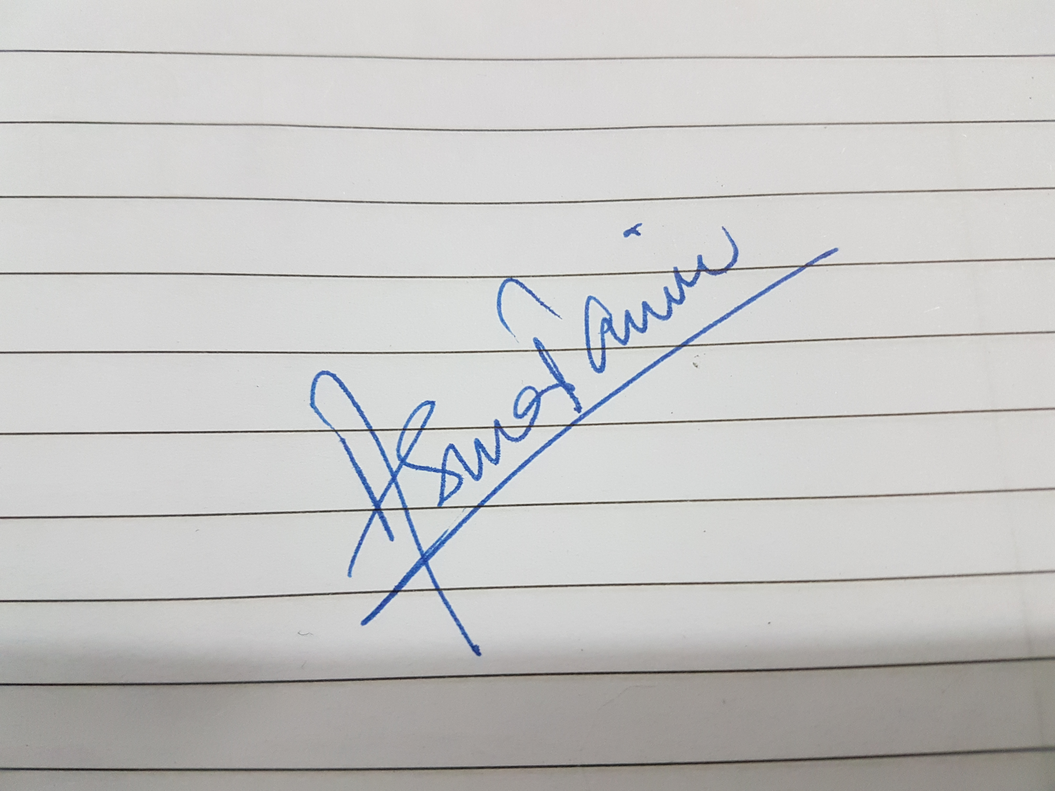

**Date:** 24.01.18

**Words: 227**