4# Create a 5-slide presentation on any topic. Use Images, Graphs, Chart, Tables, Animation, Time, Bullets, Transition, Sound, Hyperlink, Background template, Header and Footer (using MS-Power Point).

**Slide - 1**

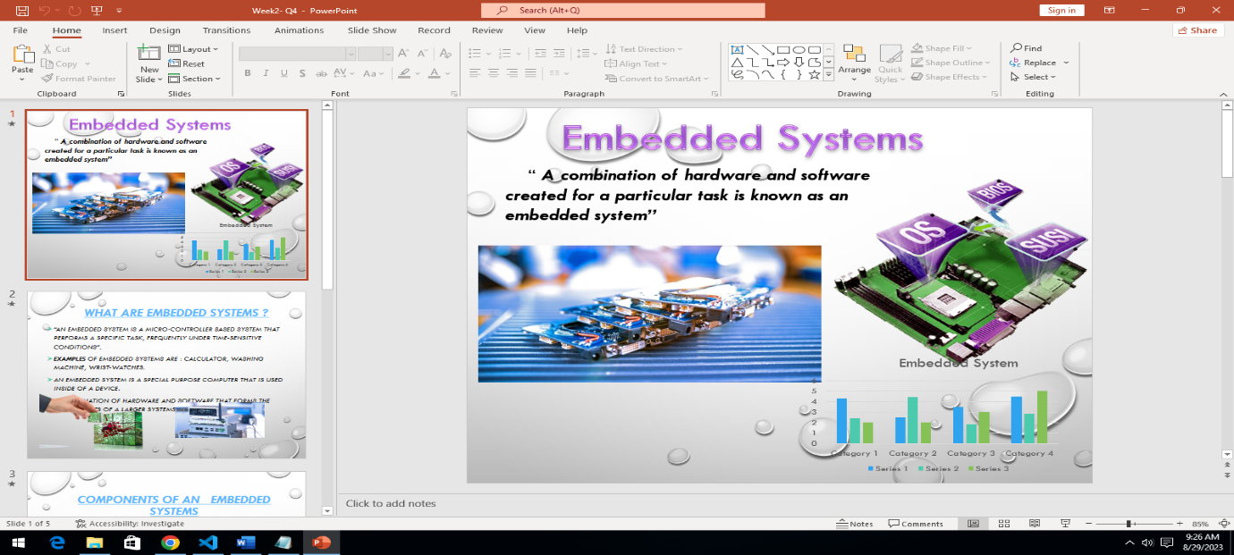

**Slide – 2**

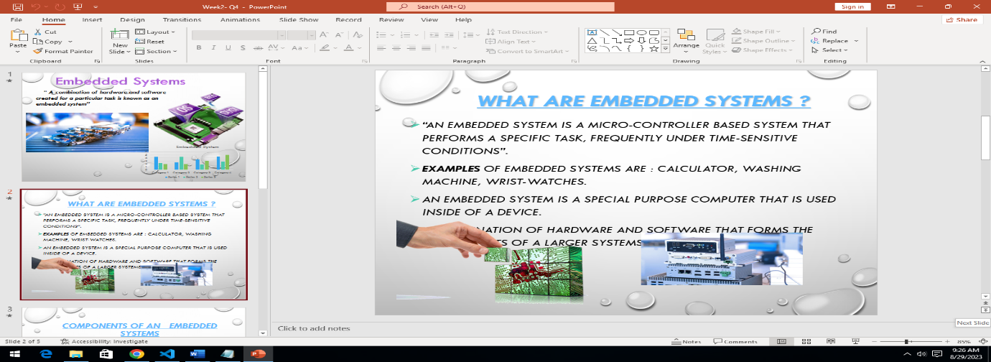

**Slide – 3**

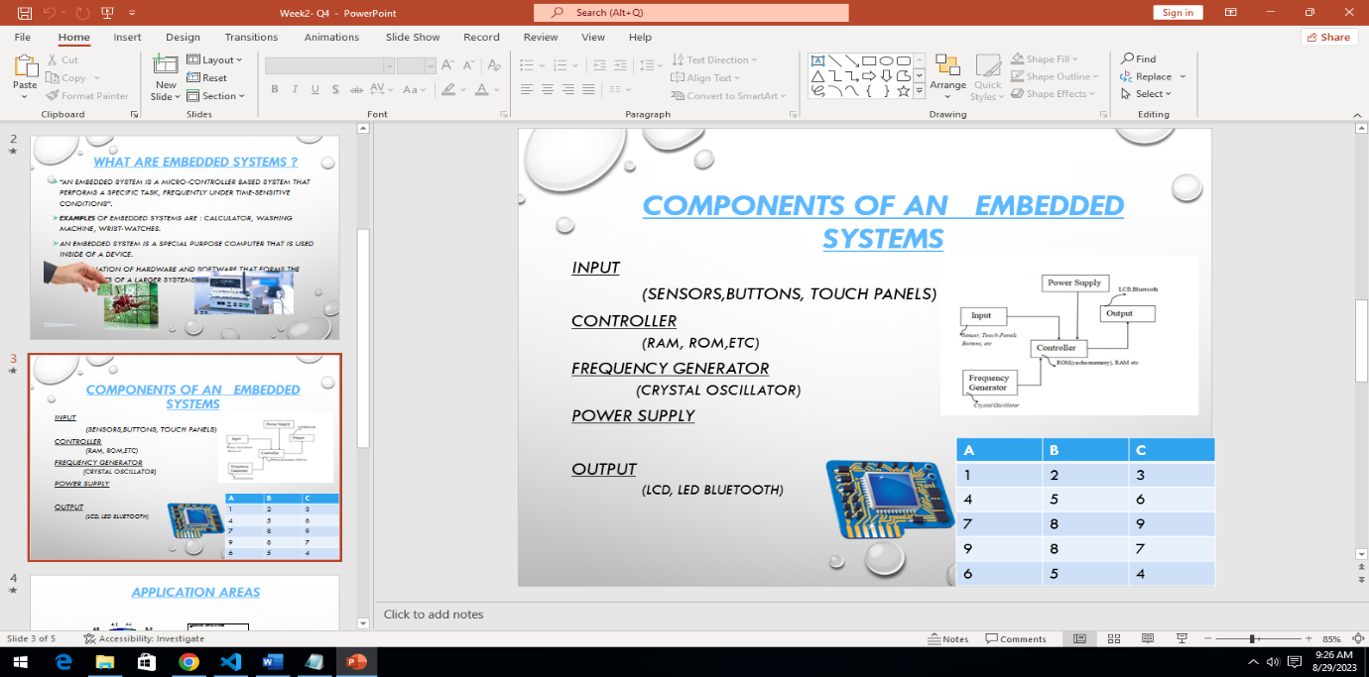

**Slide – 4**

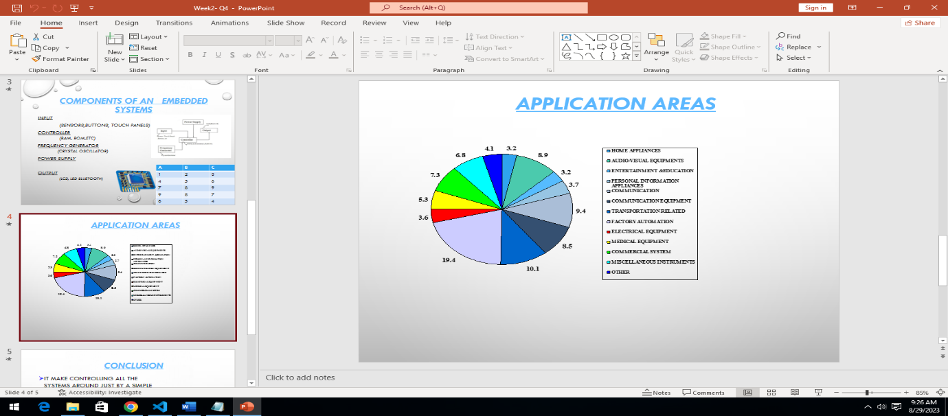

**Slide – 5**

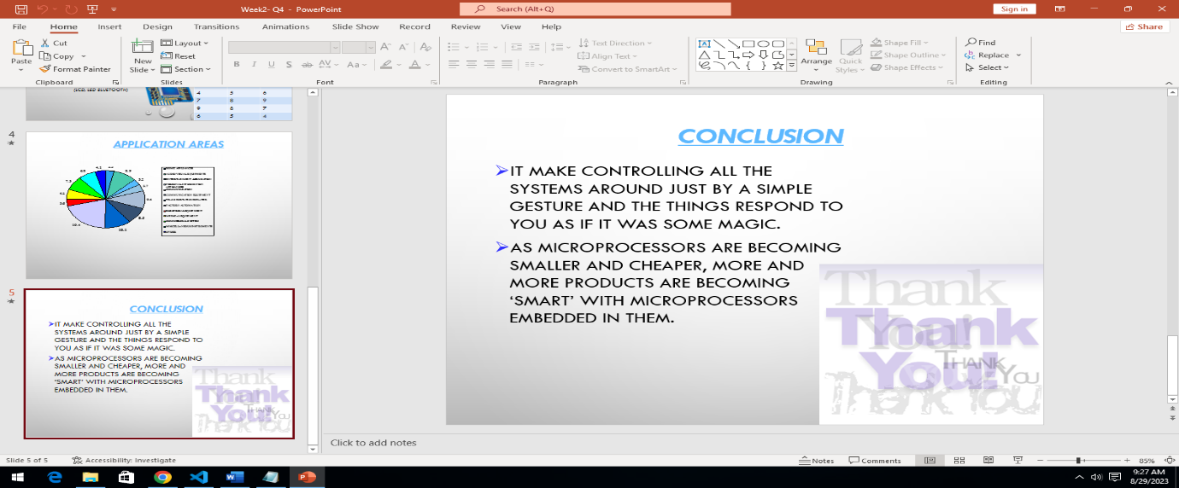

5# Create a 5-slide presentation on any topic. Use Images, Graphs, Chart, Tables, Animation, Time, Bullets, Transition, Sound, Hyperlink, Background template, Header and Footer (using MS-Power Point).

**Slide – 1**

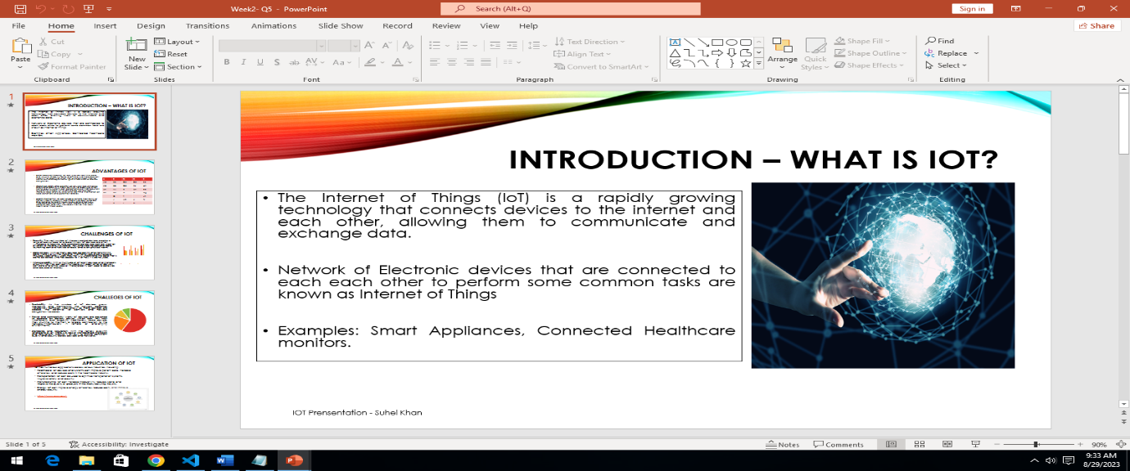

**Slide – 2**

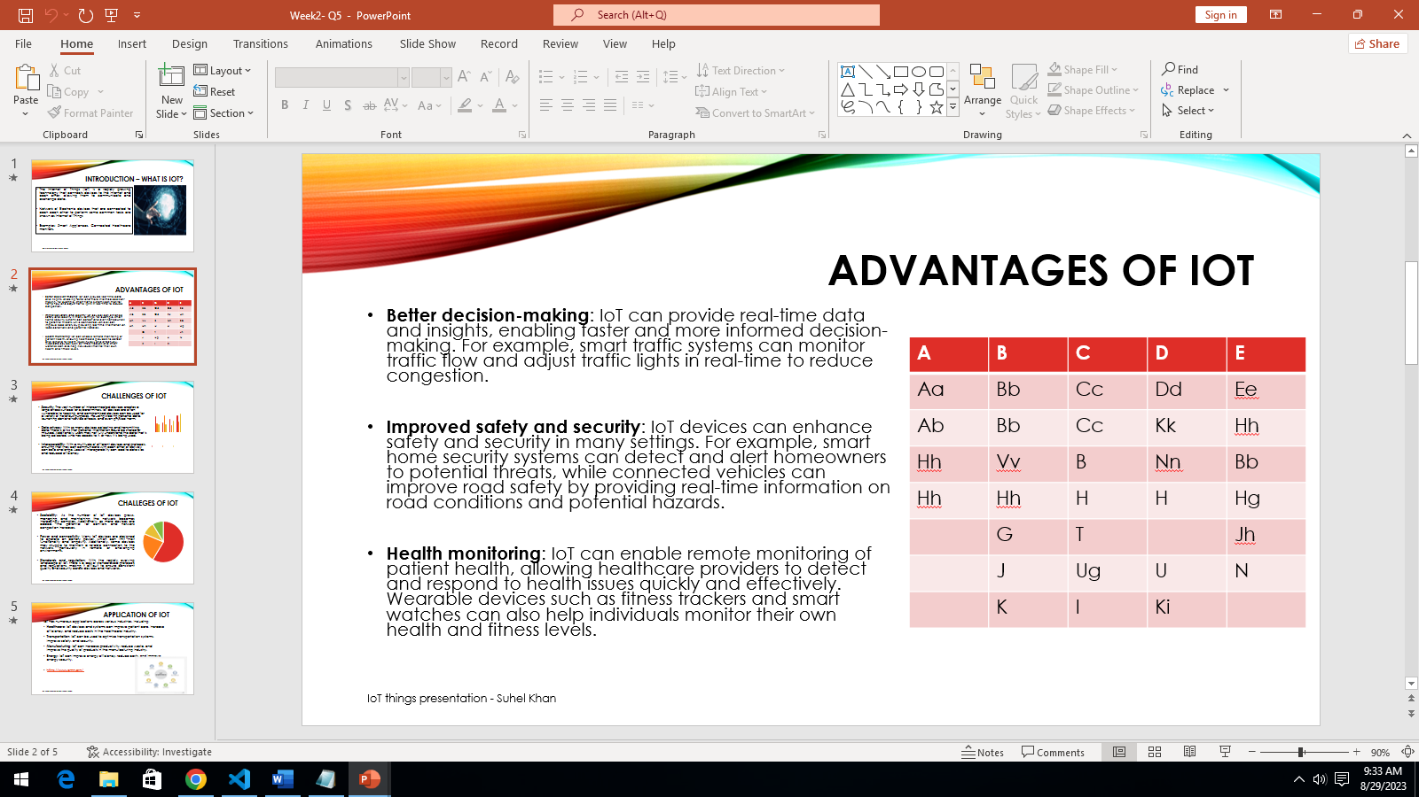

**Slide – 3**

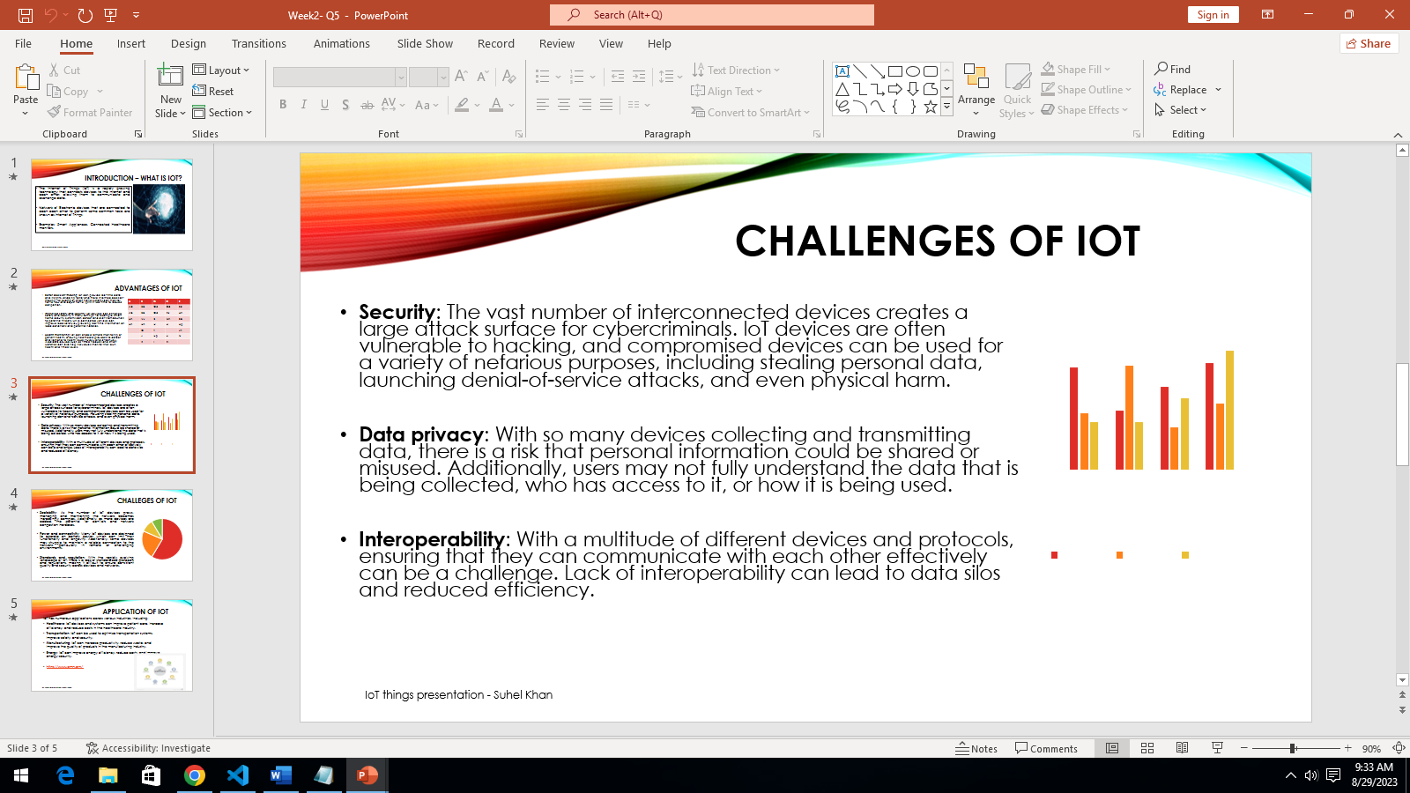

**Slide – 4**

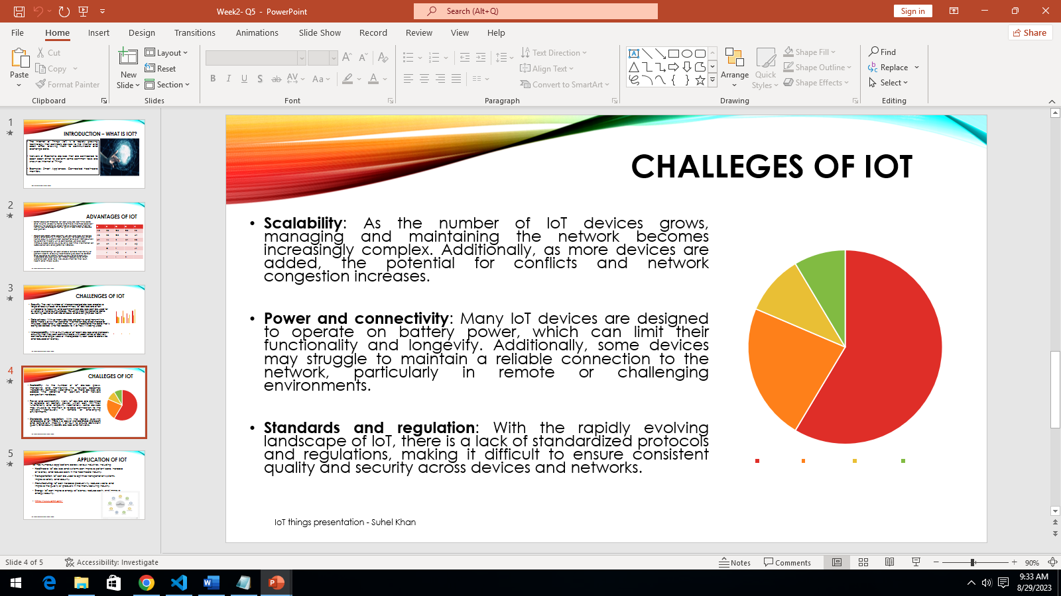

**Slide – 5**

