MY WEBPAGE

INTRODUCTION:

* The main idea of this project is to build a website for the company displaying it different area of work in simplest yet attractive way possible.
* From this people visiting website will come to know about company’s unique area of expertise and what should they expect from the company.

USER INTERFACE DESIGN AND

PROTOTYPE:

* Here is the some examples of the UI

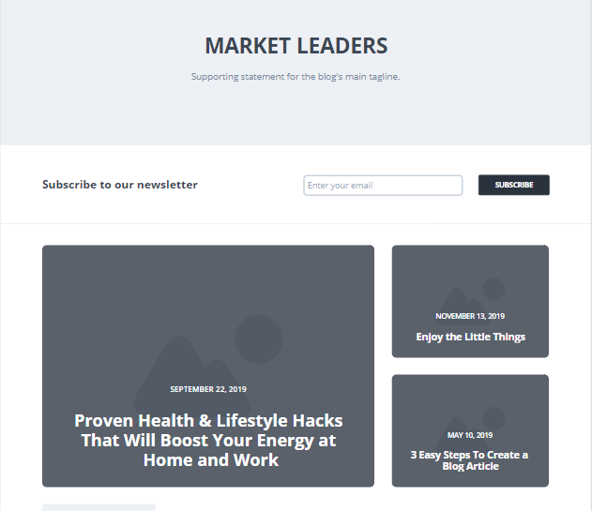

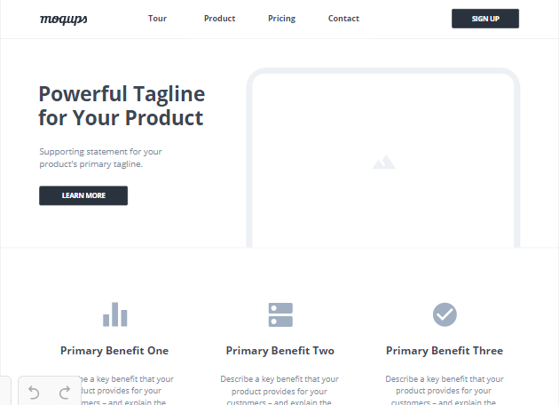

* As you can see our approach is very simple we want to display information of our company in the simplest way possible.

NAVIGATION STRUCTURE:

* For navigation purpose we will use have a drop down button like we did on last assignment and also we will have a breadcrums style navigation window also.

REFERENCE:

* <https://moqups.com/>
* <https://wireframe.cc/>