MY WEBPAGE

INTRODUCTION:

* The main idea of this project is to build a website for the company displaying it different area of work in simplest yet attractive way possible.
* From this people visiting website will come to know about company’s unique area of expertise and what should they expect from the company.

DESIGN AND IMPLEMENTATION:

* Here is the some examples of the UI

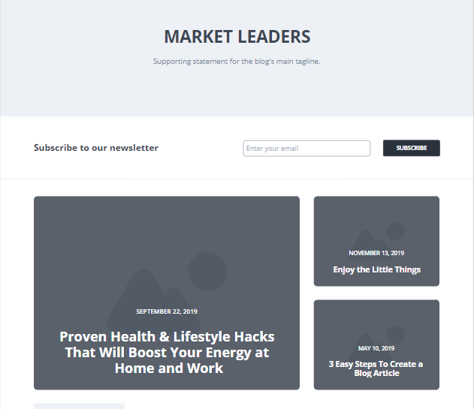

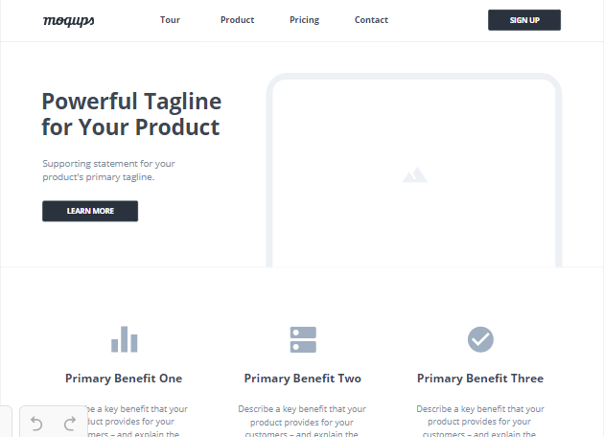

* As you can see our approach is very simple we want to display information of our company in the simplest way possible.
* We will be using Bootstrap4 as CSS framework for developing our website
* As Bootstrap4 is bult on SCSS and is very flexible to use.
* As our we website is also gonna be used on mobile phones so it must be responsive with respect to the screen size.

CONCLUSION:

* Our project will be based on bootstrap4 framework for CSS as it will be visited from mobile browser also so it is perfect for that.

REFERENCE:

* <https://moqups.com/>
* <https://wireframe.cc/>