**HD-Wallet - Guide**

The website has been deployed using GitHub in this link: <https://suhelkh0.github.io/HD-Wallet/>

The GitHub repository: <https://github.com/Suhelkh0/HD-Wallet.git>

**1. The login page: The user can login, or create a new Wallet, and also restore the account.**

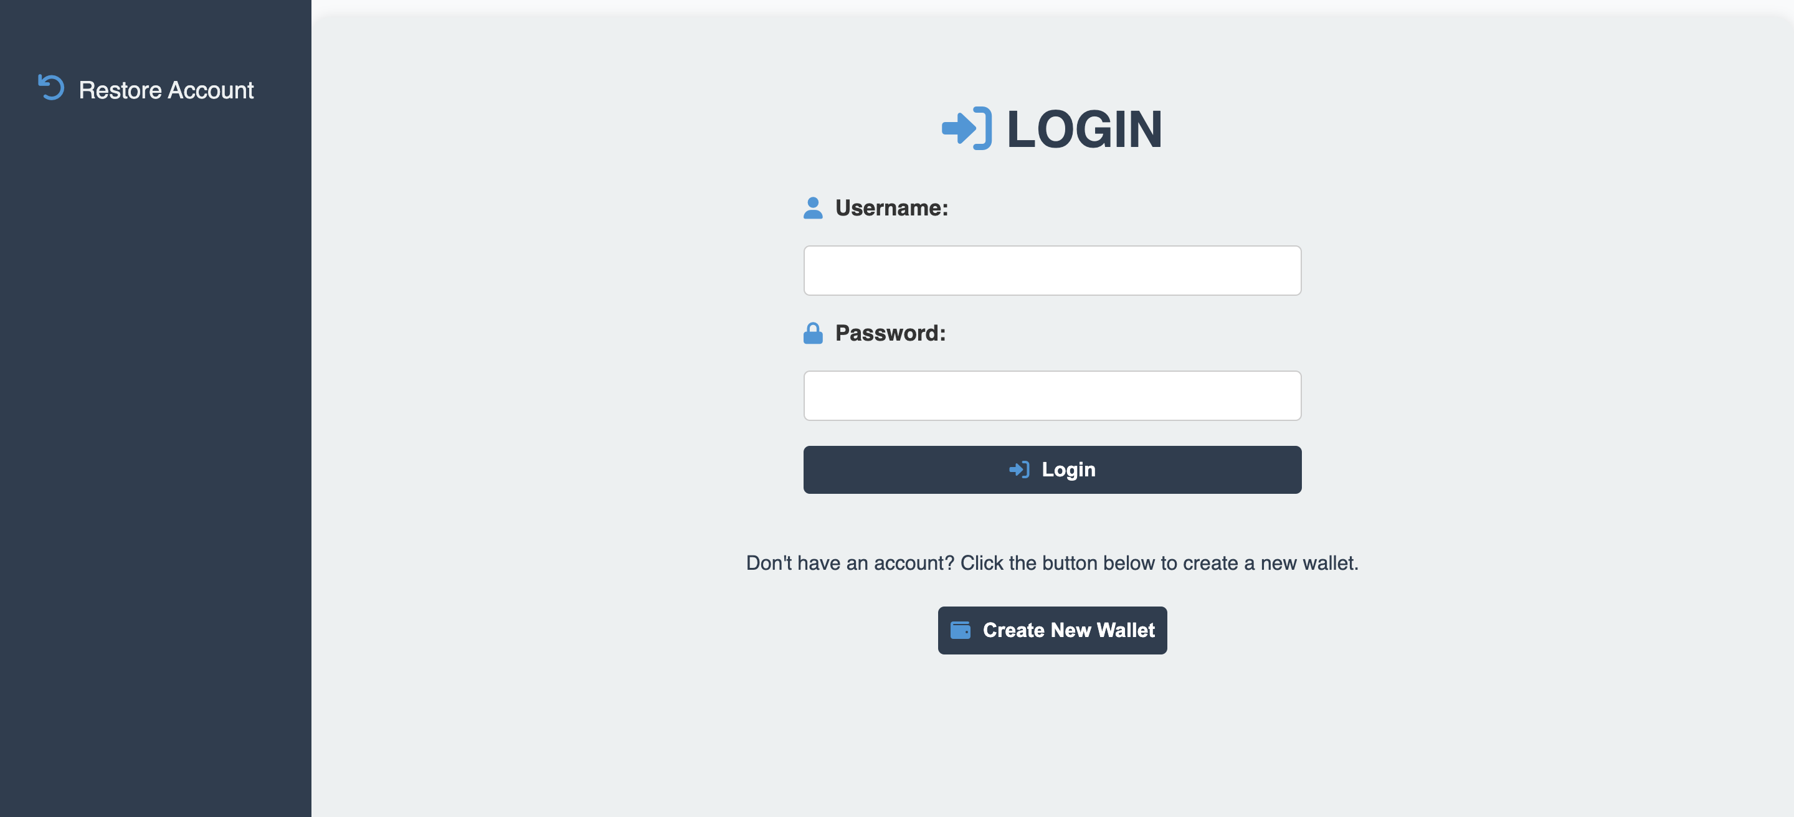

**2. Homepage: It shows your current balance Ethereum/Polygon balance and also an overview of the current Ethereum/Polygon values in the market.**

We have used infura.io API’s to get the current values of the currencies.  
  
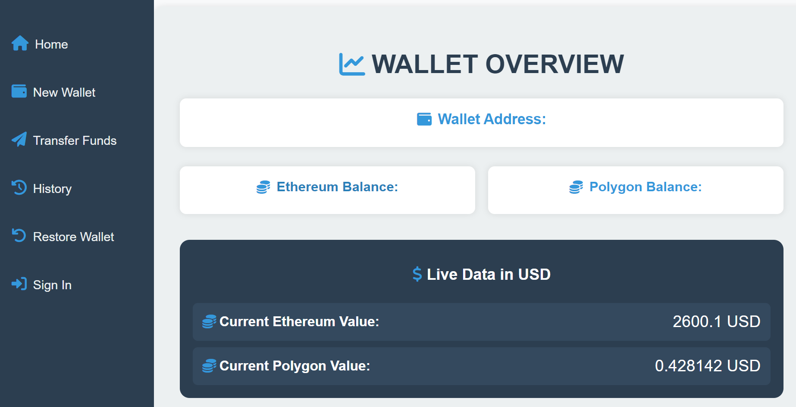

**3. Start by Creating a New Wallet**

Inset username and password, then click “create Wallet”

You can also hide or unhide your password by clicking on the eye icon.

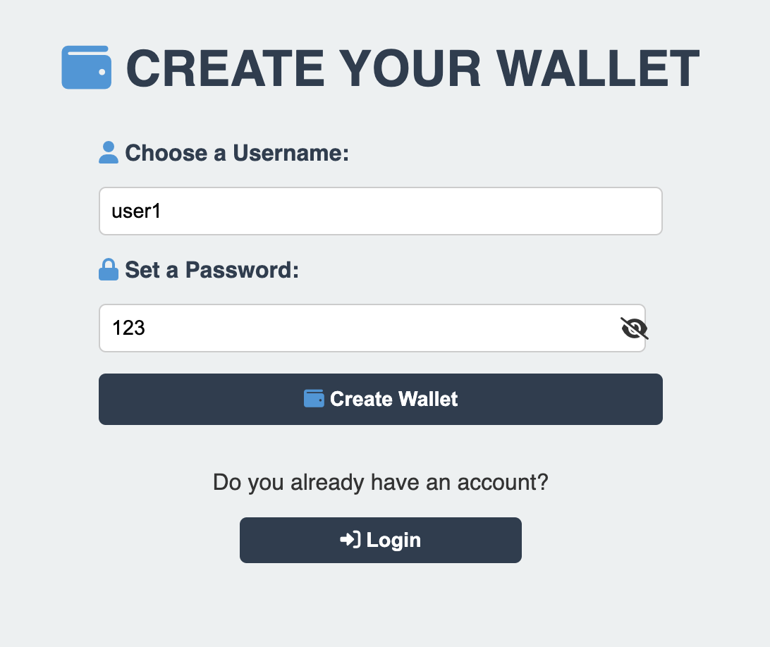

Once the wallet has been created, you can see the seed phrase which is used to restore your password, you must save the seed somewhere.

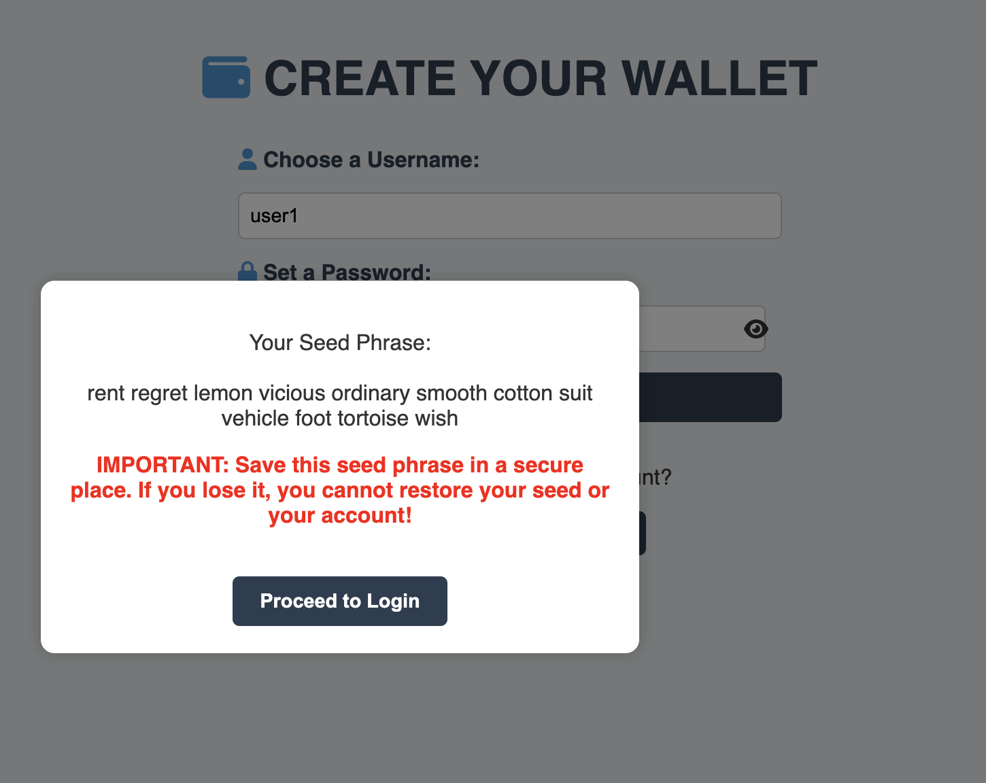

Once you’ve clicked “Proceed to Login” you’ll be redirected back to the login page to login into your account.

**4. Start by Navigating the New Wallet**

In your new wallet, you can see your wallet address, and your Ethereum and Polygon balances.

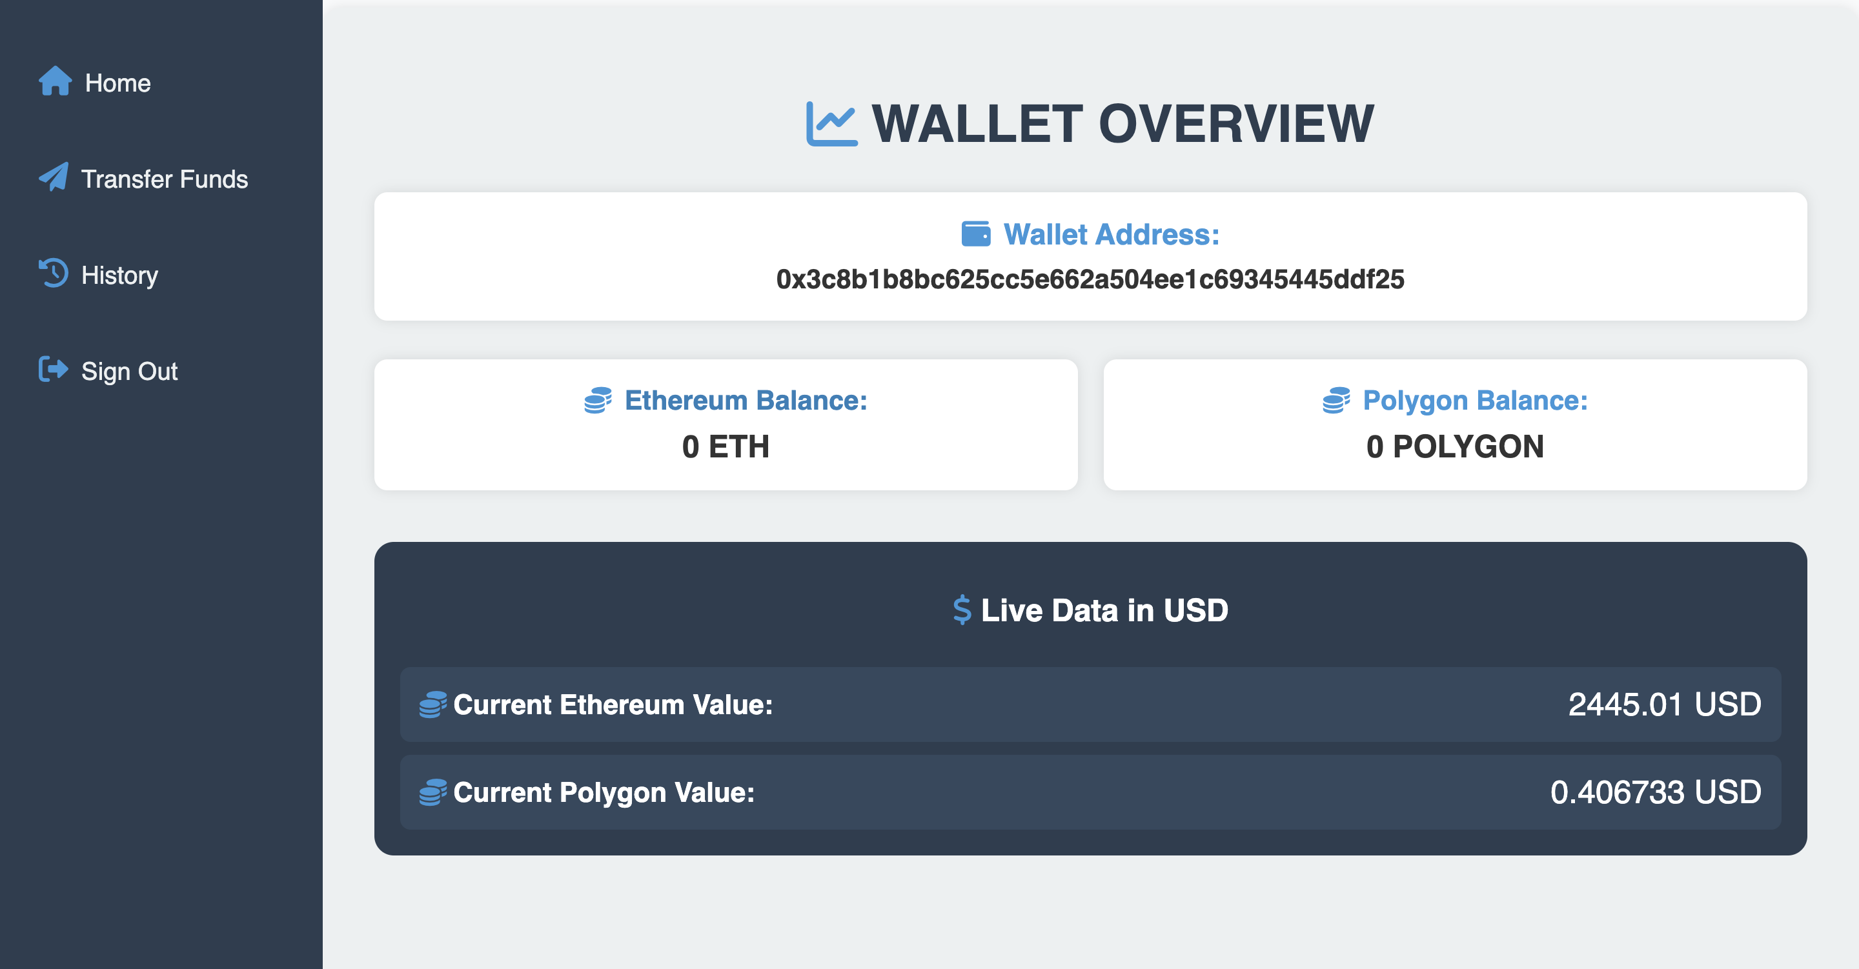

**5. Transferring Funds**

First let’s get some Ethereum coins from this link  
<https://cloud.google.com/application/web3/faucet/ethereum/sepolia>  
  
  
As we can see now, we have 0.05 Ethereum in this account. So now we can perform transactions between this account and other accounts.  
  
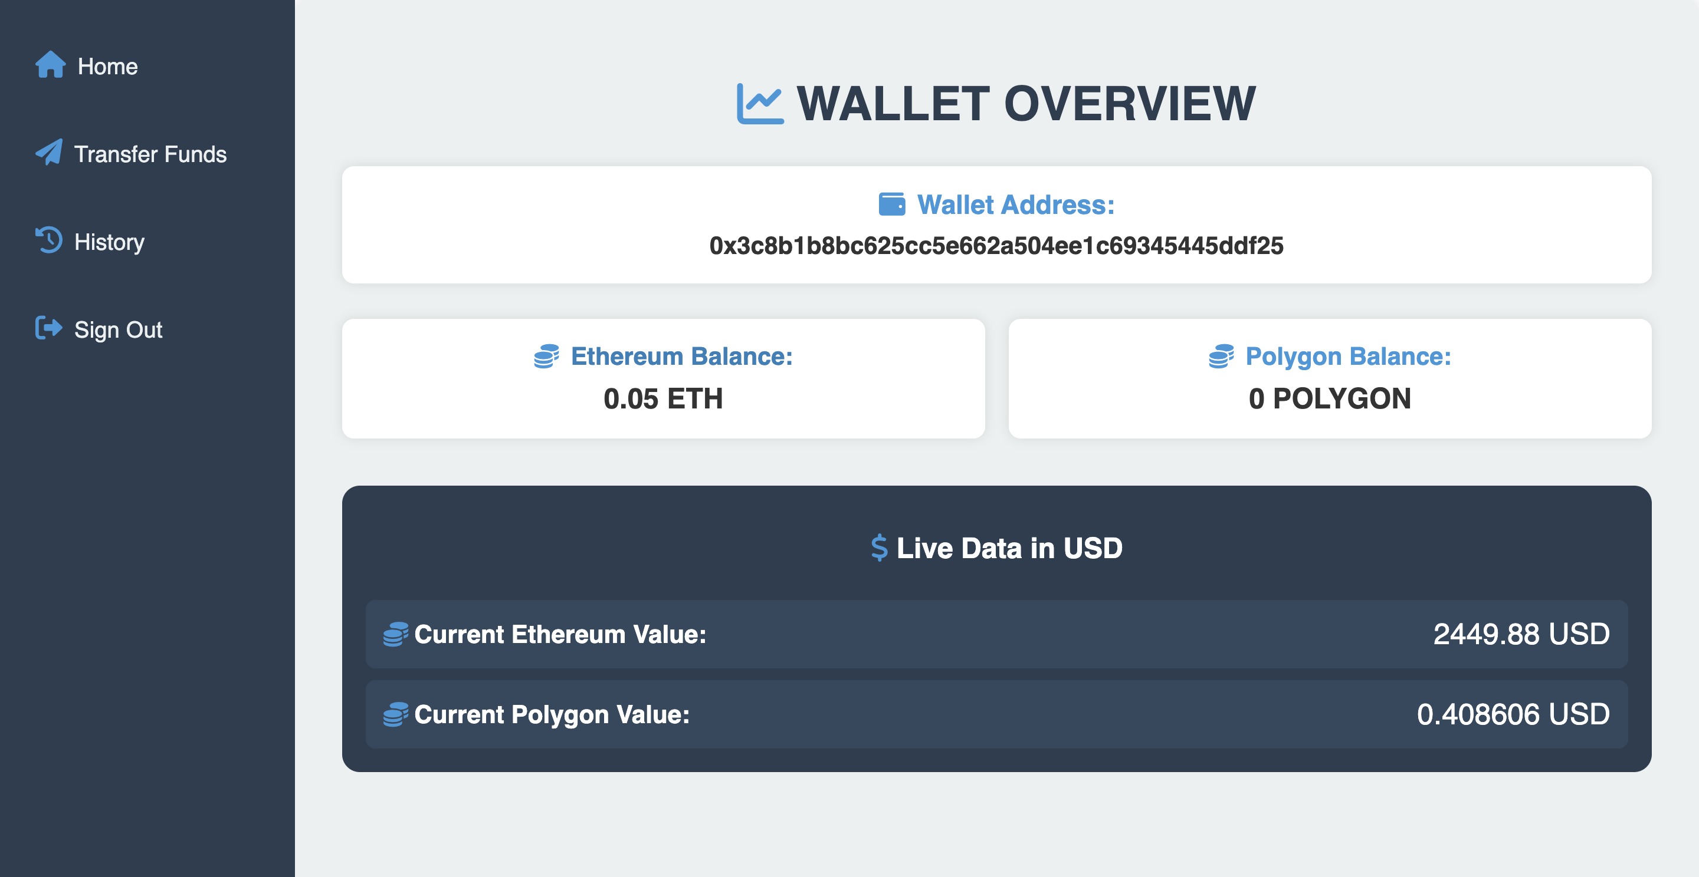

Once we clicked on “Transfer Funds” we can see this page:

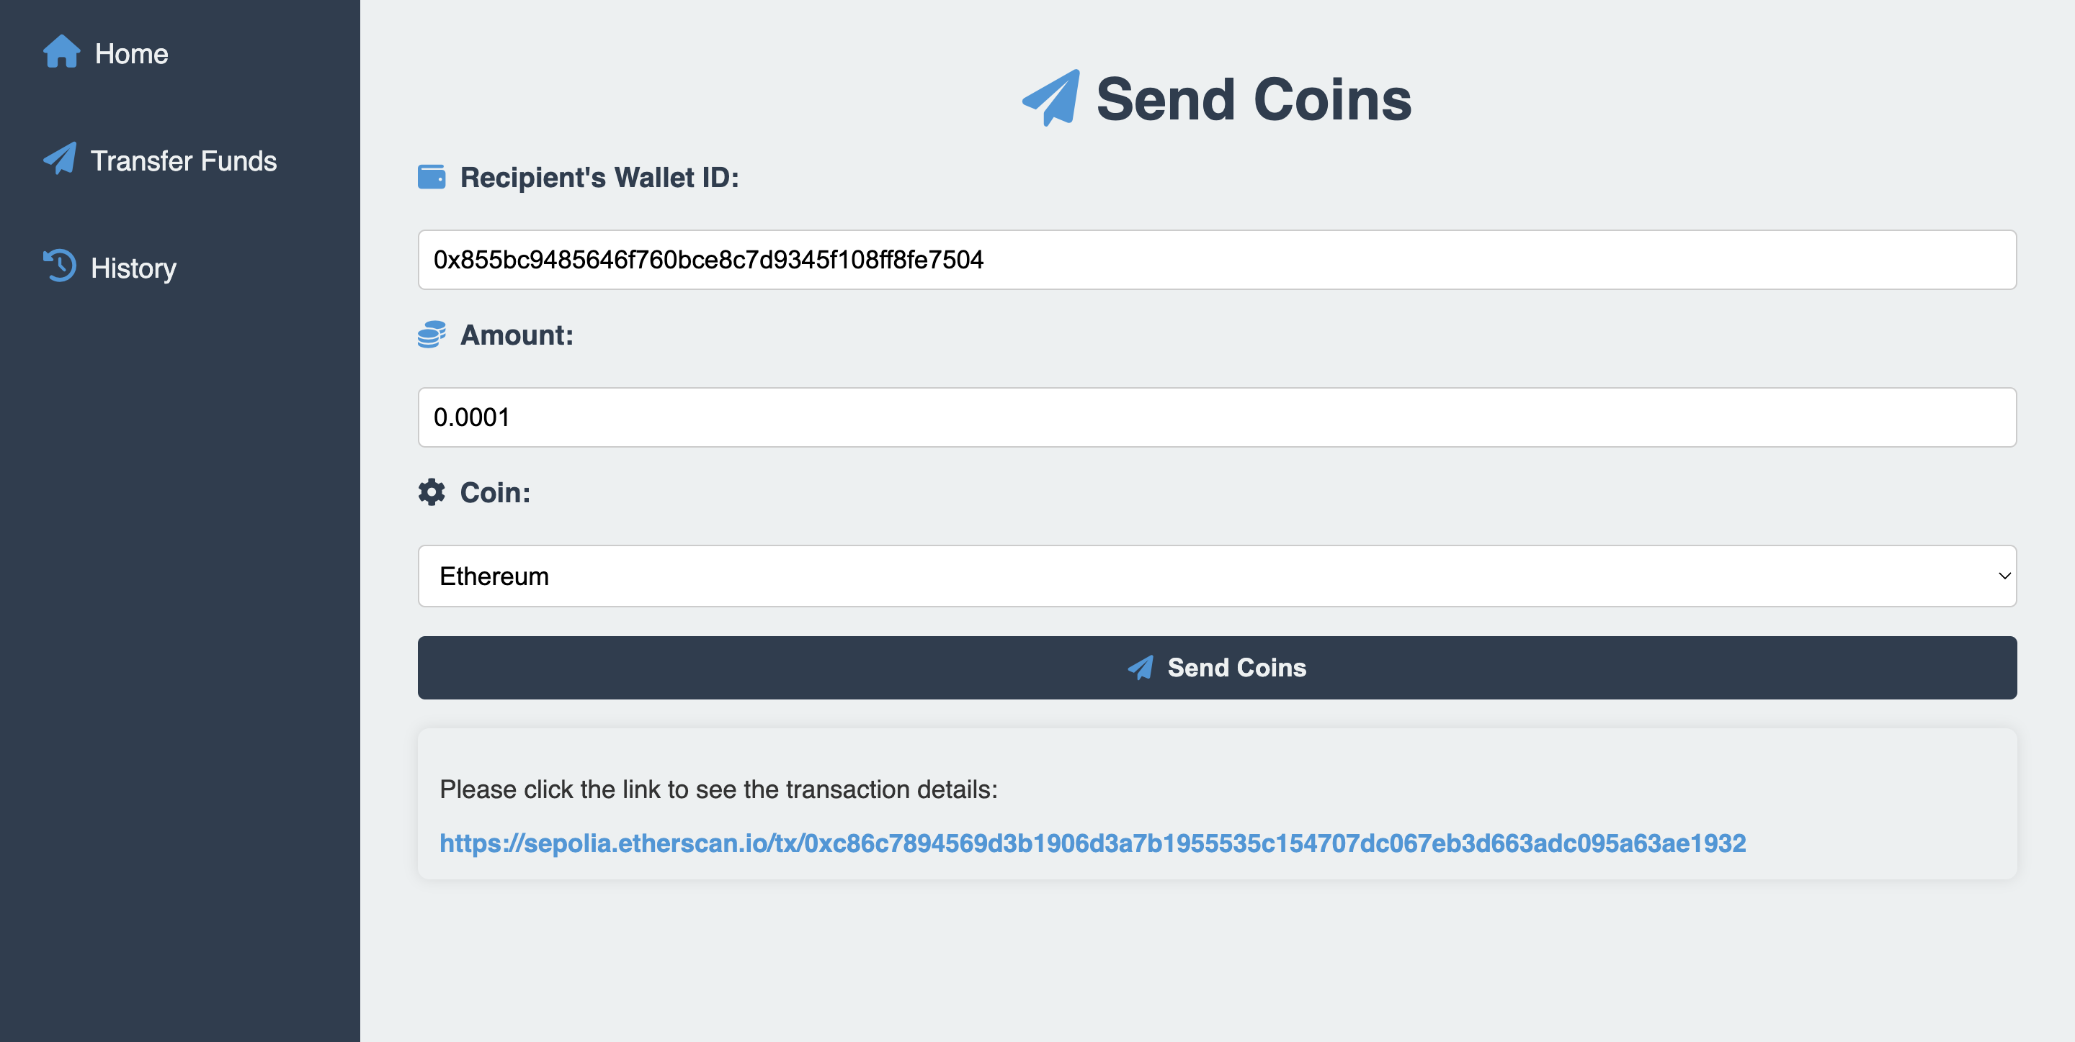

You must fill the Walled address of the one to whom you want to send coins, the number of coins, and the type of coins whether Ethereum or Polygon, and then click “Send Coins”.

We get a successful message with the transaction hash link.

Wallet after the transaction:

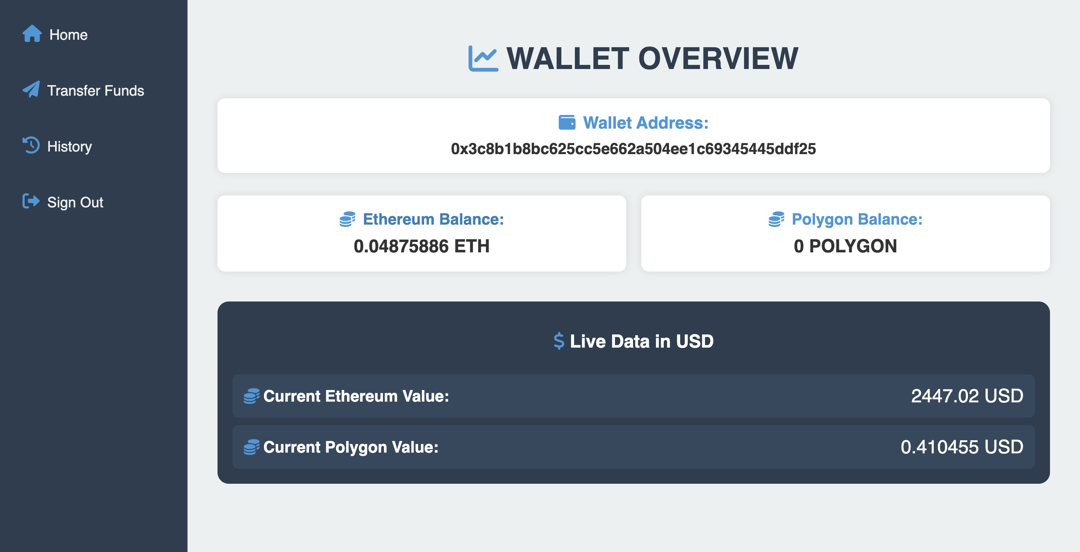

**6. Transferring Funds**

To see more details of the transactions we can go to the History tab.  
  
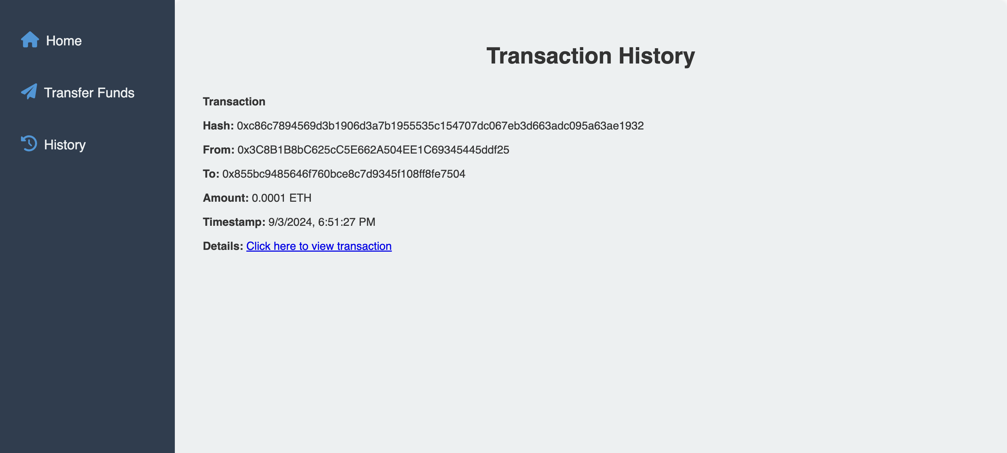

Another way is to click the link as well to see it on the sepolia testnet.  
  
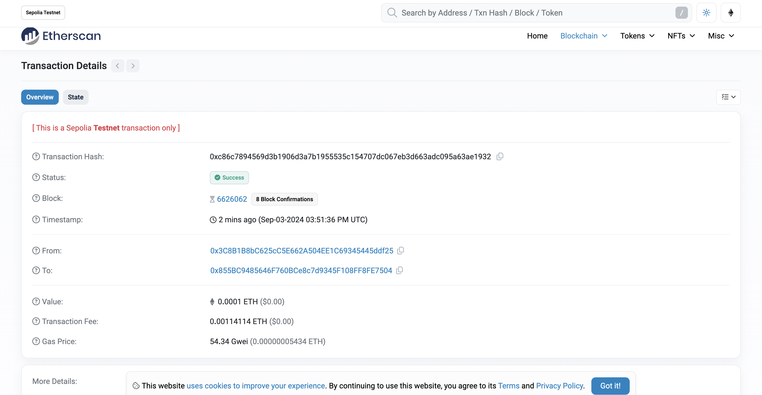

**7. Restore Account**

To restore an account (you must be logged out of the current user).  
  
You need to enter the 12 seed phrase and then click restore account the password will be changed and you will log in automatically   
  
