India–Russia Economic Relations: A Data-Driven Analysis of Bilateral Trade, 2014–2025

Abstract

This study looks at the development of India-Russia economic engagement from 2014-2025 with a specific focus on bilateral trade, trade balance and the importance of Russia's trade position. The study is based on the annual data of trade for the countries taken from the Department of Commerce (India) using descriptive statistical analysis, excel, python and power bi major trends and changes in bilateral trade relationship is identified. The results show that the bilateral trade between India and Russia was comparatively moderate for most of the time prior to 2022-23 and grew significantly thereafter. Trade between the two countries increased from US$6.35 billion in 2014-15 to US$68.69 billion in 2024-25. This growth was, However, this growth was very unevenly distributed. Indian imports from Russia increased much more rapidly than Indian exports, contributing to a widening bilateral trade deficit. An average of around 77.60% of bilateral trade is made of imports for the period, and imports exceeded 90% of bilateral trade in 2022–23 and 2024–25. The recent changes reflect a major shift in the nature of India-Russia economic cooperation and pose a number of issues on the nature of trade concentration, dependency of imports from Russia and sustainability of India-Russia trade balance.

Key words: India – Russia relations; bilateral trade; trade deficit; imports; exports; economic relations; energy; Russia.

1. Introduction

India and Russia have had a long standing and multi-faceted relationship over the years. The relationship is not limited to traditional diplomatic and defence cooperation; it also covers other aspects of economic cooperation, such as trade, investment, energy, science and technology. Their bilateral relationship is described as Special and Privileged Strategic Partnership, where they have a wide scope of bilateral contacts. (Ministry of External Affairs, 2024)

The economic relations have been gaining importance in this partnership gradually. India and Russia have been trying to conduct bilateral trade and investment at an institutional level and have set high goals for their future economic cooperation. (Ministry of External Affairs, 2024)

The years 2014-2025 are of special importance as they show the trends over a longer time period as well as the significant shift which occurred in 2021-22. According to the data used in this study, the total bilateral merchandise trade rose from around US$6.35 billion for 2014–15 to US$68.69 billion for 2024–25. Not all of the growth occurred on export orders, though. India's trade with Russia grew much faster than its exports and created a large and persistent trade imbalance.

This change was particularly noticeable from 2022–23 onwards. This new trade pattern accentuates the bilateral dependency, trade concentration and energy security aspects. The study thus also involves the analysis of the composition and balance of the growth of trade.

2. Research Question and Objectives

Research Question: What are the changes in bilateral economic relations between India and Russia from 2014-15 to 2024-25 and what does the changing pattern of bilateral trade indicate about the dependence of India on Russia?

The study has five objectives:

To study the overall trend in the India-Russia Bilateral Merchandise trade 2014-15 to 2024-25.

To study the trends in trade in goods between Russia and India during the study period.

To evaluate bilateral trade balance and how far India's trade deficit with Russia has altered over the years.

To analyse the evolution of import shares of bilateral trade and detect the key structural changes.

To situate the trends of trade within the larger context of the economic and energy cooperation between India and Russia since 2021-22.

Scope. The study is based on bilateral merchandise trade. Services, foreign direct investment and other types of economic cooperation are included as context but are not included in the main quantitative data.

3. Methodology and Data Sources

The method used in this study is descriptive and data driven. Merchandise trade data has been compiled on an annual basis for each country for financial year 2014-15 to 2024-25 from the Department of Commerce, Government of India's TradeStat system. Historical country-wise trade statistics were used for the earlier financial years and for 2017–18 onwards, the annual country-wise series from EIDB was used. The TradeStat system maintained by the Department of Commerce is considered the main quantitative source in the study. (Department of Commerce, Government of India, n.d.)

Exports, imports, total trade, trade balance, import share and year-on-year trade growth are included. Data was organised in Microsoft Excel, calculations made using formulas, quality checks were performed, a summary PivotTable was created and initial visualisations were done in Excel. Descriptive analysis and supporting charts were performed in Python library with pandas and matplotlib. An interactive dashboard was developed in Power BI displaying the key trade indicators.

Trade balance is defined as the value of exports minus imports, trade balance is defined as the value of exports minus imports, import share is defined as the value of imports divided by the value of total trade multiplied by 100, and year on year trade growth is defined as the percent change in the value of total trade from the previous financial year.

The analysis is descriptive and it is not intended to be causal analysis between geopolitical events and trade results. It also centers on trade of goods and not the bilateral economic relation in its entirety.

4. Evolution of India–Russia Trade, 2014–2025
The trade data reveal a definite shift in the magnitude of bilateral trade between India and Russia in the form of merchandise trade. The first half of the period saw a relatively low level of bilateral trade, with a significant increase starting in 2022–23. Total bilateral trade reached US$6.35 billion in 2014-15 and suddenly jumped to US$13.12 billion in 2021-22. The largest year-over-year growth was seen in 2022–23 with the total trade of US$49.36 billion, up 276.08% from the previous year. Trade grew again to US$69.68 billion in 2023-24 and remained around this level at US$68.69 billion in 2024-25. 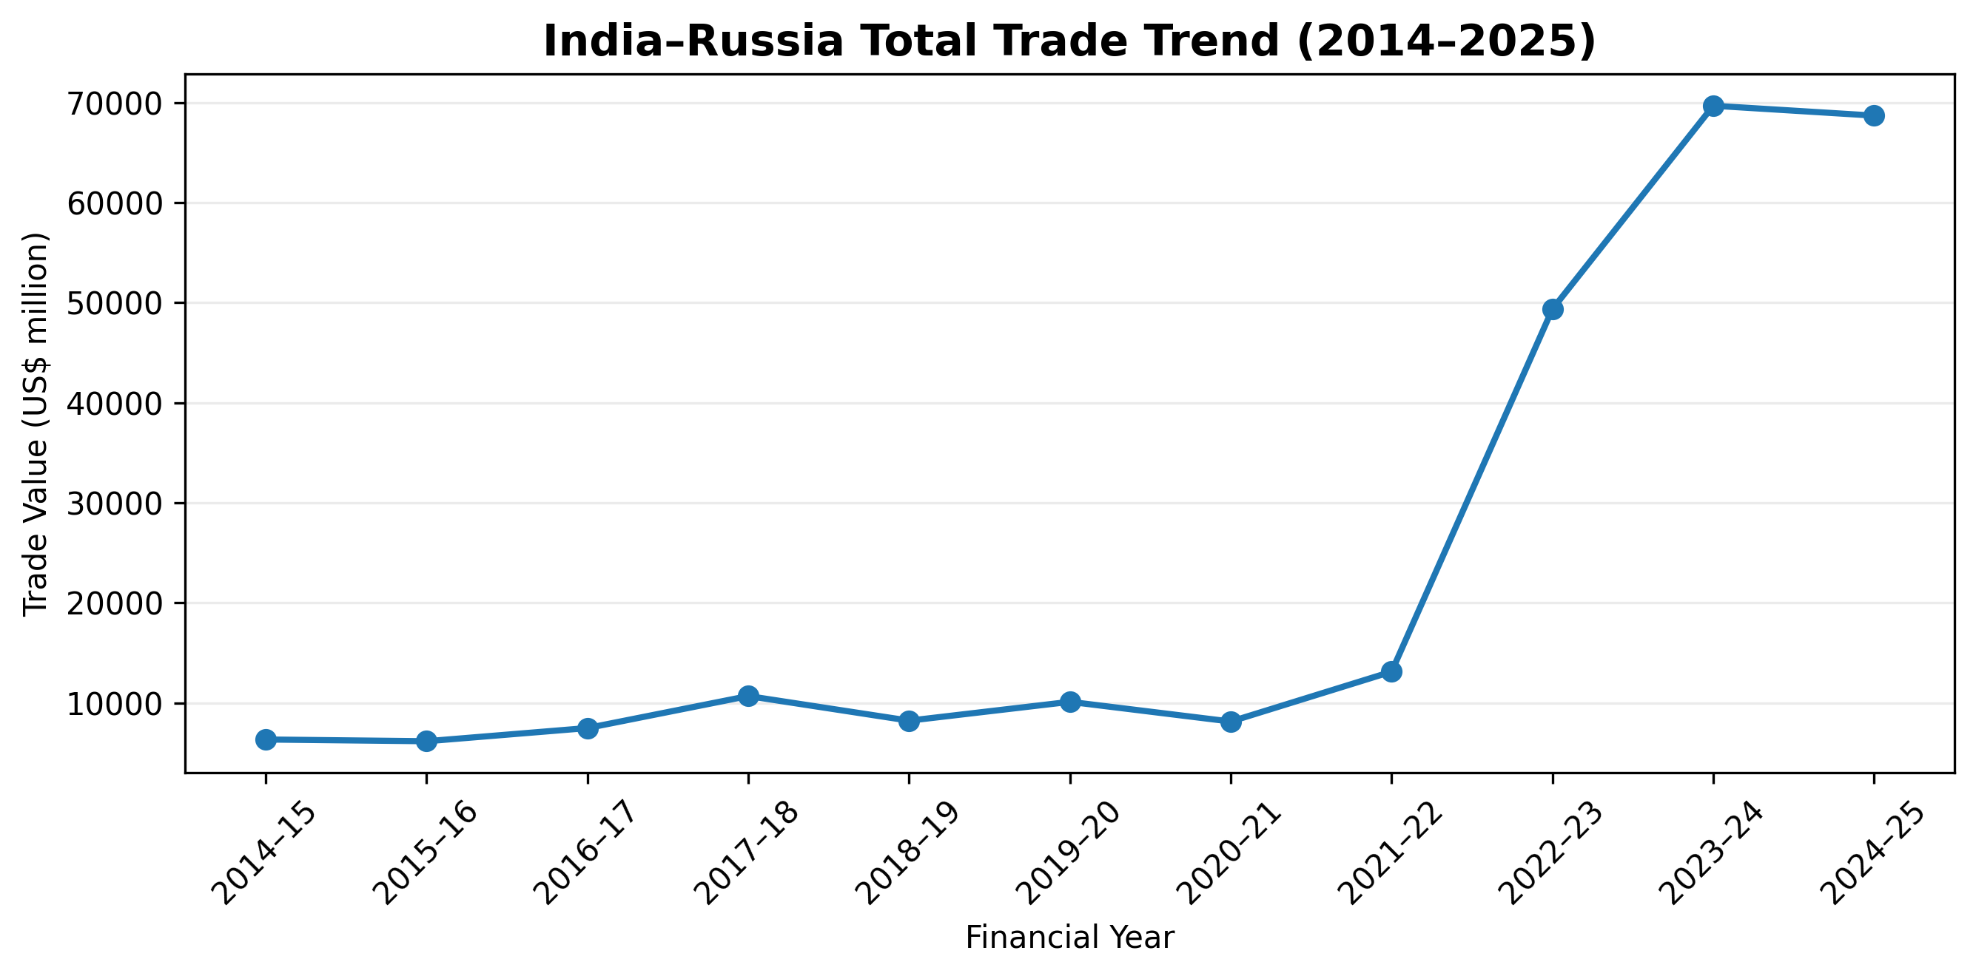
Figure 1. India–Russia total bilateral trade, 2014–15 to 2024–25. Source: Author's analysis of Government of India Department of Commerce data.

Total trade averaged around US$13.30 billion annually before 2022–23, and from 2022–23 onward, averaged around US$62.58 billion annually. This means there has been a dramatic shift in the level of bilateral trade. The rise was not even across exports and imports. In 2023-24, Indian exports were the biggest at US$8.52 billion and Russian imports were the highest at US$63.81 billion in 2024-25. 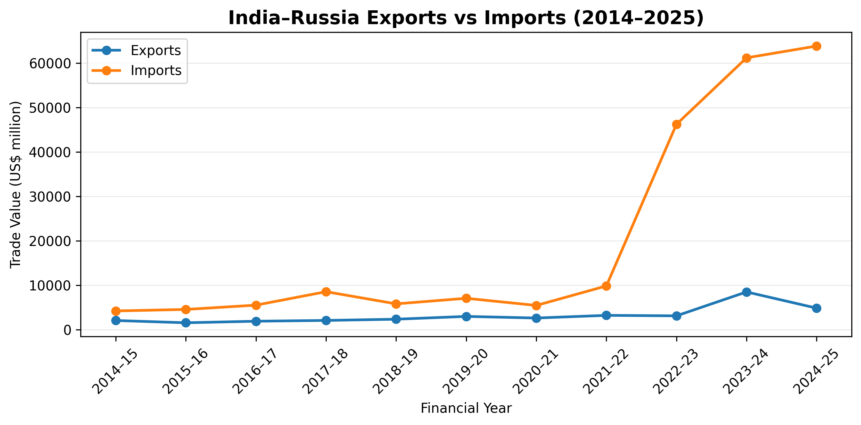
Figure 2. India–Russia exports and imports, 2014–15 to 2024–25. Source: Author's analysis of Government of India Department of Commerce data.

On average, 77.60% of bilateral trade was carried out with imports during the study period. Their share reached 93.62% in 2022–23 and remained above 90% in 2024–25. That confirms that the expansion after 2022 was quite heavily geared towards imports.

5. Trade Imbalance and Import Dependence
India had negative trade balance with Russia in all the years analysed. In 2014–15, the deficit was around US$2.15 billion and in 2021–22, it was US$6.62 billion, which then jumped markedly to US$43.07 billion in 2022–23. It increased to US$52.64 billion in 2023–24 and to its peak of approximately US$58.93 billion in 2024–25.
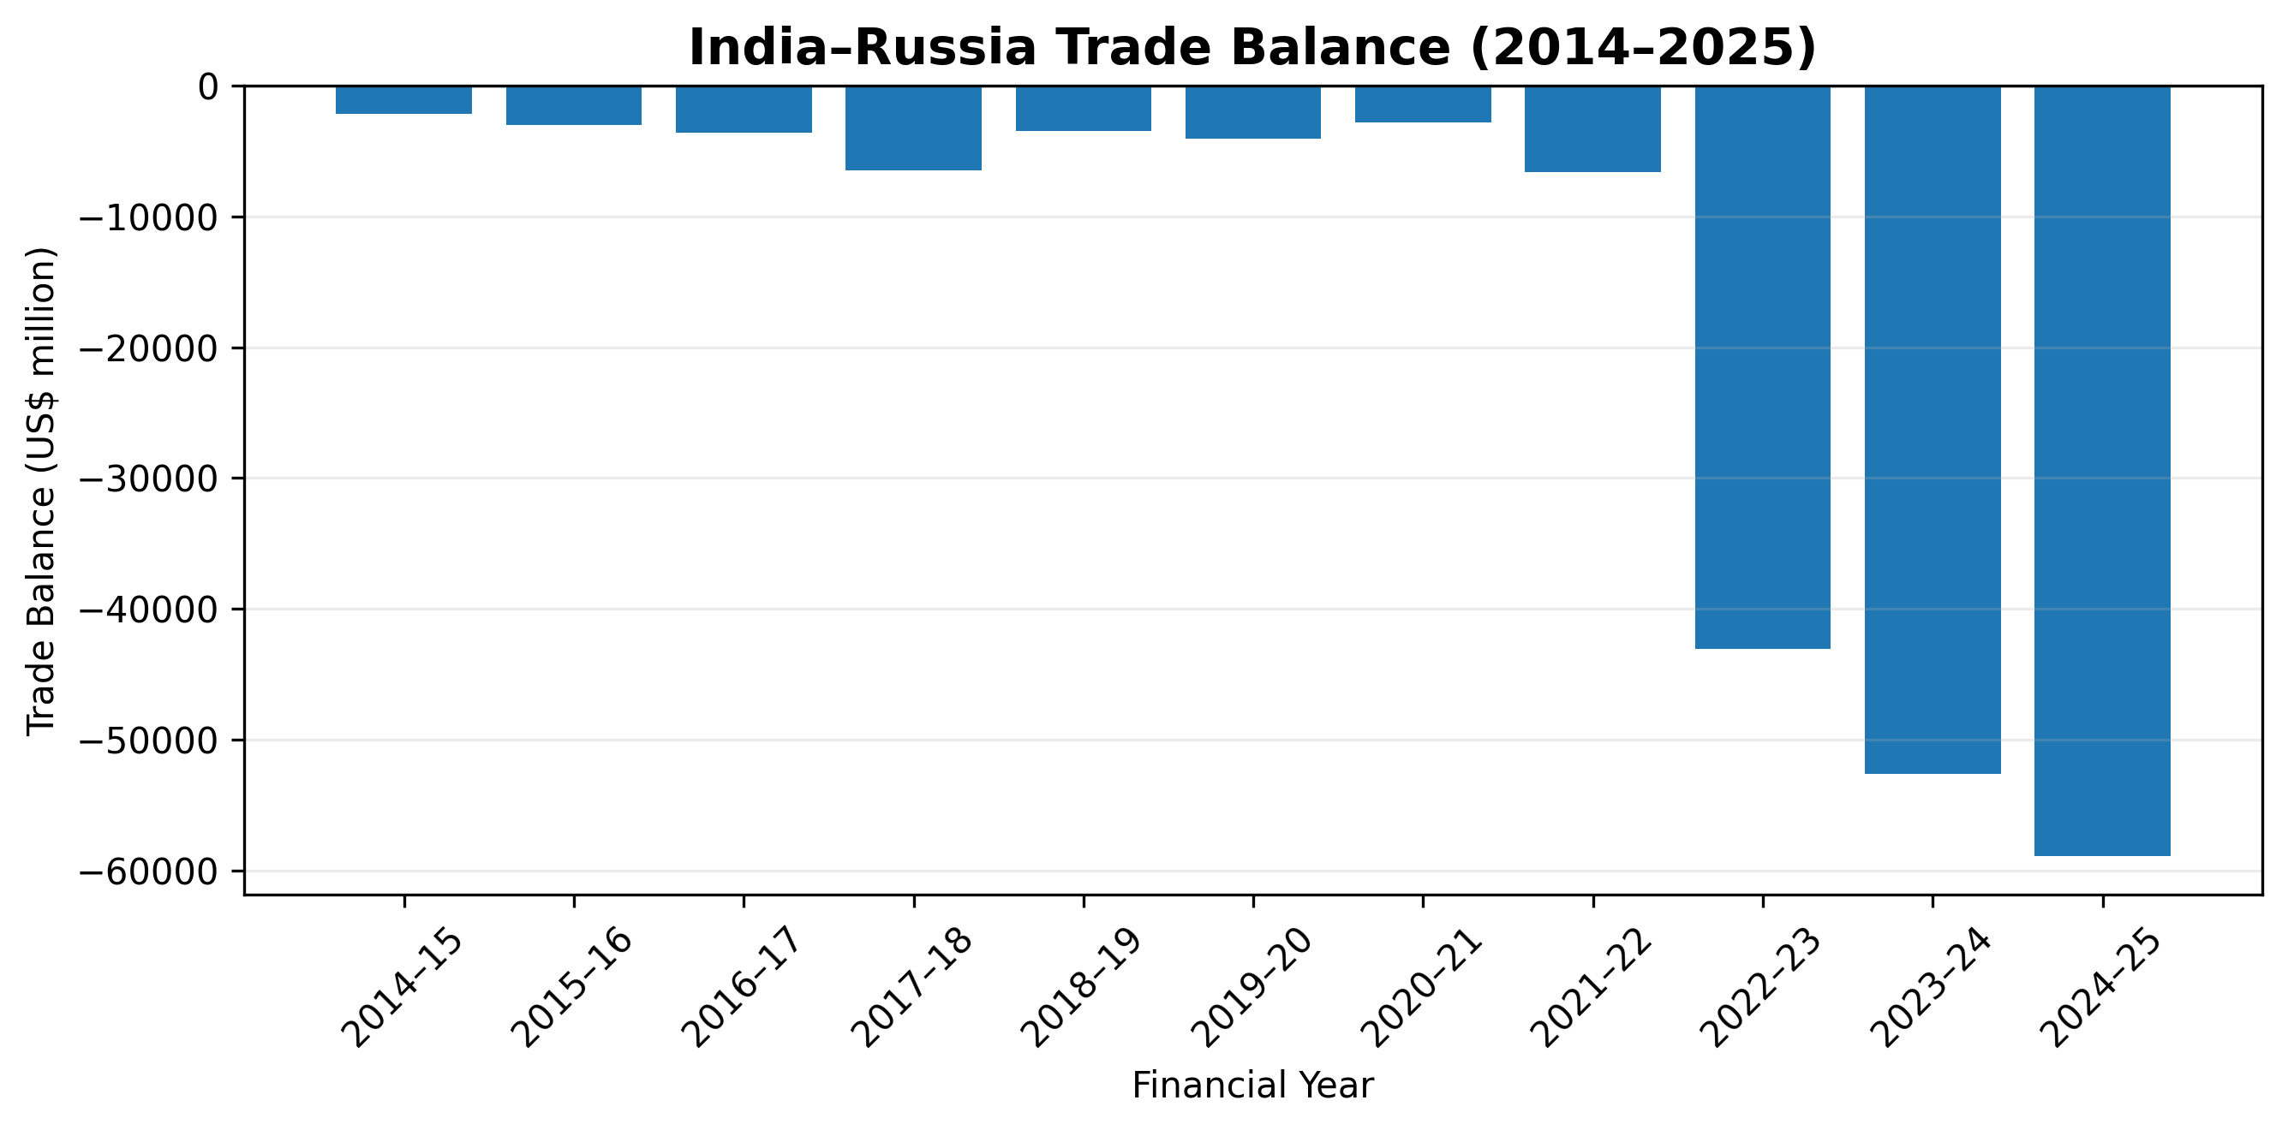

Figure 3. India–Russia trade balance, 2014–15 to 2024–25. Source: Author's analysis of Government of India Department of Commerce data.
The increasing trade deficit has a close relationship with the fluctuation of import proportion in bilateral trade.The increasing trade deficit is well correlated with the increasing import proportion in bilateral trade. A trade deficit is not, in itself, a sign of a decrease in bilateral relations, but the extent and duration of the imbalance do pose questions with regard to export diversification and the future pattern of the bilateral economic relationship.

6. The Energy Dimension

Energy is an important component of India–Russia economic relations. Cooperation in oil and gas, petrochemicals and civil nuclear energy are listed as areas of bilateral cooperation by official Indian sources. (Ministry of External Affairs, 2024)(Ministry of External Affairs, 2021)

The nature of India's imports is of additional interest. According to WITS data from the World Bank, fuels are India's most imported product group from Russia in 2022, as they have made up 83.62% of India's imports from Russia in all product group classification. Although this does not cover entire bilateral trade growth, it highlights energy trade in the bilateral trade relationship.

The energy cooperation encompasses natural gas, oil and gas investment, petrochemicals and nuclear energy, among other areas. The energy dimension also elucidates the strategic nature of the economic relationship other than its face value in terms of bilateral merchandise trade. (Ministry of External Affairs, 2024) (Ministry of External Affairs, 2021)

7. Post-2022 Transformation

This following period is a turning point (after 2021-22). Total trade increased from US$13.12 billion in 2021–22 to US$49.36 billion in 2022–23. India's imports increased from US$9.87 billion to US$46.21 billion during the same period while the exports value increased marginally from US$3.25 billion to US$3.15 billion.

The import share was thus increased to 93.62% in 2022–23. Although it declined to 87.77% in 2023–24, it rose again to 92.89% in 2024–25. The evidence thus indicates a fundamental shift in bilateral trade where India has seen Russia becoming a huge source of imports while India has comparatively limited exports.

The change should, in this sense, be interpreted not as a growth of two-way trade, but as a shift in the balance and composition of two-way trade.

8. Key Findings

The bilateral trade grew significantly, from US$6.35 billion in 2014-15 to US$68.69 billion in 2024-25.

The strongest expansion occurred after 2021–22, with 276.08% year-on-year growth in 2022–23.

Imports from Russia grew at a far higher rate than Indian exports to Russia.

On average, 77.60% of bilateral trade came from imports (more than 90% in 2022–23 and 2024–25).

In 2024–25, India's bilateral trade deficit increased to nearly US$58.93 billion.

While energy and commodity trade are relevant to the post-2022 expansion, they should not be the sole basis for a single causal explanation.

9. Policy Implications
- Trade diversification could be a way of lessening the persistent trade imbalance and expanding the economic relationship.
- Bilateral trade is also highly import-dependent, and depends on the prices and availability of commodities, which further emphasizes energy-security planning and diversifying sources.
- Total volume of bilateral trade should be analyzed with respect to the composition and the balance of bilateral trade.
- Such strategic bilateral cooperation in sectors other than energy, like pharmaceuticals, agriculture, manufacturing and technology, could open export avenues for higher value-added Indian exports.
The central policy challenge is therefore not simply to maintain high trade volumes, but to encourage a more diversified and sustainable structure of economic exchange.

10. Limitations

The analysis is quantitative and only reflects merchandise trade; it does not reflect the overall nature of India–Russia economic cooperation, such as services, foreign direct investment and others. This analysis is not causal and does not constitute a causal link between geopolitical developments and trade outcomes. Shorter-term variations in commodity prices, exchange rates and trade flows may also be masked with annual information. Lastly, revisions to official publications and reporting of periods and/or statistical methodology could cause differences in the statistics, so the Department of Commerce Trade Stat series is used consistently as the base quantitative.

11. Conclusion

The bilateral trade of merchandise between India and Russia has had a significant shift between 2014-15 and 2024-25. The volume of trade rose from around US$6.35 billion to US$68.69 billion, particularly since 2021–22. The growth has been very uneven, however, because “India's imports from Russia were growing much faster than India's exports to Russia, by 2024-25 India has a bilateral trade deficit with Russia of around US$58.93 billion. The results indicate that the recent growth is not only in bilateral trade volume but also in its composition. The context of the energy and commodity trade is important for this transformation, and the fact that the trade imbalance continues to exist is of significance in terms of export diversification and broader economic co-operation. Sustainability and a more balanced and stable economic partnership, not only on the volume of trade, but on the composition of trade between India and Russia will be the deciding parameters for the future of the relationship.

References
Ministry of External Affairs, Government of India. (2024). India–Russia Relations. October 2024. https://www.mea.gov.in/Portal/ForeignRelation/India-Russia-Relations.pdf
Department of Commerce, Ministry of Commerce and Industry, Government of India. TradeStat: Export–Import Data Bank. https://tradestat.commerce.gov.in/
Ministry of External Affairs, Government of India. India–Russia bilateral energy cooperation materials / official briefing. https://www.mea.gov.in/media-briefings.htm
World Bank. World Integrated Trade Solution (WITS). India Product Imports from Russian Federation, 2022. https://wits.worldbank.org/CountryProfile/en/Country/IND/Year/2022/TradeFlow/Import/Partner/RUS/Product/All-Groups

Appendix A. Core Dataset Summary
Financial Year | Exports | Imports | Total Trade | Trade Balance
2014–15 | 2,097.01 | 4,249.22 | 6,346.23 | -2,152.21
2015–16 | 1,587.81 | 4,584.98 | 6,172.79 | -2,997.17
2016–17 | 1,937.06 | 5,552.30 | 7,489.36 | -3,615.24
2017–18 | 2,113.39 | 8,573.46 | 10,686.85 | -6,460.07
2018–19 | 2,389.47 | 5,840.44 | 8,229.91 | -3,450.97
2019–20 | 3,017.67 | 7,093.01 | 10,110.68 | -4,075.34
2020–21 | 2,655.52 | 5,485.75 | 8,141.27 | -2,830.23
2021–22 | 3,254.68 | 9,869.99 | 13,124.67 | -6,615.31
2022–23 | 3,146.95 | 46,212.71 | 49,359.66 | -43,065.76
2023–24 | 8,522.61 | 61,159.17 | 69,681.78 | -52,636.56
2024–25 | 4,881.30 | 63,811.44 | 68,692.74 | -58,930.14
All monetary values in the appendix are US$ million. Source: Government of India Department of Commerce Trade Stat dataset used in this study.

