horizontal line

Create CI/CD Pipelines

# Install plugins that you need for your applications build.

**Pipeline plugins:**

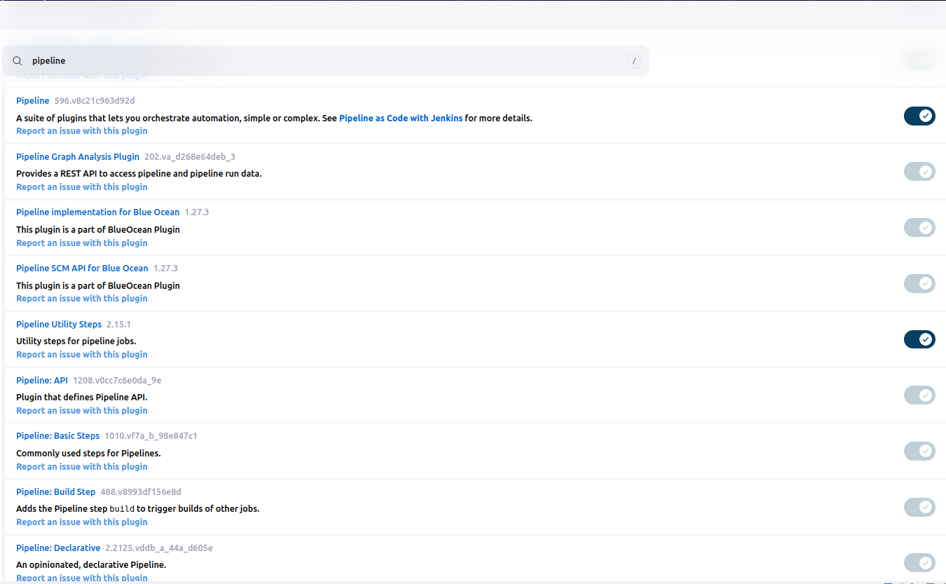

**Blue Ocean plugins:**

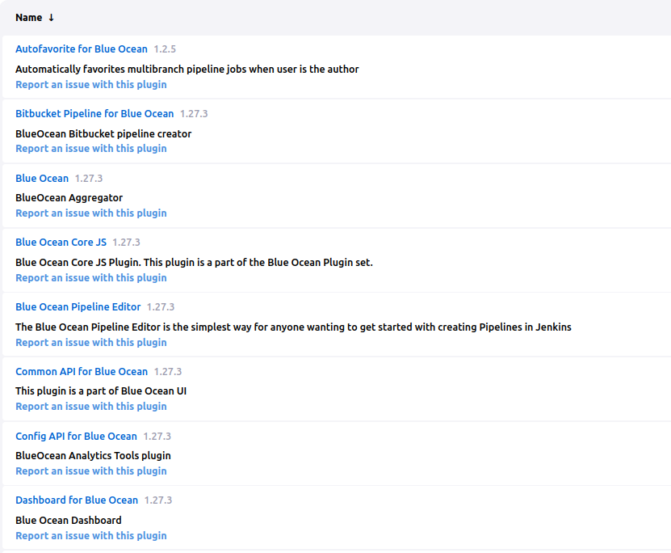

**Github plugins:**

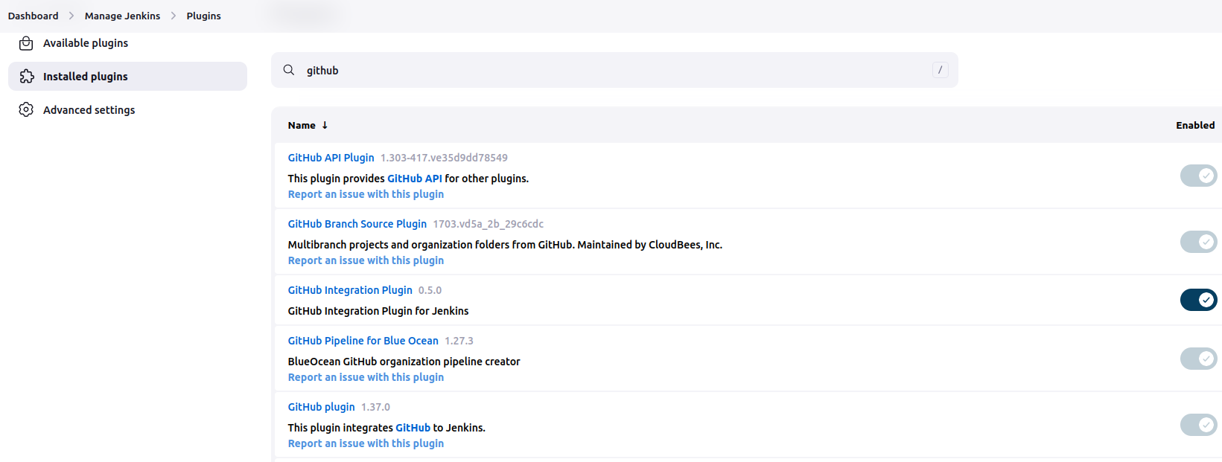

# Create a declarative pipeline(Jenkinsfile)

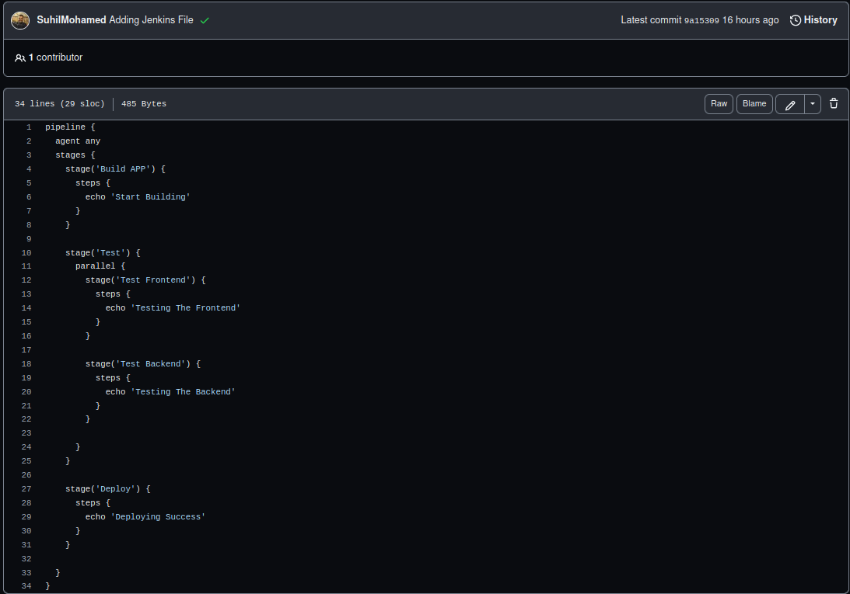

# 

# 

# 

# 

# 

# 

# Create a project and import code from SVC repo.

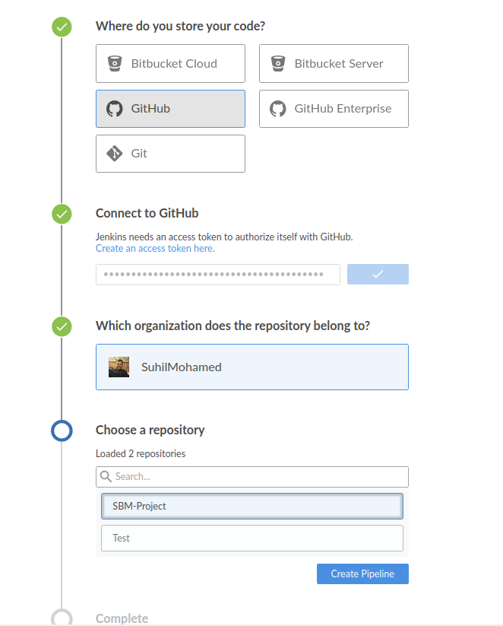

# declarative method to create a Jenkinsfile for each part of your project.

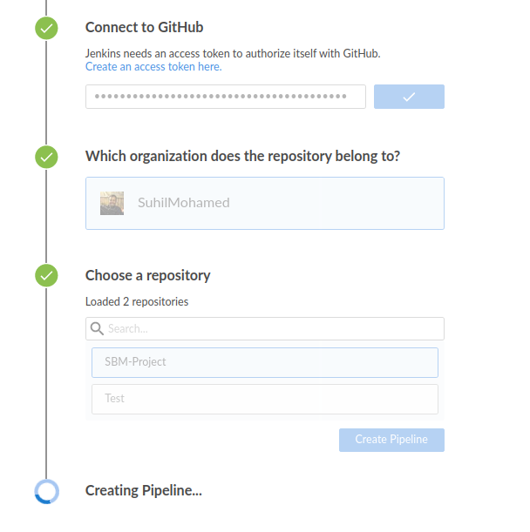

# 

# 

# 

# For Jenkins you should use the blue ocean plugin.

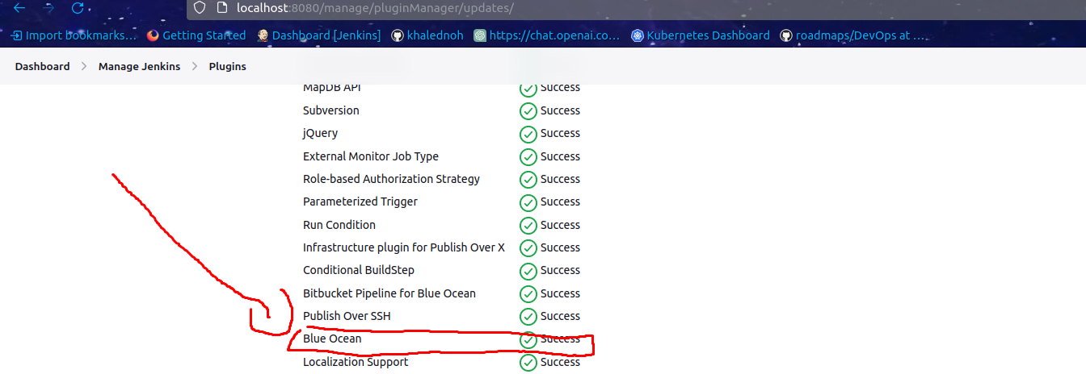

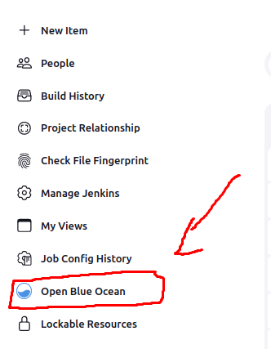

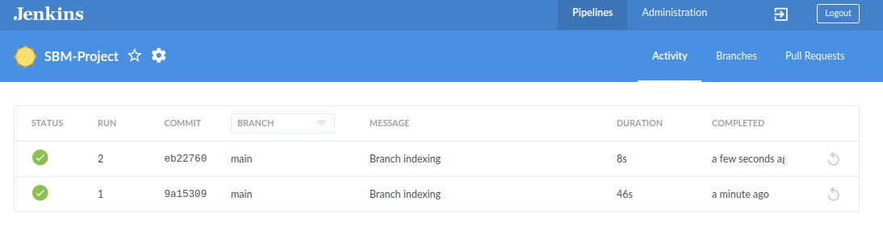

# Integrate Github and jenkins using plugin.

