Orchestration

# 

# 

# 

# 

# 

# 

# 

# 

# Deployment

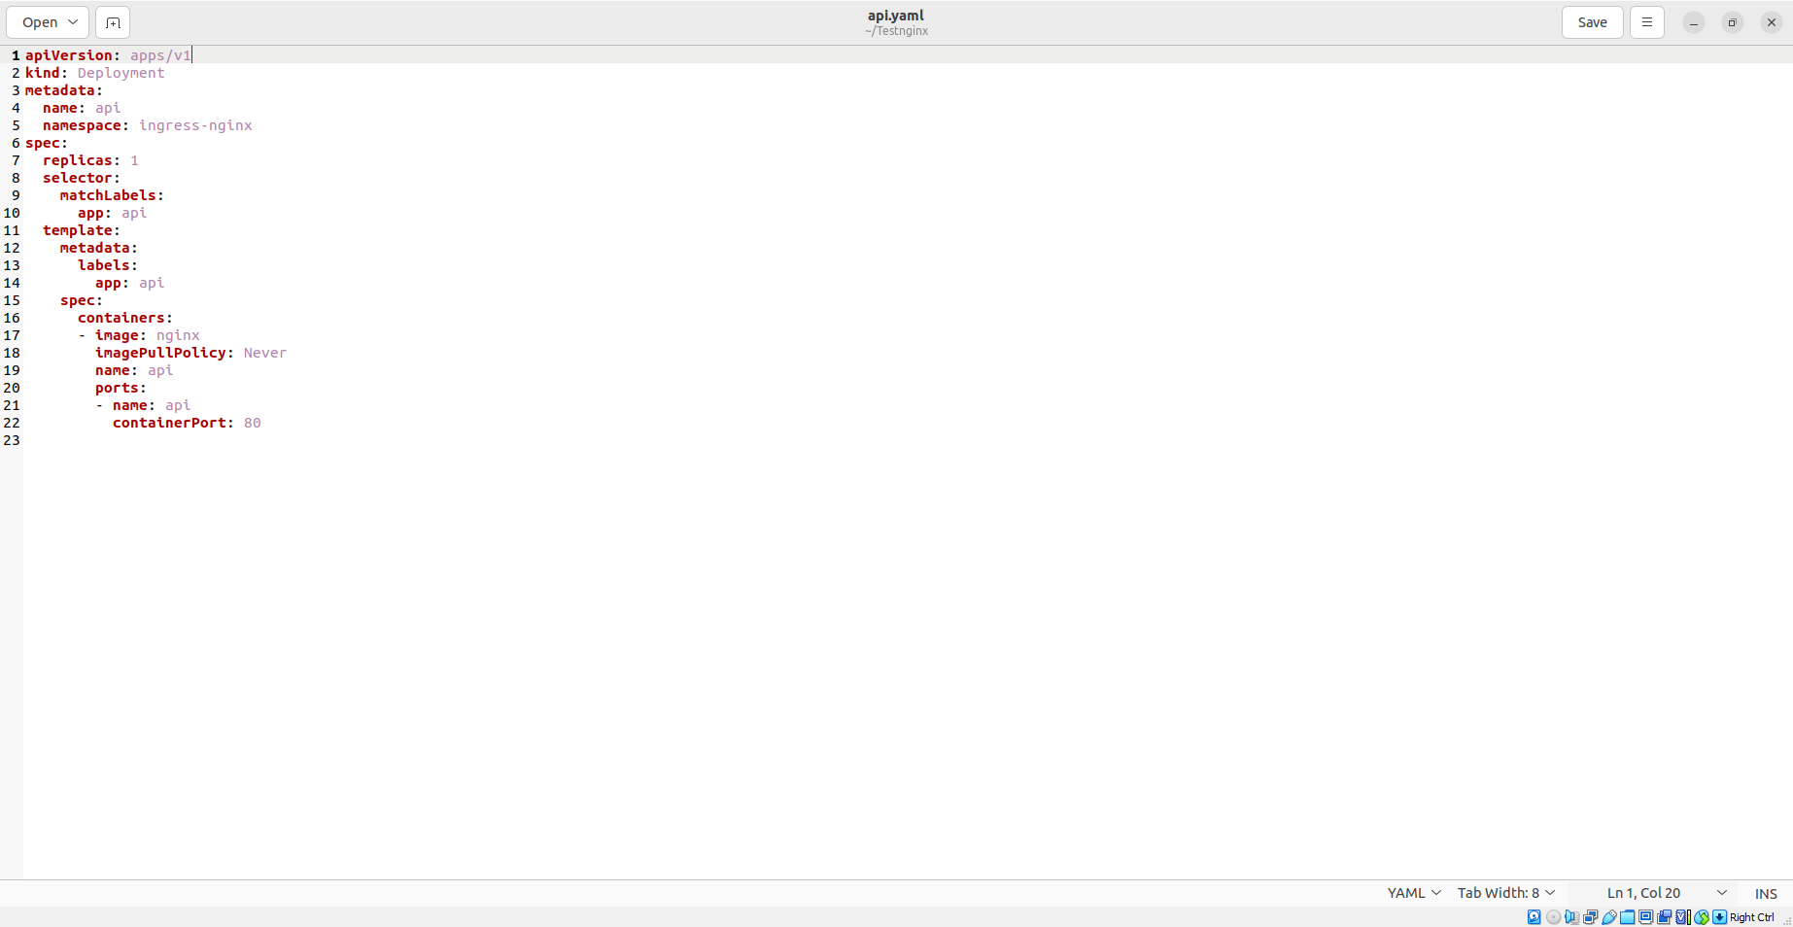

# 

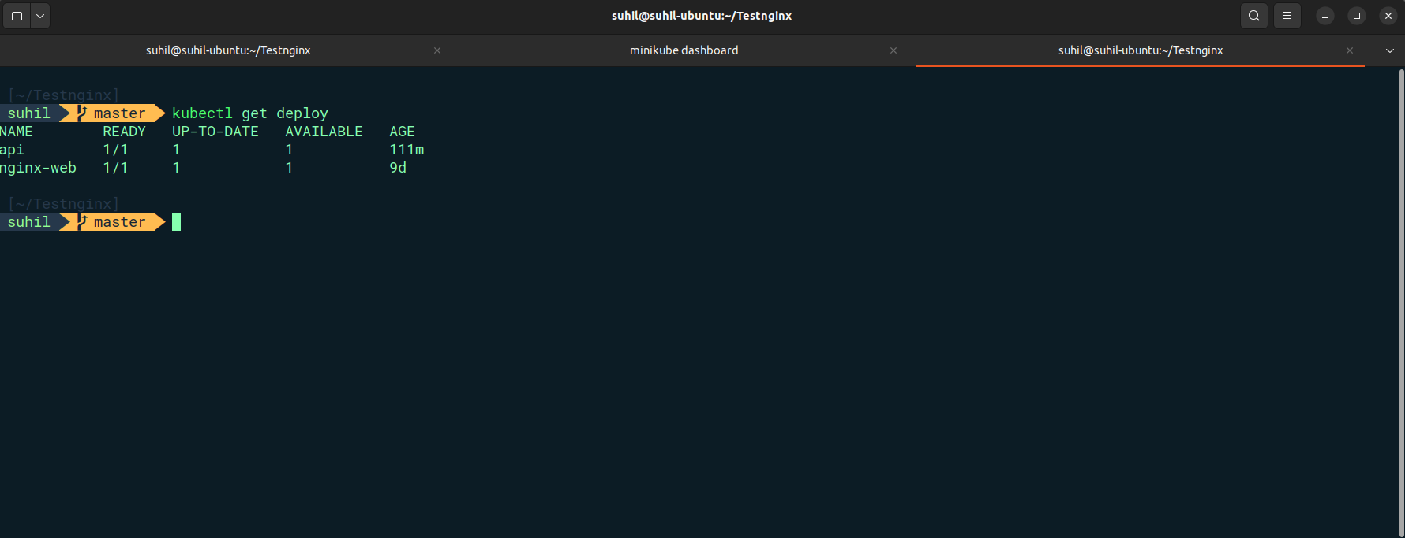

# 

# Service

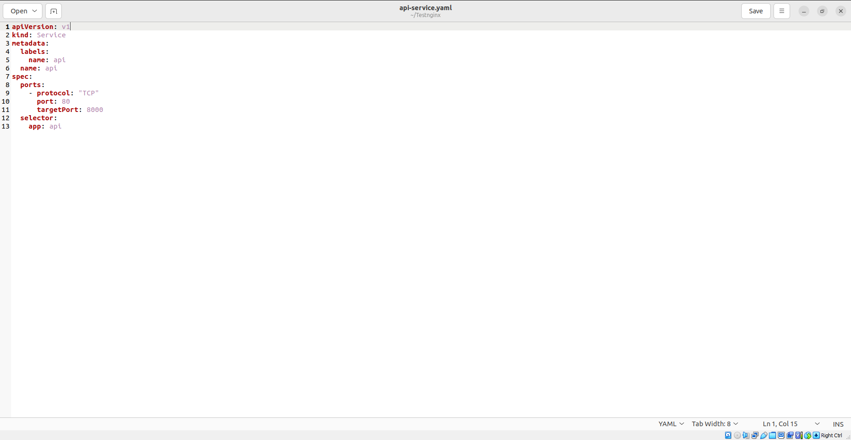

# 

# 

# 

# 

# 

# ingress

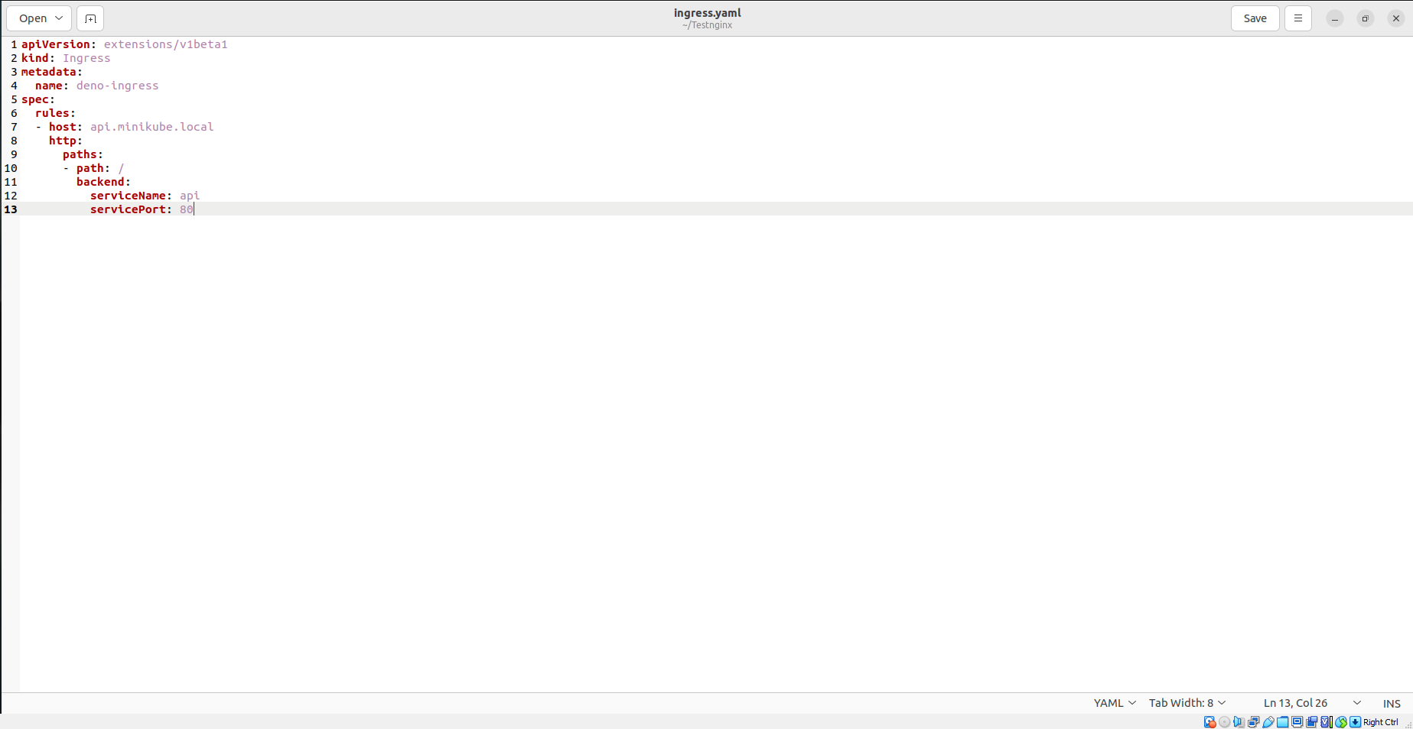

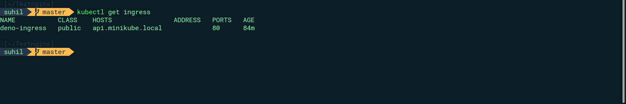

# 

# Output



