2025年南京中考真题英语
注意事项：
1. 本试卷共8页。全卷满分90分。考试时间为90分钟。试题包含选择题和非选择题。教答题全部答在答题卡上，答在本试卷上无数。
2. 请认真核对监考教师在答题卡上所粘贴条形码的姓名、考试证号是否与本人相符合，再将自己的姓名、考试证号用0.5毫米黑色墨水签字笔填写在答题卡及本试卷上。
3. 答选择题必须用2B铅笔将答题卡上对应的答案标号涂黑。如需改动，请用橡皮擦干净后，再选涂其他答案。答非选择题必须用0.5毫米黑色墨水签字笔写在答题卡的指定位置，在其他位置答题一律无数。
Some exchange students from the UK are coming to your school. As a volunteer, you are going to be with them. Are you ready?
选择题（共40分）
一、单项填空（共15小题；每小题1分，满分15分）
请认真阅读下列短文，从短文后所给的A、B、C、D四个选项中，选出最佳选项，并在答题卡上将该项涂黑。
Task I Recommend cities for their visit.
Rich in history and culture, NANJING has been a tourist attraction for many years. Nanjing City Wall has a history of over 600 years, and it is 1 and best-protected city wall in the word today. The amazing Zhongshan Mountain view 2 ancient buildings are certainly worth 3 . Don’t miss the. Confucius Temple 4 it was once the highest educational institution in ancient China, Now, Nanjing has many high-level universities. So, remember to 5 out these universities and take in the educational atmosphere. A holiday here will be the trip of a lifetime.
1．A．long B．longer C．longest D．the longest
2．A．as B．and C．but D．so
3．A．visit B．to visit C．visiting D．visited
4．A．before B．when C．though D．because
5．A．check B．checks C．checking D．checked
YAN’ AN sits on the southern bank of the Yanhe River, with hills all around it. It’s 6 full of history. The Communist Party of China 7 Yan’an as their central point from 1937 8 1947 and this city developed into a symbol for the communist heroes. Do you know 9 we can learn more about Chinese communists’ history? 10 to the Yan’an Revolutionary Memorial Hall! It’s a huge museum and it’s truly fantastic!
6．A．place B．places C．a place D．the place
7．A．use B．used C．using D．uses
8．A．since B．to C．in D．by
9．A．when B．who C．what D．where
10．A．Go B．Goes C．Going D．Went
On the banks of the Yellow River sits a famous city-LUOYANG. It used to be the capital of thirteen dynasties. The Longmen Grottoes, which 11 in ancient times, are a must-see. You can 12 some of the best examples of Chinese stone art. Luoyang is a good choice for nature lovers too. It has been famous for its peonies since the Tang Dynasty. Every spring, 13 tourists from homo and abroad come to admire these be a beautiful flowers, 14 you want to go climbing! Be sure to make 15 way to Mount Baiyun. The dreamlike see of clouds, amazing waterfalls and beautiful forests there will be a real treat.
11．A．build B．built C．are built D．were built
12．A．enjoy B．enjoys C．enjoying D．enjoyed
13．A．thousand B．thousands C．thousand of D．thousands of
14．A．Are B．Were C．Do D．Did
15．A．you B．your C．yours D．yourself
二、完形填空（共10小题；每小题1分，满分10分）
请认真阅读下面短文，从短文后备题所给的A、B、C、D四个选项中，选出最佳选项，并在答题卡上将该项涂黑。
Task II Disscuss smart technology together.
A Chinese company called DeepSeek has surprised many experts by publishing its own artificial intelligence (AI) software. Al is a computer system that can learn from 16 and do things that usually take human intelligence. DeepSeek uses generative AI; which is a type of software that can generate (生成) 17 such as text and images based on the prompt (提示) a person types in. For example, you could ask the software to write a shopping list, create computer code, make up a story or you could use it to have a chat.
AI is developing faster than anyone 18 . For tech lovers, the possibilities are endlessly exciting, but some people are worried about the new technology. They argue (争论) that as AI gets smarter, humans are actually becoming 19 . They say humans depend on AI instead of learning and practicing basic skills. For much of human history, people had to take care of many basic needs. Now, you might have all the 20 in the world at your fingertips, but is it making you any smarter? Some people say no!
Other people think that AI is a 21 tool Some adults use AI at work to make their tasks easier, such as writing an email or planning.a meeting. 22 children have the chance to use AL, they can try using it for their schoolwork. The AI software might inspire (激起) an idea to help them get started on a piece of homework or school project. Al doesn’t just have 23 uses. Some people like to use it for fun reasons, such as to create a silly story or just to draw a picture.
AI isn’t going anywhere. It’s on the 24 , becoming a part of our everyday lives. Some people think AI is still now and people don’t know enough about it. There should be 25 to protect children from any possible dangers in laws.
Now that you know both sides of the opinions, what do you think?
16．A．advice B．experience C．business D．control
17．A．inventions B．actions C．content D．attention
18．A．guarded B．expected C．collected D．charged
19．A．busier B．lazier C．wiser D．braver
20．A．warmth B．sense C．strength D．knowledge
21．A．strange B．foreign C．useful D．traditional
22．A．If B．Unless C．Thought D．Until
23．A．local B．practical C．extra D．online
24．A．top B．list C．subject D．increase
25．A．rules B．tasks C．facts D．records
三、阅读理解（共15小题；每小题1分，满分15分）
请认真阅读下列材料，从短文后备题所给的A、B、C、D四个选项中，选出最佳选项，并在答题卡上将该项涂黑。
Task III Understand the secret of prices.
A
What is economies?
Some people think that economics is all about money, banks and very difficult charts. But it’s actually a lot simpler than that—much of economics is really about understanding choices.
How prices respond to people
Prices influence how much people want to buy and produce. But it also works the other way around—how much people want to buy and produce makes prices change too.
• If there’s more supply (供应量) than there is demand (需求), it sends a signal to a seller to lower prices.
• If there’s less supply than there is demand, it sends a signal to a seller to increase prices.
Over time, the price changes until it reaches a point where there’s as much demand as there is supply. This is known as the equilibrium price. The price is just right—it’s high enough for the seller and low enough for customers.
26．What is economics mainly about?
A．Making charts. B．Studying banks.
C．Understanding choices. D．Spending money.
27．What is the best price tor both buyers and sellers?
A．A fixed price to cut costs. B．A higher price to make money.
C．A loner price to catch people’s attention. D．An accepted price to balance supply and demand.
28．Which price will the seller in the picture probably choose tomorrow?
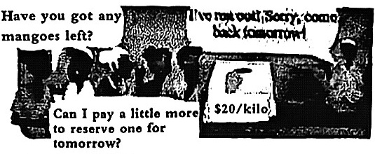
A．＄15$\text{/}$kilo.
B．＄18/ kilo.
C．＄20$\text{/}$kilo.
D．＄22$\text{/}$ kilo.
Task IV Present what to do for wildlife.
B
Word Wildlife Day takes place on Monday, March 3. One way to celebrate the wild animals that live all around us-and to educate others about their importance—is to make a mature documentary. All you need to create this film is a camera and a subject. Here’s how you can get started.
Pick a theme
First, decide what you would like your nature documentary to be about. Do you want to film wildlife that lives outside your home, or would you rather ask an adult to go with you to a nearby park or nature reserve? Do some research and choose local wildlife that interests you. For example, think about tho animals that live in your region and the animals you are more likely to see during daylight hours.
▲
Once you decide what to film, do some deeper research on your subject: Take motes that can help you look for interesting facts to film. For example, what are some of tho animal’s feeding habits? Research the physical differences you might spot between males and females of the same animals, from size to color to behavior.
Film and edit
You can just use a video camera or a phone with a camera to make a nature documentary. When you re ready to film, stay a comfortable distance from wildlife so you don't frighten (吓走) away your subject. You can also film an introduction: Put your camera iff selfie mode, Introduce yourself, and let the viewers know why you chose your subject. Finally, you can use a free app to edit your film and add titles.
Host a screening
When you're happy with your film, invite family and friends to watch it You can have a screening at home or check with your local library about a meeting room. After the screening, have a question and answer session so the viewers can ask you about your documentary. Finally, thank everyone for coming!
29．What is the purpose of making a nature documentary?
A．To improve skills of making films. B．To record some wildlife's qualities.
C．To increase awareness of wild animals. D．To carry out a survey about wild animals.
30．Which of the following is the most suitable for ▲ ?
A．Do your research B．Share the film
C．Prepare a video camera D．Organize some activities
31．What should you pay attention to when ready for filming?
A．Having a talk with the viewers. B．Inviting your friends to make notes.
C．Keeping a proper distance from wildlife. D．Making sure to use a camera to film better.
32．How does the writer organize the ideas?
A．By showing steps. B．By giving choices.
C．By asking questions. D．By comparing differences.
Task V Explore amazing nature.
C
Many years ago, people who saw waves (光波) of color dance across the sky at night were scared. Some groups of people made up legends to explain what today is known as the northern lights, while others still have the query (质疑) about them.
The sun gives off particles (粒子) that are filled with energy. Large groups of these particles travel together. They are called solar wind. The particles travel through space at hundreds of miles per second. Even traveling that fast, it still takes several days for the particles to reach Barth. When the solar wind gets close to Earth, it moves toward the two magnetic poles, the North Pole and the South Pole.
When the solar particles get close to Barth, they become trapped in Barth’s atmosphere (大气层). They collide; or run into, gases in the atmosphere. The energy that is made in that collision (碰) creates light. When lots of these collisions happen at the same time, the northern lights can be seen from Barth. The northern lights are harmless, but it can be scaring to see the sky fill with flashing colored lights if you do not know what they are.
As far as scientists can tell, the northern lights do not make any sounds that people on Barth can hear. Even so, if you live in a place where the northern lights can be seen, you might notice problems with your television or cell phone every once in a while. The energy created by solar wind in the Earth’s atmosphere can get in the way of sound waves and pictures that travel through the air to your TV or phone.
The northern lights are truly amazing, especially the first time you see them. Even in the highest latitudes, the lowest part of the lights are still 40 miles above Barth. The northern lights stretch up about six hundred miles into the atmosphere. Imagine what a light show you would see if you were an astronaut looking down on the northern lights from space.
33．What causes the northern lights?
A．The sound waves created by solar wind.
B．The particles traveling at high speed in space.
C．The solar particles hitting gases in the atmosphere.
D．The solar wind at the North Pole and the South Pole.
34．Which of the following is influenced by the Northern lights?
A．The use of e-products. B．The direction of solar wind.
C．The condition of people’s hearing. D．The level of light pollution.
35．What is the best title for the passage?
A．Space: An unknown world B．Solar Wind: Traveling at high speed
C．Lights: Fall of mystery D．Astronauts: Pioneers exploring space
36．Which is the best query after reading the passager
A．Where does the solar wind come from?
B．When are the solar particles trapped in the atmosphere?
C．How did people feel about the northern lights many years ago?
D．Why are the northem lights harmless since they cause problems?
Task VI Experience the magic of a quilt.
D
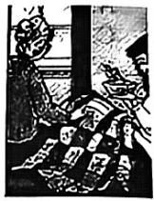
Cecily had been in bed with the flu for nearly a week. She was tired of feeling sick and achy. ① She missed going to school and seeing her friends. She missed playing in the park and going to the library.
On Friday, Cecily’s mom had to go back to work, so Cecily’s grandmother was coming to stay with her for the day. Cecily loved spending time with Nonnie. She was hoping her grandmother would bring some homemade peach ice cream. Nonnie made the best ice cream in the world. Cecily waited impatiently for her grandma to arrive. Finally, she heard voices downstairs. A couple of minutes later, Nonnie popped her head into Cecily's bedroom.
“How’s my girl?” she asked Cecily “I heard you were feeling under the weather.” Nonnie was carrying a small blue bowl in one hand. A quilt was hung over her other arm.
“Hi, Nonnie!” said Cecily cheerfully.
“ ② This peach ice cream is for your breakfast. I thought it might help you get your appetite（(食欲) back.” said
Nonnie. She handed the bowl to her granddaughter.
“Why did you bring a quilt with you?” asked Cecily.
“Well, I thought the quilt might make you feel better, too,” said Nonnie. “ ③ It was your mother’s favorite quilt when she was a little girl."
“Did you make it?” Cecily asked her grandmother.
“No,” answered Nonnie,” “but my mother and my aunt made it when I was small. This quilt has seen a lot of things," she said softly.
Cecily rubbed a comer of the quilt against her cheek. “I like this piece best, I think,” she said, pointing to a large block of red flowered fabric.
“That was from the dress I wore for my sixth birthday,” said Nonnie, smiling.
“What about this one?"Cecily asked Nonnie.
“That piece was from my mother's favorite apron,” said Nonnie, gently touching a small price of cotton. "She was wearing that apron the day my little brother fell in the river. She ran out of the house when she heard us screaming for help, “remembered Nonnie. “She tore the apron on a rock in the river, but my brother was okay."
“Nonnie, do you have a story for every block in this quilt?” asked Cecily.
“Almost every one,” answered Nonnie. “ ④ Now that you know some of them, maybe you will remember and tell your own grandchildren these stories one day.”
Cecily thought for a moment. “Nonnie, you were right. This quilt did make me feel better. The peach ice cream didn’t hurt, either!”
37．Why did Nonnie come to see Cecily?
A．Cecily’s mom went to work. B．Nonnie missed Cecily so much.
C．Cecily loved spending time with Nonnie. D．Nonnie made ice cream for Cecily.
38．What do the underlined words “under the weather” mean?
A．Ill. B．Hopeless. C．Sad D．Nervous
39．What does the quilt stand for?
A．Life full of surprises. B．The secret of family value.
C．The pleasures of growing up. D．The attraction of an old object.
40．Which underlined sentence shows a different culture from Chinese culture?
A．Sentence ①. B．Sentence ②. C．Sentence ③. D．Sentence ④.
非选择题（共50分）
四、填空（共15小题；每小题1分，满分15分）
Task VII Exchange different cultures.
A)请根据括号中所给的汉语写出单词，使短文意思完整正确，并将答案填写在答题卡标号为41~45的相应横线上。
Last 41 (周末), my friend Sandy introduced me to traditional Chinese folk music. Since I grew up in the UK, I knew little about this 42 (种类) of music, but I was interested in learning all about it. Sandy played the song “Jasmine Flower” for me. It’s a beautiful and meaningful piece of music.
“Jasmine Flower” is a well-known song all over China. A world-famous 43 (作曲家) even used it in one of his operas. Listening to “Jasmine Flower” made me feel very 44 (放松的) and happy. It reminded me of the simple beauty of the jasmine flower. I can understand why this is such a 45 (受欢迎的) song and I am excited to listen to more traditional Chinese folk music.
B)请根据短文意思,用括号中所给单词的适当形式填空，并将答案填写在答题卡标号为46~50的相应横线上。
My favourite painter is Xu Beihong, a Chinese painter born in 1895. He was an artist who was most famous in the first half of the 46 (twenty) century.
Xu began studying painting when he was very young. He 47 (quick) became an expert at traditional Chinese painting. He believed that traditional Chinese painting would lose some of its 48 (important) if painters stopped trying new methods. So he became interested in 49 (create) now forms of art that mixed traditional Chinese and Western methods.
Xu often painted 50 (animal), especially horses and birds. If you like beautiful paintings, you will certainly love Xu’s works.
C)请阅读下面对话，从方框中选择适当的单词或短语填空（方框中有一个单词或短语是多余选项），使对话内容完整正确，并将答案填写在答题卡标号为51~55的相应横线上。
as well as lasted common but first when

Andrew: Hi, Li Ping. What makes a good piece of literature?
Li Ping: Great literature usually has three key qualifies. 51 , lots of people should be able to
connect with it.
Andrew: What do you mean?
Li Ping: I mean, good literature should describe feelings and problems that are 52 to everyone. Think about the story Romeo and Juliet by William Shakespeare. People in many different countries and centuries have been able to connect to this love story.
Andrew: OK, I see.
Li Ping: Secondly, good literature is an art form of language. Great writers use language as a tool to show their thoughts and feelings, 53 their characters.
Andrew: Like Ernest Hemingway? In his novel The Old Man and the Sea, he used simple words and short sentences 54 they are really powerful. This shows the old man’s strong character.
Li Ping: Yes, exactly.
Andrew: What's the last quality?
Li Ping: It should last a long time. Li Bai and Du Fu, for example, are both writers who lived in ancient China. Their poems have 55 for more than a thousand years. People still read them today!
五、阅读填空（共19小题；满分20分）
Task VIII Learn how to solve problems in daily life.
A)请认真阅读下面短文，并根据所读内容在短文后表格中第56~63小题的空格里填入最恰当的单词，回答第64小题。将答案填写在答题卡标号为56~64的相应横线上。
注意：第56-63小题每个空格只填1个单词；第64小题不少于20个词。
Ella Dove's first children’s book, How to Rollet-Skate will One Log, is an inspiring (激励的) and uplifting story that celebrates friendship, family and overcoming (战胜) challenges. In the book we meet 12-year-old Maya Bright who has lost her leg after a road accident on her way to school. Dove is a writer and reporter who lost lost her right leg aged 25 following a running accident. During her recovery, Dove kept a diary about her experiences and decided that she wanted to help others through her writing, and change people’s ideas about what it’s like to be an amputee (someone who has had an arm or leg cut off). Dove says, “I chose roller-skating as the activity that my character learns to do because it’s one of the things where you’d be like, ‘you’ve got one leg, you can’t do that!”
In the story, we join Maya as she excitedly returns to school, only to discover that her best friend has ditched (抛弃) her for a new group of girls. “At that age you’re experiencing friendship struggles (挣扎), dilemmas, fitting in and learning who you truly are,” says Dove.
When Maya finds a list of fun things she'd like to experience that she made before her accident, she decides she’s still going to tick off everything on it by her 13th birthday. Some goals are easy, but others—like learning how to roller-skate—are more difficult with an artificial leg. With the support of family, friends and her own positive attitude (态度), Maya—who Dove describes as a “determined (坚定的) and fun”—finds away to overcome her challenges. Dove hopes the book will inspire readers to try new things, believe in themselves and depend on their friendships when things get hard.
She says, “Whatever you’re going through, whether it’s moving to a new school or a huge thing like an accident, like I had, through difficult times there is always hope. It’s going to be ok.”
BOOK OF THE WEEK
Writer: Ella Dove
• Have the 56 experience as the main character in the book.
• Dream of 57 readers’ opinions on amputees.
Main character: Maya Bright
• Become 58 because of a road accident.
• Meet with 59 friendship after returning to school.
• Make it 60 roller-skate with one leg.
• 61 in overcoming challenges with a determined heart.
Reasons to share:
• Encourage readers not to give up by setting an 62 to them.
• Make readers 63 of the importance of support from family and friends.
People around you:
64．Introduce someone whose qualities are similar to Maya’s in at least 20 words. You should show his/her qualities with supporting details.
▲

B)请根据短文内容及首字母提示，填写所缺单词，并将答案填写在答题卡标号为65~74的相应位置上。
For many people, spending time suck in traffic is an annoyingly unavoidable part of life. Ants, however, are a d 65 story. When moving in large groups, they manage to a 66 bumping into each other or getting in each other’s way. Two professors in Italy recently decided to study h 67 they move.
The professors watched a group of ants carefully as they walked along a path to find food. They found that a leader ant first marks h tail by releasing (释放) a s 68 chemical called a pheromone. Then the other ants f 69 shat trail. The ants travel in groups of 3 to 20 individuals who all keep a safe d 70 from each ourer and move at the same speed. U 71 human drivers, no ants speed up to pass another. This p 72 tams (拥挤) in the flow of their movement.
These findings of the study might be able to inspire m 73 for making cars move more efficiently (效率高地). For example, researchers suggest that sell-driving cars should communicate with each other to form coordinated (协调的) groups that move t 74 along the roads at a fixed speed. So can we have a try?
六、书面表达（满分15分）
Task IX Share what new skills you've learnt.
假设你是李华，请根据你校英国交换生Daniel的邮件内容，用英语给Daniel回复一封电子邮件。
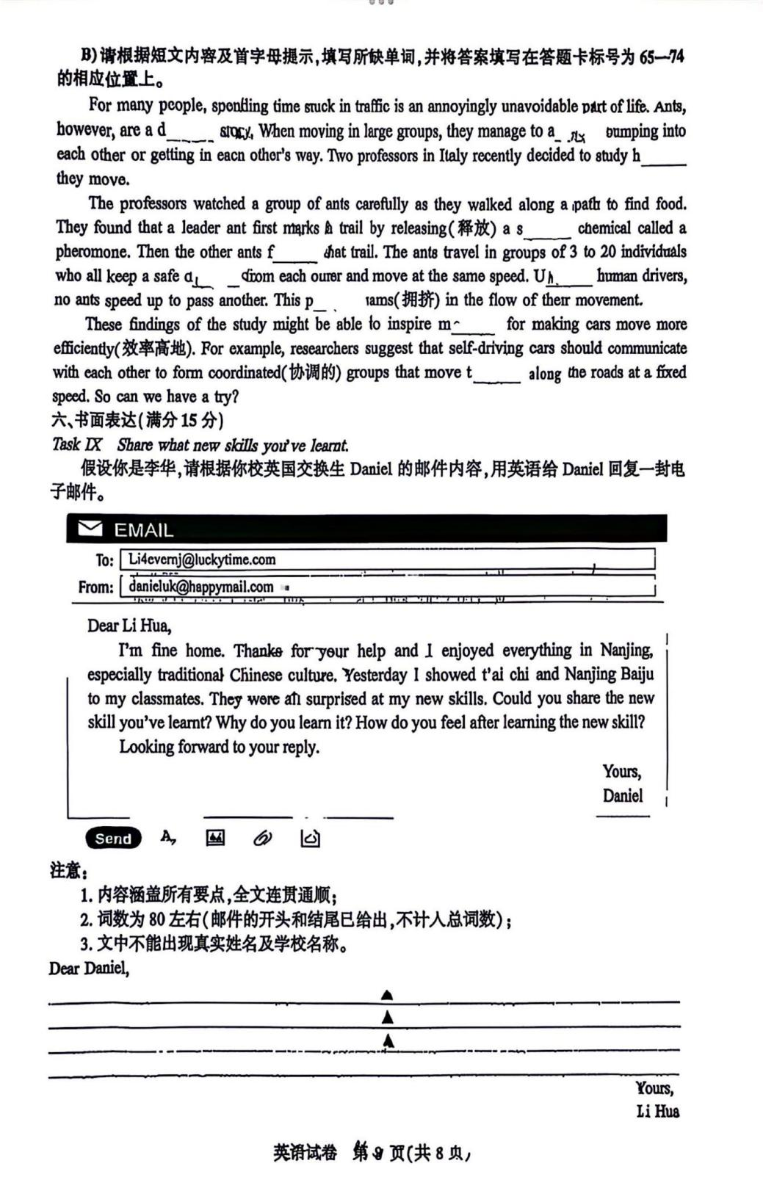

注意：
1. 内容涵盖所有要点,全文连贯通顺;
2. 词数为80左右（邮件的开头和结尾已给出,不计人总词数）;
3. 文中不能出现真实姓名及学校名称。
Dear Daniel,
▲
▲
▲
▲
Yours,
Li Hua

