2008年江苏省南京市中考英语试题
选择题(共60分)
一、听力(共20小题；每小题l分，满分20分)
(A)每小题你将听到一段对话，从A、B、C三幅图中找出与你所听内容相符的选项。听完每段对话后，你都有10秒钟的时间来回答有关小题和阅读下一小题。每段对话仅读一遍。 ．
1.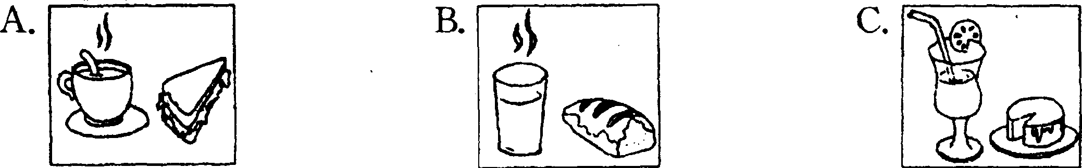
2.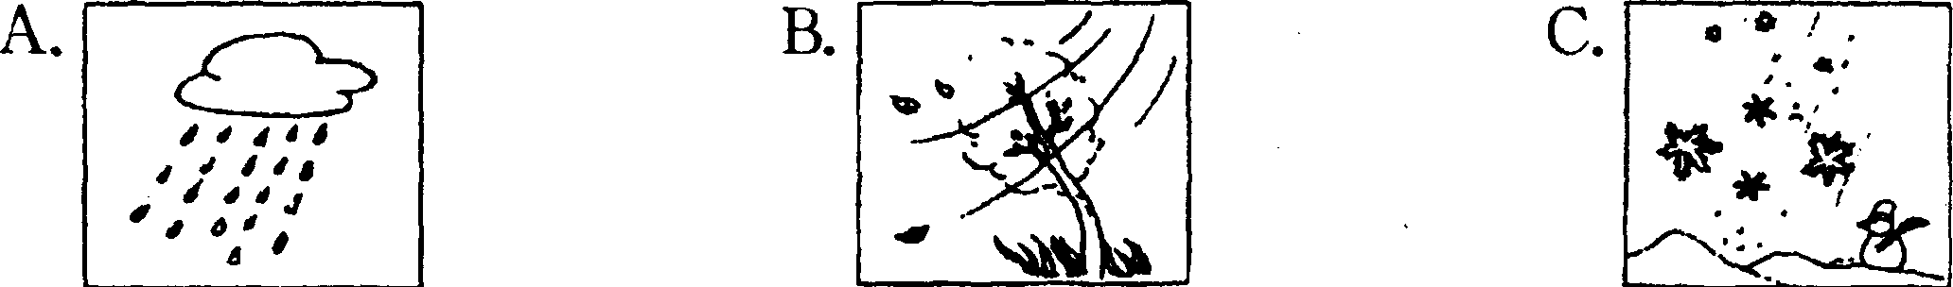
3.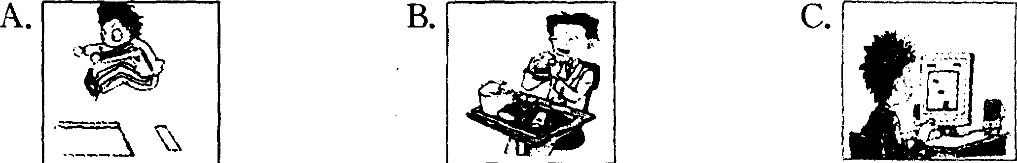
4.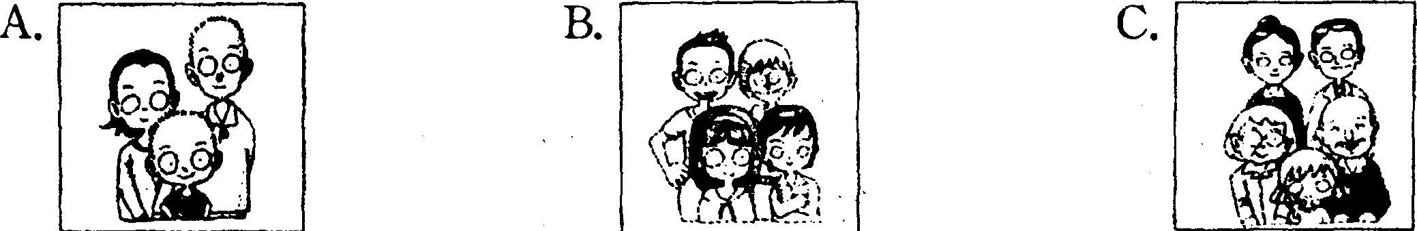
5.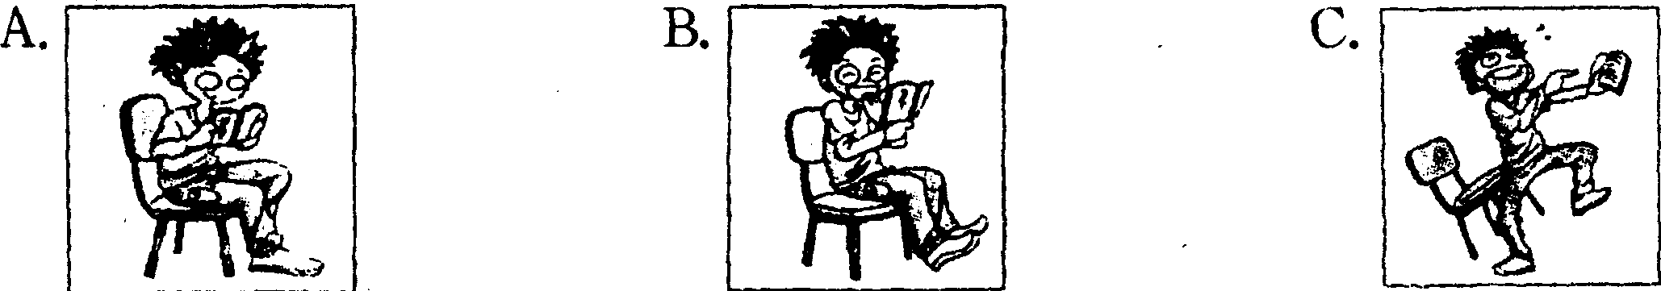
(B)听下面4段对话或独白。每段对话或独白后有几个小题，从题中所给的A、B、C三个选项中选出最佳选项。听每段对话或独白前，你都有时间阅读各个小题，每小题5秒钟；听完后，各小题将给出5秒钟的答题时间。每段对话或独自读两遍。
听下面一段对话。回答第6--7题。
6. What are they talking about?
A. The dining room. B. The bedroom. C. The house.
7. How is the kitchen?
A. It is large. B. It is nice. C. It is modern.
听下面一段对话。回答第8至10题。
8. Which bank was robbed last night?
A. The bank in Green Street.
B. The bank near Green Street.
C. The bank near the railway station.
9. How much money was taken?
A. Not one dollar.
B. All of the money in the bank.
C. Some of the money in the bank.
10. How many robbers were caught at first?
A. Three. B. Two. C. One.
新下面一段对话，回答第11至l5题。
11. Where are the man and the woman talking?
A. At home. B. In the shop. C. In the office.
12. Who does the man want to buy a present for?
A. His friend. B. His mother. C. His father.
|3. Why doesn't the man take the wallet?
A.Because he dislikes the colour. B. Because it is too expensive for him.
C. Because there is no place to put photos.
14. How much money does the man just have with him?
A. $10. B. $15. C. $25.
15..What does the man decide to buy at last?
A tie. B, A wallet. C. Nothing.
听下面一段独白，回答第l6至20题。
16. Which floor do they start from?
A. The first floor. B. The second floor. C. The fourth floor.
17.. What can they see on the second floor?
A. Technology in the old days.
B. Inventions in different centuries.
C. Modern inventions in the 20th century.
18. Where can they have a drink?
A. On the first floor. B. On the second floor. C. On the fourth floor.
19. Which is the most helpful way to find more information about the museum?
A. Searching the Internet.
B. Asking the guide for help.
C. Buying books or magazines.
20. What is the speaker?
二、单项填空(共15小题；每小题l分，满分l5分)
从A、B、C、D四个选项中，选出可以填入空白处的最佳选项。
( )21. More and more foreign students come to China to learn________Chinese.
A. a B. an C. the D. 不填
( )22. ________May 27 th, 2008, millions of people watched the Beijing Olympic Torch Relay in Nanjing.
A. On B. In C. At D. For
( )23. —Lisa, ________you speak French?
—Yes, but only a little.
A. need B. must C. may D. can
( )24. His name is James but he calls________Jim.
A. his B. himself C. him D. 不填
( )25. Last week our geography teacher told us________more information about how to protect the environment.
A. get B. got C. to get D. getting
( )26. It is reported that the Underground Line No. 3________in our city in 2010.
A. will build B. has built C. will be built D. has been built ( )27. —I'll be away on holiday. Would you mind looking after my parrot?
—Not at all. ________.
A. I've no time B. Fd rather not C. You can leave D. I'd be glad to
( )28. —Where is the comic book?
—I brought it to you________you were in the reading room yesterday.
A. when B. if C. because D. before
( )29. ________dangerous it is to ride fast on a busy road!
A. What B. What a C. How D. How a
( ) 30. My pet dog sometimes makes lots of noise and________me when I do my homework.
A. shows B. disturbs C. remembers D. refuses
( )31. —Did you see a girl in white pass by just now?
—No, sir. I________a newspaper.
A. read B. was reading C. would read D. am reading ( )32. —Why did Miss Wang look so worried when we saw her?
—Because she wondered________.
A. where did the other students go B. when would the policeman come
C. what her students have done during the trip D. if her students had survived the earthquake
( )33. Mrs King kept weighing herself to see how much________she was getting.
A. heavy B. heavier C. the heavier D. the heaviest
( )34. —The story is so amazing! It's the most interesting story Fve ever read.
—But I'm afraid it won't be liked by________.
A. everybody B. somebody C. anybody D. nobody
( )35. —Julia, will you please go and empty that drawer?
—________?
A. How is it B. How much C. What for D. What is it
三、完形填空(共10小题；每小题l分，满分l0分)
阅读下面短文，从短文中所给各题的四个选项(A、B、c和D)中，选出可以填入空白处的最佳选项。
In America, where labor( 劳工) costs are so high, "do-it-yourself" is a way of life. Many people 36 their own cars, build their own garages; and even rebuild their own houses. 37 many of them will also write their own books. In Hollywood there is a 38 that publishes ( 出版) children's books with the help of computers. 39 other book companies also publish that way, this company is not like the others. It 40 the reader to become the main character with the help of computers. Here is 41 they do it. Let us suppose a child is named Hody. The computer uses this information to make up a story 42 pictures. The story is then printed up. "This book is about me," a child who 43 such a book might say. So the company is called the "Me-Books Publishing Company".
44 like me-books because they like to see in print their own names, their pictures, and the names of their friends and their pets. But more 45 , in this way, readers are much more interested in reading the stories. Me-books are helping children to learn how to read.
( )36. A. make B. build C. buy D. repair
( )37. A. Otherwise B. Only C. Once D. Soon
( )38. A. director B. person C. company D. computer
( )39. A. However B. Although C. That D. Unless
( )40. A. allows B. hates C. hires D. pays
( )41. A. what B. how C. why D. where
( )42. A. with B. about C. for D. except
( )43. A. prints B. borrows C. sells D. receives
( )44. A. Writers B. Children C. Companies D. Friends
( )45. A. impossible B. imaginative C. important D. inactive
四、阅读理解(共15小题；每小题l分，满分l5分)
阅读下列材料，从每题所给的四个选项(A、B、C和D)中，选出最佳选项。
A
May has just moved to Sunshine Town. Read the map below and help her find the way.
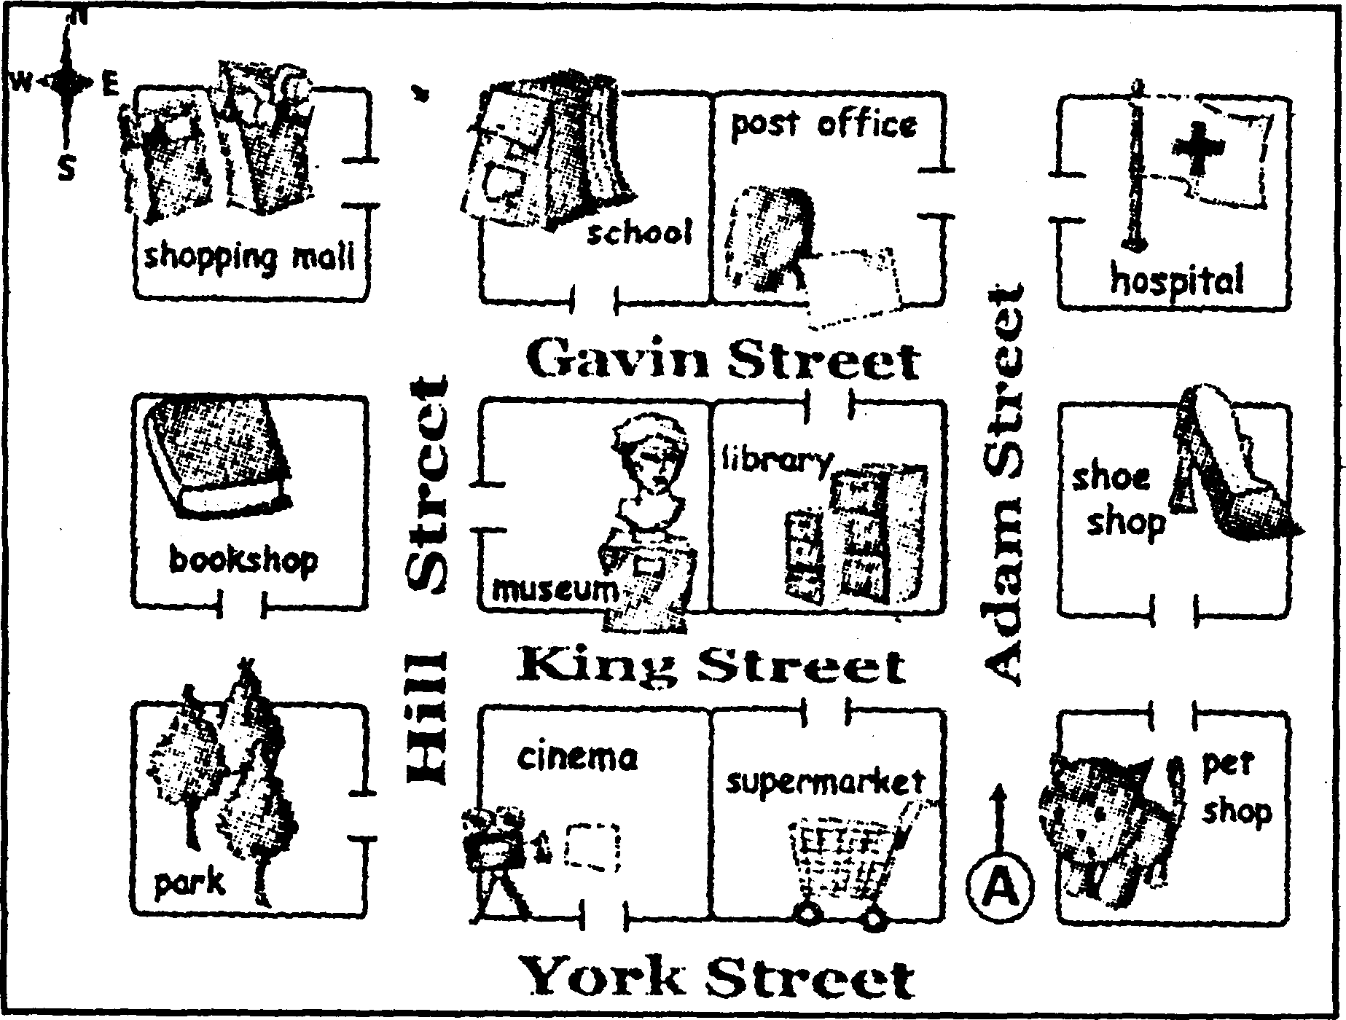
( )46. The museum is________.
A. on York Street B. beside the pet shop
C. next to the hospital D. between the bookshop and the library
( )47. If she wants to see a doctor, she can go to the hospital on________.
A. Hill street B. Adam Street C. York Street D. King Street
( )48. The nearest place for the students at school to buy stationery is________.
A. the shopping mall B. the shoe shop
C. the post office D. the supermarket
( )49. The park, a nice place in the town, is________.
A. south of the cinema B. north of the library
C. south-west of the museum D. north-east of the post office
( )50. Start from A, walk along Adam Street, turn left at the second crossing, and she will find________.
A. the park on the left B. the cinema on the right
C. the library on the left D. the bookshop on the right
B
Science fiction is a popular kind of writing, and many people think of Jules Verne as the father of science fiction. He was born in France in 1828. His father wanted him to become a lawyer, but from his early twenties Verne decided to become a writer. At first he wrote plays for the theater. Then, in 1863, he wrote a story called Five Weeks in a Balloon. The success of this book encouraged him to write more stories such as A Journey to the Center of the Earth (1864) and From the Earth to the Moon ( 1865).
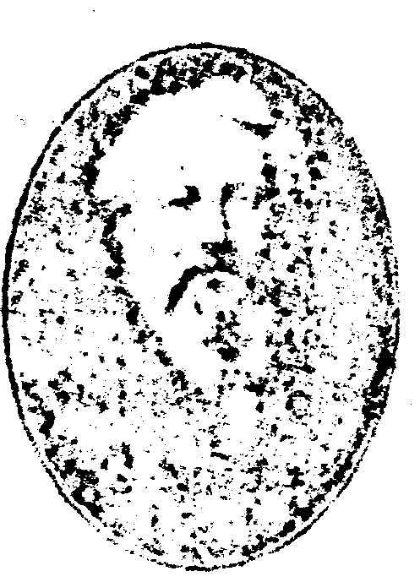
In the 19th century, many people were interested in science and inventions. Jules Verne wrote about scientific subjects in his stories and, as a result, they were very popular. Verne's writing included many predictions(预言) for the 20th century and many of them came true. He described space flight, movies, and air conditioning, a long time before they appeared. These books were very successful and they made Verae rich. Jules Verne's books have been the subjects for many movies. 20,000 Leagues Under the Sea was a successful movie for Walt Disney. It was the first Disney movie to use real actors instead of cartoon drawings. Around the World in Eighty Dap is another famous movie based on one of Verne's books. The main character is an Englishman called Pluleas Fogg. For him, the most important thing is to be always on time!
( )51. What does the phrase "the father of science fiction" mean?
A. The father who has several children.
B. The man who loves science and inventions.
C. The writer whose father wrote science fiction.
D. The man who first started writing science fiction successfully.
( )52. What encouraged Jules Verne to write more stories?
A. The plays he wrote for the theater. B. The encouragement from his father.
C The success of Five Weeks in a Balloon. D. The scientific subjects in his stories.
( )53. Why were Jules Verne's books very popular in the 19th century?
A. Because his books made him rich and famous.
B. Because he wrote many plays for the theater at that time. C Because his books have been the subjects for many movies.
D. Because many people were interested in science and inventions.
( )54. Which of the following has the main character called Phileas Fogg?
A. Five Weeks in a Balloon. B. Around the World in Eighty Days.
C. A Journey to the Center of the Earth. D. From the Earth to the Moon.
( )55. According to the passage, which of the following is TRUE?
A. Jules Verne only wrote plays in the 19th century.
B. Many of the predications in Verne's stories came true.
C The main characters in Verne's books are always on time.
D. The space flight Verne described was different from others.
C
Gloria is a famous hostess of a TV station. When she was 15, she happened to walk into a bookstore in her hometown and began looking at the books on the shelves. Hie man behind the counter, John Smith, asked if she'd like a job. She needed to start saving for college, so she said yes.
Gloria worked after school and during summer vacations, and the job helped pay for her first year of college. During college she would do many other jobs: she served coffee in the student union, was a hotel cleaner and even made maps for the Forest Service. But selling books was one of the most satisfying jobs.
One day a woman came into the bookstore and asked Gloria for books on cancer. The woman seemed anxious. Gloria showed her practically everything they had and found other books they could order. The woman left the store less worried, and Gloria has always remembered the pride( 自豪) she felt in having helped her customer( 顾客).
Years later, as a television hostess, Gloria heard about a child who was born with problems with his fingers and hand. His family could not afford an operation, and the boy lived in shame, hiding his hand in his pocket all the time.
Gloria persuaded(说服) her boss to agree to let her do the story. After the story was broadcast, some doctors called, offering to perform the operation for free.
Gloria visited the boy in the hospital after the operation. The first thing he did was to hold up his repaired hand and say, "Thank you. " What a sweet sense of satisfaction Gloria felt!
At Smith's bookstore, Gloria always realized she was working for the customers, not the store. Today it's the same. The TV station pays her, but she feels that she should work for the people who watch the programmes, helping them understand the world better.
( )56. When did Gloria get her first job?
A. A few years before college. B. Several years after college.
C When she was studying at college. D. When she was working in the TV station.
( )57. In which part-time job did Gloria feel the happiest?
A. Cleaning in the hotel. B. Selling books in the bookstore.
C. Serving coffee in the student union. D. Making maps for the Forest Service.
( )58. What does the word "she" in the third paragraph refer to( 所指) ?
A. The boss. B. The woman. C Gloria. D. The doctor.
( )59. How did Gloria help the child get the operation he needed?
A. Her boss agreed to raise money. B. She paid for the operation herself.
C She allowed the boy to show on TV. D. Her news report affected some doctors.
( )60. What particularly gives her the feeling of pride?
A. Helping people through her work. B. Reporting interesting stories.
C Being able to do different jobs well. D. Paying for her college education herself.
非选择题(共50分)
五、填空(共15小题；每小题l分，满分l5分)
A)根据括号中所给的汉语写出单词，使句子意思完整正确，
61. I think the________( 第六) lesson is the most difficult of all.
62. Come over to my house this evening and enjoy the fresh________( 鱼肉).
63. When we climb the hill on Sundays, Jack always________(到达) at the top first.
64. Susan often goes swimming in summer when it's warm and (晴朗的).
65. Sometimes we don't have our PE classes outside because of the bad________(天气).
B、根据句子意思．用括号中所给单词的适当形式填空，
66. I like working here because everyone is________(friend).
67. Alan is the________( win) of the Photo Competition this year.
68. Look! Two________(monkey) are fighting for food over there.
69. My cousin is used to ( study) with his new friends in Australia.
70. Last week I went to my________( aunt) house to teach her how to send e-mails.
C)根据对话内容，从下面方框中选择适当的单词或词组填空，使对话内容完整正确，
great fun by themselves playing take part in looking forward to
Anne: Hi, Pete. Nice to meet you.
Pete; Nice to meet you, too. Are you going to 71 the Music Festival this year?
Anne; Of course! It was very good last year, do you remember?
Pete; Yeah. I enjoyed 72 the guitar in the school band. What about you?
Anne: I enjoyed singing with other students. It was a lot of work, but it was also 73 .
Pete： Yeah. Do you know what I really like about the Music Festival?
Anne: What's that?
Pete: The students organize the festival 74 . Turt's great J
Anne: Yeah, that's true. Teachers do help, of course, but basically we do everything ourselves. So, when is the festival this year? Pete; It starts next week. I'm 75 it. Anne: Me, too.
六、阅读短文(共20小题；每小题l分，满分210分)
A)阅读下面短文，根据所读内容，在文章后的空格里填入适当的单词，
注意：1．每空不超过4个单词；2．可在短文后的Mini—dictionary．中查找带*单词的意思。．
BARCELONA Barcelona is the second largest city of Spain and is on the northeast coast, about five hundred kilometers east of the Spanish capital, Madrid. One of Barcelona's most famous landmarks is the Church of the Sagrada Familia, which was designed by an architect called Antonio Gaudi. Gaudi worked on the project from 1882 until his death in 1926.
FLORENCE Florence is an Italian city, which became famous because of the Renaissance , a great artistic movement which began in the 1300s and lasted for three hundred years. During the Renaissance, some of the greatest painters of all time lived and worked in Florence. Many of Florence's most beautiful paintings and sculptures were produced by great artists such as Leonardo da Vinci and Michelangelo. Florence is visited each year by about a million tourists who come to see the art galleries* , churches and museums.
ATHENS Athens, the capital of Greece , is knows as the birthplace of Western civilization*. Two thousand four hundred years ago, it was the world's most powerful city. Buildings such as the Parthenon on the Acropolis Hill were built during this period. Greece's best writers lived in ancient Athens. Their works have influenced other writers ever since.
AUCKLAND Auckland is the largest city in New Zealand , located on North Island. This seaside city is an important centre for business and industry. Famous scenes include Mt Eden, one of many large volcanoes, as well as the Auckland Harbour Bridge. In the city, you can enjoy an amazing view from the Sky Tower, which is the city's tallest tower. You can also see Maori traditional dances at the Auckland Museum. Auckland is called "the city of sails" because it has more boats than anywhere else in the world.

Mini-dictionay
civilization n. 文明  gallery n.美术馆  Greece n.希腊  Italian adj.意大利的 | landmark n.陆标  New Zealand n.新西兰  the Renaissance 文艺复兴时期  Spain n. 西班牙

The title: 76 | Barcelona | the 77 city of Spain
The title: 76 | Barcelona | The city's 78 : the Church of the Sagrada Familia
The title: 76 | Florence | a famous 79 city
The title: 76 | Florence | the places visited by tourists: the art galleries as well as 80
The title: 76 | Athens | 81 of Greece
The title: 76 | Athens | well-known as: 82 of Western civilization
The title: 76 | Auckland | the largest city in New Zealand, not only a seaside city but also 83 for business and industry
The title: 76 | Auckland | the city's tallest tower: 84
The title: 76 | Auckland | the city that is also called? 85

B)根据短文内容及首字母提示，填写所缺单词。
In many big cities in the world, the overuse of cars is thought to be one of the major causes of air pollution. What will cars be 1 86 in the future?
Some experts think that today's cars are in trouble b 87 they use too much petrol( 汽油 ). Tney say the car of the future will be much, much smaller. The car of tomorrow will be m 88 without a motor or air conditioning. It'll have no radio and no lights. Tomorrow's car will be an o 89 air car with no doors or windows. It needn't have a pollution control system because it w 90 use petrol. In fact, this new car will be pushed by the driver's feet. Very few people will be • killed in accidents, because the top s 91 will be five miles per hour. However, we are also warned not to ask for pretty c 92 , because the cars will come in grey only.
Other car experts do not hold the same idea. They are s 93 that the future will be happier. Tney think that all our problems will soon be solved by car companies with the production of the Supercar. Tomorrow's car will be bigger, faster, and more comfortable than b 94 . The Supercar will have four rooms, TVs, running water, heat, air conditioning, and maybe a swimming pool. Large families will travel on 1 95 trips comfortably. If petrol is in short supply ( 供给) , the Supercar will run on water.

七、书面表达(满分l5分)
下面是一份英语学习自我评价表，每个评价项目后有若干个选项。请在符合自己实际情况的选项方框中打√(可以多选)。根据你的选择，以“My English Learning”为题写一篇短文，介绍你英语学习中的优势与不足，并针对自己的不足之处，提出改进方法。
注意：1．语言通顺，意思莲贯，书写规范；2．词数80左右。短文开头已经写好，不计入总词数。
English Learning Sell-assessment

1. The new words I can remember:
□ all □ most □ some □ several
2. My favourite activities:
□ pah: work □ writing □ doing grammar exercises
□ learning new vocabulary □ class discussions
3. The most difficult part in English learning:
□ reading □ listening □ grammar
□ vocabulary □ speaking □ writing
4. Tne useful ways in English learning:
□ keeping a vocabulary notebook □ taking an active part in class discussions
□ doing English duty reports □ reading texts aloud
□ preparing lessons carefully before class
5. Need to be improved in learning areas：
□ listening □ reading □ speaking □ writing
□ grammar □ vocabulary □ pronunciation □ working with others

My English Learning
English is a very important subject at school.___________________

2008年江苏省南京市中考英语试题参考答案和听力材料
—. 1．B 2．B 3．C 4．A 5．C 6．C 7．C 8．A 9．A l 0．B 11．B l2．C l3．B l4．A l 5．A l 6．A l 7．C l 8．C 1 9．A 20．B
二、 21. D 22. A 23. D 24. B 25. C 26. C 27. D 28. A 29. C 30. B 31. B 32. D 33. B
34. A 35. C 36. D 37. D 38. C 39. B 40. A 41. B 42. A 43. D 44. B 45. C 46. D 47. B 48. A 49. C 50. C 51. D 52. C 53. D 54. B 55. B 56. A 57. B 58. C 59. D 60. A 61. sixth 62. fish 63. arrives 64. sunny 65. weather B)66. friendly 67. winner 68. monkeys 69. studying 70. aunt's C)71. take part in 72. playing 73. great fun 74. by themselves 75. looking forward to A)76. Four famous cities 77. second largest 78. famous landmark 79. Italian 80. churches and museums 81. the capital 82. the birthplace 83. an important centre 84. the Sky Tower 85. the city of sails B)86. like 87. because 88. made 89. open 90. won't 91. speed 92. colours 93. sure 94. before 95. long One possible version:
My English Learning English is a very important subject at school. With the help of the teacher, my English has improved a lot. I can remember most of the words I have learned. Of all the activities I like pair work best, because I enjoy working with my classmates. For me the most difficult part is speaking. We don't often have the chance to speak English so I find it really useful to take an active in class discussions. However, I am still very weak at listening. I think I must listen to more English stories and tapes. And I believe I can learn English well by doing so in the future.

听力材料
Text 1
1. W: What do you usually have for breakfast?
M: A glass of milk and some bread.
2. W: Shall we go to play badminton on the playground?
M: I'm afraid not, It's windy today.
3. W: What did Miss Yang talk to you just now?
M: She told me not to spend too much time playing computer games after school.
4. W: Is this a photo of your family?
M: Yes, they are my father, my mother and I.
5. W: : What do you think of the book?
M: Very funny! It was so funny that I jumped off the chair.
Text 2
W: Can I help you?
M: Yes, would you mind telling me something about the house?
W: Well, it has a nice living room, a large dining room and three comfortable bedrooms.
M: It sounds good. What about the kitchen?
W: Oh, it is quite modern. It has a fridge and an electric stove.
M: Are there any washrooms?
W: Yes, of course. There are two washrooms in the house, which are easy to use.
Text 3
W: Did you hear of the robbery in the bank last night?
M: No, I didn't. Which bank was robbed?
W: The bank in Green Street.
M: How much money was taken?
W: Not one dollar. M: Really?
W: Yes, there were three robbers. They were trying to run away, but the police caught two of them at the gate of the bank.
M: What about the other one?
W: At first he ran away. But this morning he was caught by a policeman at the railway station.
M: Great! Who called the police when the bank was robbed?
W: A brave young man.
Text 4
W: May I help you?
M: Yeah. Father's Day is coming. I'm looking for a gift for my father.
W: We have a lot of gifts here. How about this black wallet?
M: How much is it?
W: t's only $25.
M; That's too expensive for me.
W: How much money do you want to spend?
M: Ten dollars. That's all I have.
W: How about this tie?
M: It looks nice, but I don't like the colour.
W: What about this blue and black one?
M: That's OK. What's the price of it?
W: It's $ 15. There is a discount on it. It costs only $ 9.
M: Oh, thanks. I'll take it.
Text 5
Boys and girls, please stay together. Let's hurry up and begin our class trip to the museum. The visit starts on the first floor. Pay attention to the information about the technology in the old days. Spend as much time as you can looking at everything, because we won't come back.
Then we' 11 go upstairs to the second floor. After we arrive at the Inventors of the 20th Century Room, please read the invention stories and look at some modern inventions as well. While you look at these inventions, think about how they can make our lives more comfortable.
When you have finished looking at the things on show, take a lift up to the fourth floor. You can go to the cafe for a drink, but don't stay too long. If you want to know more about the museum, you can buy books or magazines, or ask the guide for help. Remember: the most helpful way is to search the museum' s website and download everything you need. I'm looking forward to reading the reports about your visit next Monday.

有的同学总是抱怨时间紧，根本没时间写作文。其实“写”的形式很多，不一定就写作文才提高写作能力。比如写下你一天中发生的一些重要的事情，或当天学了某一个词组，你可以创设一个语境恰如其份地用上这个词。这样即可帮你记住这个词的用法，又可以锻炼你的写作能力，比如学“wish”一词时，可写一小段如下：
The teacher often asks us what we want to be in the future.My good friend Tom wishes to be a soldier.However,I'm different .I wish I were a teacher in the future.But my mother wishes me to be a doctor.
口语是需要技巧的。光靠大胆自信还不够。关键是系统的方法。我是英语专业毕业的，英语八级，现在当翻译，在大学时去英语角，上课发言等都不管用，一度非常苦恼。后来发现口语练习需要系统的方法。建议你按照我的方法做。 买个口语软件，口语宝或者右脑王都不错。 1语音阶段，照软件的内容练，一天俩小时，最多一个月，语音可以过关。无论你的基础怎么样。切记一定要仔细认真模仿纠正模仿在模仿。 2篇章阶段，根据软件上的资料，句子，语音，语调，断句，停顿，高低，节奏，长短等等，越细越好，模仿，对比，模仿，纠正，再模仿。不求量只求质。同样一个月，明显可以提高。3电影阶段，看英语电影。每句话听五遍以上，看看能听懂几个单词。在看汉语五遍，看看能听懂几个词组，再看英语五遍以上。然后倒过来从英语字幕到汉语字幕到无字幕，五遍以上。冰河世纪这部影片够你看两个月，五分钟的影片可以看两小时以上。4与人交流。现在开始舍弃软件，自信大胆的与中国人，别管对错，把自己想说的说出来。与老外更好。记住耐心模仿，细心比较，持之以恒，反反复复，1,2个月以后你的口语一定很棒。

你是外企的白领要经常的说英语哦，这个很正常的哦，如果你要学英语口语的话，那么对如何学习英语口语我有一些经验了。我建议你可以跟我一样报个电话英语培训啊。现在的电话英语还很很好了，电话英语，只通过声音传递内容上课，所以要求学生要有更高的注意力，

因此对提高听力有很大的帮助，同时在听他人说话的同时，自己也要开口说话，这种学习方式被认为是锻炼听力和口语的最佳方法，还有，电话英语最大的优势就是将上课内容全程录音可以供课后复习。而且时间安排可以在你的工作空余时间来学习英语口语哦，

如何学习英语口语的必备条件—语言环境。口语是交流、是听和说。学习任何一种语言，首先要听懂，然后才学说话。口语不可以自学。学习英语口语必须进入英文语言环境。每天听的都是英文，也必须讲英文。中国学生为什么不会讲英文？因为中国的英文老师大部分不讲英文，用中文上英文课。学生在英文课上不讲英文，大部分还是讲中文。1 如何学好英语口语--学习英文口语最好是英文母语老师—即外教。英文为母语的老师，从小生活在英文的环境里。知道各种生活场景、生活内容的英文用语，并且他们的发音纯正，只有他们才可以教好口语。就像外国人要学中文，一定要请中国的老师。所有这里我向你推荐恩京电话英语培训学校，真是不错的，外教通过电话一对一教授日常口语，商务口语，雅思口语.面试英语，外贸口语,青少年英语等，每天回到家，晚上可以学10-20分钟，而且时间，外教都可以任选，均有指定教材，外教都是很有经验的老师，报名后每位学员在网站上都有专属学习地盘，每晚上课时外教会就你的问题当时提出纠正，上课后会在学员的学习地盘中留下当晚学习的详细评语和学员的进步情况分析，及第二天晚上上课讨论的建议。最重要的是，网站上有学员每晚学习的录音，学员可下载收听对照自己的学习；费用也特别实惠，我一个普通打工族就可以接受。随时随地和外教说英语，不错！！2 学习英文还必须了解英文为主的西方文化。学习口语必须知道在什么场合，说什么话？怎么样说话是有礼貌的？什么是外国人忌讳的？就如同中文，从小父母就会教我们在什么场合要说你好、对不起。看见老人、叔叔、阿姨应当怎样称呼？在客人面前该问什么问题？不该说什么话？等等。因为我们的言语得体可以给别人留下良好的印象，不至于造成误会。3 学习口语必须大量地听说练习。我们从小中文是怎么学会的？是每天起床后就不断地听不断地说。每天至少12个小时在中文听说语言环境里。其他语言的学习也是同样的道理。不断地听，不断地说，随时纠正。学生只要在与外国人或学生之间讲英文，就是在学习。
我有啊，奉献给你一些啦，快快学习吧：
Do you have some time tomorrow? 明天有空吧?
Yes, I do. 有啊。
How about having lunch with me? 一起吃顿中饭怎样？
Good idea. 好主意。
If you're free, how about lunch? 有空的话一起吃顿中饭如何？
When did you have in mind? 你想什么时候呢？
I was thinking about Thursday? 我看星期四怎样？
That will be fine with me. 没问题。
I'm calling to see if you would like to have lunch tomorrow.
我打电话给你，是想知道明天一起吃顿中饭怎样？
I'm sorry, but this week isn't very convenient for me.
对不起，这个星期我都不方便。
Perhaps we van make it later. 那么，也许改天吧。
That would be better. 好啊。
I'm calling to confirm our luncheon appointment.
我打电话来，是想确定一下我们约好吃饭的事。
It's tomorrow at twelve o'clock, right? 是明天12点吧？
Yes, that's right. 是的，没错。
I'll be there. 我会去的。
I'm sorry, but I have to cancel out luncheon appointment.
真抱歉，不过我不得不取消我们午餐的约会。
I'm sorry to hear that. 真遗憾。
I have pressing business to attend to. 我有紧急的事情要处理。
No problem. we'll make it later in the month. 没关系，这个月改天再说吧。
一、多“说”。
自己多创造机会与英语教师多讲英语，见了同学，尤其是和好朋友在一起时尽量用英语去问候，谈心情……这时候你需随身携带一个英汉互译小词典，遇到生词时查一下这些生词，也不用刻意去记，用的多了，这个单词自然而然就会记住。千万别把学英语当成负担，始终把它当成一件有趣的事情去做。
或许你有机会碰上外国人，你应大胆地上去跟他打招呼，和他谈天气、谈风景、谈学校……只是别问及他的年纪，婚史等私人问题。尽量用一些你学过的词汇，句子去和他谈天说地。不久你会发现与老外聊天要比你与中国人谈英语容易的多。因为他和你交谈时会用许多简单词汇，而且不太看重说法，你只要发音准确，准能顺利地交流下去。只是你必须要有信心，敢于表达自己的思想。
如果没有合适的伙伴也没关系，你可以拿过一本书或其它什么东西做假想对象，对它谈你一天的所见所闻，谈你的快乐，你的悲伤等等，长此坚持下去你的口语肯定会有较大的提高。

