2024年南京市中考英语真题
As a member of the students' union, you are doing some work for your classmates. Are you ready?
Problem Solving I Do a survey of students' opinions about hot topics
一、单项选择
1. ________ 2016, the AI programme Alphago beat a human at the ancient game of Go.
A. To B. At C. On D. In
2. Smart technology has entered many businesses and changed the ________ we live.
A. area B. way C. hobby D. position
3. In a questionnaire about smart technology, students are asked ________ it changes their study.
A. who B. whose C. what D. how
4. Many students find ________ helpful to use the Internet because there are plenty of resources online.
A. it B. its C. that D. those
5. The internet allows people to ________ find information about almost any subject they can imagine.
A. loudly B. hardly C. quickly D. politely
6. You can ________ up information on the internet.
A. look B. looks C. looking D. looked
7. “ClimateGPT” is used ________ people with a good understanding of weather conditions.
A. provides B. providing C. provided D. to provide
8. We might send nanobots (tiny robots) to different parts of the body, to help doctors ________ illnesses better.
A. afford B. offer C. treat D. develop
9. Self-driving cars are smart enough to follow traffic rules and park ________.
A. they B. their C. them D. themselves
10. ________ a self-driving car where you want to go, and it will take you there.
A. Tell B. Tells C. Told D. To tell
11. Technology can be of great help ________ we make an effort to control it and use it right.
A. if B. before C. though D. until
12. It is said that smart technology is making people ________ than before and doing them harm.
A. lazy B. lazier C. laziest D. the laziest
13. People who don’t have many skills are ________ that robots will make them lose jobs.
A. satisfied B. worried C. practical D. proud
14. Most people agree that smart technology ________ a big part of society so far.
A. become B. became C. has become D. is becoming
15. There ________ different opinions on smart technology. What do you think about it?
A. is B. are C. have D. has
二、完形填空
Why are sports always so popular? Maybe you can get ideas after reading the passage below.
People know why they play sports. It’s fun. They enjoy learning skills. They get exercise. ____16____ why do people watch sports? All over the world, adults love watching sports: football gymnastics, cycling… every sport. They aren’t learning skills or exercising, so ____17____ do they watch? Psychology (心理学) has become interesting ____18____ . The first is that people watch sports because everyone is still a child inside. The second is that we watch because it’s in our nature.
Life as a child is mostly fun. You play games. You spend time with friends. Life seems fair simple. But life as an adult can be ____19____ . Because we work, many of us spend time with people we don’t choose to be with. Even if people can’t choose who they work with, they can choose sport and a team to watch or ____20____ .
In some ways, ____21____ sports is like being a child again. You spend time with people you like. You follow rules. The rules are the same for everyone. They help make life simple and fair for ____22____ . For example, in soccer, the rules do not allow players, except for the goalkeeper, to touch the ball with their hands.
Millions of years ago, life was simple. See danger—run! Watching sports allows us to sometimes use his ____23____ from millions of years ago. Get the ball—run! Sports are exciting. Luckily they’re also usually safe, with little ____24____ for spectators (观众).
Sports can ____25____ us not only to our childhood and our past but also to now. We want our teams to be successful, we enjoy being in a group of fans and we love the stories that sports bring us.
16. A. or B. Till C. But D. Unless
17. A. why B. what C. when D. where
18. A. examples B. answers C. challenges D. standards
19 A. active B. simple C. pleasant D. different
20. A. form B. behave C. follow D. control
21. A. watching B. reporting C. organizing D. providing
22. A. volunteers B. players C. children D. coaches
23. A. feelings B. advantages C. backgrounds D. inventions
24. A. peace B. hope C. interest D. danger
25. A. devote B. compare C. connect D. support
三、阅读理解
The summer holiday is coming near. Make your holiday plan and have fun!
Problem solving III Give advice on your classmates' summer holidays.
阅读A
Exercise is important in our life. We ask 2000 people between 20 and 24 years old about their exercise habits. The diagrams below (下列图表) show the results.
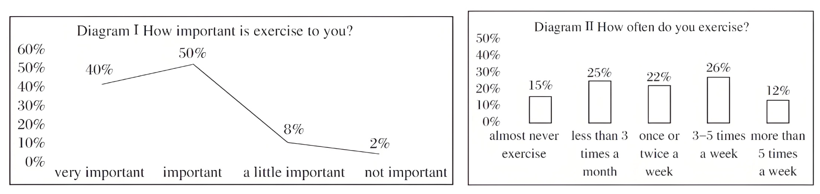
It is clear to see the fewest people think exercise is not important and people choose different kinds of activities to keep healthy. Exercise is good for both the mind and the body. So start exercising now, and it is never too late!
26. From diagram I, what percent of the people think exercise is very important?
A. 40% B. 50% C. 8% D. 2%
27. According to Diagram II, how many people exercise 3 to 5 times a week?
A. 300 B. 500 C. 520 D. 240
28. What can we know from the text?
A. They ask 500 women about their exercise habits.
B. The fewest people think exercise is a little important.
C. About 10% of the people exercise more than twice a week.
D. It is never too late to exercise.
B
In a little town, there was a clock tower that had stood for centuries. The clock tower was known for its perfect timekeeping, and was looked after by Mr. Pendulum, the town’s timekeeper.
One day, Mr. Pendulum decided to take on an apprentice (学徒). He chose a young boy named Oliver who had always been attracted by the clock tower. Oliver was excited but also nervous, knowing that keeping time was a responsibility (责任) of great importance. Mr. Pendulum taught Oliver everything he knew about the clock.
As Oliver worked alongside Mr. Pendulum he learned that time was not just about numbers and minutes—it was about moments and memories. The clock tower had a special characteristic: It could show little bits of the past and future. Mr. Pendulum showed Oliver how to use this characteristic to help people in need.
One day, a young woman named Emily came to the clock tower for help. She was feeling lost and uncertain of her future. Mr. Pendulum and Oliver let her see a piece of her past, where she had faced challenges but had also experienced moments of joy and growth. They then showed her a possible future, where she could achieve her dreams and find happiness. Emily was moved by the experience and left the clock tower with renewed hope. Oliver realized that the true power of the clock tower was not in keeping time, but in helping people find their way. He also learned that time was not something to be controlled, but something to be treasured.
Years later, Oliver became a smart timekeeper, using the clock tower’s magic to guide people through difficult times. He taught others that time was a gift, and that every moment was a chance to create a better future.
29. What was the clock tower known for?
A. Its attractive color. B. Its long history.
C. Its perfect timekeeping. D. Its smart timekeeper.
30. How did Mr. Pendulum and Oliver help Emily?
A. They sent her a special gift. B. They showed moments of her life.
C. They offered her a job as a timekeeper. D. They invited people in the town to encourage her.
31. Which words can best describe Oliver?
A. Responsible and wise. B. Brave and curious.
C. Careful and creative. D. Kind and confident.
C
A new study suggests that roosters can recognize themselves in a mirror (镜子).
Scientists use the “mark test” to test whether an animal can recognize itself. A mark is put on an animal, usually in a spot that can only be seen in a mirror. Then the animal is allowed to look in a mirror. If the animal seems to pay attention to the mark, scientists believe the animal has recognized itself.
The list of animals who can recognize themselves in a mirror isn’t long. The skill has mainly been found in animals with large brains, like dolphins, chimpanzees and elephants. Until recently, only one kind of bird had passed the test.
Scientists at the University of Bonn in Germany recently ran the mark test on roosters. They put a pink triangle (三角形) on the chests of the roosters. But when the roosters looked in a mirror, they didn’t seem to notice the mark.
The scientists then needed a different way to test whether the roosters could recognize themselves.
When there’s danger—like a hawk (鹰) flying above—roosters make loud calls to warn nearby chickens. But roosters only make the cries if other chickens can hear them. If they’re alone, they remain quiet so the hawk won’t see them.
The scientists realized that they could use the shadow (影子) of a hawk to test whether or not the roosters thought they were alone—even when they could see “another” chicken in a mirror.
First, the scientists let the roosters spend time getting used to being in a closed-in space and having a mirror around. Then, they ran several tests by making a hawk shadow appear above a rooster and watching how it reacted. When there was no mirror, the roosters reacted as usual. It called out when it was near another rooster (Picture ▲ ), but remained quiet when it was alone. But when a rooster was in a space where it could see itself in the mirror, it wasn’t fooled into thinking there was another rooster. It remained silent under the hawk shadow. It did this even if there was a rooster hidden behind the mirror.
The scientists say the results show that the roosters knew they were seeing themselves in the mirror, and not other roosters.
32. What is the purpose of the “mark test”?
A. To test a bird’s ability to fly. B. To measure an animal’s brain size.
C. To see if an animal can recognize itself. D. To compare different animals’ intelligence.
33. What does the underlined word “them” refer to?
A. Hawks. B. Roosters. C. Chickens. D. Scientists.
34. Which of the following pictures can be put into ▲ ?
A. 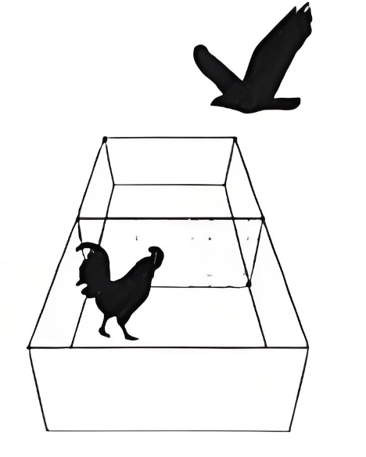 B. 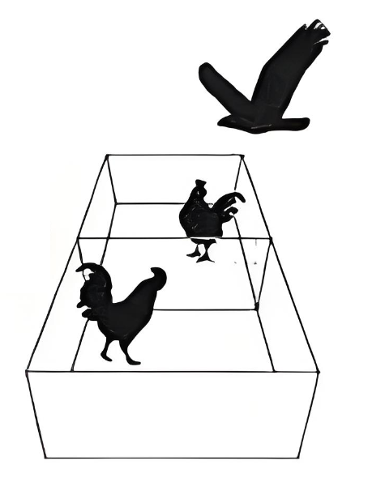 C. 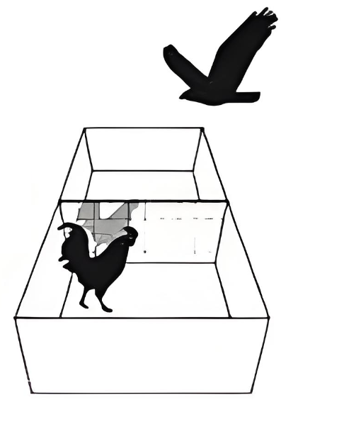 D. 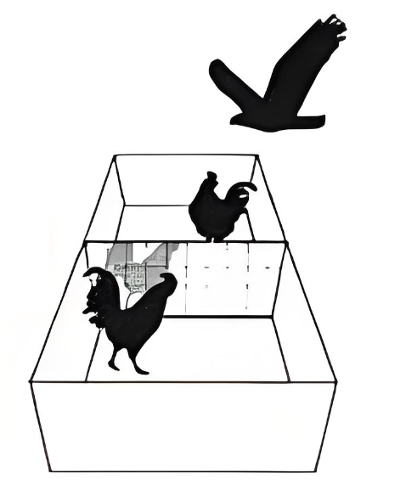
35. What can we infer from the passage?
A. Roosters prefer to make no sounds when it faces danger alone.
B. Roosters are not as smart as dolphins, chimpanzees and elephants.
C. The mark test can exactly tell if an animal can recognize itself in the mirror.
D. When seeing its image in the mirror, the rooster thinks there’s another rooster.
D
I was travelling on a British ship from India to London in 1905. Among all the passengers, no one would fail to notice Padishah, an Indian businessman. From the moment he got on the ship, he kept showing off the diamond on his turban. The big diamond successfully attracted attention, including that of the five ostriches on the deck.
One morning, as Padishah passed by the ostriches, one swallowed his diamond suddenly. The bird ran around and mixed itself with the others in no time.
“Whose are these stupid ostriches? I want my diamond back!” Padishah shouted angrily. People began to crowd on the deck. I was among the first to arrive. I didn’t feel half sorry for the man as he was asking everyone what to do for the diamond’s return.
Word swept across the ship about the accident, reaching a man named Potter. After lunch in the hall, Potter went to Padishah and claimed, “I’ve contacted the ostriches’ owner in London. He accepted my offer for all five and now I am the owner. I have the right to keep the birds and the diamond inside.” I thought Potter was rather smart and regretted deeply at a lost chance.
Padishah was so upset and blurted, “There’s no way you can get my diamond,” he continued as he got calmer. “I can offer you 100 pounds for the birds.” Potter simply refused and left.
After a while, Potter came back to the hall with a sly smile. He announced that he wanted to sell four birds separately to separate people by auction (拍卖). The starting price was 80 for a bird. One of them, he would keep for himself.
Before the crowd realized what was happening, a diamond businessman got one bird for 100 pounds. The prices for the following birds rose higher and higher. After the fourth being sold, Padishah got half mad, not knowing what to do. Potter seemed suddenly sorry and said, “I should have kept them all. But...Trust me! The last bird must be the one.”
I stared at the last bird for quite a while and asked Potter for a private conversation. After a long talk, I finally got the bird for 700 pounds. ▲
The next morning, I was waiting in line to get off the ship, picturing the amazing future life in mind. Then, I saw Padishah and Potter walk arm in arm on the shore, just like old friends. At that moment, I learnt a lesson worth a diamond.
36. What happened to Padishah on the deck?
A. He was hurt by a passenger. B. He failed to get others’ attention.
C. People shouted angrily at him. D. An ostrich took away his diamond.
37. Potter came back to the hall to ________.
A. say sorry to Padishah B. tell people he was the new owner
C. sell ostriches at high price D. talk with the diamond businessman
38. Which of the following can he put into ▲ in Paragraph 8?
A. How worried I was! B. What a great deal it was!
C. How upset Padishah was! D. What an honest man Potter was!
39 What does the writer mean by the last sentence in the last paragraph?
A. He found showing off the diamond led to the loss of his money.
B. He realized the friendship between Padishah and Potter was valuable.
C. He understood the diamond was finally found in the ostrich he bought.
D. He learned that he had been tricked and the experience cost him dearly.
40. What is the best title for this story?
A. A cheating Diamond Trick B. Padishah’s Regretful Journey
C. The Diamond in the Ostrich D. A smart Business Deal on the ship
四、填空
The summer holiday is coming near. Make your holiday plan and have fun!
A）请根据括号中所给的汉语写出单词，使句子意思完整正确
If you like traveling and are interested in modern cities, read the poster and enjoy your tour shanghai.
Welcome to Shanghai!
41. Sights: The art here is really amazing. You can either find a __________ (博物馆) or walk around the city to enjoy it.
42. Food: In shanghai you can find food from all over the world, but the city also has its __________ (自己的) food, such as qingtuan.
43. Hotel: It is easy to find a hotel because it is very close to an underground __________ (站).
44. Weather: It is said that the winter here is __________ (湿的) and cold.
45. People: The people here are very __________ (耐心). It is kind of them to answer visitors’ questions.
B）请根据句子意思，应用括号中所给单词的适当形式填空
If you like tradition Chinese culture, don't miss Dunhuang.
46. Anyone interested in Dunhuang will have heard of Fan Jinshi. Fan __________ (know) to many as “the Daughter of Dunhuang”.
47. Fan Jinshi first journeyed to Dunhuang in 1963, shortly after __________ (graduate) from university.
48. Although life in the desert was difficult, there she stayed and fell in love with the __________ (beautiful) of the caves.
49. Dunhuang caves house about 45, 000 square __________ (meter) of wall paintings and over 3000 painted sculptures.
50. Thanks to the effort from Fan and her team, the world gets to enjoy this wonder __________ (easy) on “Digital Dunhuang” website.
请根据对话内容，从下面的方框中选择适当的单词填空，使对话内容完整正确。
education wrote still pollution him
Dave: Who do you admire, Rose?
Rose: Hmm, one person I really admire is Cai Yuanpei.
Dave: Why do you admire ____51____ ?
Rose: Because he was a great educator and he made a contribution to China’s modern ____52____ system. Some of his educational ideas are ____53____ influential (有影响力的) today. What about you?
Dave: I admire Rachel Carson. She was a biologist. Have you heard of her?
Rose: No. What did she do?
Dave: She was most famous for her books about environmental protection. She ____54____ a book called Silent Spring in the 1960s. The book raised worldwide awareness of the danger of ____55____ .
Rose: It sound likes she was ahead of her time.
Dave: Yes. Her writing is still very important.
五、阅读填空
Would you like to learn about a new type of travel? Read the passage and takes notes so as to share with your classmates later.
请认真阅读下面短文，根据所读内容完成完整后表格中的任务。
注意：第1—7小题每个空格只填一个单词；第8—10小题词数不限。
What is your perfect vacation? Popular trips include relaxing on a warm beach. Or they involve sightseeing in a beautiful city. Increasingly, though, many of us don’t want to just visit a place. We want to experience it.
Experiential travel allows to get closer to local people and their culture. For example, experiential travelers might stay a few weeks with local hosts. They might take classes to learn craft. In other words, these travelers immerse (沉浸) themselves in a different culture. One such trip is in Fujian. There, a small group of travelers meet with a local fishermen. They learn how to fix nets and throw them in the water. They can fish together. Afterwards they all cook and eat a meal with the fisherman’s family.
Experiential travel helps people become better citizens. First of all, it lets them understand a place more deeply than tourists usually do. As one traveler says, traditional travel is “like” studying science without ever doing a scientific experiment. Since they often stay and work in one place, travelers learn more about the lives of local people. It exposes (使体验) them to different ways of living and working. Experiential travelers often make life-long friends with local people. They stay in touch after the trip has finished. Expriential travel helps travelers—and local people—feel like they are part of a global community.
You don’t need to use a travel company to get the benefits (好处) of experiential travel. You can do it by yourself. You can ask local people questions when you travel. Ask a driver about her life. You can also join a soccer game in the street. Listening to people’s stories and interacting (交流) with local people will change your understanding of the place you are visiting.
Experiential travel
What | Experience ____56____ life when traveling.
Why | Help people become better citizens | Encouraging them to have a deeper ____57____ of a place.
 |  | Improving their ____58____ about how local people live
 |  | Making it ____59____ for them to experience different ways of living and working.
 |  | Making lasting ____60____ between travelers and local people.
 |  | Helping them feel like they ____61____ a global community.
How | Do it ____62____ .
Your idea | Think of an experiential trip in Nanjing for your friend.  Place: ____63____ is a good place for experiential  Activity 1:___________________64___________________  Activity 2:____________________65____________________

请根据短文内容及首字母提示，填写所缺单词。
Do you take music and art classes? These classes, which are part of a group of classes often known as arts education, allow students to learn new things in a c___66___ way.
Many people believe music and art classes play an important part in the lives of students. However, some people believe art and music matter l___67___ than other classes. Different opinions about art and music can i___68___ arts education, so it's important to understand these points of view.
Most people believe music and art classes should be part of a student’s education. They can give students r___69___ to enjoy school if they don’t like other subjects. Children who take music classes have higher math and English test scores than those who don’t, and music classes have been shown to help with language d___70___ and memory.
Some people argue (争论) that art and music classes r___71___ too much money for things such as art supplies and instruments. They believe that money should be spent on things such as new science or math books, which are often seen as more useful for f___72___ jobs.
Although some people might argue about how much art and music classes matter compared to other subjects, it is clear that they do matter. Students who take these classes generally do b___73___ in school and are more likely to stay in school. In this way, art and music classes can be a path to s___74___ for some students.
Studies show some ways art and music classes matter to student. However, there are some ways that can’t be s___75___ . Art and music classes help students see the world in new, creative ways.
六、书面表达
Now it's your turn to write down your advice.
76. You see this announcement in an international teenage magazine. Write your article (60 words)
Articles Wanted!
School camping
Where can we go camping?
What should we take with us, and why?
The best article will be published in next month’s magazine.
注意：
1. 内容涵盖所有要点，全文连贯通顺。
2. 词数不少于60字（已给出文章开头，不计入总字数）
3. 文中不得提及有关考生个人身份的任何信息，如校名、人名等。
Camping is a good way to relax.
___________________________________________________________________________________________________________________________________________________________________________________________________________________________________________________________________________________________________________________________________________________________________________________________________________________________________________________________________________________________________________________________________________________________

