江苏省南京市2015年中考试题
英语试卷

一、单选题（共15小题）
1．In the picture, the chair is ______ the table．
A．under B．on C．above D．beside
2．Everyone makes mistakes in his or her life．The important thing is not to repeat ______．
A．it B．them C．him D．her
3．— Why didn’t Peter ______ his homework?
— He said he had lost his workbook．I think it’s an excuse．
A．does B．doing C．do D．did
4．Pukou Railway Station ______ in 1911 and it has become a filming location for films and TV plays in recent years．
A．build B．is built
C．built D．was built
5．— What would you like to drink?
— I’m very thirsty．______ you can get．Just get it now．
A．Anything B．Something
C．Nothing D．Other things
6．This kind of plant is ______ seen in our city because it lives 4500m above sea level and is hard to find．
A．commonly B．always[
C．seldom D．easily
7．Lisa was still very weak when she left hospital．But after a week’s rest, she felt much ______ and went back to school．
A．good B．better C．bad D．worse
8．— I saw David in the teachers’ office this morning．Do you know ______ he was there?
— He went there to hand in his homework．
A．how B．whether
C．when D．why
9．It’s important for us to protect nature because we ______ its rich resources to live．
A．depend on B．leave for
C．give up D．lead to
10．— Mom, must I go shopping with you?
— No, you ______．You can watch the film Big Hero 6 with your friends．
A．needn’t B．can’t
C．shouldn’t D．mustn’t
11．You’d better travel around Nanjing with a local tour guide ______ you want to know more about its culture．
A．unless B．until
C．although D．if
12．— What’s wrong with Simon? He isn’t at school today．
— His legs hurt．He was ______ by a motorcycle this morning．
A．treated B．hit
C．operated D．cured
13．— When will Uncle Sam come to see us?
— He’ll visit us this weekend．He ______ me that by email．
A．told B．is told
C．will tell D．was going to tell
14．— Is it OK if I keep this photo?
—______．I have another copy．
A．Sorry, no B．No, I’m not sure
C．Yes, that’s fine D．Don’t mention it
15．— Too bad you didn’t go to the beach with us．It was so much fun there! You must go next time．
—______．I don’t think I’ll have any fun．I can’t swim．
A．Yes, please B．No, thanks．
C．You are welcome D．My pleasure
二、完形填空（共1小题）
16.
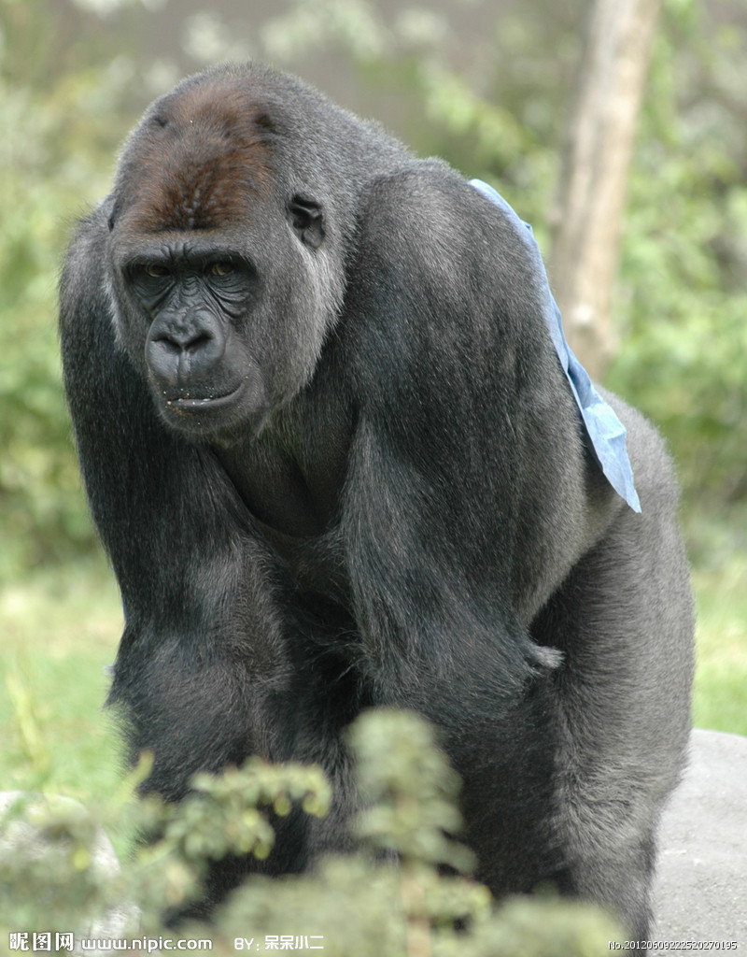
阅读下面短文，从短文后所给各题的四个选项（A、B、C和D）中，选出可以填入空白处的最佳选项。
Have you ever taken a tour of a zoo? If so, it likely that the person who led you through the zoo helped you to learn a lot about the __1__．
Amelia Rinas is a high school student who lives in Ohio．One day Amelia __2__ the Cleveland Metropark Zoo．The moment she saw the gorillas there, she left __3__ about them．She wondered if they were getting the right foods．
Amelia read all she could about gorillas and learned what they like to __4__．Then she started a “gorilla garden”．She grows the fruits and vegetables that gorillas love to eat．Some of those foods are tomatoes, carrots, and strawberries．Amelia works with other volunteers in her community who use their __5__ time to help America and the gorillas．When they take the food to the zoo, the gorillas are thrilled．they look so excited!
Who is responsible for Amelia’s interest in animals? Amelia is a member of Roots & Shoots．Its members are young people who __6__ animals and the environment．They helped Amelia understand that animals need our care, too．The slogan on the Roots & Shoots Website is “Inspire, take action make a difference．” These words tell __7__ the group is all about．The group urges(力劝) kids and grown ups, including parents and teachers, to do what they can to make a __8__ where they live．
When interviewed about her project, Amelia said, “I joined Root & Shoots __9__ I wanted to make a difference in the world．”
There are many __10__ to make a difference in the world．Amelia Rinas’s gorilla garden has helped make gorillas happier and healthier．
1．A．gardens B．foods C．plants D．animals
2．A．opened B．bought C．visited D．started
3．A．bored B．tired C．worried D．relaxed
4．A．eat B．bite C．fight D．kick
5．A．paid B．last C．extra D．lost
6．A．care about B．look for C．run after D．laugh at
7．A．when B．what C．how D．where
8．A．living B．mistake C．note D．difference
9．A．because B．but C．though D．unless
10．A．ways B．mysteries C．courses D．inventions
三、阅读理解（共4小题）
17.阅读下列材料，从每题所给的四个选项（A、B、C和D）中，选出最佳选项。
Today is Sunday, June 14th．Andy is planning a trip to South Island with his family．He loves doing water sports, especially swimming．However, his parents won’t allow him to swim when the highest temperature is below 30℃．Here is the weather forecast(预报) for South Island for the coming week．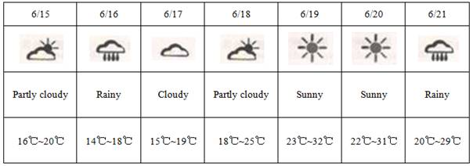1．On which days can Andy go swimming?
A．June 17th and June 18th．
B．June 19th and June 20th．
C．This Tuesday and Wednesday．
D．Tomorrow and the day after tomorrow．
2．What should Andy’s family take with them if they go to South Island on June 21st?
A．Kites．
B．Sunglasses．
C．Umbrellas．
D．Sun hats．
18.根据表格内容，从每题所给的四个选项（A、B、C和D）中，选出最佳选项。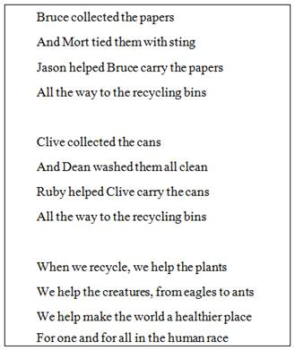
1．Who washed the cans clean in the poem?
A．Dean． B．Clive． C．Ruby． D．Jason．
2．The last line from the poem “For one and for all in the human race” tells ______．
A．the action of recycling
B．the way of recycling
C．the purpose of recycling
D．the situation of recycling
3．In the poem “plants” rhymes with “ants”．Which of the following rhyme with each other?
A．Ants and place．
B．Cans and clean．
C．Papers and string．
D．Place and race．
19.根据下面文段内容，从每题所给的四个选项（A、B、C和D）中，选出最佳选项。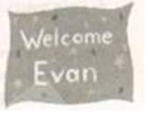
Characters: Evan, Mrs．Bordoni, Mr．Contei, Rita．Marco．Tom
Setting: An elementary school
Mrs．Bordoni: (Stands at the school gate) Good morning! You ne ed to go straight to your classrooms, children．(A shy boy walks up, looking nervous．) What is your name?
Evan: (Looking at the ground) My name is Evan．
Mrs．Bordoni: Welcome to Northside．I’m the principal(校长)．Mrs．Bordoni．
Evan: (Looks surprised) Oh! Good morning．
Mrs．Bordoni: I know you are new to our school, but you will like it here．I will take you to your classroom．
Evan: I didn’t want to move _ and leave my friends．
Mrs．Bordoni: You will have friends here．You’ll see．
Mrs．Bordoni: Here’s your room, 106．
Mr．Cortez: Welcome to our class! I’m Mr．Cortez．
Evan: (The class looks at him．He speaks softly) Hello．
Mr．Cortez: We are talking about a story we just read．Who can tell Evan what it was about?
Rita: This family moves to a new state．Their story is both funny and sad．
Evan: (Cheering up) Did they like the new place?
Marco: Not at first．But they made lots of new friends．
Mr．Cortez: What happened to make them change their minds?
Tom: The girl from next door said he needed help．When they got to her house, a sign said, “Welcome”．
Marco: It was a surprise party for them．The whole family was laughing．
Mr．Cortez: The neighbors made the family feel welcome．
Mrs．Bordoni: (Stands in the doorway) Evan, it’s time for lunch．(They enter the lunchroom．A sign says, “Welcome Evan”．) It is hard to change schools and leave old friends．Now, we are your friends．
Evan: (Smiles) I can’t believe you did this for me．
1．Who is Rita in the play?
A．The principal．
B．The teacher．
C．Evan’s new classmate．
D．Evan’s old friend．
2．The words in brackets, such as “(A shy boy walks up, looking nervous,)” tell _____．
A．what the play is about
B．What the writer acts in the play
C．what the characters are saying to each other
D．what the characters are doing and how they are acting
3．How does Evan feel at the beginning of the play?
A．He is happy because he makes some new friends．
B．He is afraid because he can’t find the new school．
C．He is angry because the others don’t talk to him．
D．He is nervous because it is his first day in a new school．
4．Which is the correct order according to the play?
a．Evan is taken to the classroom．
b．Evan’s new classmates tell him a story．
c．Evan meets the principal, Mrs．Bordoni, at the school gate．
d．Evan enters the lunchroom and finds the sign “Welcome Evan”．
A．a-c-b-d
B．c-a-b-d
C．d-a-c-b
D．b-c-d-a
5．What is the best title of the play?
A．A Sad Story
B．Evan’s Sign
C．A Surprise Party
D．Evan’s Welcome
20.阅读下面短文，从每题所给的四个选项（A、B、C和D）中，选出最佳选项。
Nowadays, the food that you buy comes from many different countries．Have a look in your fridge, cupboard, and fruit bowl and check the origins(来源) of the food．Perhaps there are apples from California, lamb from New Zealand, or potatoes from Egypt? You will probably be surprised how far food travels to get to your plate．This journey, from “field to plate”, is called “food miles”．A food mile is the distance that food travels from the farmer’s field to the person who buys the food．Nowadays, food often travels thousands of miles to get to the consumer(消费者)．Why is this, and what are the effects(影响) of these long distances?
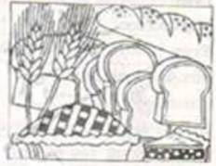
Traditionally, farmers sold their food in the local market so the food didn’t have to travel very far．The consumers also did not travel very far, because they went to their local market to buy the food．This was a good system for farmers and consumers．However, there were some disadvantages．For example, consumers could only buy food that farmers produced locally．In addition, they could only get food that was in season．Now, because of modern technology, food comes from all over the world．We do not have to wait for spring or summer to buy strawberries or tomatoes．They are available in winter if we want．
Some countries have to import(进口) most of their food．This is because they have difficult climates．The United Arab Emirates(UAE), for example, gets 85% of its food from other countries．Even food made in the UAE often uses imported materials．
What’s wrong with “food miles”? Is this not a good way of increasing international trade? I believe these miles are worrying for a number of reasons．First of all, because food travels such long distances．we need more planes, lorries, and ships to move the food．This means we use more oil or petrol, so there is more pollution and more global(全球的) warming．In addition, food that travels a long way is not fresh and usually not very tasty．Tomatoes, for example, are picked early and stored for their long journey．For this reason, they are usually tasteless when they get to the consumer．Local food has a better taste, and it also reduces the amount of global pollution．We need to buy more local food．
1．What is called “food miles” according to this passage?
A．The origins of the food．
B．The effects of long distances．
C．The journey from field to plate．
D．The disadvantages of imported food．
2．The underlined word “available” in Paragraph 2 most probably means “______”．
A．easy to get
B．not busy
C．willing to talk
D．impossible to get
3．Some countries like the United Arab Emirates have to import most of their food because of ____．
A．long distances
B．difficult climates
C．fresh and tasty food
D．modern technology
4．The writer uses the LAST paragraph mostly to encourage readers to ______．
A．buy more local food
B．increase international trade
C．travel long distances
D．use imported materials
5．This passage is mainly about ______．
A．how local food travels from field to plate
B．what “food miles” is and its effects
C．how some countries import their food
D．where different kinds of food come from
四、单词拼写（共3小题）
21.根据括号中所给的汉语写出单词，使句子意思完整正确。
1．This kind of mobile phone is very ____ (便宜) and simple to use．
2．“Nanjing Week” at Expo Milano 2015 will last from ____(七月) 7th to 13th in Milan, Italy．
3．Harry doesn’t take medicine when he catches a cold．He always believes that body is able to fight it by ____ (自己)．
4．Dad always tells me not to study only for tests．If that’s all I’m doing, he says, I will soon ____ (失去) interest in learning．
5．The Chinese Character Dictation Contest reminds us that Chinese characters play an important ____ (角色) in passing on Chinese language and culture．
22.根据句子意思，用括号中所给单词的适当形式填空。
1．— I really like your bike．Is it expensive?
— I don’t know how much it is．It’s my ____ (uncle)．
2．We think Samuel is the most suitable person to be our monitor because he does everything very ____ (careful)．
3．Citizens can enjoy ____ (read) thousands of volumes of electronic books online with the first “WeChat library” in Jianye Library, Nanjing．
4．We need to make more young people ____ (learn) Shadow Play so that it won’t disappear in China．
5．With the ____(develop) of technology, the journey to Mars might only take about 20 minutes in spacecraft in the future．
23.根据短文内容及首字母提示，填写所缺单词。
Suppose you find a bright yellow bike on a street corner in the city．You hop on it and ride away．But wait-isn’t this s__1__? No one shouts, “Stop! Thief!” That b__2__ this free ride is just fine with the city． 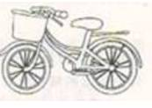
You can find h__3__ of free yellow bikes in some U．S．cities．The idea began in Portland, Oregon, in 1994．People saw a need for f__4__ transportation, and they wanted to help c__5__ pollution．So, to get citizens out of their cars and onto pollution free bikes, they s__6__ the Yellow Bike Project．
The public bike are p__7__ bright yellow and placed throughout the city．People can hop on a yellow bike and ride to work to school, or to run errands．They then leave the bike for the n__8__ rider．There have been times when bikes have been stolen, but most people obey the r__9__．What would be the point of stealing something that’s already free?
Portland’s i__10__ quickly became popular．Within two years of its start similar programs were set up in cities in six other states．
五、信息匹配（共1小题）
24.根据对话内容，从下面方框中选择适当的单词或短语填空，使对话内容完整正确。
A: Guess what? I’m going to Chiang Mai next week．
B: Wow, sounds like fun! But I believe that April is the __1__ month of the year there．
A: Yes, that’s true．But there’s a water festival there from April 13th to 15th．
B: I wonder if it’s __2__ the Water Festival of the Dai people in Yunnan Province．
A: Yes, I think so．This is the time of the Thai New Year．People go on the streets to throw water at __3__．
B: Cool! But __4__ do they do that?
A: Because the new year is a time for cleaning and __5__ bad things．Then you’ll have good luck in the new year．
六、阅读填空（共1小题）
- 阅读下面短文，根据所读内容，在文章后第1-10小题的空格里填入一个最恰当的单词。注意：每个空格只填1个单词。
Noah Webster was born on October 16, 1758, in the West Division of Hartford, where his father farmed and worked as a weaver．His mother was a housewife．
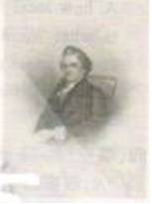
Few people went to college at that time, but Noah loved so much to learn that his parents let him go to Yale, Connecticut’s only college．Noah graduated in 1778．He desired (渴望) to study law, but his parents didn’t have more money to send him to school．So, in order to make a living, Noah taught in Glastonbury, Hartford and West Harford．Later he studied law．
Noah did not like American schools．Sometimes 70 children of all ages were crammed (挤满) into one room schoolhouses with poor books and untrained teachers．Their books came from England．Noah thought that Americans should learn from American books so in 1783．Noah wrote his own textbook A Grammatical Institute of the English Language．Mot people called it the “Blue Backed Speller” because of its blue cover．
For 100 years, Noah’s book taught children how to read, spell, and pronounce words．It was the most popular American book of its time．Ben Franklin used Noah’s book to teach his granddaughter to read．
When Noah was 43, he started writing the first American dictionary．He did that because Americans in different parts of the country spelled, pronounced and used words differently．He thought that all Americans should speak in the same way．He also thought that Americans should not speak and spell just like the English．Noah used American spellings like color instead of the English color and music instead of musick．He also added American words that weren’t in English dictionaries like skunk and souash．He spent over 27 years writing his dictionary．When Noah accomplished (完成) his dictionary in 1828, at the age of 70, the first American dictionary came out．It had 70．000 words in it．
Noah did many things in his life．He worked for copyright laws, wrote textbooks, Americanized the English language, and edited magazines．When Noah Webster died in 1843, he was considered an American hero．
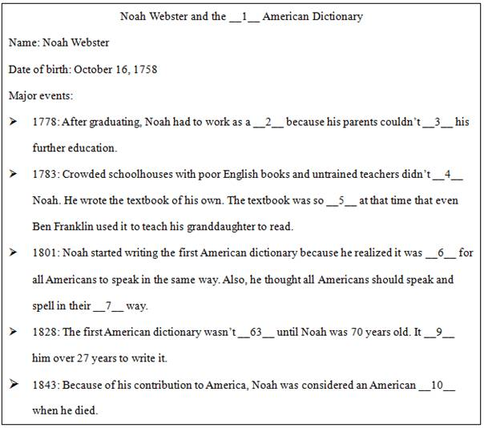
七、书面表达（共1小题）
26.
假如你是阳光中学的李磊，你在学校网站看到国际学生Stephen的求助信。请根据Stephen信的内容，用英语给Stephen写一封回信，介绍你校图书馆借书的要求和流程。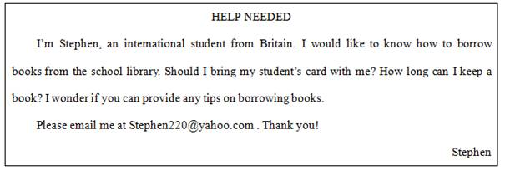
注意：
1．文中不得出现你的真实姓名和学校名称；
2．语言通顺，意思连贯，条理清楚，书写规范；
3．词数80左右，邮件的开头与结尾已经给出，不计入总词数。
Dear Stephen,
I am writing to tell you how to borrow books from the school library． _________________________________________
__________________________________________ __________________________________________ __________________________________________ __________________________________________ __________________________________________ ___________________________________________
Yours faithfully．
Li Lei

答案部分
1.考点：介词／介词短语
试题解析：
beside:旁边；under：在．．下面 ; on:在．．．上面；above：在正上方；
答案：D
2.考点：代词／不定代词
试题解析：
them代替mistakes。
答案：B
3.考点：一般过去时
试题解析：
do one’s homework:做作业；助动词did提前后面的动词要用动词原形。
答案：C
4.考点：一般过去时被动式
试题解析：
火车站是被修建的，故该句要用被动句；又根据in 1911得知该句要用一般过去时的被动：was/were+pp (动词的过去分词)
答案：D
5.考点：代词／不定代词
试题解析：
根据Just get it now得知。Anything：任何东西; Something；某个东西；Nothing：没有什么；Other things：其他东西；
答案：A
6.考点：副词
试题解析：
根据because it lives 4500m above sea level and is hard to find．得知选C．seldom:几乎不
答案：C
7.考点：形容词
试题解析：
much在句中修饰比较级；故选B．
答案：B
8.考点：句意理解
试题解析：
根据答语得知选D．why:为什么；句意：你知道他为什么要在哪儿？
答案：D
9.考点：动词／动词短语
试题解析：
depend on：依赖；依靠 leave for：前往；give up：放弃；lead to：导致；通向
答案：A
10.考点：情态动词
试题解析：
needn’t：没有必要；can’t：不可能；shouldn’t：不应该；mustn’t：表示禁止；不允许；
答案：A
11.考点：连词／连接词
试题解析：
句意：如果你想要了解更多的关于它的文化。你最好和当地的导游一块； if：如果；
答案：D
12.考点：动词／动词短语
试题解析：
treated：对待；治疗；hit：撞击；operated ：操作；做手术；cured：治疗；句意：今天早晨他被一辆摩托车撞了。
答案：B
13.考点：一般过去时
试题解析：
句意：他通过邮件告诉了我。才知道他这个周末将会拜访我。得知告诉我这个动作已经发生在过去了。
答案：A
14.考点：交际用语
试题解析：
根据Is it OK if I keep this photo? 排除AD;又根据I have another copy．得知选C．
答案：C
15.考点：交际用语
试题解析：
根据You must go next time．得知。
答案：B
16.考点：人物传记／故事阅读类
试题解析：1．根据Have you ever taken a tour of a zoo?得知选D．
2．visit:拜访；参观；visit the Zoo：参观动物园
3．worry about：担心；
4．根据She grows the fruits and vegetables that gorillas love to eat．得知选A．
5．extra time:额外的时间。句意：他们使用额外的时间来帮助．．．．．
6．care about:关心；look for ：寻找；run after：追逐；追赶；laugh at：嘲笑；句意：关心动物的年轻人。
7．what在the group is all about中做介词的宾语。
8．make a difference：有影响，有关系（固定搭配）
9．because:因为;句意：因为我想要与众不同所以我加入了．．．
10．ways:方法；句意：有许多方法可以让这个世界变得不同。
答案：1-5．DCCAC 6-10．ABDAA
17.考点：人物传记／故事类阅读
试题解析：
1．根据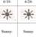得知。
2．根据得知。
答案：1．B 2．C
18.考点：政治经济文化类阅读
试题解析：
1．根据And Dean washed them all clean。得知。
2．根据When we recycle, we help the plants
We help the creatures, from eagles to ants
We help make the world a healthier place得知。
3．根据We help make the world a healthier place
For one and for all in the human race得知。
答案：1．A 2．C 3．D
19.考点：教育类阅读
试题解析：
1．根据Mr．Cortez: Welcome to our class! I’m Mr．Cortez．
Evan: (The class looks at him．He speaks softly) Hello．
Mr．Cortez: We are talking about a story we just read．Who can tell Evan what it was about?
Rita: This family moves to a new state．Their story is both funny and sad．得知。
2．A shy boy walks up, looking nervous告诉我们的是此刻这个男孩的心理状态以及他们是如何表现的。
3．根据(A shy boy walks up, looking nervous．) What is your name?
Evan: (Looking at the ground) My name is Evan．得知。
4．Welcome to Northside．I’m the principal(校长)．Mrs．Bordoni．
Evan: (Looks surprised) Oh! Good morning．- I will take you to your classroom．- This family moves to a new state．Their story is both funny and sad．- They enter the lunchroom．A sign says, “Welcome Evan”．
5．这篇剧情讲的都是学校对Evan的欢迎仪式。
答案：1．C 2．D 3．D 4．B 5．D
20.考点：政治经济文化类阅读
试题解析：
1．根据This journey, from “field to plate”, is called “food miles”．得知。
2．根据We do not have to wait for spring or summer to buy strawberries or tomatoes．They are available in winter if we want．得知是比较容易买到的的意思。
3．根据Some countries have to import(进口) most of their food．This is because they have difficult climates．得知。
4．根据Local food has a better taste, and it also reduces the amount of global pollution．We need to buy more local food．得知。
5．这篇文章主要是给我们介绍了什么是food miles以及它给人们带来的影响。
答案：1．C 2．A 3．B 4．A 5．B
21.考点：单词拼写
试题解析：
1．cheap：便宜
2．July：七月
3．itself ：自己
4．lose：失去
5．role：角色
答案：1．cheap 2．July 3．itself 4．lose 5．role
22.考点：用单词适当形式填空
试题解析：
1．uncle’s= uncle’s bike
2．carefully这个副词修饰动词does
3．enjoy doing sth:喜欢做某事
4．make sb do sth:使某人做某事
5．development：发展(名词)；跟在the后面要用名词。
答案：1．uncle’s 2．carefully 3．reading 4．learn 5．development
23.考点：单词拼写
试题解析：
1．stealing：偷盗
2．because：因为
3．hundreds of: 数以百计的
4．free：自由的；免费的
5．control：控制
6．started：开始；创办
7．painted：绘画
8．next ：接下来
9．rule/rules：规则
10．idea：注意；想法
答案：1．stealing/strange 2．because 3．hundreds 4．free 5．control 6．started 7．painted 8．next 9．rule/rules 10．idea
24.考点：补全对话
试题解析：
1．hottest：最热的
2．be similar to:与．．．相似
3．each other：彼此；互相
4．根据Because the new year is a time for cleaning得知。
5．根据a time for cleaning and得知，前后并列。
答案：1．hottest 2．similar to 3．each other 4．why 5．washing away
25.考点：阅读填空
试题解析：
1．根据the first American dictionary came out．得知。
2．根据So, in order to make a living, Noah taught in Glastonbury, Hartford and West Harford．得知。
3．根据He desired (渴望) to study law, but his parents didn’t have more money to send him to school．得知。
4．根据Sometimes 70 children of all ages were crammed (挤满) into one room schoolhouses with poor books and untrained teachers．得知。
5．根据For 100 years, Noah’s book taught children how to read, spell, and pronounce words．It was the most popular American book of its time．得知。
6．根据He thought that all Americans should speak in the same way．得知。
7．根据because he realized it was __61__ for all Americans to speak in the same way．得知。因该用own：自己的
8．根据When Noah accomplished (完成) his dictionary in 1828, at the age of 70,得知。
9．根据He spent over 27 years writing his dictionary．得知。
10．根据When Noah Webster died in 1843, he was considered an American hero．得知。
答案：1．First 2．teacher 3．afford 4．satisfy 5．popular 6．necessary 7．own 8．accomplished/finished 9．took 10．hero
26.考点：提纲作文
试题解析：根据题目要求，本文应从三方面入手进行写作：1、从图书馆借书的流程。2、回答Stephen的两个问题。3、一些借书是的建议。建议用2个段落分别进行阐述，注意条理清晰，语言准确。谈论这个故事用一般现在时。
答案：One possible version: Dear Stephen, I am writing to tell you how to borrow books from the school library．Remember to go to the library with your student’s card．When you enter the library, first show your student’s card to a librarian．Then you can choose books you want．At last you can take the books away after you show them to a librarian． You can only borrow 3 books at a time and keep them for a month．You will have to go back to the library to renew the books if you want to keep them longer． Please email me if you have any other questions． Yours faithfully, Li Lei

