**REFACTORING**

For this assignment, you need to:

1. Figure out which line numbers from the original HTML file are determined by each bad practice. List your answers in a new text file “answers.txt”.

Too much wrapping tag = <line numbers>

Using inline css = <line numbers>

Inappropriate naming = <line numbers>

Wrong indentation in css = <line numbers>

Not utilizing semantic tag = <line numbers>

Repeated style = <line numbers>

Redundant display of a block element = <line numbers>

Using too many classes over and over again = <line numbers>

Using html tag that dictates style = <line numbers>

Styling an element using tag's attribute/s = <line numbers>

Unordered import of stylesheet = <line numbers>

Using Internal css = <line numbers>

1. After listing all the line numbers having bad practices, go by fixing these lines. Create a new copy of html file and name it “refactored.html”. At the end, the output should be:

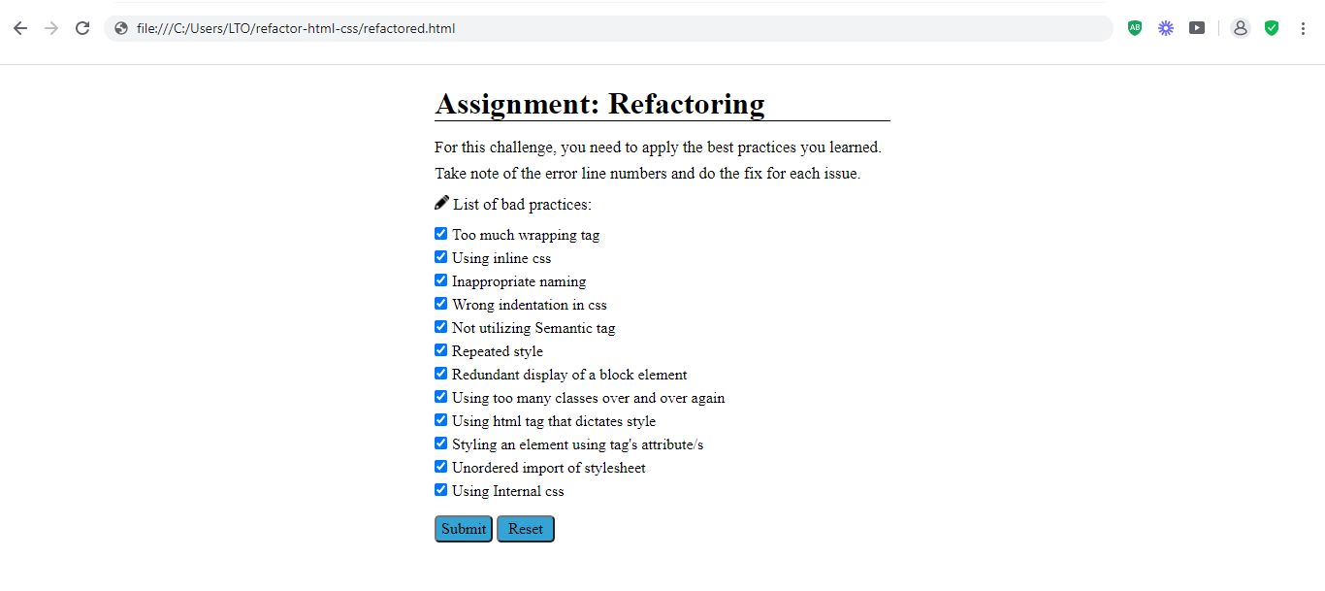

Bonus: Check all the checkboxes upon completion of tasks.

Good luck!