Total distance: 84178.02922653334

I ran a greedy nearest unvisited neighbor algorithm that started at a random city and then navigated to the nearest unvisited city until it had visited every city and then untangled that path.

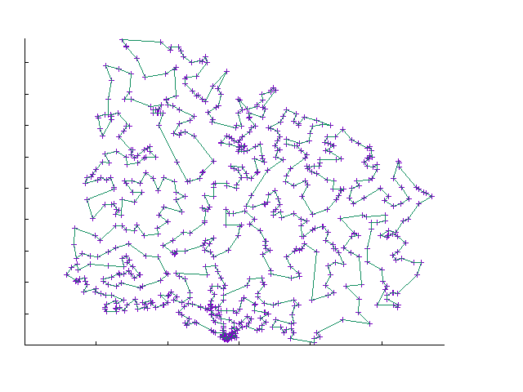

[1, 2, 7, 5, 4, 8, 10, 15, 12, 13, 9, 14, 23, 24, 26, 28, 34, 40, 39, 43, 51, 29, 20, 31, 38, 55, 60, 69, 92, 98, 113, 104, 108, 71, 65, 42, 49, 62, 57, 52, 48, 37, 35, 33, 30, 32, 59, 61, 88, 70, 89, 90, 107, 112, 119, 131, 137, 142, 140, 134, 132, 125, 143, 147, 151, 163, 161, 157, 156, 160, 167, 168, 179, 178, 176, 159, 150, 186, 199, 207, 200, 233, 235, 251, 243, 239, 224, 220, 227, 231, 244, 274, 284, 277, 267, 268, 272, 280, 305, 301, 330, 336, 332, 340, 364, 368, 392, 390, 411, 424, 447, 446, 451, 448, 439, 438, 422, 416, 410, 408, 418, 436, 442, 458, 435, 400, 378, 370, 371, 335, 346, 345, 339, 360, 369, 386, 414, 413, 423, 432, 434, 450, 484, 491, 505, 502, 487, 477, 457, 437, 431, 433, 430, 417, 441, 568, 554, 547, 528, 496, 474, 469, 471, 445, 428, 429, 420, 409, 389, 376, 377, 380, 383, 405, 406, 373, 363, 359, 344, 355, 341, 351, 342, 334, 323, 310, 291, 298, 316, 324, 321, 329, 328, 300, 230, 203, 189, 175, 166, 155, 139, 130, 117, 114, 111, 97, 82, 64, 78, 96, 103, 99, 87, 94, 102, 101, 106, 122, 138, 146, 135, 149, 154, 153, 174, 183, 194, 226, 241, 264, 276, 260, 273, 304, 347, 333, 311, 299, 290, 286, 287, 288, 259, 255, 238, 232, 225, 219, 223, 218, 217, 211, 202, 201, 198, 177, 173, 152, 148, 145, 141, 129, 128, 116, 136, 144, 164, 158, 172, 188, 185, 193, 197, 206, 216, 222, 214, 228, 250, 254, 258, 275, 283, 308, 320, 307, 282, 303, 315, 327, 319, 309, 279, 249, 204, 210, 221, 278, 285, 293, 297, 302, 318, 358, 361, 388, 385, 398, 407, 397, 396, 393, 403, 415, 440, 452, 464, 461, 468, 467, 495, 549, 545, 546, 553, 565, 593, 608, 594, 595, 540, 531, 516, 482, 466, 427, 382, 367, 366, 362, 349, 354, 350, 356, 391, 394, 399, 404, 425, 444, 456, 524, 532, 566, 634, 667, 652, 692, 712, 723, 734, 724, 693, 679, 683, 694, 675, 676, 653, 668, 661, 641, 603, 596, 569, 582, 597, 583, 561, 550, 525, 521, 506, 510, 529, 555, 570, 605, 609, 629, 628, 627, 625, 638, 620, 574, 563, 587, 598, 626, 636, 635, 639, 648, 656, 670, 684, 680, 689, 673, 662, 649, 647, 657, 669, 677, 686, 681, 682, 674, 660, 654, 651, 644, 645, 646, 631, 640, 643, 655, 658, 666, 672, 678, 685, 688, 701, 710, 713, 717, 714, 707, 702, 703, 700, 698, 690, 699, 711, 716, 722, 706, 725, 726, 727, 732, 733, 729, 728, 730, 731, 718, 719, 720, 721, 715, 709, 708, 704, 705, 695, 696, 697, 691, 687, 663, 659, 671, 665, 664, 650, 642, 637, 607, 586, 588, 604, 610, 616, 624, 619, 615, 606, 599, 592, 573, 552, 541, 534, 533, 538, 530, 507, 486, 475, 478, 497, 488, 503, 511, 548, 564, 577, 581, 571, 562, 542, 556, 560, 557, 578, 600, 601, 611, 584, 579, 575, 580, 589, 617, 612, 621, 590, 567, 602, 630, 613, 618, 622, 632, 633, 623, 614, 591, 576, 585, 572, 558, 559, 551, 543, 539, 544, 527, 518, 509, 513, 519, 522, 520, 515, 501, 481, 473, 483, 472, 476, 480, 462, 454, 465, 470, 479, 498, 499, 508, 493, 485, 494, 500, 490, 504, 512, 517, 526, 536, 523, 537, 535, 514, 492, 489, 459, 453, 419, 426, 443, 460, 455, 449, 463, 421, 379, 402, 412, 375, 374, 384, 387, 372, 401, 395, 381, 365, 352, 331, 343, 312, 306, 294, 266, 245, 292, 253, 237, 269, 262, 263, 270, 296, 295, 317, 313, 353, 348, 338, 337, 322, 325, 326, 357, 314, 289, 281, 246, 256, 247, 257, 271, 248, 242, 240, 229, 209, 213, 182, 181, 192, 215, 212, 195, 191, 190, 180, 162, 165, 169, 187, 196, 184, 170, 171, 133, 118, 110, 109, 77, 79, 85, 84, 93, 127, 115, 91, 86, 81, 80, 47, 27, 16, 18, 22, 36, 46, 45, 58, 54, 63, 67, 68, 76, 75, 74, 73, 72, 105, 208, 265, 261, 252, 236, 234, 205, 126, 120, 121, 124, 123, 100, 95, 83, 66, 56, 53, 50, 44, 41, 19, 17, 21, 25, 11, 6, 3]