Local Min using swapping:

[1, 2, 4, 11, 12, 17, 19, 18, 37, 35, 32, 14, 10, 22, 24, 28, 31, 36, 38, 33, 34, 27, 16, 9, 8, 7, 5, 3, 6, 13, 15, 20, 23, 25, 26, 30, 29, 21]

Total distance: 10315.49124482629

Found in 0.81619 seconds.

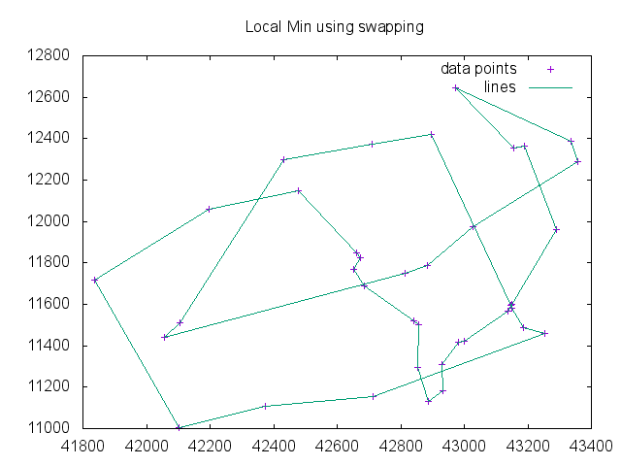

Greedy Algorithm (Best of 5 runs):

[1, 2, 4, 3, 5, 6, 7, 8, 9, 11, 12, 16, 17, 19, 18, 13, 15, 26, 25, 23, 20, 22, 24, 28, 27, 31, 36, 34, 33, 38, 37, 35, 32, 30, 29, 21, 14, 10]

Total distance: 6771.534590959325

Found in 0.010719999999999952 seconds.

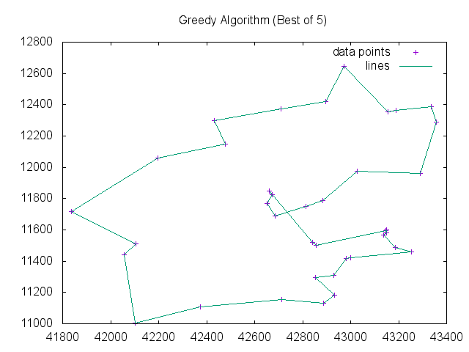

Greedy + Reversal Algorithm:

[1, 2, 4, 3, 5, 6, 7, 8, 9, 12, 11, 19, 18, 17, 16, 13, 15, 20, 23, 26, 25, 22, 24, 28, 27, 31, 36, 34, 33, 38, 37, 35, 32, 30, 29, 21, 14, 10]

Total distance: 6659.431532931466

Found in 0.131865 seconds.

