Distance: 90524.51443971512

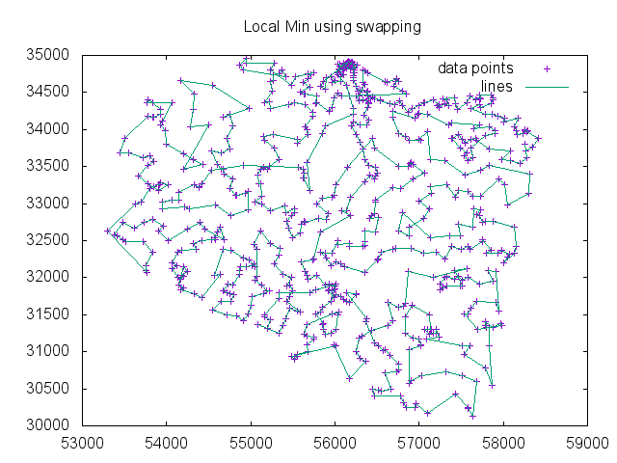

[1, 3, 6, 11, 2, 7, 5, 4, 8, 10, 9, 14, 13, 12, 15, 23, 24, 26, 28, 34, 40, 39, 43, 51, 92, 98, 151, 147, 143, 125, 132, 134, 140, 142, 137, 156, 160, 157, 161, 163, 168, 167, 178, 176, 200, 186, 199, 207, 230, 233, 235, 300, 335, 345, 346, 371, 408, 418, 410, 416, 422, 436, 442, 458, 475, 486, 507, 530, 538, 533, 534, 541, 552, 573, 592, 599, 606, 609, 605, 628, 629, 655, 658, 697, 691, 687, 663, 659, 671, 665, 664, 650, 642, 637, 625, 638, 620, 574, 563, 598, 587, 626, 636, 635, 639, 648, 656, 670, 680, 684, 689, 676, 653, 693, 724, 723, 734, 712, 692, 675, 694, 683, 679, 668, 661, 641, 596, 603, 569, 582, 597, 583, 561, 550, 525, 521, 506, 484, 491, 505, 502, 487, 477, 457, 437, 431, 433, 430, 417, 405, 406, 373, 363, 359, 344, 355, 341, 351, 342, 334, 323, 310, 291, 298, 316, 324, 321, 329, 328, 339, 360, 369, 370, 378, 400, 435, 497, 478, 438, 439, 448, 446, 451, 447, 424, 411, 390, 392, 368, 364, 340, 336, 330, 332, 301, 305, 280, 272, 268, 267, 277, 274, 284, 244, 243, 251, 239, 224, 231, 227, 220, 205, 234, 236, 252, 261, 265, 266, 245, 253, 237, 269, 262, 270, 263, 281, 289, 256, 246, 247, 257, 242, 240, 229, 248, 271, 314, 326, 325, 322, 337, 338, 348, 353, 313, 317, 296, 295, 292, 343, 306, 294, 312, 331, 352, 365, 381, 395, 401, 372, 387, 384, 374, 375, 412, 402, 357, 379, 421, 443, 426, 419, 453, 459, 514, 492, 489, 488, 503, 511, 548, 564, 542, 556, 560, 557, 535, 537, 536, 523, 526, 517, 512, 504, 480, 462, 454, 465, 470, 479, 498, 499, 508, 493, 485, 494, 500, 490, 476, 472, 460, 455, 449, 463, 483, 473, 481, 501, 515, 520, 522, 519, 513, 509, 518, 527, 544, 539, 543, 551, 559, 558, 572, 585, 576, 591, 614, 623, 633, 632, 618, 622, 613, 630, 602, 567, 590, 621, 617, 612, 580, 589, 575, 579, 584, 611, 601, 600, 578, 571, 562, 581, 577, 607, 586, 588, 604, 610, 616, 624, 619, 615, 631, 643, 640, 646, 645, 644, 651, 666, 672, 678, 685, 688, 695, 696, 715, 721, 720, 708, 709, 705, 704, 701, 702, 710, 713, 718, 719, 731, 730, 728, 729, 733, 732, 727, 717, 714, 707, 703, 700, 698, 699, 690, 682, 674, 660, 657, 669, 677, 673, 647, 649, 662, 726, 725, 706, 716, 722, 711, 686, 681, 654, 627, 570, 555, 529, 510, 450, 386, 413, 414, 423, 432, 434, 441, 425, 404, 394, 391, 399, 382, 367, 366, 362, 349, 354, 350, 356, 333, 347, 383, 380, 377, 376, 389, 409, 420, 429, 428, 445, 471, 469, 474, 496, 528, 554, 547, 568, 652, 667, 634, 566, 524, 532, 427, 444, 456, 466, 482, 516, 531, 540, 595, 593, 608, 594, 565, 553, 546, 545, 549, 495, 467, 468, 461, 464, 452, 440, 415, 403, 385, 398, 407, 397, 396, 393, 388, 361, 358, 302, 204, 210, 221, 249, 279, 278, 285, 293, 297, 318, 309, 319, 327, 315, 303, 282, 307, 320, 308, 288, 311, 299, 290, 287, 286, 283, 275, 258, 254, 250, 228, 222, 214, 188, 185, 193, 197, 206, 216, 172, 164, 158, 144, 136, 201, 198, 259, 255, 238, 232, 219, 225, 223, 218, 217, 211, 202, 173, 177, 152, 148, 145, 141, 129, 128, 116, 102, 101, 94, 106, 122, 138, 146, 154, 153, 174, 183, 194, 260, 273, 304, 276, 264, 241, 226, 203, 189, 166, 175, 155, 139, 130, 111, 114, 117, 97, 82, 64, 87, 78, 96, 99, 103, 135, 149, 150, 159, 179, 131, 119, 112, 107, 90, 89, 70, 62, 65, 71, 104, 113, 108, 88, 61, 59, 57, 52, 48, 37, 35, 33, 30, 32, 42, 49, 20, 29, 31, 38, 55, 60, 69, 83, 95, 126, 120, 121, 124, 208, 190, 215, 212, 171, 170, 169, 162, 165, 180, 191, 195, 187, 196, 184, 192, 181, 182, 213, 209, 115, 127, 133, 118, 110, 109, 77, 86, 91, 81, 93, 84, 85, 79, 80, 47, 16, 27, 36, 46, 45, 54, 58, 76, 68, 67, 63, 72, 73, 75, 74, 105, 123, 100, 66, 56, 53, 50, 44, 41, 17, 19, 21, 25, 22, 18]