Predictive-SHM: An open-source, extensible software toolkit for multi-sensor structural health monitoring and time-series prediction
Siran Yang^{a,b} ,Mengyao Li^{c} , Ji’an Liao^{a,b} ,JianmingWang^{a,b} ,Dengke Zhao^{a,b} , Zhaoyan Li^{a,b} ,
Zifa Wang^{a,b,*}
a)Key Laboratory of Earthquake Engineering and Engineering Vibration, Institute of Engineering Mechanics, China Earthquake Administration, Harbin 150080, China
b)Key Laboratory Earthquake Disaster Mitigation, Ministry of Emergency Management, Harbin 150080, China
c)School of Civil Engineering and Architecture, Henan University, Kaifeng, 475000, China

* Corresponding Author: Zifa Wang
E-mail address: zifa@iem.ac.cn
Full mailing address: Institute of Engineering Mechanics, China Earthquake Administration, No.29 Xuefu Road, Harbin 150080, China

Abstract
Predictive-SHM is a lightweight, extensible open-source software toolkit for structural health monitoring (SHM). Addressing the gap between advanced algorithms and engineering practice, as well as high system integration barriers, it offers an end-to-end workflow with a pluggable model architecture for time-series prediction. The paper describes its modular architecture, multi-source data fusion, and alerting strategy. System stability and reproducibility are demonstrated via a case study on the Yuhuang Pavilion historic building. By open-sourcing the toolkit, Predictive-SHM aims to reduce barriers in transitioning SHM from laboratory research to practical applications.

Keywords
Structural health monitoring; Time series prediction; Multi-sensor data fusion; Open-source software

Metadata

Nr | Software metadata description | Metadata
S1 | Current code version | V1.0
S2 | Permanent link to executables of this version | https://github.com/SuihanGu/Predictive-SHM
S3 | Permanent link to executables of latest version | https://github.com/SuihanGu/Predictive-SHM
S4 | Legal code license | MIT
S5 | Computing platforms/Operating Systems | Windows
S6 | Installation requirements & dependencies | Python(backed),Node.js/JavaScript(frontend),  Pytorch,TensorFlow
S7 | If available, link to developer documentation/manual | https://github.com/SuihanGu/Predictive-SHM/README.md
S8 | Support email for questions | siranyang111@gmail.com
S9 | Aim of the software | Lightweight open-source toolkit for multi-sensor time-series prediction in structural health monitoring with pluggable models and anomaly detection.

Nr | Code metadata description | Metadata
C1 | Current code version | V1.0
C2 | Permanent link to code/repository used for this code version | https://github.com/SuihanGu/Predictive-SHM
C3 | Permanent link to reproducible capsule | https://github.com/SuihanGu/Predictive-SHM
C4 | Legal code license | MIT
C5 | Code versioning system used | git
C6 | Software code languages, tools and services used | Python(backed),Node.js/JavaScript(frontend),  Pytorch,TensorFlow
C7 | Compilation requirements, operating environments and dependencies | Node.js ≥ 18, pnpm ≥ 8;  Python ≥ 3.10
C8 | If available, link to developer documentation/manual | https://github.com/SuihanGu/Predictive-SHM/README.md
C9 | Support email for questions | siranyang111@gmail.com

Motivation and significance

Structural Health Monitoring (SHM) is a critical technology for ensuring the safe operation of historical buildings and engineering structures. With the advancement of sensing technologies, data-driven time series prediction models have become essential tools for assessing future structural states and identifying anomalous trends [1,2]. However, existing SHM software still faces numerous challenges in engineering applications: high costs in translating algorithms to practice, closed system architectures that hinder compatibility with multi-source sensor data, and the lack of open-source frameworks specifically focused on time series prediction, making research outcomes difficult to reproduce and compare [3-6,11].
In recent years, relevant research has made progress in areas such as data-driven decision support, vibration-based damage analysis, and digital twins, yet significant gaps remain. For instance, Monti et al. (2025) developed a data-driven decision support system for railway bridge networks [17], Rabi et al. (2024) reviewed the application of vibration-based techniques in bridge damage localization and remaining useful life prediction [18], and Rabi et al. (2025) constructed a real-time digital twin for steel bridges using genetic algorithms for model updating [19]. Nevertheless, there remains a notable absence of lightweight, scalable open-source toolkits capable of providing end-to-end workflows for multi-sensor time series prediction, pluggable model integration, and configuration-driven visualization—particularly for resource-constrained scenarios such as historical buildings.
To address these challenges, this paper presents Predictive-SHM—a lightweight, reproducible, and scalable multi-source structural health monitoring software toolkit. The toolkit employs a modular architecture with standardized interfaces to implement an end-to-end workflow encompassing multi-source data ingestion, pluggable prediction models based on a Universal Logic Data Model (ULDM), customizable early warning mechanisms, and configuration-driven visualization. In the practical application to the Yuhuangge historical building, Predictive-SHM stably processed multi-source structural and environmental data, achieving unified preprocessing, multi-step prediction, real-time visualization, and anomaly alerting. This significantly reduced model testing and on-site diagnostic costs, providing a reproducible software solution that bridges advanced algorithms and SHM engineering practice.

Software description
This section describes the system architecture design and workflow of each module in Predictive-SHM.

Software architecture
Predictive-SHM adopts a modular architecture in which functional modules are divided by responsibility and collaborate through standardized interfaces [8], thereby realizing an end-to-end workflow that includes multi-source data access, unified format processing, a pluggable prediction model, and custom alerting (see Fig. 1).
The platform consists of four core modules:
  - Multi-source data access module: converts heterogeneous sensor data into a unified internal time-series format;
  - Pluggable prediction module: supports dynamic loading of different time-series prediction models and interfaces with the unified data format through adapters;
  - Custom alert module: marks anomalies based on prediction results and thresholds;
  - Visualization module: provides a configuration-driven unified display interface.
The multi-source data access module supplies stable unified input, while the pluggable prediction module employs an adapter pattern and metadata-driven registration mechanism to achieve true plug-and-play functionality. The alert and visualization modules are loosely coupled and consume only standardized interfaces. This design maintains core workflow stability while supporting flexible extension of data sources, prediction models, and configurations [13].
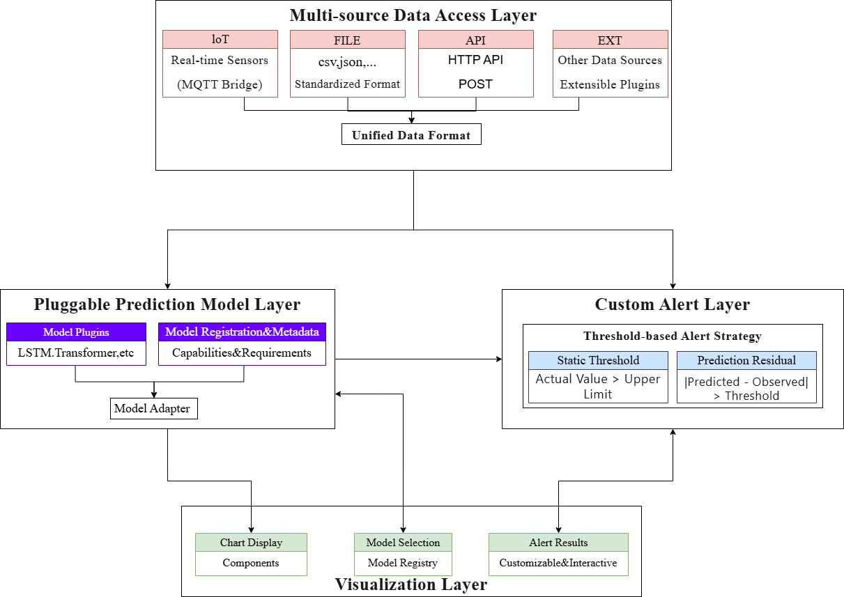
Fig. 1. Predictive-SHM functional and architectural design.

Multi-source data access
The platform targets multi-sensor monitoring scenarios. The multi-source data access module provides unified data ingestion and management to resolve inconsistencies in sensor protocols and fragmented access points.
The module abstracts multi-source sensor data into timestamped time-series record streams. Data enter via standardized or flattened formats and are converted into a unique internal representation (timestamp + columns) (see Table 1).
Table 1 Format specifications

Type | Format |  | Description
Standardized format | { "ts": int, "data": { "k": v, ... } } |  | Time and data are separated; data contains arbitrary sensor key-value pairs
Flattened format | { "timestamp": int, "k":v, ... } |  | Time and data reside in the same layer; backward-compatible interface
Internal format | { "timestamp":int, ...columns } |  | Unified internal representation; column order and channels defined by model_config (user-modifiable)
Once processed, data from all sources participate in analysis and prediction using the same internal format. A unified data-processing pipeline converts time-series records into the tensor format required by each model. Column order, channels, and display mappings are declared in configuration files. Actual data sources (HTTP reporting, file loading, bridging scripts, etc.) are determined at runtime, eliminating the need for repeated code modifications across projects.
This mechanism allows new data sources to be added without altering core code and enables sensor-type and display extensions through configuration alone, thereby reducing deployment and maintenance costs while providing the pluggable prediction module with stable, consistent input.

Pluggable prediction model
In SHM, time-series prediction typically aims to forecast future sensor readings directly rather than aggregated indices. To meet this requirement, the module first introduces a Universal Logical Data Model (ULDM) as a semantic abstraction layer over the internal format. The ULDM comprises:
- Time-index sequence: sensor sampling timestamps (equal-interval or irregular timestamps permitted);
- Target variable sequence: physical quantities to be predicted (single-variable, e.g., strain at a point, or multi-variable, e.g., responses from multiple accelerometers);
- Dynamic covariate matrix: time-varying external factors (ambient temperature, wind speed, traffic load, etc.);
- Static metadata vector: inherent structural attributes (structure type, material parameters, sensor coordinates) and sensor configuration information (sampling rate, range).
For the data input/output specifications of common SHM models (LSTM, GRU, Transformer, and traditional statistical models), the system adopts the Model Adapter pattern [9,10]. Each model plugin is paired with a dedicated adapter that performs bidirectional conversion:
- Input: transforms the unified internal format (or ULDM components) into the model-specific physical format (e.g., 3D tensor for LSTM/GRU, position encoding for Transformer, differencing for ARIMA);
- Output: maps model predictions back to a timestamped standard structure (prediction steps × number of sensors, with optional confidence intervals).
Model registration uses a metadata-driven mechanism. Model capabilities and requirements are declared in a YAML/JSON metadata file (see Fig. 2). Adding a new model requires only implementing the adapter interface (Table 2), supplying the metadata file, and placing the model file in the designated directory; the model then becomes selectable in the user interface.
To facilitate comparison and downstream applications, all models enforce output semantic standardization: predictions are uniformly returned as engineering-friendly future sensor reading sequences (with timestamps and optional uncertainty), supporting multi-step forecasting and anomaly trend analysis.
The platform currently includes a built-in Transformer-CNN model as the reference implementation. At runtime, the corresponding model adapter is loaded via configuration, enabling dynamic model switching and comparison without modifying core backend logic.
This module substantially reduces algorithm iteration and model replacement costs, allowing researchers to rapidly compare different prediction methods within the same framework and thereby promoting scientific reproducibility and engineering validation [11,14].
Table 2 Adapter interface specification

Item | Specification
Input | Time-series tensor of defined dimensions (batch × time steps × features)
Output | Prediction tensor of defined dimensions (batch × prediction steps × targets)
Integration | Format conversion handled by the unified data-processing pipeline

Listing 1. Model registration example.

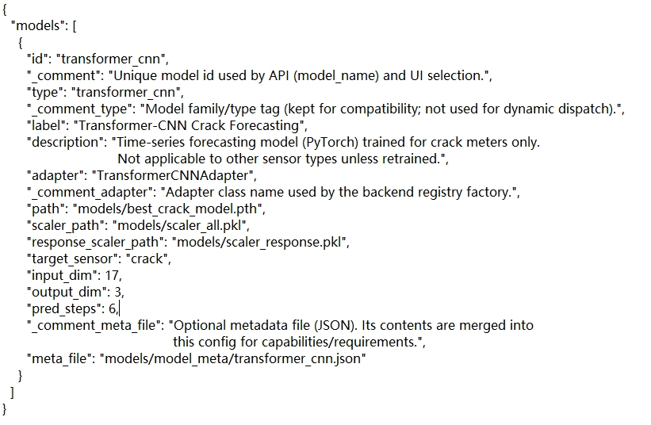

Custom alert
To prevent complex alarm rules and notification mechanisms from being coupled too early into the prediction workflow, the platform separates the alert logic from the prediction module. Predictive-SHM employs a basic strategy based on thresholds and prediction residuals to mark and highlight abnormal trends in structural responses (the monitoring chart border turns red upon anomaly detection). This assists users in identifying potential anomaly clues without providing direct engineering-level risk judgments.
Threshold configuration and synchronization allow each channel to have independent static and residual thresholds. Default values are set globally in the configuration file, while users can modify them via interface controls. Modified thresholds are synchronized to the backend through a unified interface and participate in subsequent alert decisions. The frontend pulls the latest backend thresholds on page load or refresh to ensure consistency across clients.
This design reserves space for future plug-in alarm modules or external alerting systems while maintaining core workflow stability and providing an engineering foundation for gradual evolution of multi-scenario early-warning strategies.

Visualization
Predictive-SHM employs a configuration-driven visualization design that centrally displays multi-source monitoring data, prediction results, thresholds, and alerts, forming a unified monitoring interface consistent with the data, prediction, and alert modules (see Fig. 3). The visualization module consumes only the public interfaces of each module and does not implement business rules, allowing display layouts and sensor configurations to be extended or adjusted solely by modifying configuration files without touching core code [16].
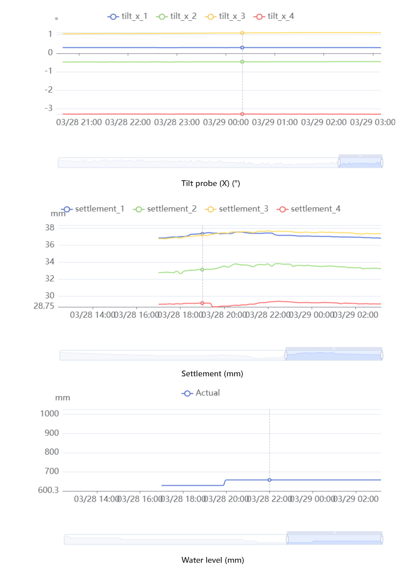

(a)

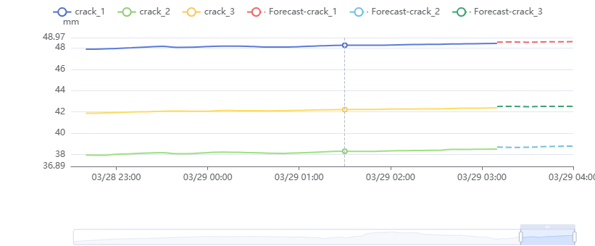
(b)
Fig.3 Overview of time-series prediction results for crack width.
(a) Representative multi-sensor inputs used for prediction.
(b) Comparison between predicted and observed crack width.

Illustrative examples
To verify the deployability and system stability of Predictive-SHM in a real engineering environment, the Yuhuang Pavilion historic building was selected as a demonstration scenario. The case validates the complete data-access workflow, model invocation mechanism, and frontend visualization pipeline in an end-to-end manner. The example primarily illustrates the software’s operational feasibility in practical engineering settings rather than serving as the sole basis for algorithm performance evaluation.
Results demonstrate that Predictive-SHM stably handles multi-source structural response and environmental data, achieving unified data preprocessing, multi-step prediction, and real-time visualization functions. Sensors were strategically deployed at key locations of the Yuhuang Pavilion to capture structural and environmental responses. Figure 5(a) shows a schematic diagram of sensor positions on the walls of this historic building. Figure 5(b) presents on-site photographs of representative sensor installations, illustrating the actual mounting conditions and their integration with the masonry structure (see Fig. 5). Users can customize warning thresholds through the interface, thereby enabling identification and monitoring of anomalous trends. Figure 4 illustrates real-time structural health monitoring of crack development under multi-sensor inputs, where users can customize warning thresholds via the interface to achieve identification and monitoring of anomalous trends. The combination of historical data playback and overlaid prediction information further enhances the intuitiveness of structural state analysis (see Fig. 3(b).The modular design and pluggable model interface allow users to rapidly replace or extend prediction models without modifying core business logic. Overall, the case confirms that the platform delivers complete end-to-end capabilities in multi-source data fusion, intelligent prediction, and visualization, providing a reproducible and extensible software solution for monitoring and risk assessment of historic buildings, bridges, tunnels, and other engineering structures [15].


Fig. 4. Real-time structural health monitoring and time-series prediction of crack development at the Yuhuang Pavilion under multi-sensor inputs.
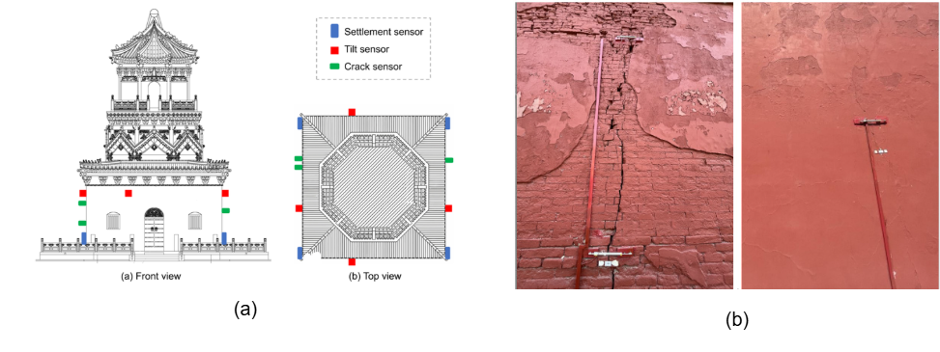
Fig. 5. Sensor deployment at the Yuhuang Pavilion historic building for real-time structural health monitoring.
    - Schematic layout showing sensor positions on walls.
    - On-site photographs of representative sensor installations, demonstrating practical mounting conditions.

Impact
Predictive-SHM, an open-source toolkit specifically designed for time-series prediction in structural health monitoring (SHM), effectively bridges the gap between advanced laboratory algorithms and real-world engineering practice. Its standardized data interface, pluggable model architecture, and fully reproducible end-to-end workflow enable researchers to rapidly integrate, compare, and iterate on advanced prediction models (e.g., LSTM, GRU, Transformer) within a single lightweight platform. This significantly improves the efficiency of existing research by eliminating the need to rebuild custom data pipelines for each model, allowing rigorous benchmarking of predictive accuracy, uncertainty quantification, and anomaly detection directly on real multi-sensor engineering datasets. Such capabilities directly support core SHM topics including damage prognosis, environmental load effects, and long-term structural degradation modeling ^{[5,7]}.
The software opens the following new research directions:
- Performance evaluation of physics-informed and purely data-driven hybrid models in transfer learning across different historic buildings (enabled by ULDM’s static metadata support);
- Value of uncertainty-aware prediction models for early-warning decision-making in historic structures under climate change;
- Privacy-preserving and data-sharing potential of lightweight edge-deployment strategies in multi-institutional collaborative SHM of historic buildings.
In daily practice, Predictive-SHM has been deployed in the real-time health monitoring and early-warning system of the Yuhuang Pavilion historic building in China. It replaces fragmented scripting workflows with a configuration-driven browser interface, reducing model testing and on-site diagnosis time from days to hours while enhancing visualization of prediction-versus-observation residuals. Its lightweight design (Python/Node.js backend with minimal dependencies) further lowers deployment barriers for remote historic sites.
Although recently released (v1.0), the software is currently primarily used for the real-time monitoring of Yuhuang Pavilion, with GitHub metrics showing steady growth. The MIT license and modular architecture lay a solid foundation for future expansion into additional engineering validation projects, academic collaborations, and potential industrial applications.
Predictive-SHM contributes to the transformation of SHM toward open, reproducible, and community-driven tools, promoting fair model comparison, rapid knowledge transfer, and improved infrastructure risk management in resource-constrained settings.

Conclusions
Predictive-SHM provides a lightweight and extensible structural health monitoring and time-series prediction toolkit. Its differentiated features—simple deployment, modular integration, reproducible end-to-end workflow, and standardized interfaces—make it suitable for monitoring historic buildings, bridges, tunnels, and other engineering structures as well as for scientific research and teaching applications. As an open-source platform, it enables rapid replication, model switching, and customization while maintaining a stable core, thereby facilitating continuous community-driven evolution.
Acknowledgements
The authors thank all members of the research group for their support in system development and manuscript preparation. This work was supported by the National Key Research and Development Program of China (No. 2023YFC3805203) and the National Natural Science Foundation of China (No. 52378544, 52378543).

References
- S. Sony, K. Dunphy, A. Sadhu, J. Lardner, A systematic review of convolutional neural network-based structural health monitoring methods, Smart Mater. Struct. 30 (2021) 043002. https://doi.org/10.1088/1361-665X/abe4d6.
- C.R. Farrar, K. Worden, Structural Health Monitoring: A Machine Learning Perspective, John Wiley & Sons, Chichester, UK, 2012.
- M.Z. Guglielmetti, J.W. Berman, Challenges in the deployment of structural health monitoring systems for infrastructure management, Struct. Control Health Monit. 28 (2021) e2733. https://doi.org/10.1002/stc.2733.
- J.P. Lynch, K.J. Loh, A summary review of wireless sensors and sensor networks for structural health monitoring, Shock Vib. Dig. 38 (2006) 91–130.
- L. Sun, Z. Shang, Y. Xia, S. Bhowmick, S. Nagarajaiah, Review of bridge structural health monitoring aided by big data and artificial intelligence: From condition assessment to damage detection, J. Struct. Eng. 146 (2020) 04020073.
- G. De Matteis, L. Cascini, F. Giannino, Integrated monitoring of historical structures: the case of the Santa Maria di Collemaggio Basilica, J. Civil Struct. Health Monit. 11 (2021) 1243–1260. https://doi.org/10.1007/s13349-021-00508-3.
- J. Hou, M. Lukacova, R.P. Singh, Open-source software for real-time environmental and structural monitoring: A review of current trends, Softw. Pract. Exp. 53 (2023) 412-435.
- D.L. Parnas, On the criteria to be used in decomposing systems into modules, Commun. ACM 15 (12) (1972) 1053–1058.
- Y. Sheng et al., S-LoRA: Serving Thousands of Concurrent LoRA Adapters, arXiv:2311.03285 (2023). https://doi.org/10.48550/arXiv.2311.03285.
- Y. Yang et al., MTL-LoRA: Low-Rank Adaptation for Multi-Task Learning, arXiv:2410.09437 (2024). https://doi.org/10.48550/arXiv.2410.09437.
- A.Fernández-Montes et al., SimilarityTS: Toolkit for the evaluation of similarity for multivariate time series, SoftwareX 23 (2023) 101223. https://doi.org/10.1016/j.softx.2023.101223.
- Sergio Cantero-Chinchilla et al.,OptiSens—Convex optimization of sensor and actuator placement for ultrasonic guided-wave based structural health monitoring,SoftwareX,Volume 13,2021,100643,ISSN 2352-7110,https://doi.org/10.1016/j.softx.2020.100643.
- Y. Lai et al., Framework for long-term structural health monitoring by computer vision and digital twin, Structures 44 (2022) 152–163. https://doi.org/10.1016/j.istruc.2022.08.052.
- J. Huang et al., Framework for a practical and cost-effective IoT-enhanced structural health monitoring and damage diagnostics system with digital twinning, J. Civil Struct. Health Monit. (2025). https://doi.org/10.1007/s13349-025-00927-9.
- R. Boccagna et al., Unsupervised Deep Learning for Structural Health Monitoring, Big Data Cogn. Comput. 7 (2023) 99. https://doi.org/10.3390/bdcc7020099.
- E. Carter et al., Augmented Reality-Based Real-Time Visualization for Structural Health Monitoring, Sensors 24 (2024) (PMC10934679).
- Monti, G., Rabi, R.R., Marella, L., Proietti, S.T., 2025. Data-driven decision support system for the safety management of railway bridge networks. Reliability Engineering & System Safety, 262, 111202. https://doi.org/10.1016/j.ress.2025.111202.
- Rabi, R.R., Vailati, M., Monti, G., 2024. Effectiveness of vibration-based techniques for damage localization and lifetime prediction in structural health monitoring of bridges: A comprehensive review. Buildings, 14(4), 1183. https://doi.org/10.3390/buildings14041183.
- Rabi, R.R., Monti, G., 2025. Genetic algorithm-based model updating in a real-time digital twin for steel bridge monitoring. Applied Sciences, 15(8), 4074. https://doi.org/10.3390/app15084074.

