**4.16**

#include <iostream>

#include <iomanip>

using namespace std;

int main()

{

int hours;

double rate;

double salary;

cout << "Enter hours worked (-1 to end): ";

while (cin >> hours) {

//End Check

if (hours == -1)

break;

//Positive Hours Check

if (hours <= 0) {

cout << "Illegal Hours Input!\nEnter hours worked (-1 to end): ";

continue;

}

cout << "Enter hourly rate of the employee ($00.00): ";

//Positive Rate Check

while (cin >> rate) {

if (rate <= 0) {

cout << "Illegal Rate Input!\nEnter hourly rate of the employee ($00.00): ";

continue;

} else {

break;

}

}

//Calculate Salary

if (hours <= 40)

salary = hours * rate;

else

salary = 40 * rate + (hours - 40) * rate * 1.5;

//Output

cout << "Salary is $" << fixed << setprecision(2) << salary << "\n\nEnter hours worked (-1 to end): ";

}

}

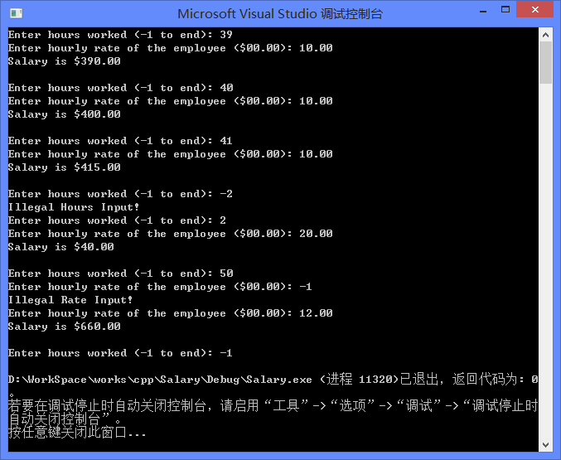

**4.25**

#include <iostream>

#include <iomanip>

using namespace std;

int main()

{

int size;

cout << "Enter size of the square (1 to 20): ";

while (cin >> size) {

//Illegal Input Check

if (size < 1 || size > 20) {

cout << "Illegal Size Input!\nEnter size of the square (1 to 20): ";

continue;

}

//Print

for (int i = 0; i < size; i++) {

if (i != 0 && i != size - 1)

//Print midst lines

cout << "*" << setw(size - 1) << "*" << "\n";

else {

//Print head and tail

for (int j = 0; j < size; j++)

cout << "*";

cout << "\n";

}

}

//Continue

cout << "\nEnter size of the square (1 to 20): ";

}

}

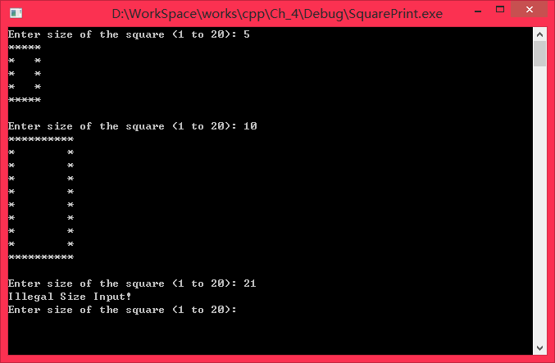

**4.26**

#include <iostream>

using namespace std;

int main()

{

int origin;//Oirgin number

int reversed = 0;//Reversed number

int temp;

cout << "Enter a positive integer: ";

while (cin >> origin) {

reversed = 0;

//Input Check

if (origin <= 0) {

cout << "Illegal Input!\nEnter a positive integer: ";

continue;

}

//Build reversed number

temp = origin;

while (temp != 0) {

reversed *= 10;

reversed += temp % 10;

temp /= 10;

}

//Output

cout << origin;

if (origin == reversed)

cout << " is a palindrome.";

else

cout << " is not a palindrome.";

cout << "\n\nEnter a positive integer: ";

}

}

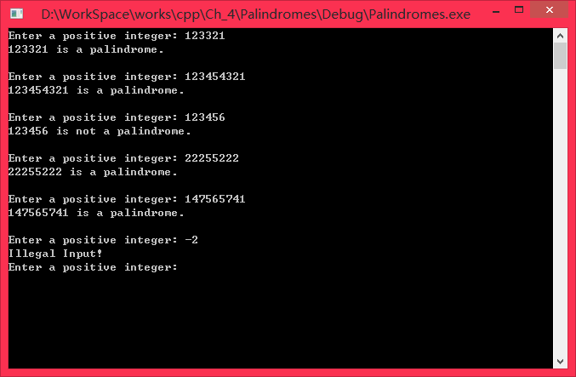

**4.27**

**4.34**