5.29

#include <iostream>

#include <iomanip>

using namespace std;

int main() {

const int principle = 24;//起始资金

double totalMoney = principle;//资金合计

int rate;//利率=rate%

cout << "Rate\t" << setw(23) << "Wondered Interest" << endl;

for (int i = 0; i < 6; i++) {

rate = i + 5;

totalMoney = principle;

for (int j = 0; j < (2018 - 1626); j++) {

totalMoney *= (1 + rate / 100.0);

}

cout << rate << "%\t$" << setw(22) << fixed << setprecision(2) << totalMoney - principle << endl;

}

}

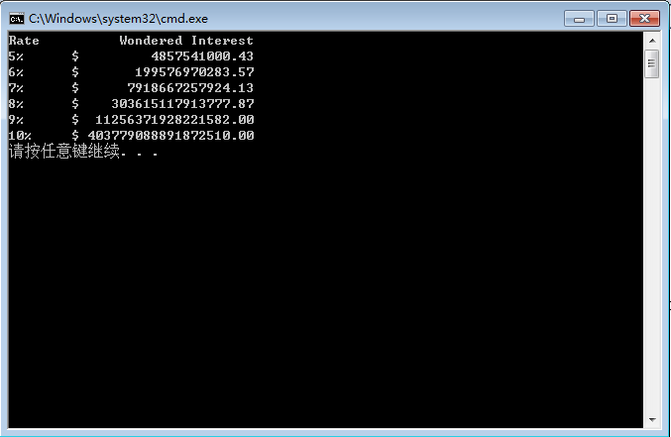

6.19

#include <iostream>

#include <iomanip>

using namespace std;

double hypotenuse(double, double);

int main() {

double side1, side2;

while (cin) {

cout << "Please type in the length of side 1: ";

cin >> side1;

cout << "Please type in the length of side 2: ";

cin >> side2;

cout << "The length of hypotenuse is " << fixed << setprecision(1) << hypotenuse(side1, side2) << endl << endl;

}

}

double hypotenuse(double side1, double side2) {

return pow(side1 * side1 + side2 * side2, 0.5);

}

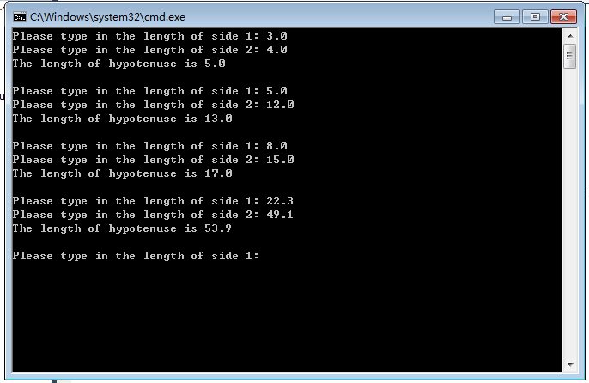

**Debugging**

#include <iostream>

using std::cout;

using std::endl;

#include <iomanip>

using std::setprecision;

int main()

{

int i = 1;

int j = 0;

double a;

double b;

cout << setprecision(2);

for (; i <= 2; i++) {

cout << "i is now equal to " << i << endl;

j = 0;

for (; j <= 3; j++) {

cout << "\tj is now equal to " << j << endl;

cout << "\t\ti + j = " << i + j << "\ti - j = " << i - j << endl;

cout << "\t\ti * j = " << i * j << "\ti ^ j = " << pow(static_cast<double>(i), j) << endl;

if (j == 0)

continue;

else

{

a = i;

b = j;

cout << "\t\ti / j = " << a / b << "\ti % j = " << i % j << endl;

}

}

}

cout << "\nThe final values of i and j are: " << i << " and " << j << endl;

return 0;

}

