**5.6**

#include <iostream>

using namespace std;

int main()

{

int sum = 0;

int temp;//暂存器

int count;//计数器

for (count = 0; cin >> temp; count++) {

if (temp != 9999)

sum += temp;

else

break;

}

if (count != 0)//检查输入数是否为0

cout << "The average is " << static_cast<double>(sum) / count << endl;

else

cout << "Illegal input!" << endl;

}

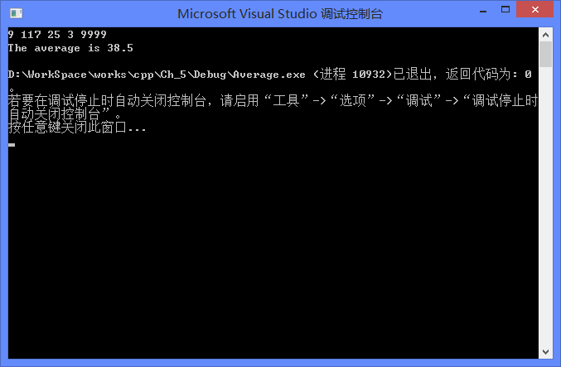

**5.9**

#include <iostream>

using namespace std;

int main()

{

int product = 1;//initialize product

for (int i = 1; i <= 15; i += 2)

product *= i;

cout << "The product of the odd integers from 1 to 15 is " << product << endl;

}

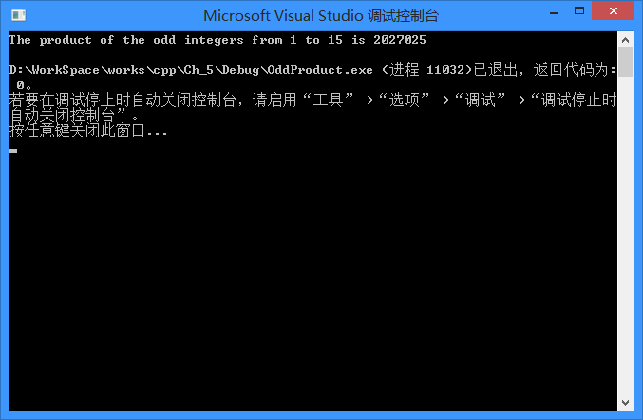

**5.12**

#include <iostream>

using namespace std;

int main()

{

/* (a) */

for (int i = 1; i <= 10; i++) {

for (int j = 0; j < i; j++)

cout << '*';

cout << endl;

}

cout << endl;

/* (b) */

for (int i = 10; i >= 1; i--) {

for (int j = 0; j < i; j++)

cout << '*';

cout << endl;

}

cout << endl;

/* (c) */

for (int i = 0; i < 10; i++) {

for (int j = 0; j < i; j++)

cout << ' ';

for (int j = 0; j < 10 - i; j++)

cout << '*';

cout << endl;

}

cout << endl;

/* (d) */

for (int i = 1; i <= 10; i++) {

for (int j = 0; j < 10 - i; j++)

cout << ' ';

for (int j = 0; j < i; j++)

cout << '*';

cout << endl;

}

}

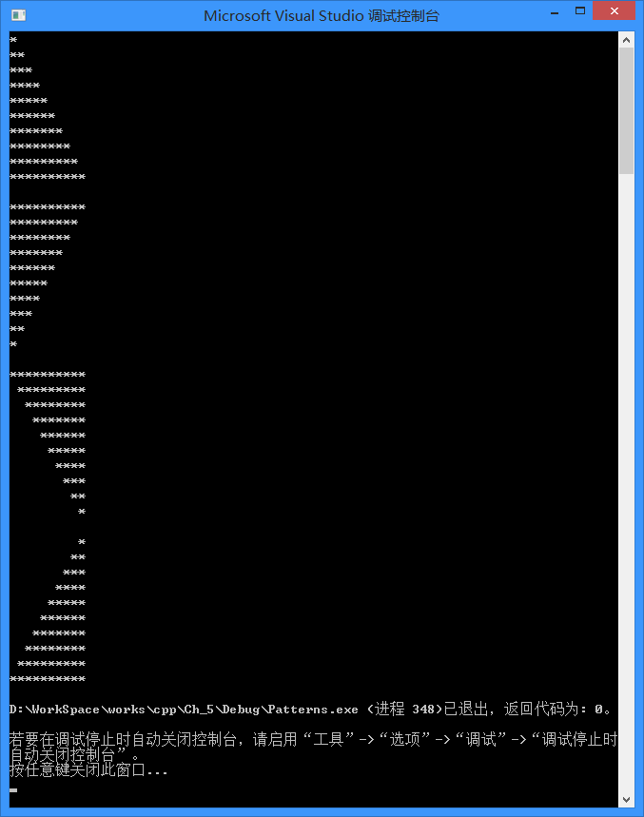

**5.14**

#include <iostream>

using namespace std;

int main()

{

const double PRICE_1 = 2.98;

const double PRICE_2 = 4.50;

const double PRICE_3 = 9.98;

const double PRICE_4 = 4.49;

const double PRICE_5 = 6.87;

double sum = 0.0;

int type = 0;//商品类型标识

int temp;//零售数量暂存器

double price = 0;//价格暂存器

for (int i = 0; i < 5;) {

cin >> type;

switch (type) {

case 1:

price = PRICE_1;

break;

case 2:

price = PRICE_2;

break;

case 3:

price = PRICE_3;

break;

case 4:

price = PRICE_4;

break;

case 5:

price = PRICE_5;

break;

default:

price = 0;//非法输入标识

break;

}

cin >> temp;

if (price != 0 && temp >= 0) {

sum += price * temp;

i++;//合法输入再自增

} else {

cout << "Illegal input!\n";

continue;

}

}

cout << "The total retail value is $" << sum << endl;

}

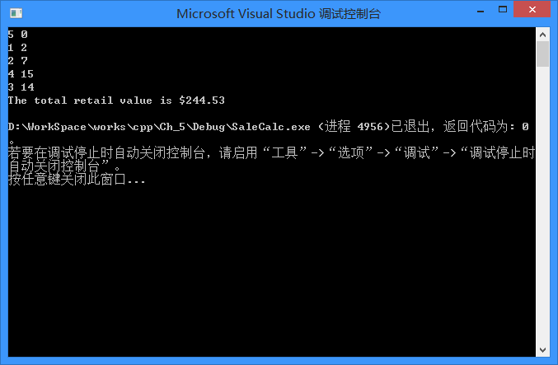

**5.19**

#include <iostream>

#include <iomanip>

using namespace std;

int main()

{

int count = 0;

double pi = 0;

for (int i = 1; i <= 1000; i++) {

if (i % 2 != 0)

pi += 4.0 / (2 * i - 1);//奇数项

else

pi -= 4.0 / (2 * i - 1);//偶数项

cout << i << "\t" << fixed << setprecision(10) << pi << endl;

}

}

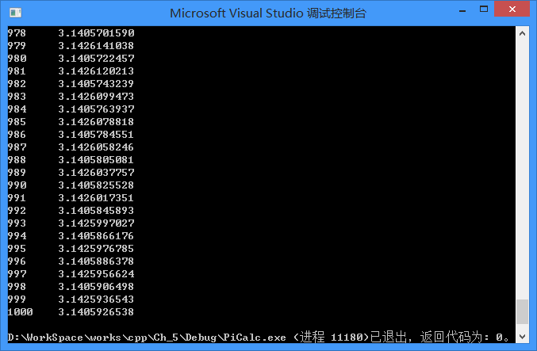

**5.20**

#include <iostream>

using namespace std;

int main()

{

cout << "side1\tside2\thypotenuse\n";

for (int a = 1; a <= 500; a++)

for (int b = 1; b <= 500; b++)

for (int c = 1; c <= 500; c++)

if (c * c == a * a + b * b)//c为斜边

cout << a << "\t" << b << "\t" << c << endl;

}

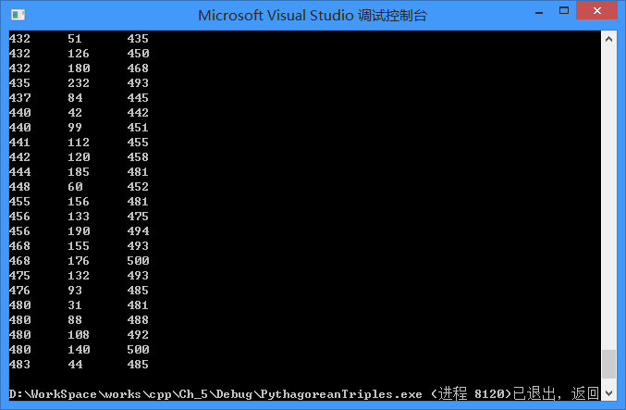

**5.23**

#include <iostream>

using namespace std;

int main()

{

int spaceNum;//空格数量

int astNum;//星号数量

for (int i = 1; i <= 9; i++) {

if (i <= 5) {

//上半部分

spaceNum = 5 - i;

astNum = 2 * i - 1;

} else {

//下半部分

spaceNum = i - 5;

astNum = 19 - 2 * i;

}

for (int j = 0; j < spaceNum; j++)

cout << ' ';

for (int j = 0; j < astNum; j++)

cout << '*';

cout << endl;

}

}

